Lance Imaging & Morphometrics v3
Landmark + semilandmark protocol. Generated 2026-09-29 from Lance_Landmarking_Protocol.md (protocol v1.4). Rehydration and imaging are unchanged from v2; Lance Morphometrics is new and replaces the v2 multipoint landmarking.

Lance Rehydration
- Grab vial with Lance in 100% ethanol
- Transfer lance from vial of 100% ethanol into a vial of 75% ethanol and let it acclimate for 5 minutes
- After acclimation period 1 is over, transfer lance from vial of 75% ethanol into a vial of 50% ethanol and let it acclimate for 5 minutes
- After acclimation period 2, transfer lance from vial of 50% ethanol into a vial of 25% ethanol and let it acclimate for 5 minutes
- After acclimation period 3 is over transfer lance from vial of 25% ethanol into a vial of 10x PBS for lance to be imaged.

Lance Imaging
- Turn on camera, fiber-light, and 4k monitor.
- Set camera magnification to 5x.
- Right click and select “Set Scale” from the menu.
- Select “Nikon 5x”.
- Right click and select “Scale Bar” from the menu to add a scale bar to the image. The scale bar must stay in the saved image: it calibrates each image during morphometrics.
- Orient the lance for imaging (see below for guidelines pertaining to each side).
- If needed, you can digitally zoom by moving the mouse to the right of the screen and click on the “Zoom in” Icon.
- When you are ready to capture the image, move the mouse to the right of the screen and click the “Freeze” icon on the bottom.
- Right click and select “Text”.
- Rapidly click the screen until a text box appears. Click in the box and type the ID of the lance being measured.
- Drag this to an appropriate place near the lance.
- Move the mouse to the top right of the screen and click the “Capture” icon. Right click and select “exit” when done.
- At the end of imaging, remove the USB and transfer it to a computer of your choice.
- Rename each image with its ID (see below for guidelines pertaining to each side) and upload the images to SharePoint.

Imaging the “Right” Face
- Orient the lance such that the tip is facing to the right and the sclerotized (darkened) edge is facing downward.
- The tip of the other side of the lance should not be visible.
- Ensure that the top edge of the tip is flat and not slanted.
- The bottom middle suture should not be visible.
- The entire lance should be in sharp focus. If it is not, then it should be reoriented accordingly.
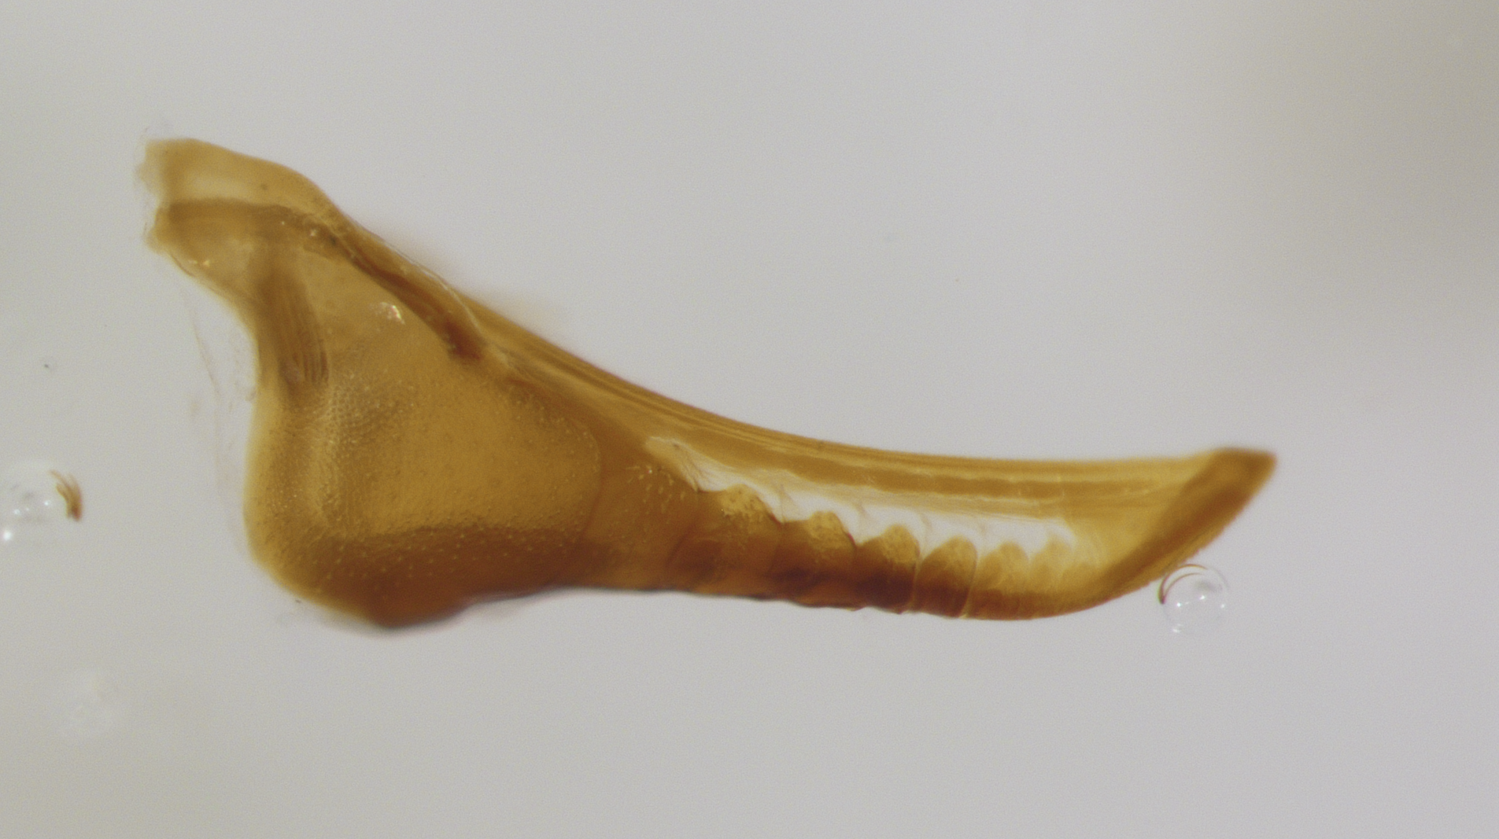
Reference image for a right-facing lance that is correctly oriented.

Imaging the “Left” Face
- Orient the lance such that the tip is facing to the left and the sclerotized edge is facing downward.
- The tip of the other side should be visible but ensure that both tips are level with each other.
- The bottom middle suture should not be visible.
- The entire lance should be in sharp focus. If it is not, then it should be reoriented accordingly.
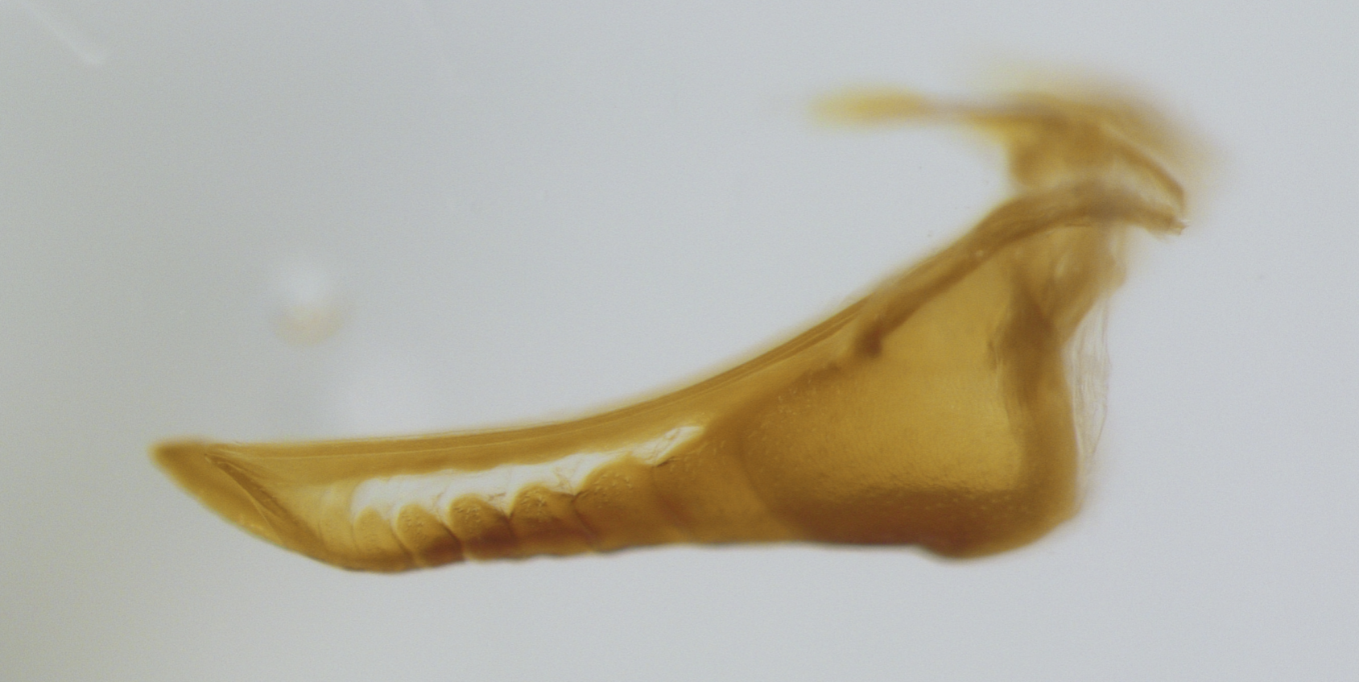
Reference image for a left-facing lance that is correctly oriented.
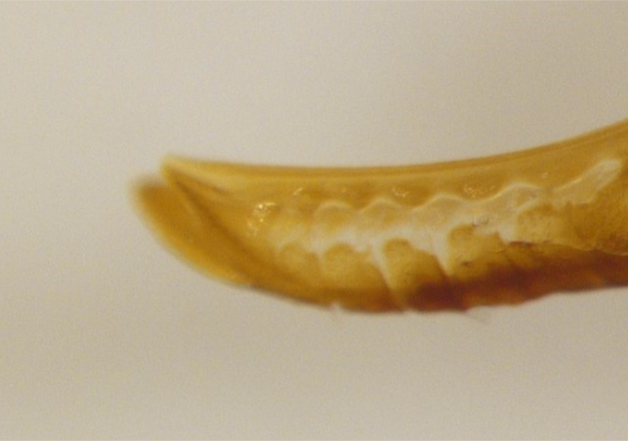
An incorrectly oriented left-facing lance where the asymmetrical sides are not aligned properly.

Imaging the Dorsal Face
- Orient the lance such that it is downward facing, and they are facing to the right.
- The tips of both the short and long side should be visible.
- The bottom middle suture should be a straight line.
- The entire lance should be in sharp focus. If it is not, then it should be reoriented accordingly. The whole structure is now measured, so check that the proximal end (the V-shaped notch between the two basal lobes) and the lobes' outer margins are in focus, not only the tips.
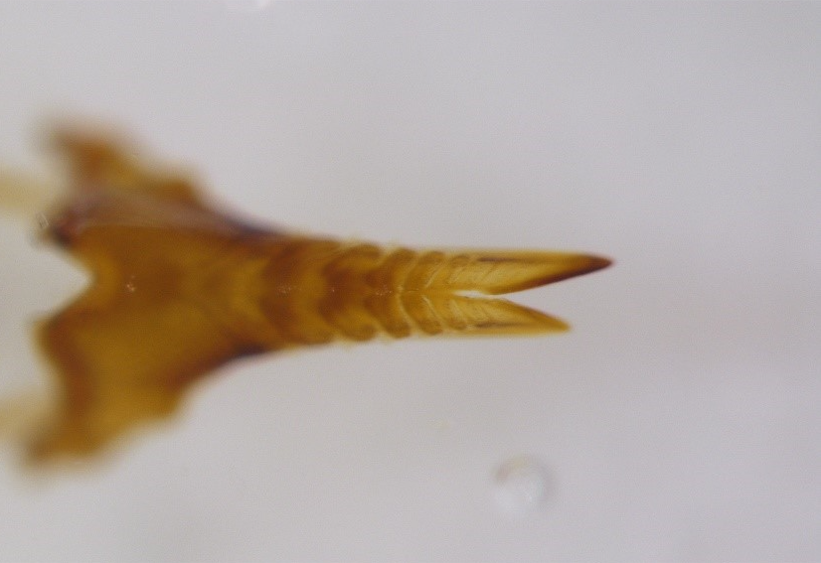
Reference image where the downward-facing lance is correctly oriented.
Save files as “.tif”:
- “SampleID_R” for right-facing lances
- “SampleID_L” for left-facing images
- “SampleID_B” for downward-facing images (images of the dorsal face)

Lance Morphometrics
Each image gets three kinds of points:
- Anchors (red dots in the figures): anatomical points you click with the Multi-point tool, in a fixed order. Right 17, Left 17, Dorsal 13.
- Curves (blue lines): margins you trace with the Segmented Line tool, from one anchor to another. You only trace the edge. Never try to space points evenly by eye: the software places the evenly spaced semilandmarks (white dots) on your trace afterwards.
- Computed points (purple diamonds): R18, L18 and B14. You never click these; the software works them out from your anchors and traces.
For each image you save one ROI set (SampleID_R_ROI.zip, SampleID_L_ROI.zip or SampleID_B_ROI.zip) and fill one row of the annotation sheet (annotation_sheet_template.csv).

One-time setup in Fiji/ImageJ
- Use Fiji (ImageJ).
- Double-click the Multi-point tool icon and set: Type Hybrid, Color Yellow, Size Small, and tick Label points so each click shows its number. Untick “Add to ROI Manager” and “Measure”.
- Double-click the Segmented Line tool icon and set the line width to 1.
- Open the ROI Manager: Analyze › Tools › ROI Manager.

Steps for every image
- Open the raw TIFF (from lance_landmarking/raw_images), never a previously landmarked _MARK file.
- Calibrate from the scale bar. Use the Straight Line tool to draw a line exactly along the scale bar, end to end. Analyze › Set Scale: Known distance = the bar's length (1 mm), Unit = mm, Global unticked. Write the “Distance in pixels” into the px_per_mm column of the sheet.
– If an image has no scale bar, write the session value instead: 927 px/mm for 3840 × 2160 images, 1260 px/mm for 2560 × 1920 images.
- Empty the ROI Manager: select all entries and Delete.
- Click the anchors. Select the Multi-point tool and click the anchors in the order in the table for that face. Zoom to at least 200% (Ctrl +) for each point.
– To move a misplaced point, drag it. Do not delete points (Alt-click): deleting renumbers everything after it.
– If a point cannot be seen (hidden by debris, damaged, out of focus), still click your best estimate so the numbering stays correct, and write its ID (e.g. B12) in the flagged_points column. The analysis treats flagged points as missing rather than trusting the estimate.
- Press T to add the anchors to the ROI Manager, then Rename… it to anchors.
- Trace the curves, one at a time, in the order in the curve table. For each: select the Segmented Line tool; click once on the starting anchor; click along the margin every 20–40 pixels (closer where it bends); double-click on the ending anchor. Press T and Rename… it to the curve's name (e.g. R.heel).
– Follow the edge of the amber/dark sclerotized cuticle, not pale membrane, and not rods or flaps attached to the lance (see Rules).
– Starting or stopping a little past the anchor is fine; the software trims each trace at its anchors.
– Keep the ROI Manager order: anchors first, then the curves in table order.
- Tick Show All in the ROI Manager and compare against the reference figure for that face.
- Save: ROI Manager › More › Save… as SampleID_R_ROI.zip (or _L_ / _B_), in the same folder layout as the images.
- Fill in the annotation sheet row (columns described at the end of this section).

Right face (long half)
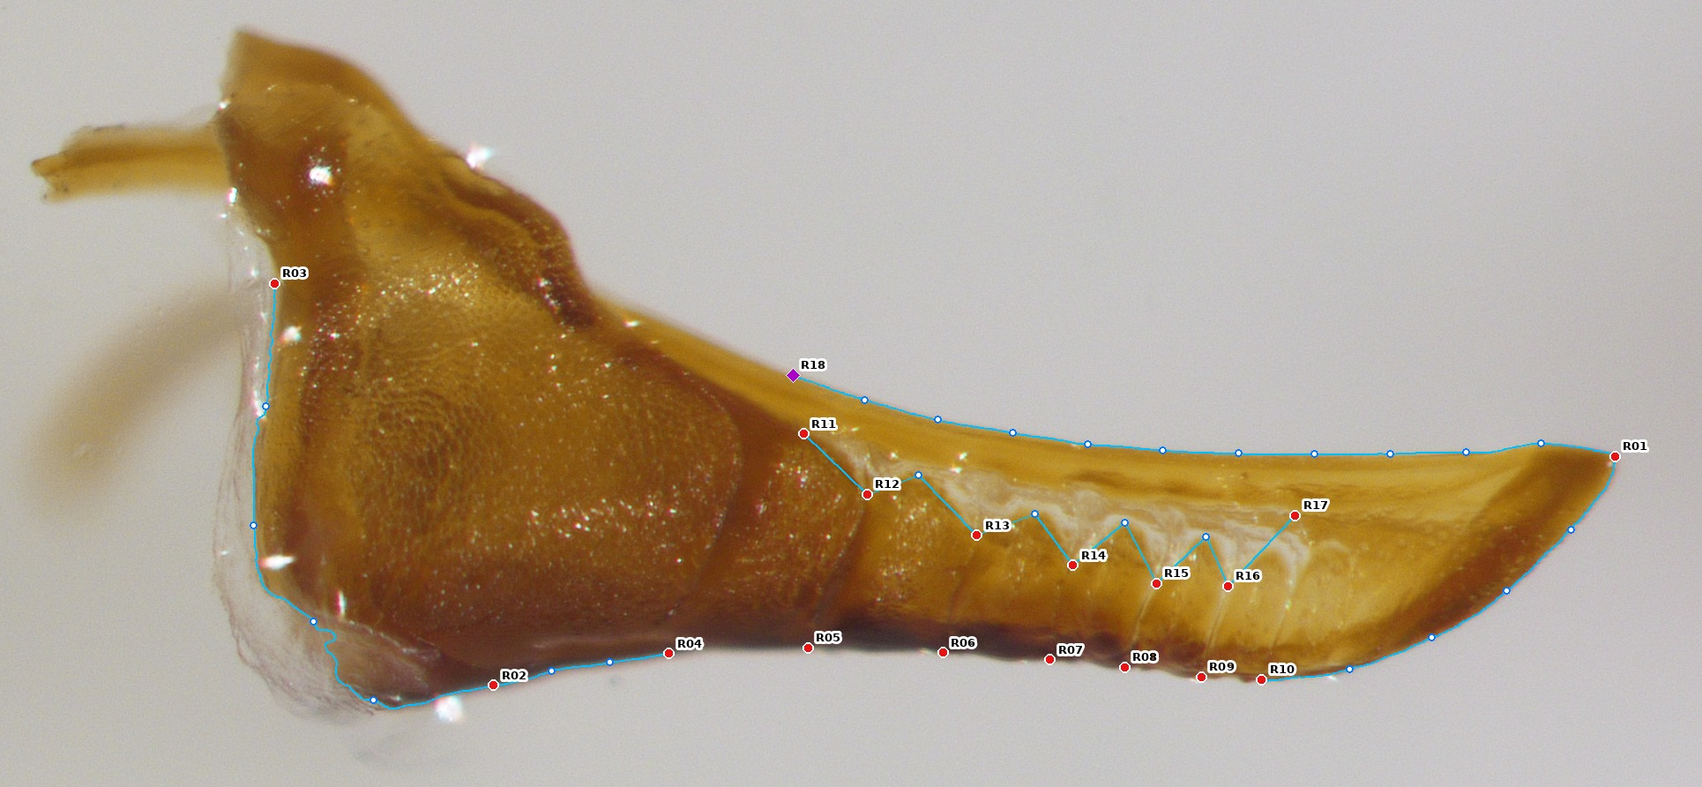
Right face (N. lecontei parent LL280xLL284-1). Red = anchors, white = semilandmarks placed by the software, purple = computed point R18.
Anchors: click in this order (17 clicks).
Click | ID | Where | Old #
1 | R01 | Apex: the very tip of the lance. | 13
2 | R02 | Heel–ventral junction: the proximal end of the dark sclerotized ventral edge, where it meets the heel. | 3
3 | R03 | Proximal heel notch: the deepest point of the notch in the proximal (back) edge, between the heel and the basal process above it. | 1
4 | R04 | Suture 1, ventral end: where the first suture from the heel meets the ventral edge. | 4
5 | R05 | Suture 2, ventral end. | 5
6 | R06 | Suture 3, ventral end. | 6
7 | R07 | Suture 4, ventral end. | 7
8 | R08 | Suture 5, ventral end. | 8
9 | R09 | Suture 6, ventral end. | 9
10 | R10 | Suture 7, ventral end. | 10
11 | R11 | Window, proximal end: the most proximal point of the upper edge of the pale cuticular window. | 14
12 | R12 | Suture 2, dorsal end: where suture 2 meets the upper edge of the window. | 15
13 | R13 | Suture 3, dorsal end. | 17
14 | R14 | Suture 4, dorsal end. | 19
15 | R15 | Suture 5, dorsal end. | 21
16 | R16 | Suture 6, dorsal end. | 23
17 | R17 | Window, distal end: the most distal point of the upper edge of the window. | 25

Curves: trace in this order.
Order | Name | Trace | Points
1 | R.heel | From R03 down the proximal (back) edge of the heel to R02. | 4
2 | R.vbase | From R02 along the ventral edge to R04. | 2
3 | R.vdist | From R10 along the ventral edge to the apex R01. | 4
4 | R.dorsal | From anywhere behind the point directly above R11 (the window's proximal end), along the upper (dorsal) edge of the lance to R01. The software starts the curve at R18, the point on this edge straight above R11. Stay on the lance's own edge: never trace onto the golden basal flap that can lie above it near the heel. | 10
5 | R.window | From R11 along the upper edge of the pale window to R17, passing through R12–R16 and following the scalloped edge between them. | 4

Count every suture you can see meeting the ventral edge from heel to tip, and write the number in sutures_visible.

Left face (short half)
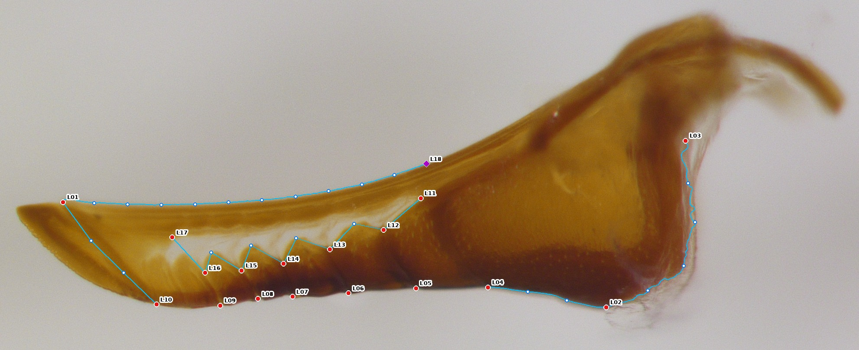
Left face. Same scheme as Right, with 6 anchored sutures and the ventral split point L10.
Anchors: click in this order (17 clicks).
Click | ID | Where | Old #
1 | L01 | Short-half apex: the tip of the short half. In this view the long half's tip sticks out past it, so L01 is inside the outline, not the tip of the silhouette. | 13
2 | L02 | Heel–ventral junction: the proximal end of the dark sclerotized ventral edge, where it meets the heel. | 3
3 | L03 | Proximal heel notch: the deepest point of the notch in the proximal (back) edge, between the heel and the basal process above it. | 1
4 | L04 | Suture 1, ventral end: where the first suture from the heel meets the ventral edge. | 4
5 | L05 | Suture 2, ventral end. | 5
6 | L06 | Suture 3, ventral end. | 6
7 | L07 | Suture 4, ventral end. | 7
8 | L08 | Suture 5, ventral end. | 8
9 | L09 | Suture 6, ventral end. | 9
10 | L10 | Ventral split point: the last point on the ventral edge before the edges of the two halves separate. | 10
11 | L11 | Window, proximal end: the most proximal point of the upper edge of the pale cuticular window. | 14
12 | L12 | Suture 2, dorsal end: where suture 2 meets the upper edge of the window. | 15
13 | L13 | Suture 3, dorsal end. | 17
14 | L14 | Suture 4, dorsal end. | 19
15 | L15 | Suture 5, dorsal end. | 21
16 | L16 | Suture 6, dorsal end. | 23
17 | L17 | Window, distal end: the most distal point of the upper edge of the window. | 24

Curves: trace in this order.
Order | Name | Trace | Points
1 | L.heel | From L03 down the proximal edge of the heel to L02. | 4
2 | L.vbase | From L02 along the ventral edge to L04. | 2
3 | L.vdist | From L10 along the short half's own ventral edge to L01. This edge runs inside the outline; the long half's tip forms the outline here. | 2
4 | L.dorsal | From anywhere behind the point directly above L11 (the window's proximal end), along the dorsal edge of the lance to L01. The software starts the curve at L18, straight above L11. Stay on the lance's own edge, never on the golden basal flap. | 10
5 | L.window | From L11 along the upper edge of the pale window to L17, through L12–L16. | 4

Count every visible suture on the short half and write the number in sutures_visible.

Dorsal face (both halves, whole structure)
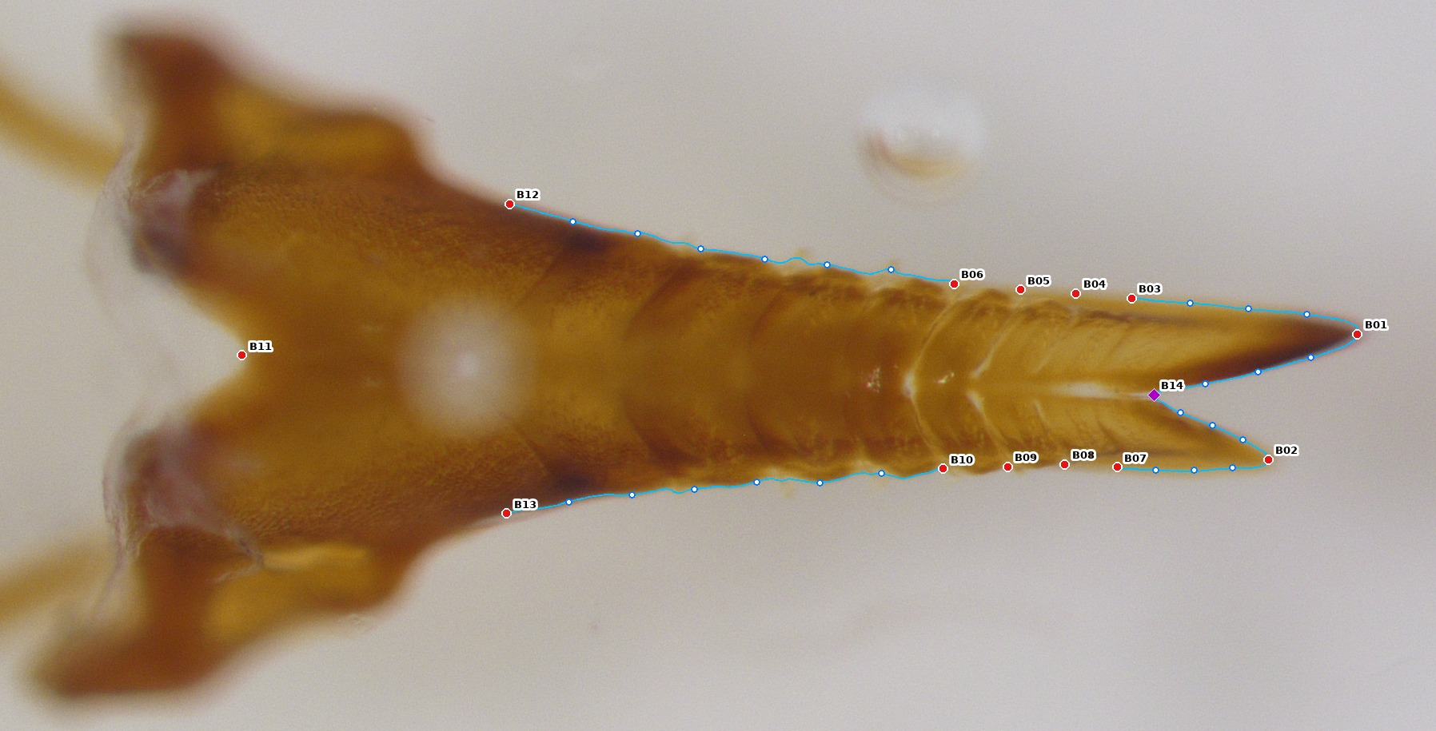
Dorsal face. B14 (purple) is the bottom of the gap between the tips, computed by the software from the fork trace.
Anchors: click in this order (13 clicks).
Click | ID | Where | Old #
1 | B01 | Long-half apex: the tip of the longer half. | 1
2 | B02 | Short-half apex: the tip of the shorter half. | 13
3 | B03 | Long half, suture 1 from the apex: where the most distal suture meets the long half's outer edge. | 2
4 | B04 | Long half, suture 2 from the apex, outer end. | 3
5 | B05 | Long half, suture 3 from the apex, outer end. | 4
6 | B06 | Long half, suture 4 from the apex, outer end. | 5
7 | B07 | Short half, suture 1 from the apex, outer end. | 14
8 | B08 | Short half, suture 2 from the apex, outer end. | 15
9 | B09 | Short half, suture 3 from the apex, outer end. | 16
10 | B10 | Short half, suture 4 from the apex, outer end. | 17
11 | B11 | Median basal notch: the deepest point of the V-shaped notch in the proximal end, between the two basal lobes. | new
12 | B12 | Long-half shoulder: where the long half's outer edge begins to curve outward into the basal lobe. Lay a straight edge (e.g. the Straight Line tool) against the outer edge so it touches the shaft edge and the front of the lobe; B12 is the edge point farthest from it. | new
13 | B13 | Short-half shoulder: the same on the short half. | new

Curves: trace in this order.
Order | Name | Trace | Points
1 | B.fork | From B01 back along the inner edge of the long tip, round the bottom of the gap between the tips, and out along the inner edge of the short tip to B02. Follow the gap you can see background through, not the pale slit that sometimes continues further back. | 3 + 3
2 | B.outL | From B03 along the long tip's outer edge to B01. | 3
3 | B.outS | From B07 along the short tip's outer edge to B02. | 3
4 | B.sideL | From B06 back along the long half's outer edge to the shoulder B12. | 6
5 | B.sideS | From B10 back along the short half's outer edge to the shoulder B13. | 6

Nothing is traced or clicked on the lobes behind the shoulders, or on their proximal edges. These can be hidden by membrane or the basal flap on these samples.

Rules
- Sclerite, not membrane. Trace the edge of the amber/dark cuticle. The pale, translucent fringe around the heel and over the basal lobes is not part of the lance.
- Not attached structures. Thin golden rods and the golden basal flap that touch the lance are not part of it: do not trace onto them; cut across at the point where they join the lance's edge.
- Count sutures the same way every time: from the heel on the Right and Left faces, from the apex on the Dorsal face.
- Flag, don't guess. If a point is hidden or damaged, click your best estimate to keep the numbering and write its ID in flagged_points.
- Points in order. The software checks that sutures run in order along the edge and warns if two were clicked in the wrong order.

Annotation sheet (one row per image)
Column | What to write
sample_id | Specimen ID, as in the file name.
view | R, L or B.
image_file | The raw TIFF's file name.
roi_file | The ROI set you saved (SampleID_R_ROI.zip etc.).
px_per_mm | “Distance in pixels” from Set Scale on the scale bar, with its labelled length (1 mm on the 3840 × 2160 images; 200 µm on the 2560 × 1920 Nikon images). See “Scale calibration” below.
digitizer | Your initials.
date | Date digitized.
flagged_points | IDs of anchors you couldn't see properly, separated by spaces (e.g. B12 B13); blank if none.
sutures_visible | Right/Left: number of sutures you can see on that half. Dorsal: leave blank.
notes | Anything unusual (damage, debris, focus).

After digitizing: converting ROI sets to landmarks
- From the repository root, run: python genai_lance_landmarking/tools/roi_to_landmarks.py auto --table all_landmarks.csv path/to/*_ROI.zip
- Each ROI set gets a SampleID_V_ROI_landmarks.csv (Right 42 points, Left 40, Dorsal 38), and all_landmarks.csv gets one row per image.
- Read the messages:
– OK: converted with no issues.
– WARN: converted, but check the named item (e.g. a trace end far from its anchor, a curve with an unexpected name, or sutures out of order).
– FAIL: not converted. Usually the wrong number of anchors or curves; fix the ROI set and rerun.

Automated Landmarking: Reviewing and Correcting the CNN Output
The production pipeline (genai_lance_landmarking/production/, see its README) places all points of this protocol automatically with 15 CNNs (3 faces × 5 cross-validation folds). An image whose label was used in training is predicted by the one model that never saw it (source oof_f0–oof_f4); every other image, including new images, gets the mean of the 5 models (source ensemble). Every image is then checked automatically. Images that fail a check are flagged and get an overlay picture in output/overlays/<View>/<key>.jpg for a person to review.
A flag means “look at this”, not “this is wrong”. In the first full run (MCC, September 2026), 58 of 963 images were flagged (Right 12, Left 12, Dorsal 34). Most needed no change.

Reading an overlay
Each overlay is the raw image cropped to the specimen, with the CNN's points drawn on it:
Mark | Meaning
Red circles with IDs (R01, B06, …) | Anchor landmarks placed by the CNN.
Blue circle (R18, L18, B14) | The computed point: the dorsal curve start or the fork crotch.
Small yellow circles | Semilandmarks. They should lie on the outline, spread along each curve.
Cyan circles joined by white lines | Only on images that had a training label: the label's position for each point, with a white line to the CNN's prediction of the same point. Long white lines show where the two disagree.
Yellow text, top left | Image key; source (oof_f3 = the held-out model, ensemble = mean of 5 models); the flags; for labelled images, the label gap in µm.

Judge every point against the anatomy, using the definitions in this protocol, not against the cyan points: the automatic label can be the one that is wrong.

What each flag means
Flag | Meaning | Usual outcome
label_gap | The held-out prediction is far from the image's own automatic label (more than 21 µm on average on Right/Left, 27 µm on Dorsal). | Either can be wrong. Example: on rx001-v5_l the label's dorsal points fall inside the blade and the CNN is right (keep); on rx013xinv7-1-v38_l, a pale specimen, the CNN put the ventral suture ends in the middle of the blade (correct or drop). On Dorsal it is often semilandmarks shifted along the outline, which sliding in the analysis absorbs (keep).
shape | The whole configuration is an unusual shape compared with all specimens of that face. | Often real biology. In the first run 18 of 22 were parents, mostly Lecontei on the Dorsal face, whose shape is a minority in the pooled population; ll279xll297-1_b03 has every point on the anatomy (keep).
spread | The 5 models disagree about this image (meaningful only for ensemble images). | Likely a real failure: check closely.
order | Sutures or window ends are out of sequence along the lance. | Likely a real failure.
outside | A point lies outside the image. | A real failure.
scale_bar / no_bar | The red scale bar is not a round length under the calibration used, or is missing. | Wrong calibration or a changed zoom: check the image's scale before using its mm values.
no_scale | No calibration could be found for the image. | Supply one (--px-per-mm).
in_sample | The model that should have held this image out is missing. | Retrain the missing fold model.

Several flags at once usually means a total failure. Example: lx028xll255v2-1_r00 (spread, order, shape) points the opposite way from every training image (apex to the left) and runs off the frame, so the points are scattered. It cannot be fixed point by point: re-image it, or digitize it by hand.

Recording decisions
- Open each overlay in output/overlays/<View>/.
- Decide one of:
– keep: every point is on the anatomy (the flag was a false alarm or real biology);
– drop: the prediction is wrong and the specimen will be left out;
– correct: the prediction is wrong and will be fixed by hand (next section).
- Write one row per reviewed image in genai_lance_landmarking/production/qc_review.csv with the columns view, key, decision, note (for example: Bottom, ll279xll297-1_b03, keep, Lecontei shape; points correct). Use keep or drop. An image you correct needs no row: a correction clears its flags. If it already has a drop row, change the decision to keep, because a qc_review.csv decision always wins.
- Rerun python export_geomorph.py. Your decisions override the flags; unflagged images pass automatically.
Images whose file name has no _R, _L or _B (listed in output/unparsed_images.txt; in the first run RX008-V3.tif, LL286xLL255-V2.tif, PX013xNP068-V4.tif, PBX009V19.tif and PBX013V18.tif) are not landmarked at all. Rename them with the correct face and run them as a small batch.

Correcting landmarks by hand in Fiji
Corrections are made in Fiji (ImageJ), on a full-size TIFF, never on an overlay picture (overlays are cropped and resized, so their pixel positions are not the image's). Two scripts in genai_lance_landmarking/production/ connect Fiji to the pipeline: write_roi_tiffs.py puts the CNN's points into a TIFF, and read_roi_tiffs.py reads your corrected points back.
1. Make the TIFFs to correct.
- From genai_lance_landmarking/production/, run: python write_roi_tiffs.py (every flagged image), or python write_roi_tiffs.py --keys rx001-v5_r ll279xll297-1_b03 (chosen images), or --all.
- Each image is written to output/roi_tiffs/<View>/<key>.tif. It holds:
– the raw image, unchanged, calibrated in µm from its own scale bar;
– the CNN's points as one multi-point selection, in the order of landmark_key_v14.csv;
– an overlay naming each anchor (red) and computed point (blue) and marking the semilandmarks (yellow), all at the CNN's positions. It stays put when you move a point, so you can see where the CNN had it. Image > Overlay > Hide Overlay hides it;
– Image > Show Info: the key, view, CNN source, flags, label gap and the point order.
2. Correct the points in Fiji.
- Open the TIFF (drag it onto Fiji). The points appear as the active selection.
- Turn on Edit > Options > Point Tool > Label points so each point shows its number.
- With the multi-point tool active, drag each wrong point to its correct position, following the definitions in this protocol. Never delete or add a point: the numbering must stay the same.
- Semilandmarks only need to sit on the outline in the right order; their exact spacing does not matter, because they slide during the Procrustes analysis. The computed point (R18, L18, B14) is placed by its definition.
- If the prediction is unusable (e.g. a reversed or cut-off specimen), move every point: the file still needs all of them, in order.
- Save with File > Save (keep the name and the TIFF format). Fiji stores the selection in the file. If you clicked away and lost it, use Edit > Selection > Restore Selection before saving.
3. Read the corrections back.
- Run: python read_roi_tiffs.py (every TIFF under output/roi_tiffs/), or give it files or folders. Add --dry-run to see the report without recording anything.
- For each file it prints:
– OK and the points you moved, with the largest move in µm;
– same: nothing moved, so nothing is recorded;
– FAIL: not read. Points were added or deleted, the image was cropped or resized, or no selection was saved. Fix it (or run write_roi_tiffs.py again for that image) and rerun.
- Corrections are recorded in production/fiji_corrections.csv, one row per view and image. Reading an image again replaces its row. The file sits alongside qc_review.csv, so rerunning landmark_images.py does not erase it.
- Rerun python export_geomorph.py. Corrected images use your points, show source <CNN source>+fiji (e.g. oof_f3+fiji), and pass QC unless qc_review.csv says drop. export_report.txt counts them and lists any that are still dropped.
Re-digitizing from scratch (anchors plus traced curves, converted with tools/roi_to_landmarks.py as in “After digitizing”) gives a landmark table, but export_geomorph.py does not read it yet. For the production tables, use the steps above.

Scale calibration
The images come from two camera setups, which is why they have two sizes:
 | 3840 × 2160 | 2560 × 1920
Images | 815: LBX, PBX, non-laying parents, 60 F1 | 153: 147 Parents, 6 F1
Camera | Not recorded in the file (a stand-alone device with no clock) | Nikon DS-Fi2-U3 through NIS-Elements D 4.60, SMZ stereo microscope at 3.00× zoom, Feb–Mar 2024
Scale bar | 1 mm = 926–929 px | 200 µm = 264 px
Calibration used | 927 px/mm | 1321.9 px/mm, read from each file's NIS-Elements metadata

The ImageJ calibration stored in the marked 2560 × 1920 TIFFs (1260 px/mm) is about 5% low: it disagrees with both the scale bar and the camera's own calibration, so mm values from those files (the old coordinate exports) are about 4.9% too large. Shape is not affected, and neither is the backcross QTL data (all 3840 × 2160). The pipeline measures every image's red scale bar and flags any image where it does not come out as a round length (scale_bar), which catches a changed zoom or camera in new batches.

Appendix: old (v2) point numbers and the new points
Anchors with an old number re-use the old point's definition (R02/R03 and L02/L03 are redefined slightly: a tissue junction and a deepest notch instead of “lowest”/“most recessed”). Old points not listed are retired: constructions (“equidistant”, “directly above”) became software-placed semilandmarks, and the tongue-and-groove × heel point (old R29/L25) was dropped as inconsistent.
Right face: retired old points 2, 11, 12, 24, 26, 27, 28, 29, 30, 31, 32, 33, 34, 35, 36
ID | Role | Definition | Old #
R01 | anchor | apex | 13
R02 | anchor | heel-ventral junction | 3
R03 | anchor | proximal heel notch | 1
R04 | anchor | suture 1 ventral end | 4
R05 | anchor | suture 2 ventral end | 5
R06 | anchor | suture 3 ventral end | 6
R07 | anchor | suture 4 ventral end | 7
R08 | anchor | suture 5 ventral end | 8
R09 | anchor | suture 6 ventral end | 9
R10 | anchor | suture 7 ventral end | 10
R11 | anchor | window proximal end | 14
R12 | anchor | suture 2 dorsal end | 15
R13 | anchor | suture 3 dorsal end | 17
R14 | anchor | suture 4 dorsal end | 19
R15 | anchor | suture 5 dorsal end | 21
R16 | anchor | suture 6 dorsal end | 23
R17 | anchor | window distal end | 25
R18 | computed | dorsal curve start: first point where the line through the window's proximal end, perpendicular to the heel-ventral junction -> apex axis, reaches the lance's dorsal edge (not the basal flap above it) | new

Left face: retired old points 2, 25, 26, 27, 28, 29, 30, 31, 32
ID | Role | Definition | Old #
L01 | anchor | apex | 13
L02 | anchor | heel-ventral junction | 3
L03 | anchor | proximal heel notch | 1
L04 | anchor | suture 1 ventral end | 4
L05 | anchor | suture 2 ventral end | 5
L06 | anchor | suture 3 ventral end | 6
L07 | anchor | suture 4 ventral end | 7
L08 | anchor | suture 5 ventral end | 8
L09 | anchor | suture 6 ventral end | 9
L10 | anchor | ventral split point | 10
L11 | anchor | window proximal end | 14
L12 | anchor | suture 2 dorsal end | 15
L13 | anchor | suture 3 dorsal end | 17
L14 | anchor | suture 4 dorsal end | 19
L15 | anchor | suture 5 dorsal end | 21
L16 | anchor | suture 6 dorsal end | 23
L17 | anchor | window distal end | 24
L18 | computed | dorsal curve start: first point where the line through the window's proximal end, perpendicular to the heel-ventral junction -> apex axis, reaches the lance's dorsal edge (not the basal flap above it) | new

Dorsal face: retired old points 6, 7, 8, 9, 10, 11, 12
ID | Role | Definition | Old #
B01 | anchor | long-half apex | 1
B02 | anchor | short-half apex | 13
B03 | anchor | long half, suture 1 from apex, outer end | 2
B04 | anchor | long half, suture 2 from apex, outer end | 3
B05 | anchor | long half, suture 3 from apex, outer end | 4
B06 | anchor | long half, suture 4 from apex, outer end | 5
B07 | anchor | short half, suture 1 from apex, outer end | 14
B08 | anchor | short half, suture 2 from apex, outer end | 15
B09 | anchor | short half, suture 3 from apex, outer end | 16
B10 | anchor | short half, suture 4 from apex, outer end | 17
B11 | anchor | median basal notch: deepest point of the proximal median emargination between the two basal lobes | new
B12 | anchor | long half shoulder: where the outer margin begins to curve outward into the basal lobe -- deepest point of the first concavity (>0.15 shaft widths) proximal to the 4th-from-apex suture, measured from a straight edge laid against the shaft margin and the front of the lobe | new
B13 | anchor | short half shoulder (as B12) | new
B14 | computed | fork crotch | replaces 9

