LBX - Right Side
Shape and Size
Component 1 (Chr3 [pos 219, lod 4.2] & 4 [pos 228, lod 6.73] (Red) & 12 (Chr 4 [pos 228, lod 4.04]) (Blue)
Plotted against Saw Bottom Length (Grey1) and Saw Centroid (Grey2)
Plotted against Saw Ann2 (Grey1) and Saw Ann8 (Grey2)

Linnear Measurements
Distance from the Cuticular Window to the Lance Tip (Chr 3 [pos 275, lod 4.03]) (Red)
Plotted against Saw Bottom Length (Grey1) and Saw Centroid (Grey2)

Suture 6 Width (Chr 6 [pos 49.8, lod 3.73, p-value 0.045]) (Red)
Plotted against Saw Ann2 (Grey1) and Saw Ann8 (Grey2)
This peak is flirting the line of significance
Length of the 5th Arch (Chr 6 [pos 135, lod 4.57]) (Red)
Plotted against Saw Bottom Length (Grey1) and Saw Centroid (Grey2)

Rail Width (Chr 5 [pos 135, lod 4.57]) (Red)
Plotted against Saw Ann2 (Grey1) and Saw Ann8 (Grey2)

Right Side Width #1 (Chr 2 [pos 57.8, lod 4.48]) (Red), Right Side Width #2 (Chr2 [pos 45, lod 4.67]) (Blue), & Right Side Width #7 (Chr 5 [pos 300, lod 4.12]) (Green)
Plotted against Saw Ann2 (Grey1) and Saw Ann8 (Grey2)

LBX - Left Side
Shape and Size
PC #1 (Chr 4 [pos 204, lod 3.72], Chr 5 [pos 102, lod 4.22]) (Red), PC #3 (Chr 3 [pos 104, lod 4.64]) (Blue), PC#6 (Chr 4 [pos 265, lod 5.12]) (Green), PC #10(Chr 1 [pos 86.2, lod 4.13]) (Yellow)
Plotted against Saw Bottom Length (Grey1) and Saw Centroid (Grey2)
Plotted against Saw Ann2 (Grey1) and Saw Ann8 (Grey2)

Centroid Size (Chr 2 [pos 70.2, lod 4.09]) (Red)
Plotted against Saw Bottom Length (Grey1) and Saw Centroid (Grey2)
Linear Measurements
Width of Suture #2 (Chr 4 [pos 262, lod 3.97]) (Red) & Suture #3 (Chr 4 [pos 260, lod 5.01]) (Blue)
Plotted against Saw Ann2 (Grey1) and Saw Ann8 (Grey2)

Noncutting Edge (Chr2 [pos 16.1, lod 4.04]) (Red)
Plotted against Saw Ann2 (Grey1) and Saw Ann8 (Grey2)

Left Side Height # 5 (Chr 4 [pos 230, lod 4.33]) (Red)
Plotted against Saw Ann2 (Grey1) and Saw Ann8 (Grey2)

PBX - Right Side
Shape and Size
PC #1 (Ch4 [pos 105, lod 5.84], Ch5 [pos 118, lod 3.32, p-value 0.047) (Red),
PC #5 (Chr1 [pos 173, lod 6.28], Chr2 [pos 256, lod 3.61]) (Blue),
PC #7 Chr2 [pos 256, lod 5.4] )(Green), and PC#11 (Chr1 [pos 160, lod 3.5]) (Yellow)
Plotted against Saw Bottom Length (Grey1) and Saw Centroid (Grey2)
Plotted against Saw Ann2 (Grey1) and Saw Ann8 (Grey2)
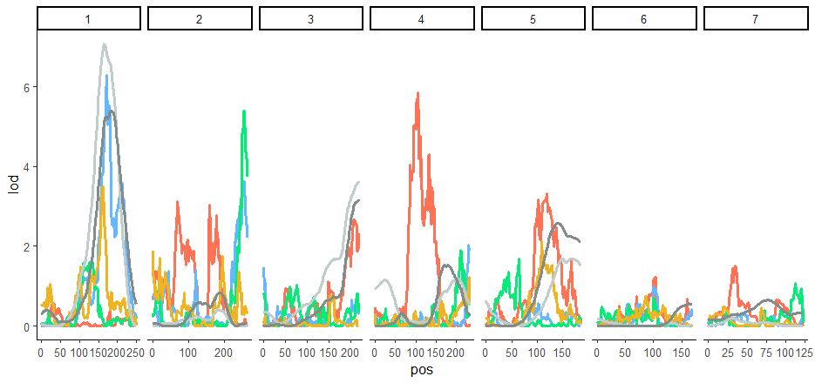
Centroid Size (Chr1 [pos 178, lod 4.09], Chr4 [pos 122, lod 3.88]) (Red)
Plotted against Saw Bottom Length (Grey1) and Saw Centroid (Grey2)
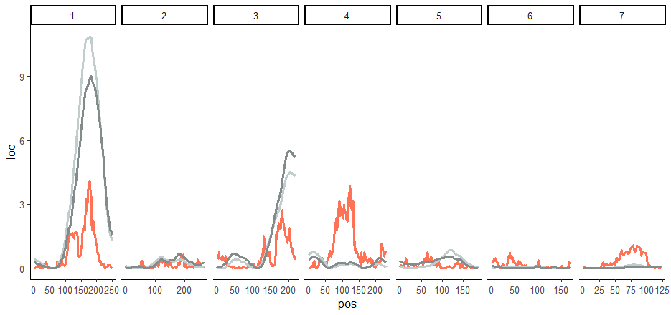

Cuticular Window Length (Chr1 [pos 177, lod 4.18]) (Red) and Distance to Tip #1 (Chr3 [pos 182, lod 3.89]) (Blue)
Plotted against Saw Bottom Length (Grey1) and Saw Centroid (Grey2)
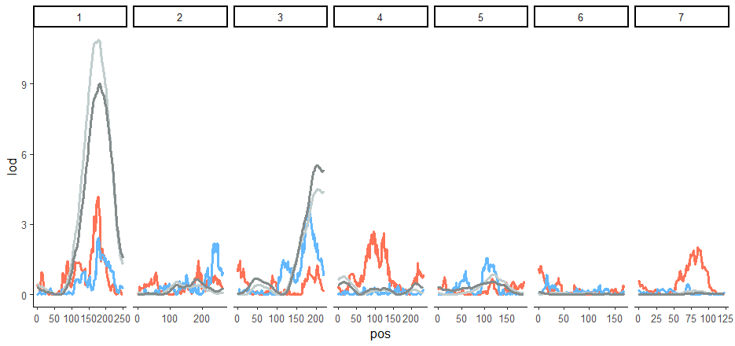

Suture Width #5 (Chr 5 [pos 79, lod 4.33]) (Red)
Plotted against Saw Ann2 (Grey1) and Saw Ann8 (Grey2)
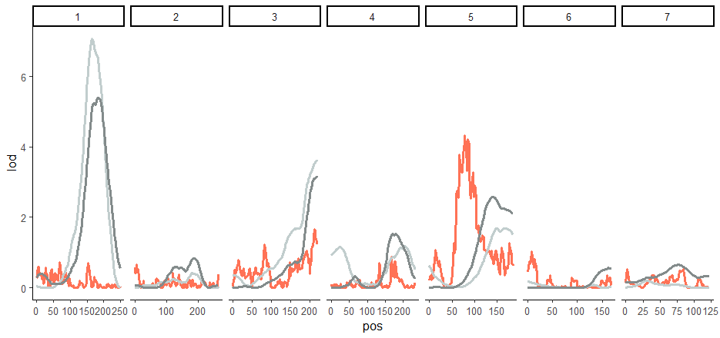

Arch #1 Length (Chr4 [pos 117, lod 3.75]) (Red)
Plotted against Saw Bottom Length (Grey1) and Saw Centroid (Grey2)
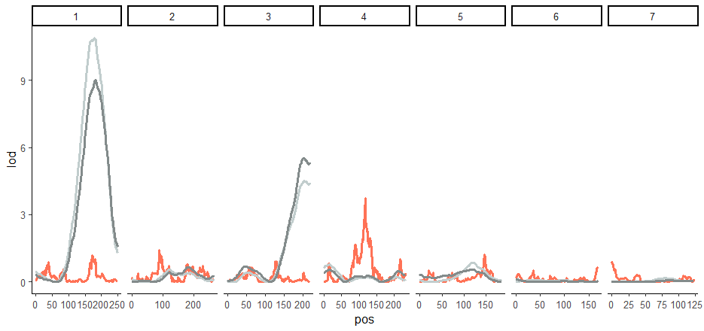

Total Length (Chr1 [pos 178, lod 4.73], Chr3 [pos 182, lod 3.55]) (Red)
Plotted against Saw Bottom Length (Grey1) and Saw Centroid (Grey2)
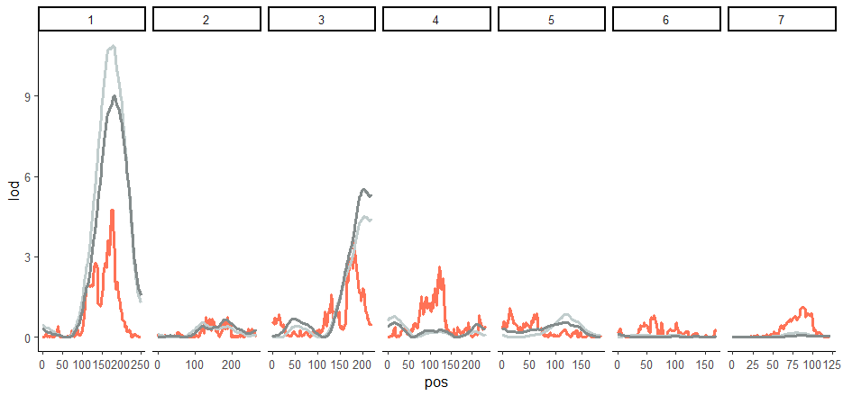

Length of the Cutting Edge (Chr3 [pos 182, lod 3.64]) (Red)
Plotted against Saw Bottom Length (Grey1) and Saw Centroid (Grey2)
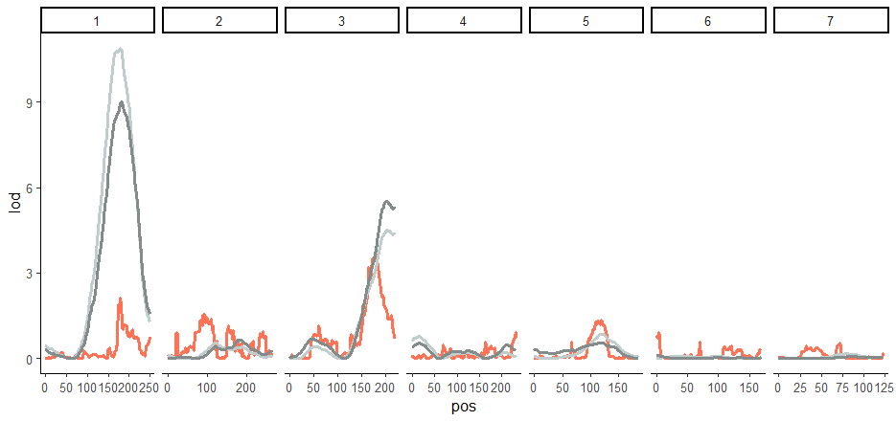

Distance between Arch 4 and Arch 5 (Chr 4 [pos 108, lod 4.48]) (Red)
Plotted against Saw Bottom Length (Grey1) and Saw Centroid (Grey2)
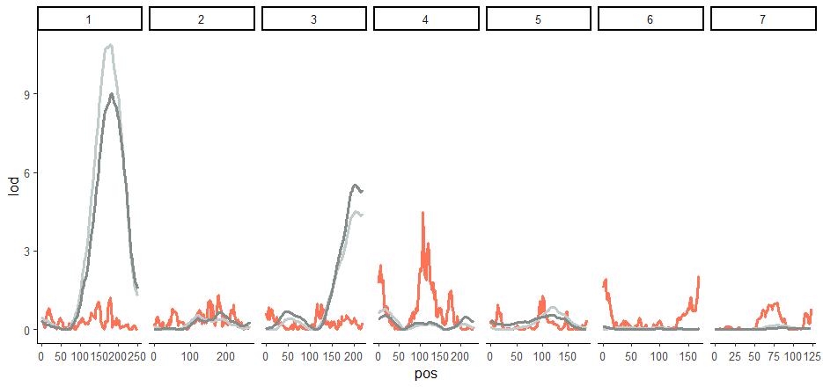

Right Face Width #5 (Chr2) (Red)

PBX – Left Side
Size and Shape
PC 1 (Red), PC 2 (Blue), PC 4 (Green), and PC 8 (Yellow)

Total Length (Chr 1) (Red)

Noncutting edge (Chr1,3, and 5)

Left Face Height 1 (Chr1), 2 (Chr1), 3 (Chr1), 6 (Chr4), 7 (Chr4)

