Lance Protocol v1.4: Linear Measurements
Definitions of the linear measures written by production/lance_v14_morphometrics.R into PRIME_Lance<View>_Pheno_v14.csv (functions lateral_measures and bottom_measures). They are computed from the CNN configurations in Lance<View>_v14_XY.csv.
- Units: millimetres, from each image's own scale bar. Angles are in degrees.
- Column names carry the view as a suffix: _right, _left, _bot (e.g. Face_length_right).
- Point numbers follow landmark_key_v14.csv and are given in brackets, e.g. R04 (4). The Left view uses the same numbers for L01–L18. Its curve numbers differ (see the Left section).
- Lance axis for the lateral views: heel-ventral junction → apex (R02 → R01). Heights are measured perpendicular to this axis, from a point up to where that perpendicular meets the dorsal curve (R18 → dorsal semilandmarks → R01).
- Distances are straight lines unless the definition says 'along' a curve (sum of the segments through the curve's points).
- Figures: CNN landmarks of the N. pinetum parent PX014xNP060v4-2, drawn exactly as the script computes the measures.

Right view (long half)
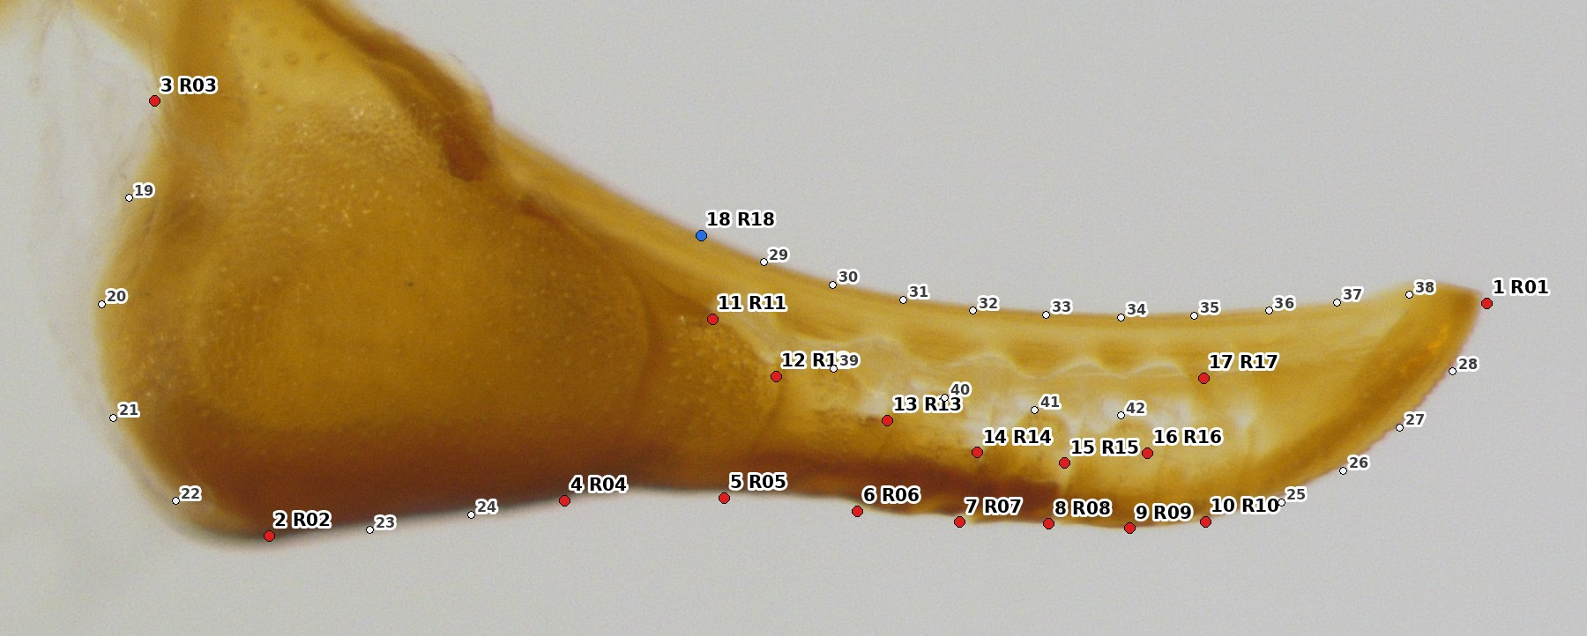
Figure 1. Right view: the 42 points (red = anchors, blue = computed R18, white = semilandmarks).

Lengths and curves
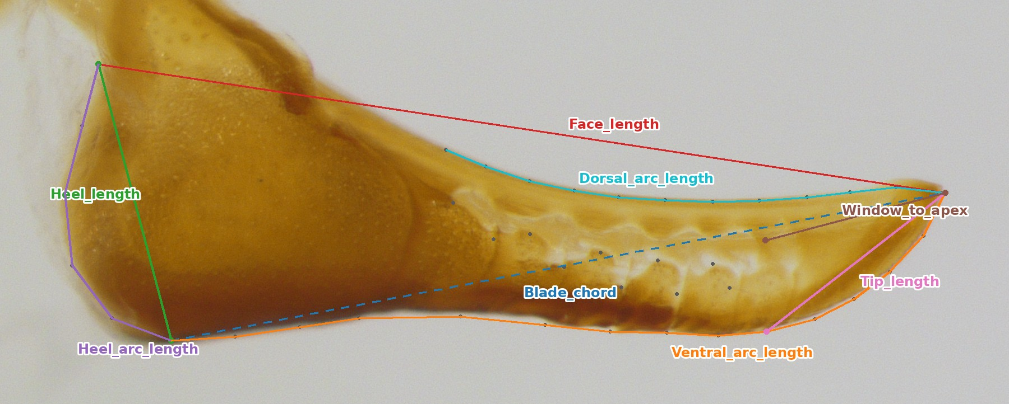
Figure 2. Right view: lengths and curve lengths.
Measure (column) | Points (Right view) | Definition
Face_length | R03 (3)–R01 (1) | Proximal heel notch to apex: whole face length.
Blade_chord | R02 (2)–R01 (1) | Heel-ventral junction to apex (straight). Also the lance axis.
Heel_length | R03 (3)–R02 (2) | Heel notch to heel-ventral junction (straight).
Heel_arc_length | R03, 19–22, R02 | Heel notch to heel-ventral junction along the heel margin.
Ventral_arc_length | R02, 23–24, R04–R10, 25–28, R01 | Blade length along the ventral (sclerotized) margin, heel junction to apex.
Dorsal_arc_length | R18, 29–38, R01 | Blade length along the dorsal curve, from its start R18 to the apex.
Tip_length | R10 (10)–R01 (1) | Last ventral suture end (suture 7) to apex.
Window_to_apex | R17 (17)–R01 (1) | Distal end of the cuticular window to apex.

Window and sutures
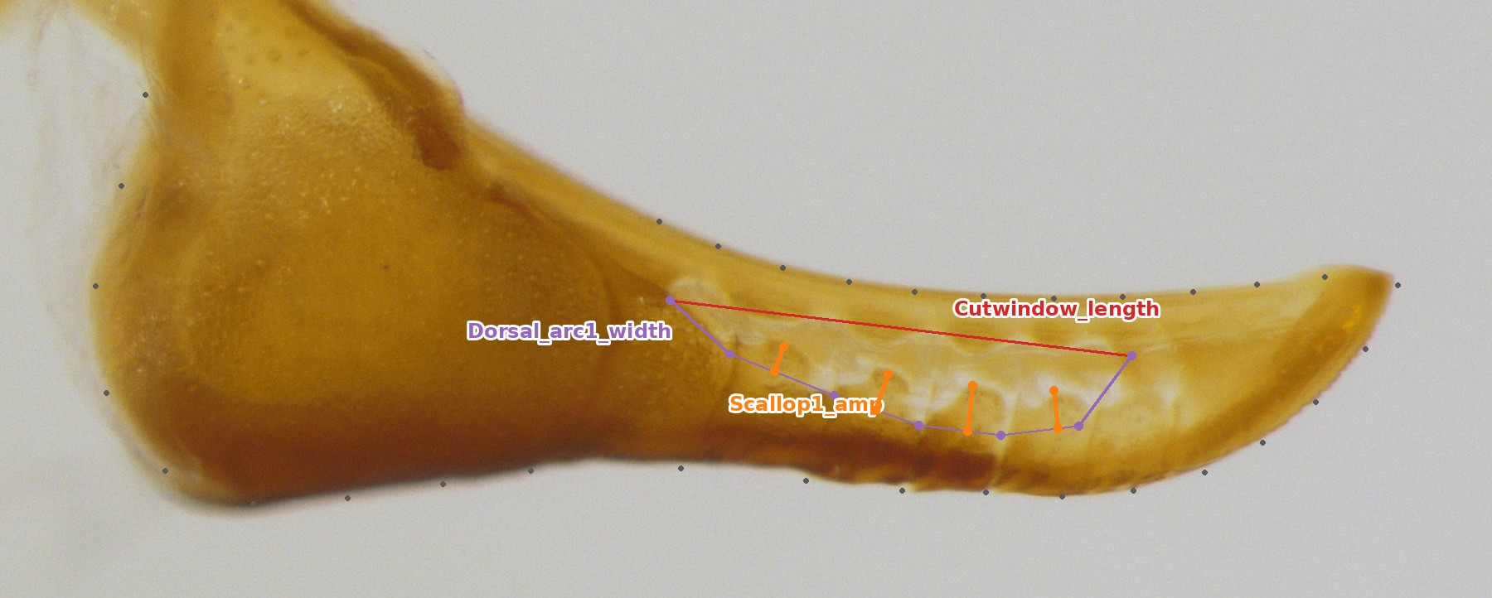
Figure 3. Right view: the cuticular window: length, spacing of the dorsal suture ends, and scallop amplitudes.
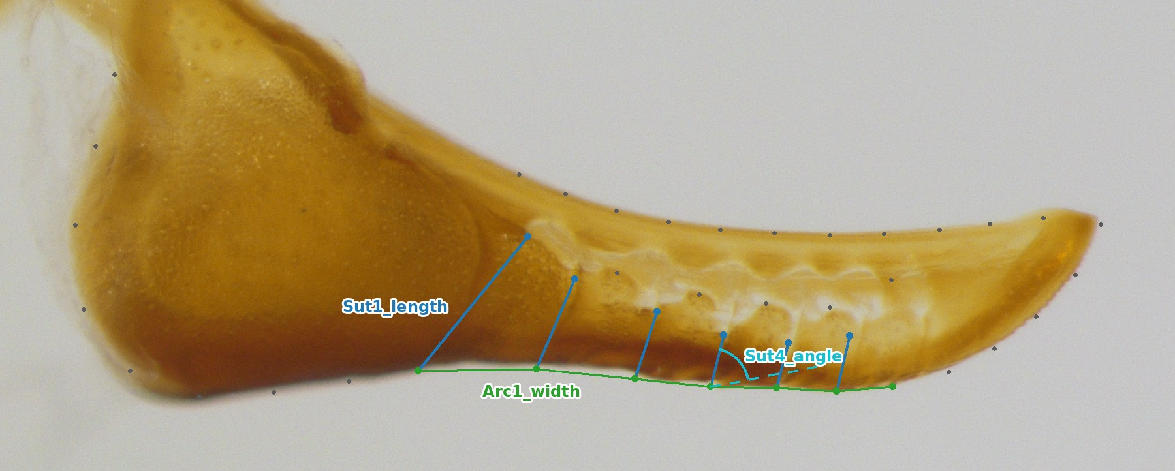
Figure 4. Right view: suture lengths, spacing of the ventral suture ends, and the suture angle (drawn for suture 4).
Measure (column) | Points (Right view) | Definition
Cutwindow_length | R11 (11)–R17 (17) | Window, proximal to distal end.
Sutk_length (k = 1–6) | R(10+k)–R(3+k) | Suture k, dorsal end on the window margin to ventral end (suture 1 uses the window's proximal end R11).
Sutk_angle (k = 1–6) | R(3+k)→R(10+k) vs R02→R01 | Inclination of suture k to the lance axis, 0–90°.
Arck_width (k = 1–6) | R(3+k)–R(4+k) | Spacing of ventral suture ends k and k+1 (R04–R05 … R09–R10).
Dorsal_arck_width (k = 1–6) | R(10+k)–R(11+k) | Spacing of the dorsal suture ends along the window (R11–R12 … R16–R17).
Scallopk_amp (k = 1–4) | window point 38+k vs chord R(11+k)–R(12+k) | Height of the k-th window scallop crest above the straight line between its two suture ends.

Heights
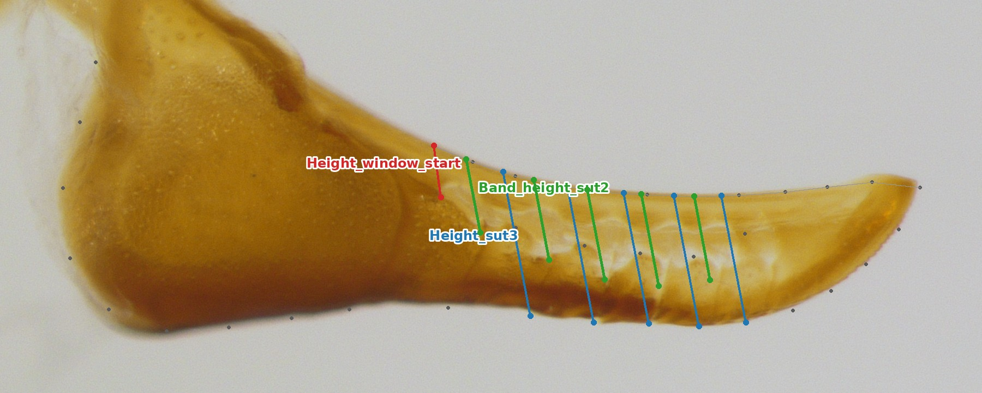
Figure 5. Right view: heights, measured perpendicular to the lance axis up to the dorsal curve (grey).
Measure (column) | Points (Right view) | Definition
Height_window_start | R11 (11)–R18 (18) | Window's proximal end to the dorsal edge (perpendicular to the axis by construction of R18).
Height_sutk (k = 3–7) | R(3+k) → dorsal curve | Lance height at ventral suture end k. Sutures 1–2 lie proximal to R18, so they have no height.
Band_height_sutk (k = 2–6) | R(10+k) → dorsal curve | Dorsal suture end (window margin) to the dorsal edge: the 'cutting depth' band above the window.

Left view (short half)
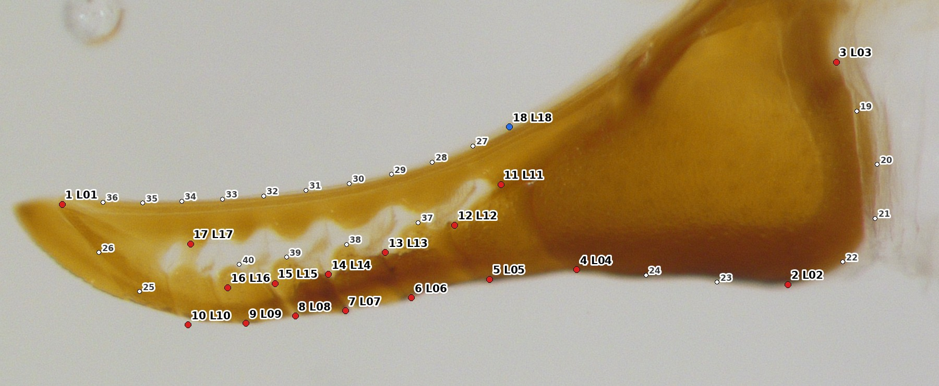
Figure 6. Left view: the 40 points.
Every Right-view measure is also computed for the Left view with the same definition, suffix _left, and L in place of R. The differences follow from the Left view's points:
- L10 (10) is the ventral split point, where the short half separates, not a seventh suture. So there are only Arc1–Arc5 widths, and Height_sut runs k = 3–6.
- The curves are numbered differently: L.vdist = 25–26 (2 points), L.dorsal = 27–36, L.window = 37–40 (Scallopk_amp uses window point 36+k).
- Two extra measures (Figure 7): Sut6_to_split = L09 (9)–L10 (10), the last suture to the split point; and Height_split = L10 → dorsal curve, the lance height at the split point.
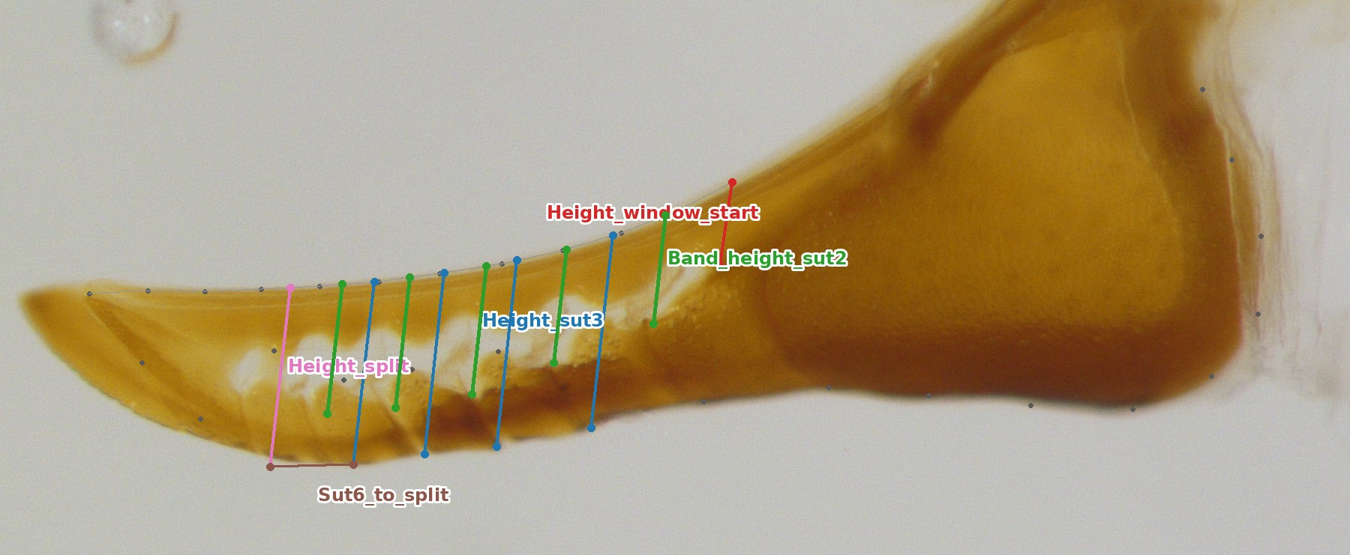
Figure 7. Left view: heights, including the Left-only Height_split and Sut6_to_split.

Bottom view (both halves)
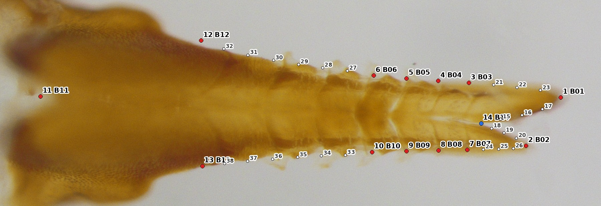
Figure 8. Bottom view: the 38 points (B14 fork crotch computed).

Tips and fork
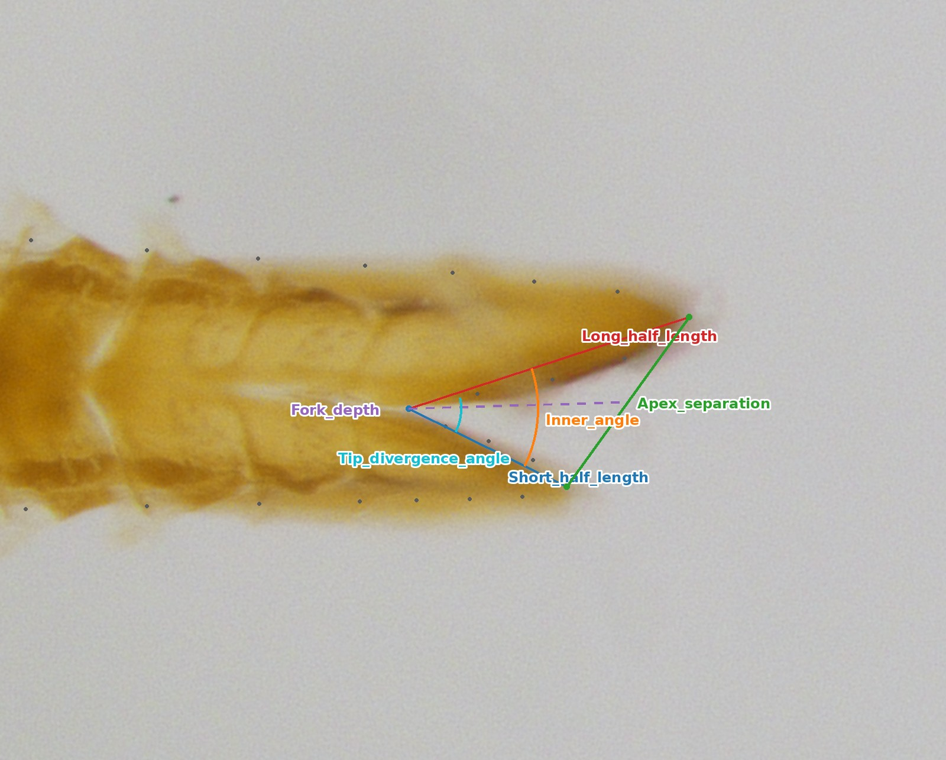
Figure 9. Bottom view: half lengths, apex separation, fork depth and angles.
Measure (column) | Points | Definition
Long_half_length | B14 (14)–B01 (1) | Fork crotch to the long-half apex.
Short_half_length | B14 (14)–B02 (2) | Fork crotch to the short-half apex.
Apex_separation | B01 (1)–B02 (2) | Distance between the two apices.
Fork_depth | B14 → midpoint of B01, B02 | Fork crotch to the midpoint between the apices.
Inner_angle | B01–B14–B02 | Angle at the fork crotch between the two apices.
Tip_divergence_angle | 15–B14–18 | Angle at the crotch between the first medial semilandmark of each tip (how the tips diverge just past the fork).

Positions along the lance axis
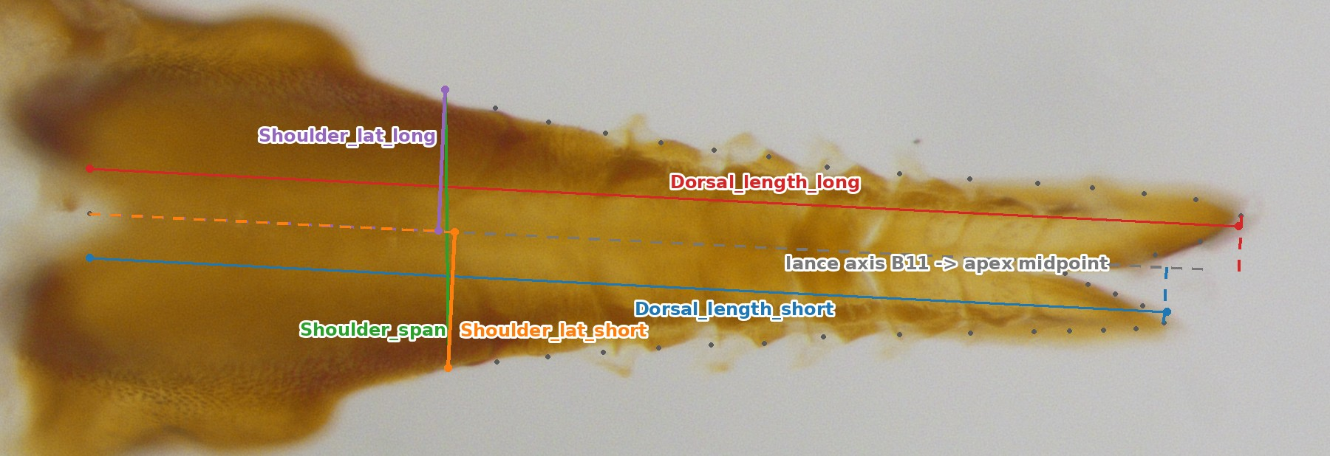
Figure 10. Bottom view: the lance axis (B11 → apex midpoint), positions along it and distances from it.
Measure (column) | Points | Definition
Dorsal_length_long / _short | B01 / B02 projected on the axis | Length of the whole structure along the axis, from the basal notch B11 to each apex.
Apex_offset | Dorsal_length_long − _short | How far the long apex extends beyond the short one (half-length asymmetry).
Shoulder_span | B12 (12)–B13 (13) | Distance between the two shoulders.
Shoulder_pos_long / _short | B12 / B13 projected on the axis | Position of each shoulder along the axis from B11.
Shoulder_to_apex_long / _short | Dorsal_length − Shoulder_pos | Shoulder to apex, along the axis.
Shoulder_lat_long / _short | B12 / B13 to the axis | Perpendicular distance of each shoulder from the axis.
Shoulder_asym_pos / _lat | long − short | Shoulder asymmetry along and across the axis.

Widths and curves
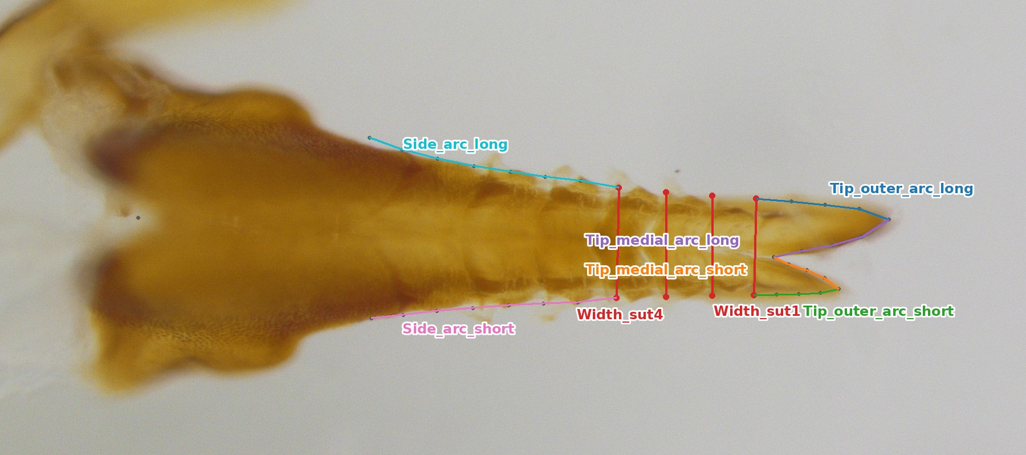
Figure 11. Bottom view: widths across the suture pairs and curve lengths.
Measure (column) | Points | Definition
Width_sutk (k = 1–4) | B(2+k)–B(6+k) | Width across the k-th suture pair counted from the apex (B03–B07 … B06–B10).
Shaft_taper | (Shoulder_span − Width_sut1) / axis distance | Width gained per mm from suture 1 to the shoulders (axis positions of the suture-1 midpoint and the shoulder midpoint).
Tip_outer_arc_long / _short | B03, 21–23, B01 / B07, 24–26, B02 | Outer margin of each tip, suture 1 to apex.
Tip_medial_arc_long / _short | B14, 15–17, B01 / B14, 18–20, B02 | Medial (inner) margin of each tip, fork crotch to apex.
Side_arc_long / _short | B06, 27–32, B12 / B10, 33–38, B13 | Outer margin from the 4th suture to the shoulder.

Notes
- Shape is analysed separately, by Procrustes superimposition of all points with the semilandmarks sliding. The linear measures are for univariate and QTL models.
- Every length scales with lance size. Use centroid_size_<view> (in the same table) as a covariate for size-corrected comparisons.
- A height is NA when the perpendicular from its point does not meet the dorsal curve (rare, e.g. in very bent specimens).
Generated by genai_lance_landmarking/tools/docgen/make_linear_measures_docx.py. Example scale (Right): 1320.0 px/mm.

