Saw Protocol v1.2: Linear Measurements
Definitions of the linear measures written by production/saw_v12_morphometrics.R (function saw_measures) into PRIME_Saw_Pheno_v12.csv, one row per female. Each measure is computed from the 52-point configuration in Saw_v12_XY.csv.
- Units: millimetres, from each image's own scale bar. Angles are in degrees.
- Orientation (protocol frame): apex left, teeth (serrulae) up, annulus 1 on the right. Point names are anatomical: V = ventral (toothed) end of an annulus, T = serrula tip, R = annulus × ventral margin of the rachis, D = dorsal end of an annulus.
- Point numbers follow landmark_key_v12.csv. They are given in brackets after each point name, e.g. V3 (4).
- Distances are straight lines between points unless the definition says 'along' a curve (sum of the segments through the curve's points).
- Figures: CNN landmarks of the N. lecontei saw AG008_F10_R (g0, virginia pine). The measures are drawn exactly as the script computes them.

Landmarks
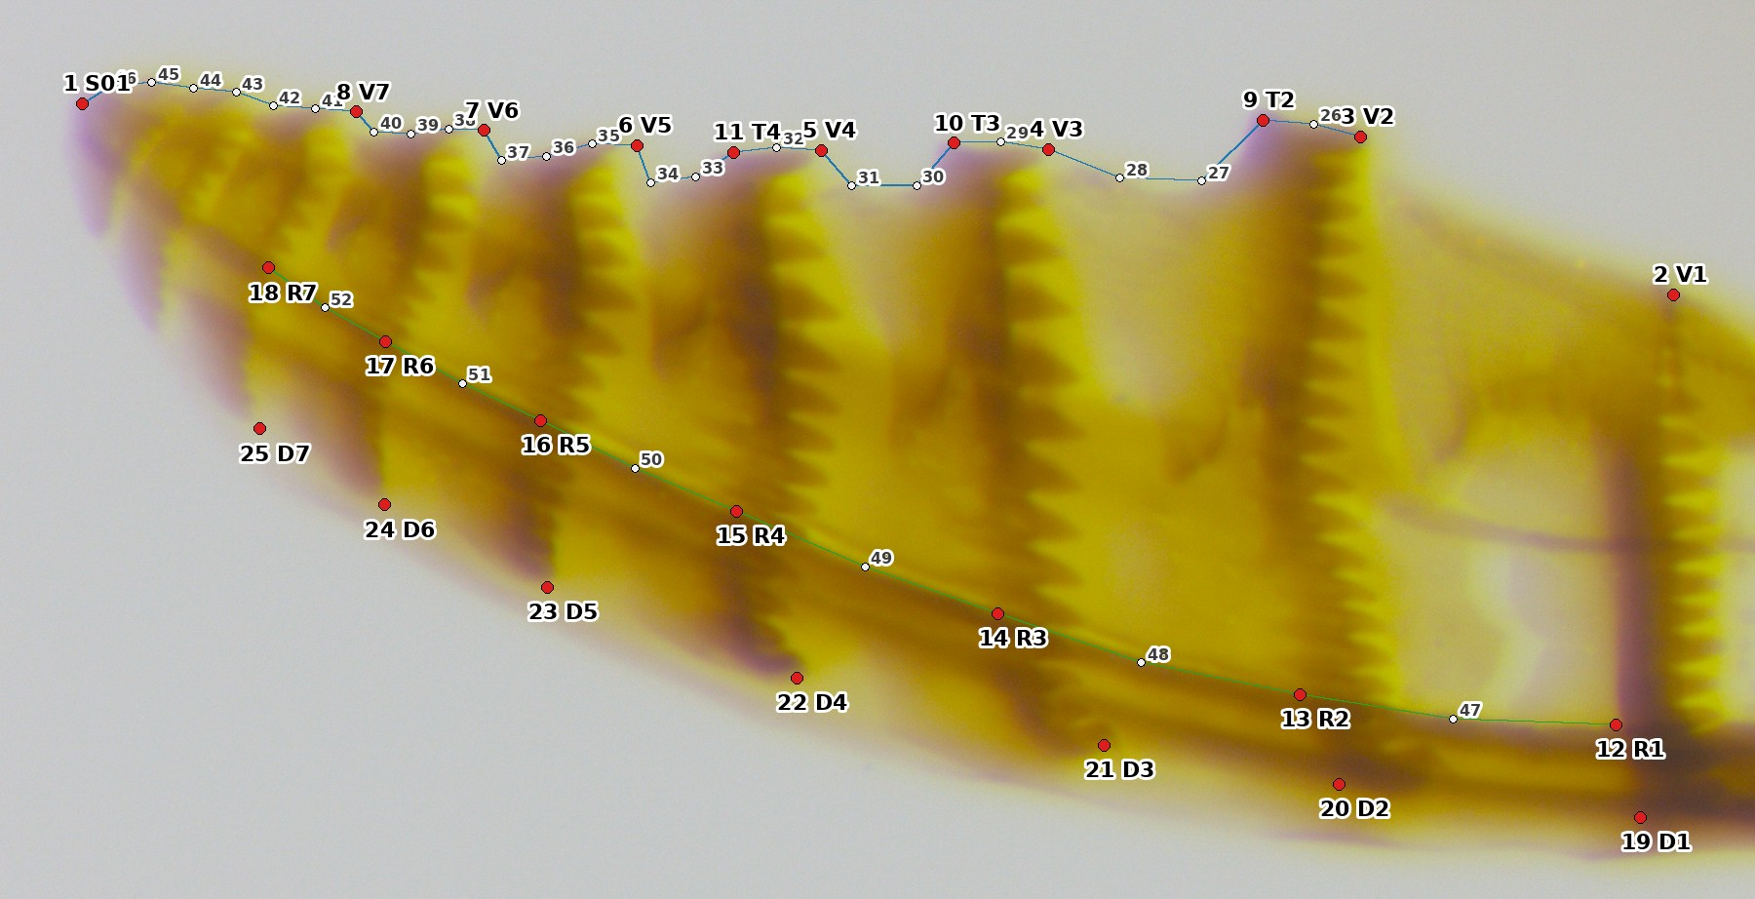
Figure 1. The 52 points. Red: the 25 anchors (number and name). White: sliding semilandmarks (26–46 on the toothed edge, blue line; 47–52 on the rachis, green line).
Points | Numbers | What they are
S01 | 1 | Apex of the saw
V1–V7 | 2–8 | Ventral end of annuli 1–7 (V2–V7 on the toothed edge; V1 at the end of the band)
T2–T4 | 9–11 | Tips of serrulae 2–4
R1–R7 | 12–18 | Where annuli 1–7 cross the ventral margin of the rachis
D1–D7 | 19–25 | Dorsal ends of annuli 1–7 (D1–D2 on the dorsal margin of the rachis)
semilandmarks | 26–46 | Toothed (ventral) edge, V2 → apex
semilandmarks | 47–52 | Ventral margin of the rachis, R1 → R7

Whole saw
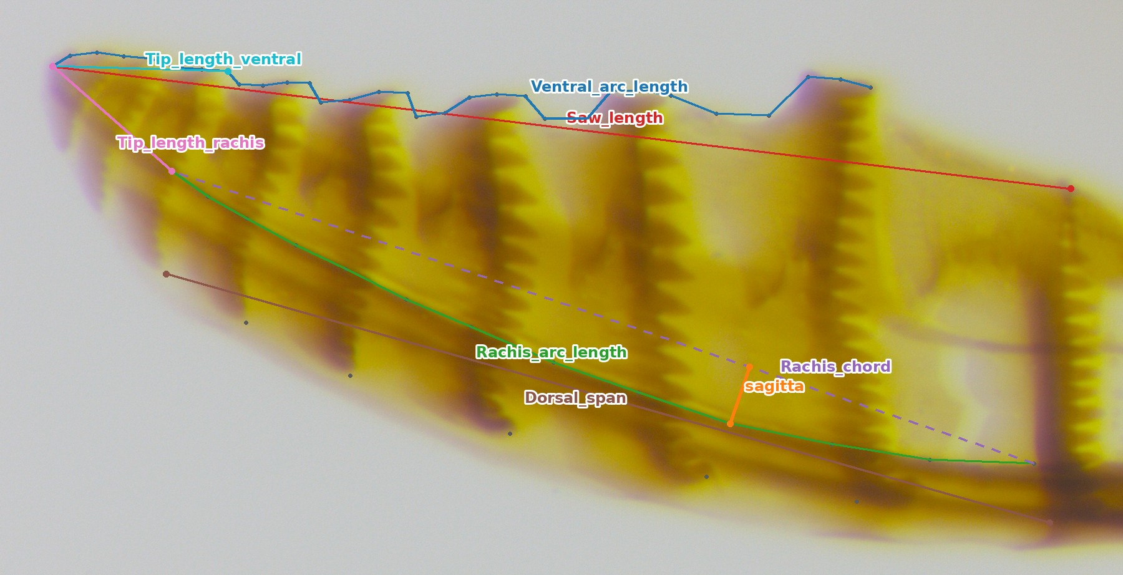
Figure 2. Whole-saw measures.
Measure (column) | Points | Definition
Saw_length | S01 (1)–V1 (2) | Apex to the ventral end of annulus 1. Replaces the old BottomLengthLM (old points 15–1).
Ventral_arc_length | V2 (3) … S01 (1), along points 26–46 | Length of the toothed edge, following every serrula and notch from annulus 2 to the apex.
Rachis_arc_length | R1 (12) … R7 (18), along 47–52 | Length of the rachis (the side of the saw that slides on the lance) from annulus 1 to annulus 7.
Rachis_chord | R1 (12)–R7 (18) | Straight-line length of the rachis, annulus 1 to 7. Also defines the saw axis used for angles.
Rachis_sagitta | rachis points vs chord R1–R7 | Curvature of the rachis: the largest perpendicular distance of the rachis curve from its chord, divided by the chord (unitless; larger = more curved).
Tip_length_ventral | V7 (8)–S01 (1) | Annulus 7 (ventral end) to the apex: the distal, crowded tip region.
Tip_length_rachis | R7 (18)–S01 (1) | Annulus 7 on the rachis to the apex. Replaces the old DistAnn7_tiptopLM.
Dorsal_span | D1 (19)–D7 (25) | Distance between the dorsal ends of annuli 1 and 7.

Annuli (k = 1–7)
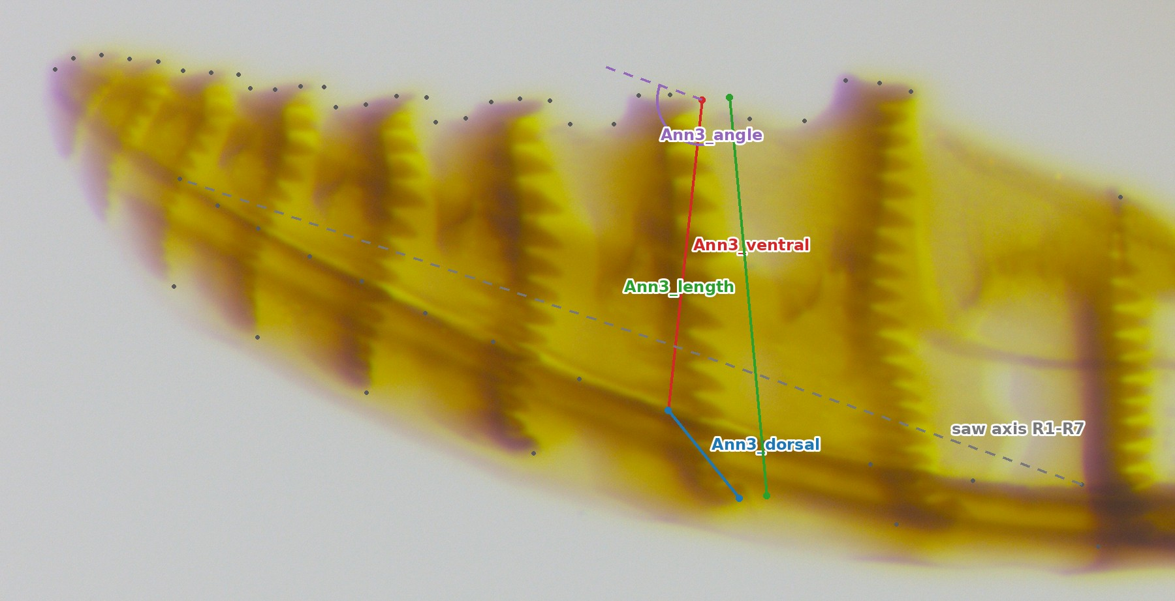
Figure 3. Measures of one annulus, drawn for annulus 3 (the same four measures are computed for annuli 1–7). Ann3_length is drawn offset to the left of the band so it does not hide the other two.
Measure (column) | Points | Definition
Annk_length | Vk–Dk | Full length of annulus k, ventral end to dorsal end. Replaces the old AnnkLM.
Annk_ventral | Vk–Rk | Blade depth below the rachis at annulus k: ventral end to the rachis.
Annk_dorsal | Rk–Dk | Part of annulus k above the rachis ventral margin (rachis and dorsal strip).
Annk_angle | Vk→Dk vs R1→R7 | Inclination of annulus k to the saw axis (R1 → R7), 0–90°. 90° = perpendicular to the rachis.

Point numbers: V1–V7 = 2–8, R1–R7 = 12–18, D1–D7 = 19–25 (for annulus k: V = k+1, R = k+11, D = k+18).

Spacing between annuli (k = 1–6)
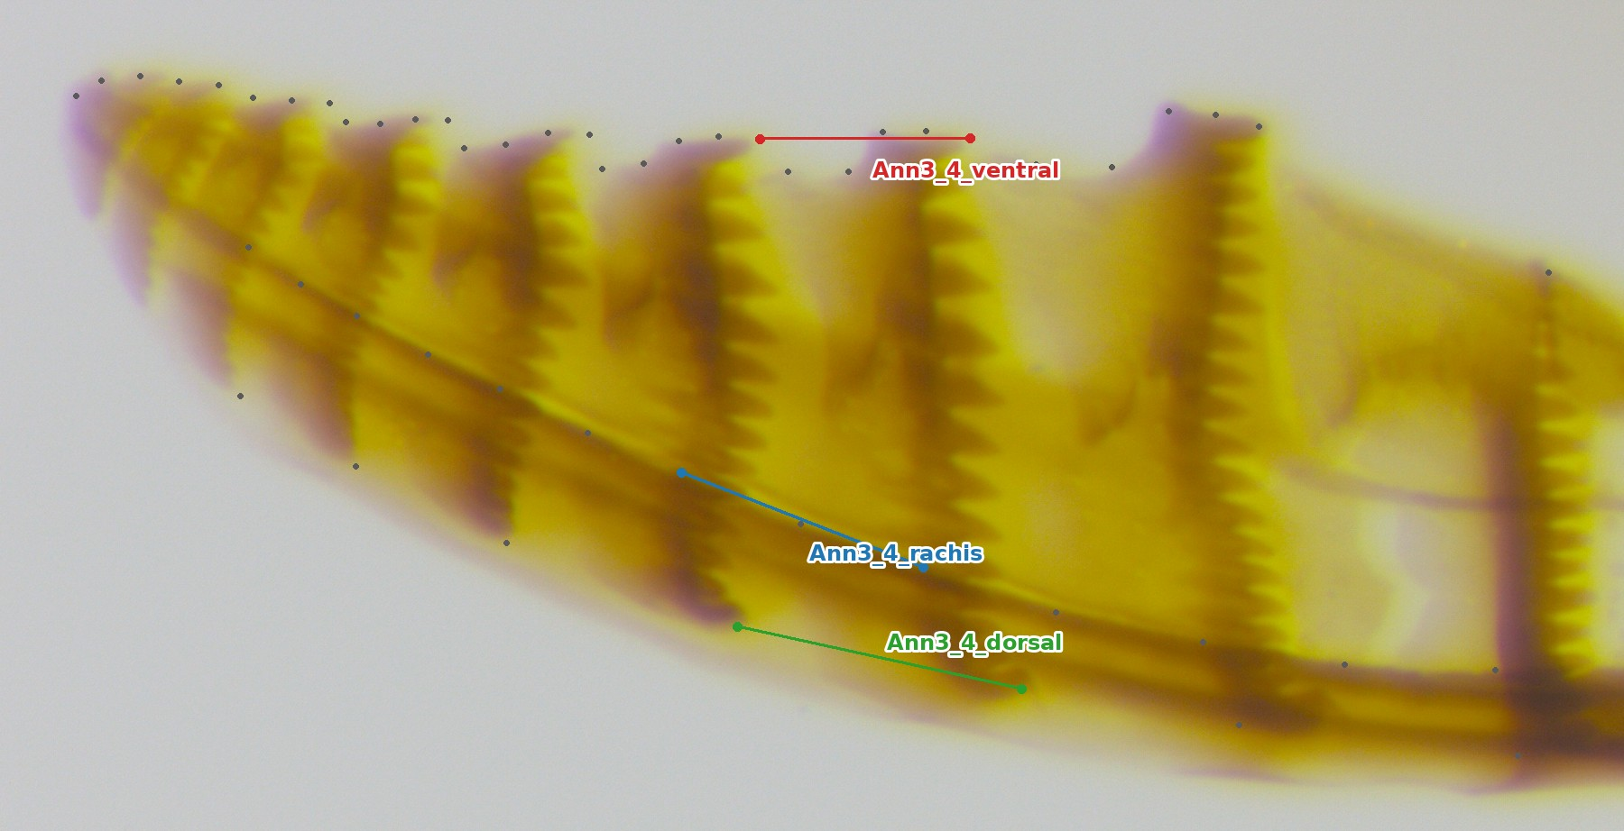
Figure 4. Spacing between neighbouring annuli, drawn for annuli 3 and 4 (computed for every pair 1–2 … 6–7).
Measure (column) | Points | Definition
Annk_k+1_ventral | Vk–Vk+1 | Spacing on the toothed edge. Replaces the old DistAnnk_k+1botLM.
Annk_k+1_rachis | Rk–Rk+1 | Spacing along the rachis. Replaces the old DistAnnk_k+1topLM (old points 16–22 were the rachis crossings).
Annk_k+1_dorsal | Dk–Dk+1 | Spacing of the dorsal band ends.

Serrulae (teeth), k = 2–4
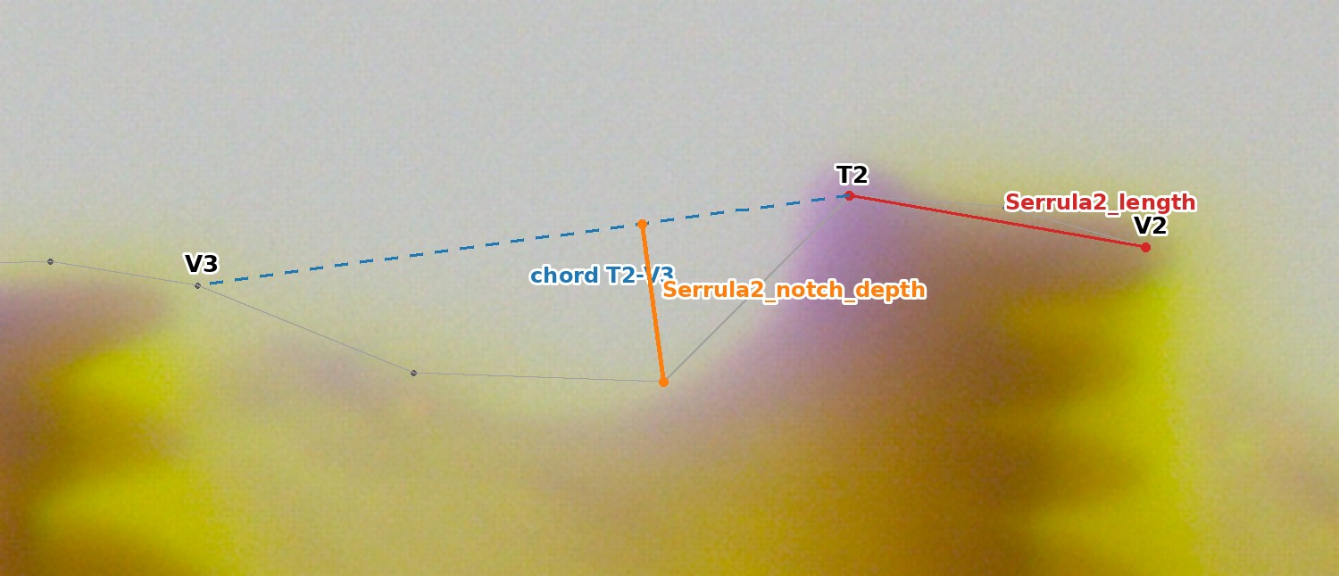
Figure 5. Serrula 2 (the same for serrulae 3 and 4), enlarged. The grey line is the traced toothed edge.
Measure (column) | Points | Definition
Serrulak_length | Vk–Tk | From the base of serrula k (ventral end of annulus k) to its tip. Replaces the old Tooth1–3LM (serrulae 2–4).
Serrulak_notch_depth | semilandmarks between Tk and Vk+1 vs chord Tk–Vk+1 | Depth of the notch after serrula k: the larger perpendicular distance of the two toothed-edge semilandmarks between the tip Tk and the next annulus Vk+1 (27–28 for k = 2, 30–31 for k = 3, 33–34 for k = 4) from the straight line Tk–Vk+1. Replaces the old notch points 4 and 7.

Notes
- Old-protocol measures without a v1.2 equivalent: TopLengthLM and RootTipLM used old points 25 and 32, which were dropped (25 was the least repeatable point; 32 is not the same annulus in the two species). Tip measures beyond annulus 7 (old annuli 8–9) are not computed, because the number of distal annuli differs between species.
- Shape is analysed separately, by Procrustes superimposition of all 52 points with the semilandmarks sliding. The linear measures are for univariate models and comparison with the old tables.
- Size: every measure scales with saw size. For size-corrected comparisons, include centroid_size or body_length in the model, as the script does for the host models.
- Only QC-passed saws are used, one saw per female (the left if both were imaged). Side (left/right saw) can be added to the models as a nuisance term.
Generated by genai_saw_landmarking/tools/docgen/make_linear_measures_docx.py. Example scale: 2142.5 px/mm.

