Movie Ticket Request Application
(Kerala Theatrical Catalog)
Pega National Internship Program Capstone Deliverable
System Implementation & Verification Report
Intern Name: R. D. Sourav
Case Type Name: Movie Ticket Request
University: APJ Abdul Kalam Technological University

1. Executive Summary & Blueprint Scaffold
This project report documents the implementation of the 'Movie Ticket Request' case type on the Pega Academy platform. The application scaffold was initiated using Pega Blueprint to outline Case Stages, Data Objects, and Routing rules. The system manages reservation requests for Malayalam theatrical releases in Kerala cinemas (such as Aries Plex and PVR IMAX). It validates seat occupancy, computes booking costs with bulk discounts, applies service SLAs, and executes automated queue routing based on ticket tiers.

2. Case Lifecycle Stage Configuration
Following the Pega Academy exercise guidelines, the 'Movie Ticket Request' case type was structured with four core stages and specific automation checkpoints:
Stage Name | Process / Steps | Configured Rules & SLA
1. Initial Stage | Submit Movie Ticket Request form (customer & movie fields) | Collect Information Step, Movie & Show Data Objects
2. Availability | Check Show Availability (Seat grid visualizer) | Data Page verification, Row categories validation
3. Approval | Calculate Booking Cost (Calculate properties & check) | Declare Expressions, 18% Tax, 10% Bulk Discount
4. Booking Execution | Case Resolution & Confirmation (Ticket release) | Email Correspondence, Case Status (Resolved-Completed)

3. System Specifications & Implementations

3.1 Data Structures (Movie & Show Data Objects)
Two core Pega Data Objects were established to support this booking flow:
• Movie Data Object: Stores metadata for available films, including Title, Cast, Genre, and Release Date.
• Show Data Object: Stores operational variables, including Theater Location, Date, Showtime, Available Seats, and Pricing Tiers.

3.2 Total Cost Calculated Properties
Pricing logic was implemented in an automated calculation engine. Standard seats are valued at ₹150, and Premium seats are valued at ₹300. The system automatically computes the total cost using the following rule parameters:
• Base Ticket Cost = Selected Seats x Category Rate
• Service Tax / GST = Base Ticket Cost x 18%
• Bulk Booking Discount = 10% of Base Ticket Cost (triggered only if Ticket Quantity >= 4)
• Net Total Cost = Base Ticket Cost + Service Tax - Bulk Discount

3.3 Service Level Agreement (SLA) Configuration
To ensure reservations are processed in a timely manner, an SLA rule was attached to the case type:
• Goal: 1 Day (The booking must be calculated and approved within 24 hours of creation).
• Deadline: 2 Days (Urgent processing actions are triggered if the case remains unresolved after 48 hours).

3.4 Work Queue Routing (Premium vs. Standard)
To balance workflow tasks, routing rules direct cases based on Show Type:
• Premium Tickets: Automatically routed to Premium ShowQueue for priority audit.
• Standard Tickets: Automatically routed to Standard ShowQueue.

3.5 Email Correspondence Rules
An email correspondence rule is triggered during the Booking Execution stage. Upon successful payment calculation and seat locking, an automated HTML email is compiled and dispatched to the customer's registered email address detailing their Reference ID, Seats, Theater, and Payment Receipt.

4. Screenshots & Verification Checkpoints
The following sections contain the execution screenshots captured during system run verification:
■ Pega Case Lifecycle Flow (Initial, Availability, Approval, Booking Execution)
Scaffolded workflow showing Pega case stages, routing nodes, and SLA configurations.
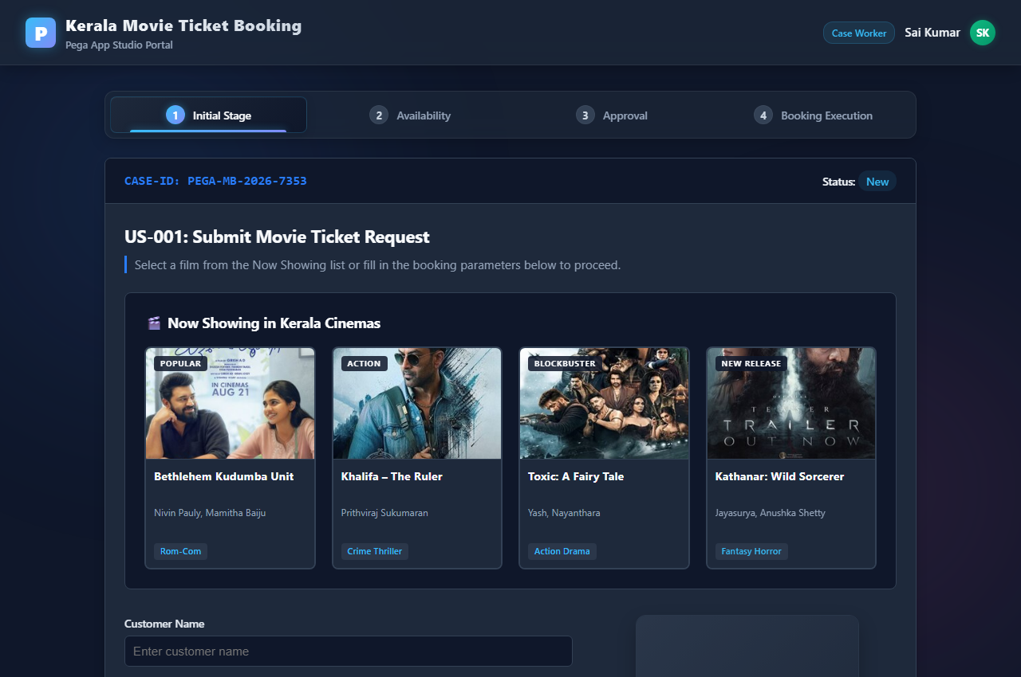

■ US-001: Initial Stage Movie Ticket Request UI
Submit Movie Ticket Request form showing Customer details, select Kerala Theater, and selected movie poster card.
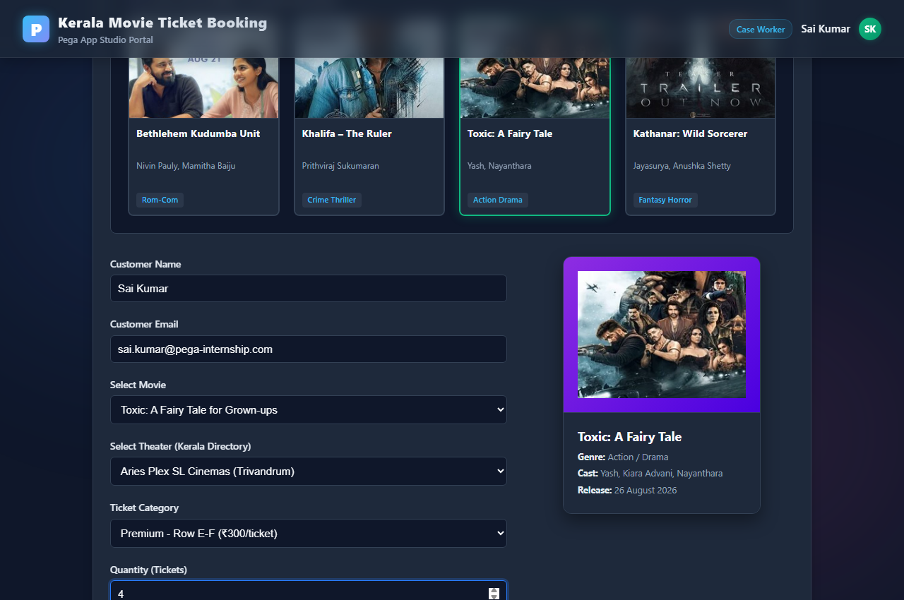

■ US-002: Availability Stage Seating Map UI
Check Show Availability seat map showing standard rows, premium rows, occupied seats, and selected seat nodes.
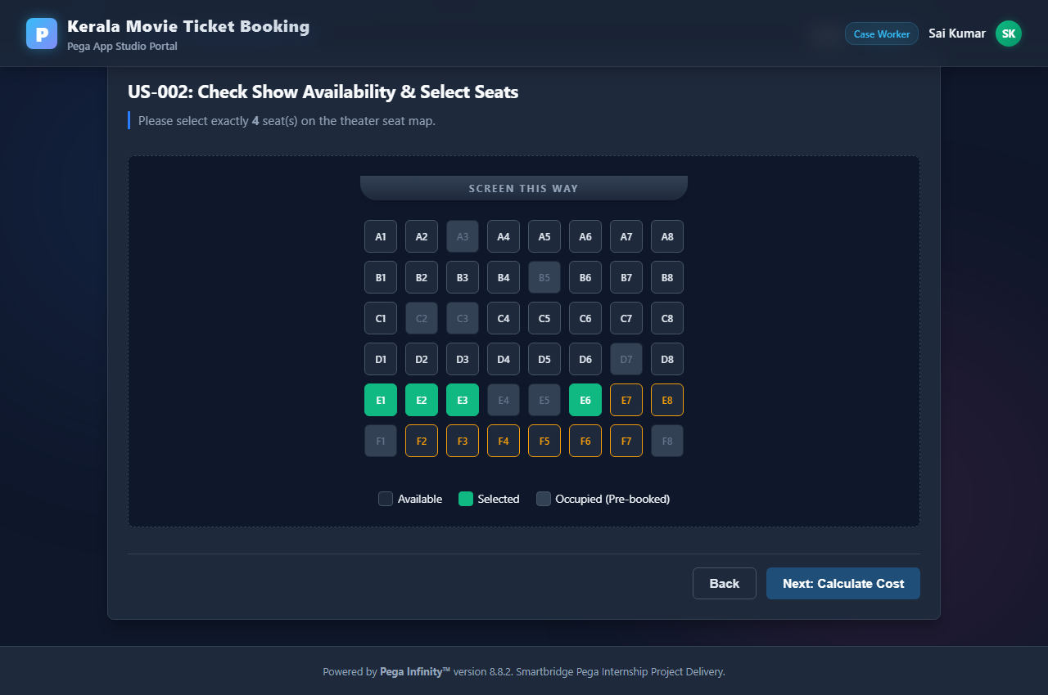

■ US-003: Approval Stage Cost Calculation UI
Receipt billing invoice showing Base Fare, 18% Tax, 10% Bulk Discount deduction, and total net payable.
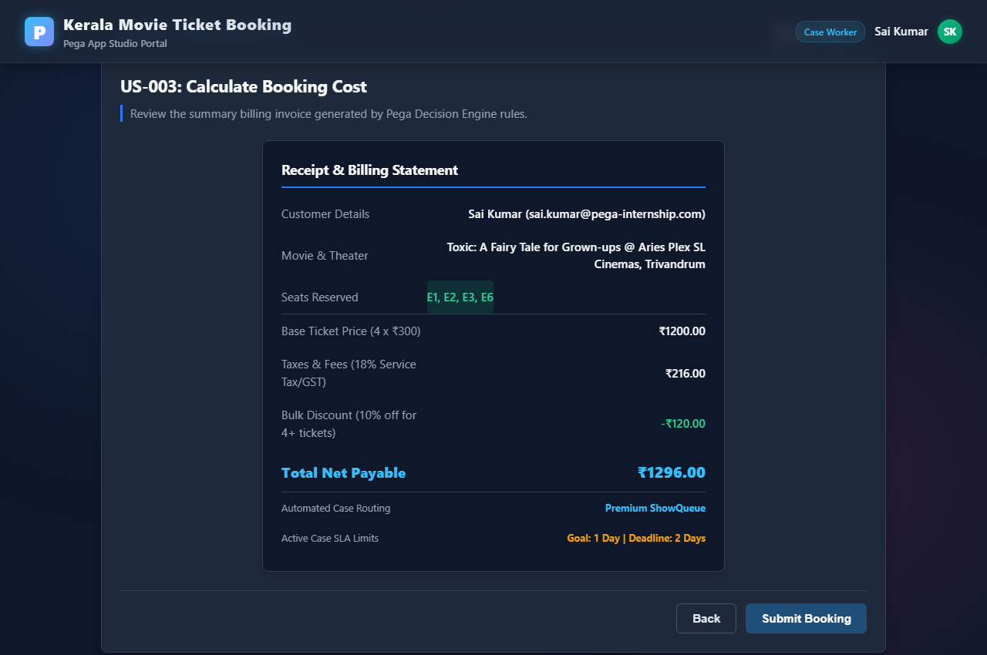

■ Booking Execution Resolved Case Confirmation
Resolved-Completed case page displaying transaction reference ID, SLA timelines, and case status transition log.
