SOFTWARE ENGINEERING LAB (EXPERIMENT 7)
Assignment 2: Testing, CI/CD Pipelines & Agile Collaboration Report
Student Name: Sooraj Jose George | Roll Number: 60
GitHub Username: SoorajGeorge123 | Role / Module: Face Detection Module
Project Title: SAFE-VISION: AI-Powered Media Moderation & Quality Assurance System | Subject Code: CS331
Collaboration Repo: RDSOURAV05/software_engineering_lab_experiment_7_assignment | Feature Branch: feature-sooraj
Part 1: GitHub Issues & Branching
In this step, an issue was created in the collaboration repository RDSOURAV05/software_engineering_lab_experiment_7_assignment to define requirements and track progress for the Face Detection Module. The issue titled 'Implement testing for Face Detection Module.' was assigned to SoorajGeorge123. A dedicated feature branch named feature-sooraj was created locally using git checkout -b feature-sooraj to isolate module development and unit tests.
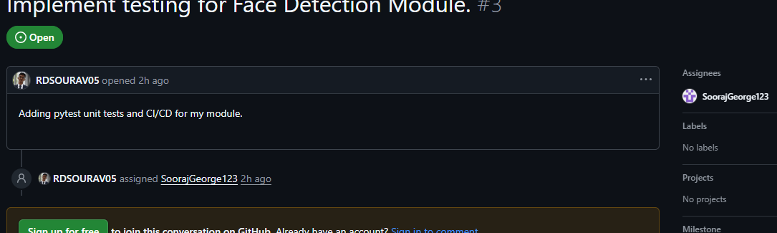
Figure 1 (Screenshot 1 Required): Assigned Issue #3 showing Title, Description, and Assignee (SoorajGeorge123).
Part 2: Unit Testing Suite & CI/CD Pipeline Implementation
The Face Detection Module logic was implemented in face_detection.py featuring format validation, empty/missing checks, resolution validation, and detection logic. A comprehensive PyTest suite was authored in test_sooraj.py covering 5 test cases including Boundary Value Analysis (BVA) for 0x0 resolution and Equivalence Partitioning (EP) for corrupted inputs and unsupported formats. The automated CI/CD pipeline was configured under .github/workflows/ci.yml to trigger on both push and pull request events.
Sequential Git Commits Performed:
1. Commit 1: "Added unit tests for Face Detection Module" (test suite & face_detection module)
2. Commit 2: "Updated README for feature-sooraj" (required documentation update)
3. Merge Commit: "Merge origin/main and resolve conflicts for feature-sooraj" (synced latest team updates)

Part 3: Pull Requests, Peer Review & GitHub Actions (CI/CD)
A Pull Request (PR #9) titled "Add tests and CI for Sooraj." was created from feature-sooraj targeting main. Code review was requested from peer collaborator RDSOURAV05, who approved the pull request. All GitHub Actions automated CI tests executed successfully with zero merge conflicts.
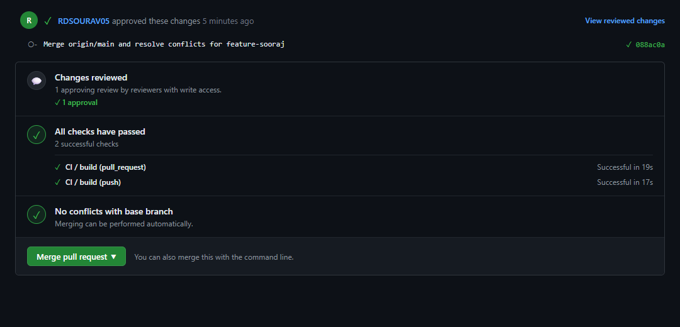
Figure 2 (Screenshot 2 Required): Pull Request #9 approved by teammate, with all checks passed and no merge conflicts.
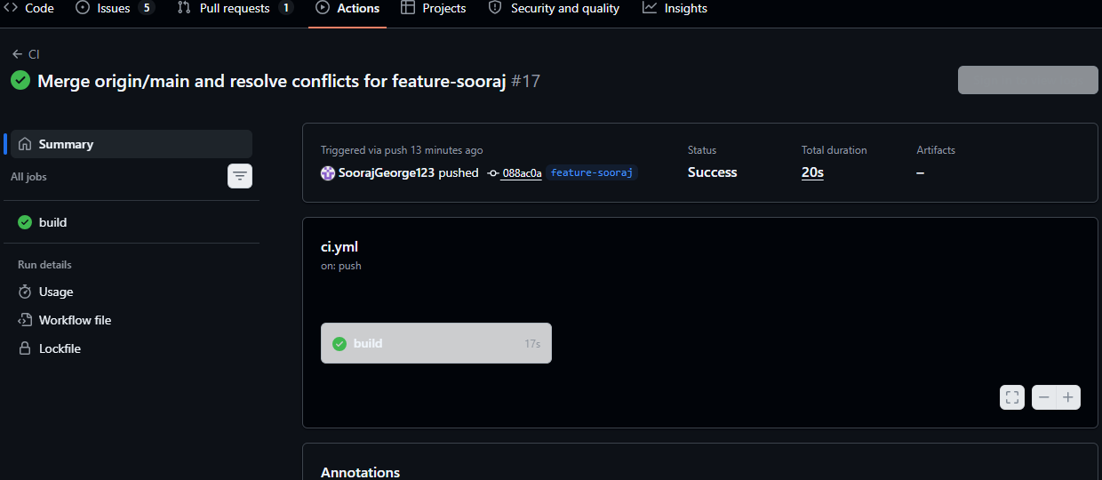
Figure 3 (Screenshot 4 Required): GitHub Actions CI workflow run passing with successful green tick status.

Part 4: CI/CD Status Badge & Agile Project Management
The passing CI/CD status badge was copied and placed at the top of README.md displaying real-time build and test health. An Agile Kanban Board ('Experiment 7 Board') was established with three columns: Todo, In Progress, and Done. Issue #3 ('Implement testing for Face Detection Module.') was added to the board and tracked actively in the In Progress column during module test development.
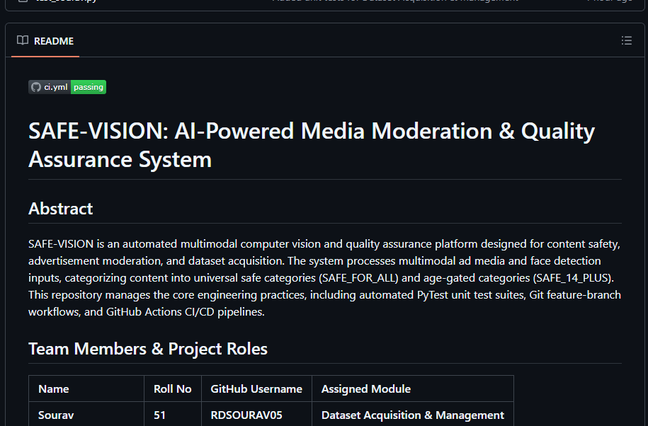
Figure 4 (Screenshot 5 Required): Repository README showing the passing CI status badge and project abstract.
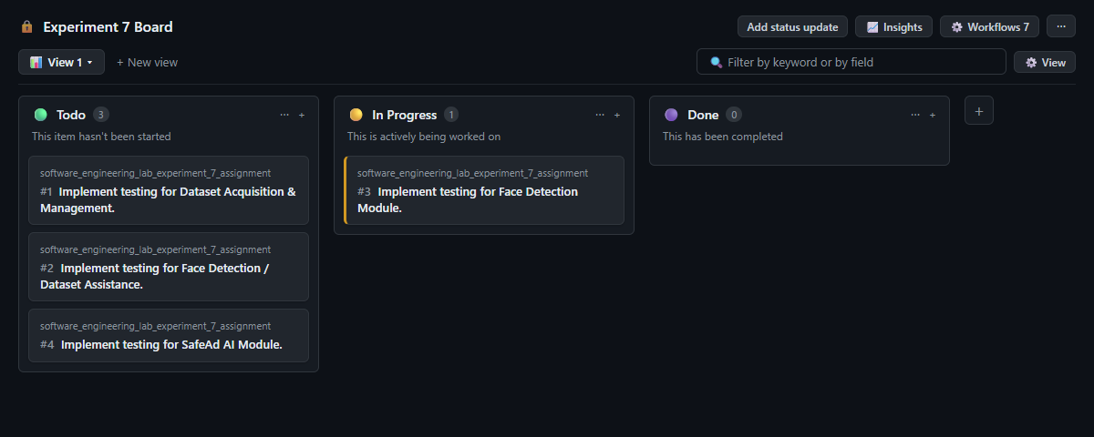
Figure 5 (Screenshot 3 Required): Kanban Board showing Issue #3 in the 'In Progress' column.

Part 5: Gantt Chart & Risk Management
Project Execution Timeline (Gantt Chart - 6 Tasks):
Task ID & Description | W1 | W2 | W3 | W4 | W5 | W6
Task 1: Requirement Analysis & Repo Setup | ■■■
Task 2: Dataset Preparation & Preprocessing |  | ■■■
Task 3: Model Development (Face Detection Module) |  |  | ■■■ | ■■■
Task 4: Module Integration & Unit Testing |  |  |  |  | ■■■
Task 5: CI/CD Pipeline Setup |  |  |  |  | ■■■
Task 6: Final Deployment & Documentation |  |  |  |  |  | ■■■
Risk List & Mitigation Strategies (Exact Specification):
1. Risk 1 (Technical): Inaccurate AI classification. Mitigation: Use a diverse dataset and adjust risk score thresholds.
2. Risk 2 (Operational): GitHub merge conflicts. Mitigation: Commit frequently and always peer-review pull requests.
3. Risk 3 (Technical): CI/CD pipeline failures due to dependencies. Mitigation: Pin specific package versions in requirements.txt.
Part 6: Test Case Specification & Verification Table
Unit Test Case Results (Step 4.3 Table):
TC ID | Function Tested | Input | Expected Output | Actual Output | Pass/Fail
TC-01 | detect_faces | valid_face.jpg | >= 1 | 1 | Pass
TC-02 | detect_faces | empty.jpg | ValueError | ValueError | Pass
TC-03 | detect_faces | corrupt.txt | IOError (EP) | IOError (EP) | Pass
TC-04 | detect_faces | zero_res.jpg | ValueError (BVA) | ValueError (BVA) | Pass
TC-05 | detect_faces | video.mp4 | ValueError (EP) | ValueError (EP) | Pass
(Note: BVA = Boundary Value Analysis, EP = Equivalence Partitioning)
Part 7: Cloud Deployment Architecture & Strategy
Deployment Note (Exact Specification):
"The SAFE-VISION project can be deployed on an Infrastructure as a Service (IaaS) platform such as AWS EC2, or a Platform as a Service (PaaS) such as Heroku. Because the technology stack is Python-based (FastAPI and Streamlit), the application can be seamlessly packaged as a Docker container by configuring a Dockerfile, ensuring a consistent execution environment from local testing to cloud production."
Part 8: Final Submission Verification Checklist
[ ✓ ] Screenshot 1: Assigned Issue (Issue #3 with SoorajGeorge123) | [ ✓ ] The Gantt Chart (6 Tasks covering project lifecycle)
[ ✓ ] Screenshot 2: Approved Pull Request (PR #9 approved by peer) | [ ✓ ] The Risk List (3 Technical & Operational risks with mitigations)
[ ✓ ] Screenshot 3: Kanban Board (Issue #3 in 'In Progress' column) | [ ✓ ] The Test Case Table (5 BVA and EP test cases passed)
[ ✓ ] Screenshot 4: Successful GitHub Actions run (Green Tick status) | [ ✓ ] The Deployment Note (Cloud architecture for SAFE-VISION)
[ ✓ ] Screenshot 5: README file showing passing status badge | [ ✓ ] Submission Format: Exact A2_60_Sooraj.pdf

