Customer can provide some feedbacks regarding the foods and app. They can view all other feedbacks which are provided by other customers and can rate our service using the rating bar.

Customers can add, view, edit and delete their feedbacks as well. User can View the average rate and average rate will be updated for each feedback sending process. The feedback number will be displayed as an alert dialog box, once the feedback is sent successfully.

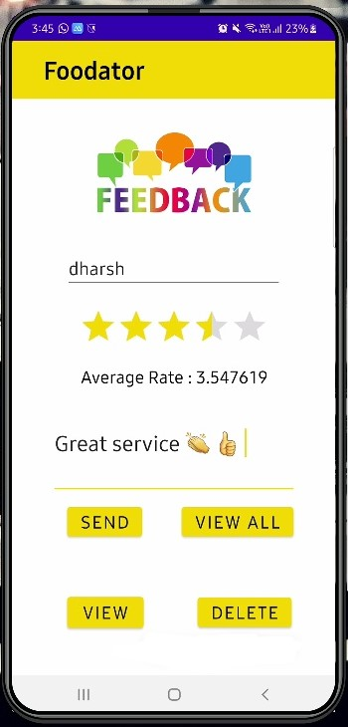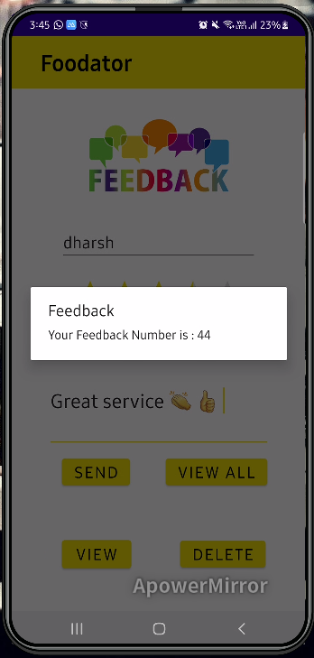

Test Cases:

Nothing filled and pressing Send button – Toast message displaying “Fill the fields”.

Pressing View all button: If there are no records, then toast message will display “No records found message”

**IT20003982 - Feedback Management**

CRUD operations

Users can view all other the feedbacks and rate details using the **view all** button in the user interface. Once it is clicked the all feedback and rate details will be displayed

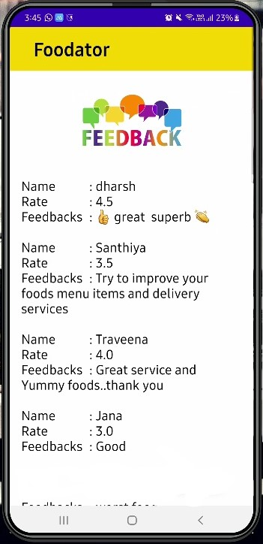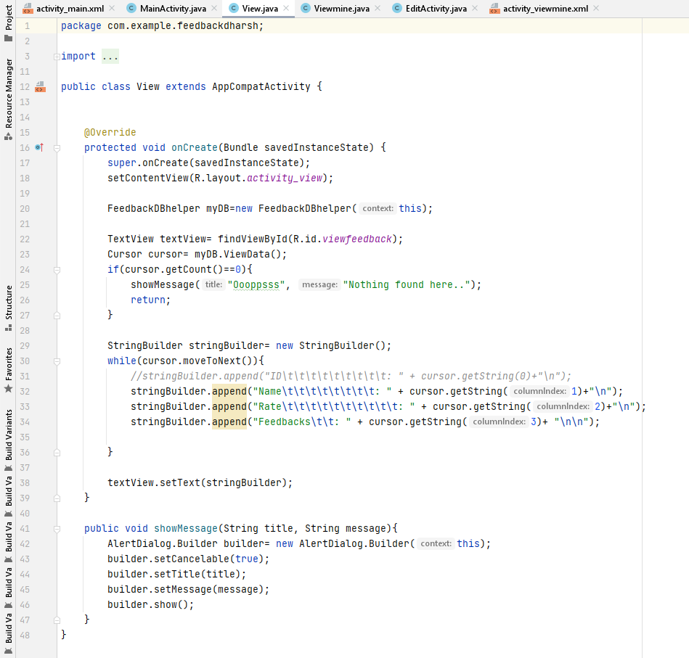

**View All - code**

Users can **view** their submitted feedback using the feedback id and can **edit** their feedback as well.

If there is no feedback available, then the toast message “not found” message will be displayed. And when they update their feedbacks the “updated” toast message will be displayed in the interface. They can edit their name, rate and feedbacks as well

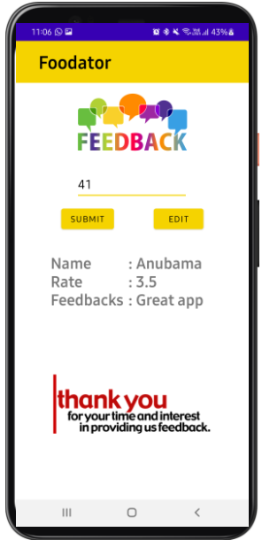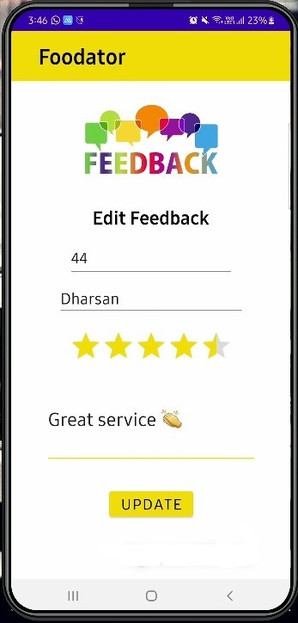

Users can **delete** their feedbacks using their feedback number. When the user clicked the delete button which is on the main page of the feedback UI, the alert dialog box will be displayed. User has to enter their feedback number and can delete it once they press the delete option in the alert box. If it is successfully deleted, then the toast message will display.

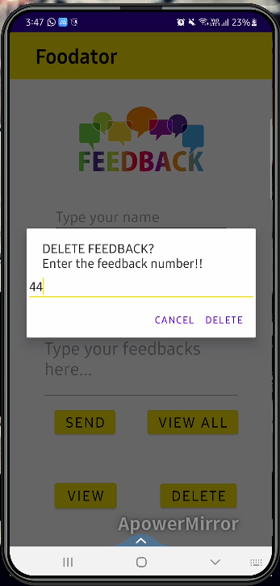

Test Cases:

Entering unavailable feedback number: toast message displaying “Nothing found error” message

Deletion success: Toast message displaying “successfully deleted” message

Test Cases:

Entering unavailable feedback number: toast message displaying “Nothing found error” message

Updating success: Toast message displaying “successfully updated” message and redirect to the feedback main page

Edit feedback: Nothing filled and pressing Update button – Toast message displaying “Fill the fields”.

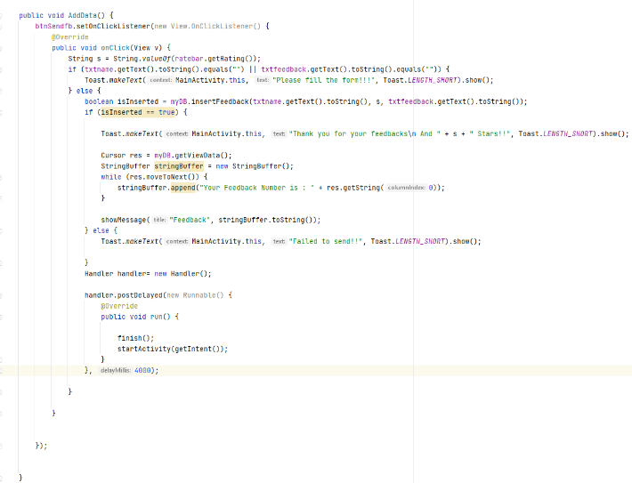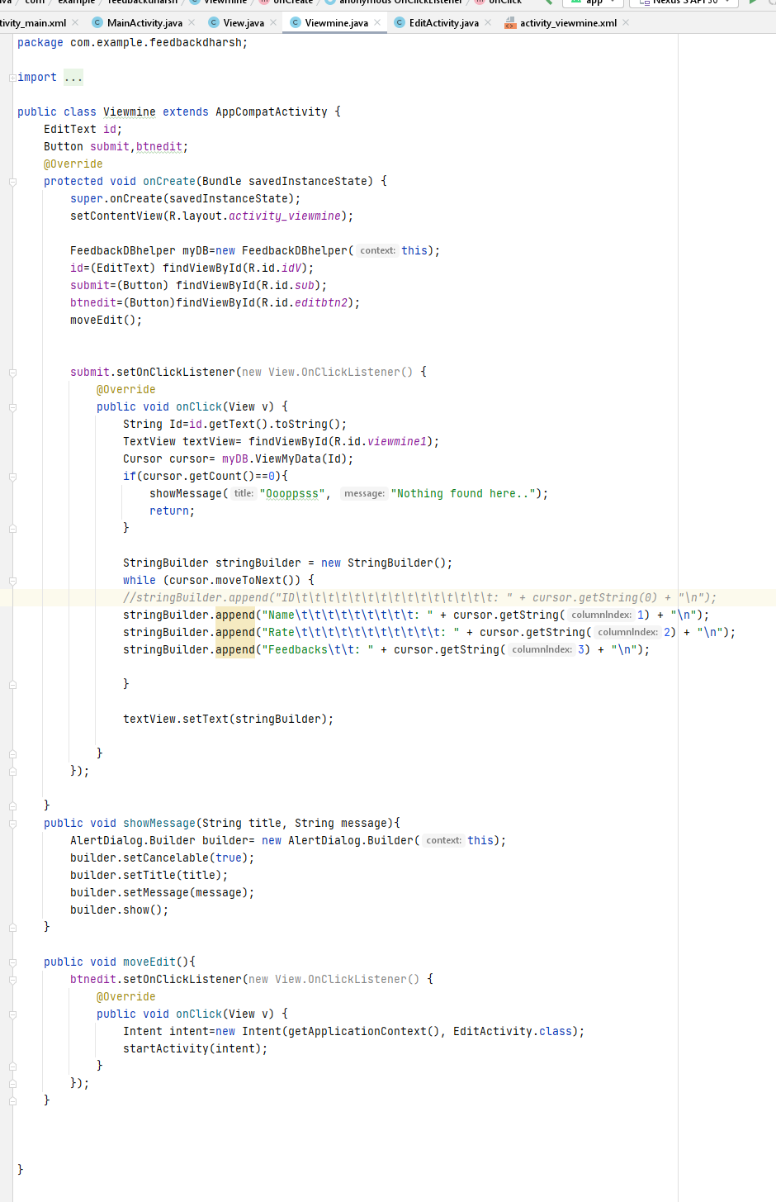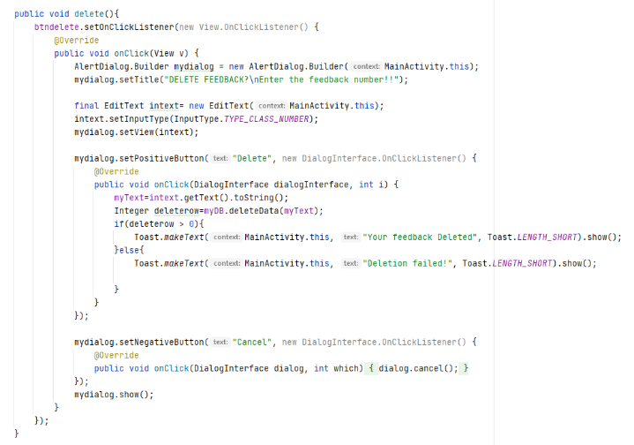

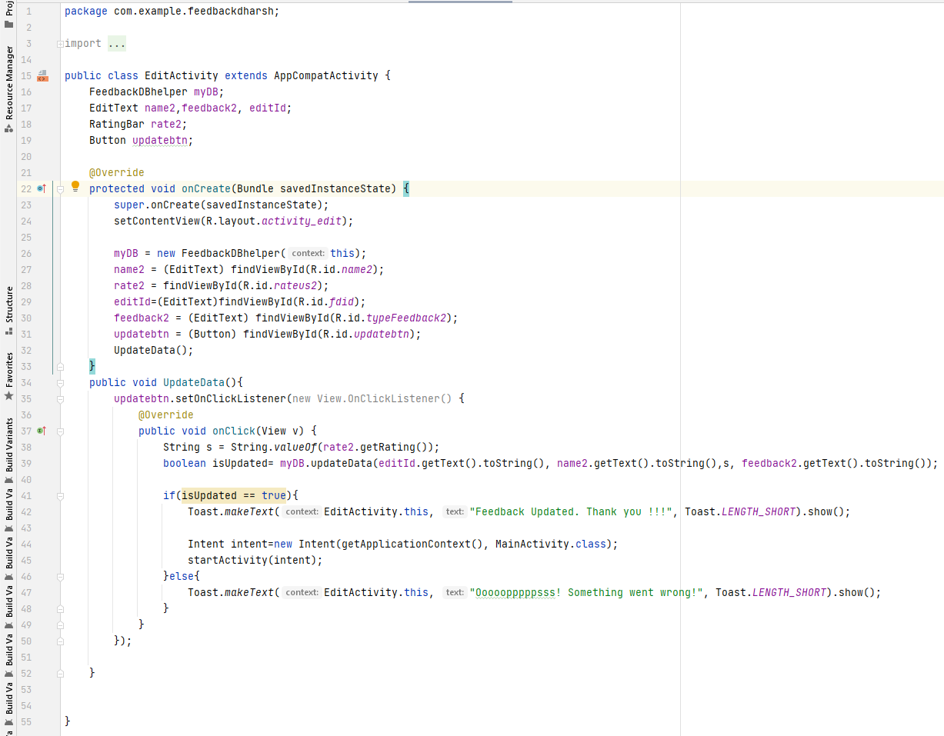

**Add feedback - code**

**Delete feedback - code**

**View feedback - code**

**Edit feedback - code**