***IT20001452- Grocery Ordering Management (Create, Retrieve, update***

***and delete orders).***

**CRUD operations**

My part of this project is GroceryOrderingManagement. In GroceryOrderingManagement first of all the customer will be directed to the Grocerymenu. On that page, customer can select the Grocerytype they want.

**CREATE**-Then the customer will be directed to the page where they can choose the number of items using the increment and decrement icons and the customer can provide their name and phone number. After providing the details customer can click on the “Order now” button and if the order is successfully added a toast message will be displayed on the screen saying” Ordered Successfully!”. If not an” Order failed” message is displayed.

**RETRIVE**-After making the order customer can view their order details by clicking the “My Orders” option and can view their orders.

In case if the customer wants to UPDATE or DELETE the orders, they will have to click on the order they want to change and it will direct them to the edit page.

**UPDATE**-After updating the details the customer needs to click on the “Update Order” button and when the order is updated successfully a toast message will appear saying “Updated successfully”. Else display an “Update Failed” message.

**DELETE**-Customer can delete their order item by long press on the item and an alert box will be displayed asking whether to delete the item or not and by clicking “Yes” the item can be deleted. And if the order is deleted successfully a toast message will appear saying “Item Deleted”. Else display an “Error” message.

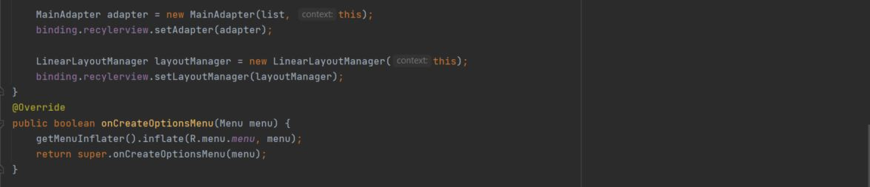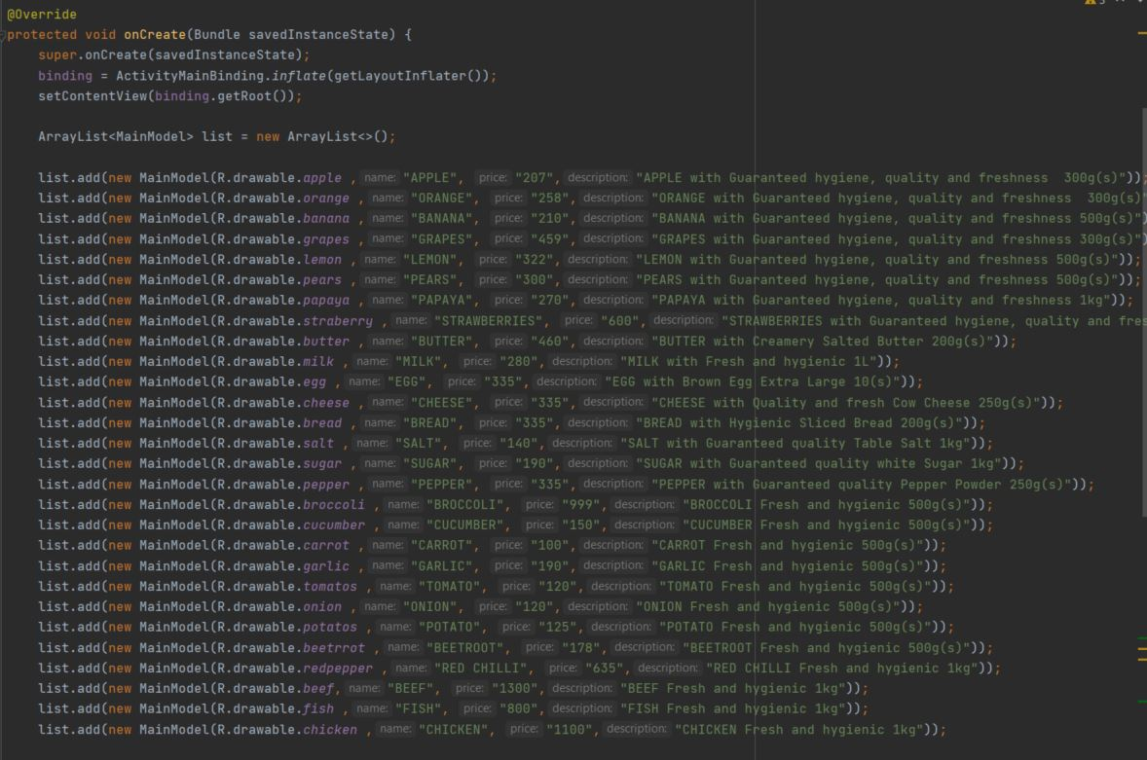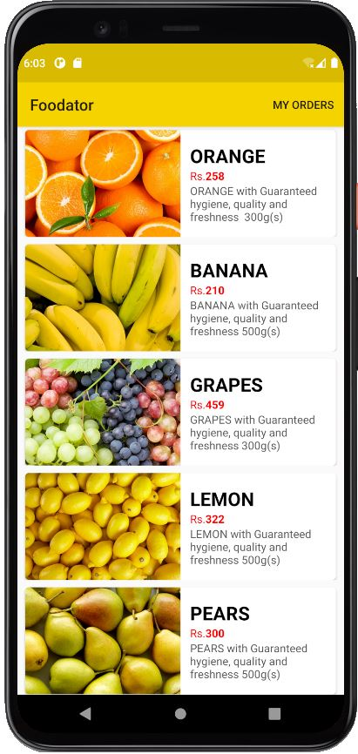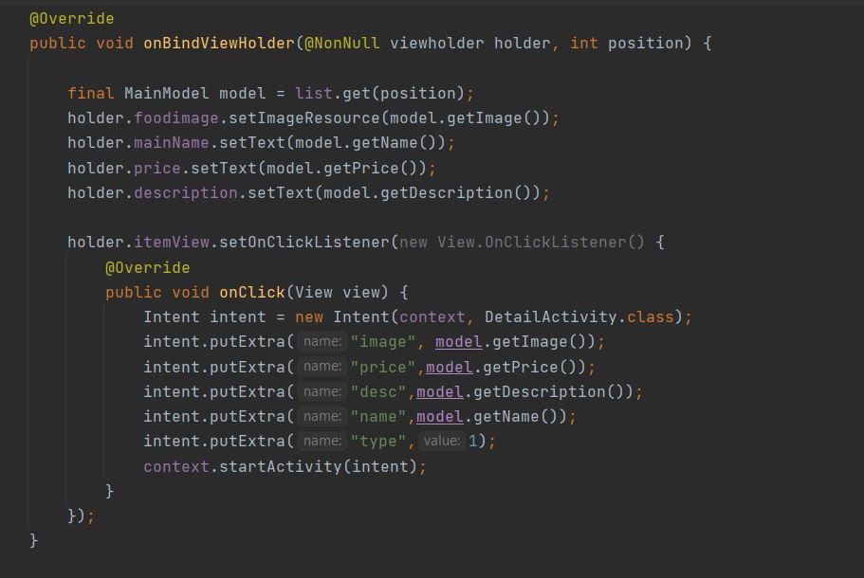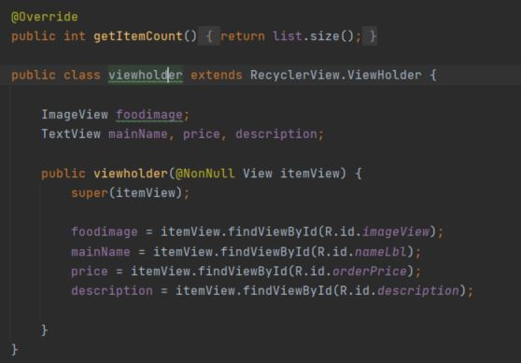

**Menu-**

**MENU-**View the food menu and select whatever the food wanted by clicking on it

**CREATE**- Once the customer click on an item they will be directed to the page where they can choose the number of items using the increment and decrement icons and customers should provide their name and phone number. After providing necessary details customer can click on “Order now” button. If the order is successfully added a toast message will appear saying” Ordered successfully!” If not will receive an” Order Failed”.

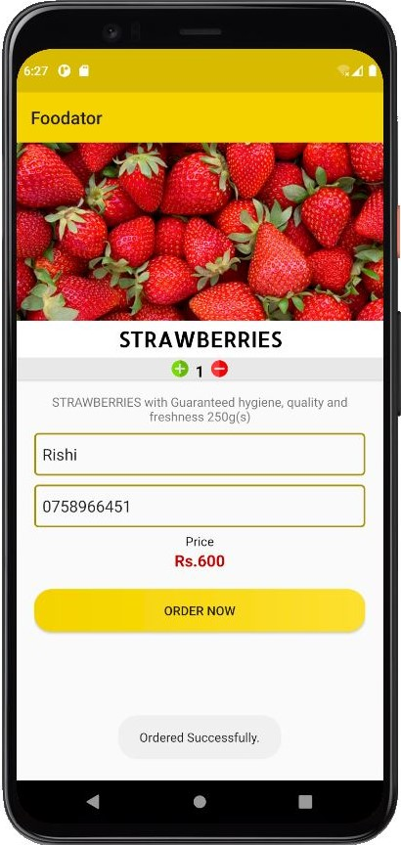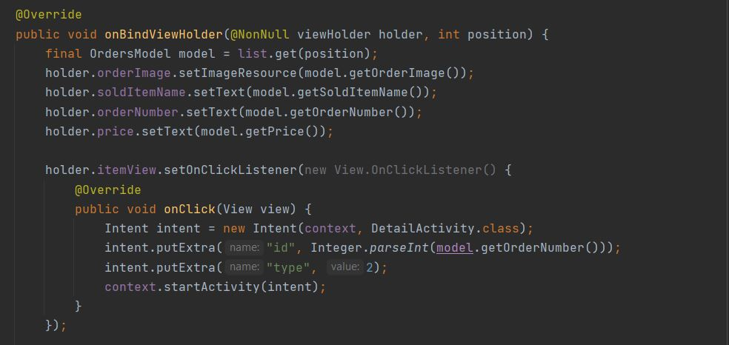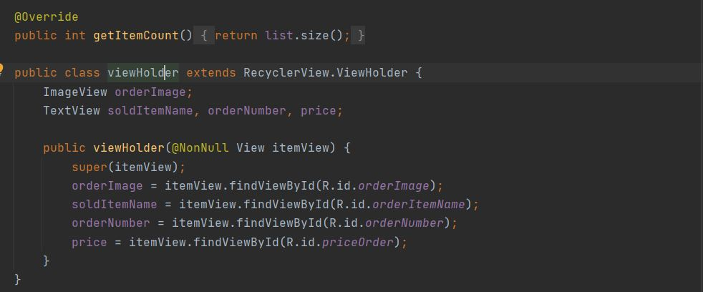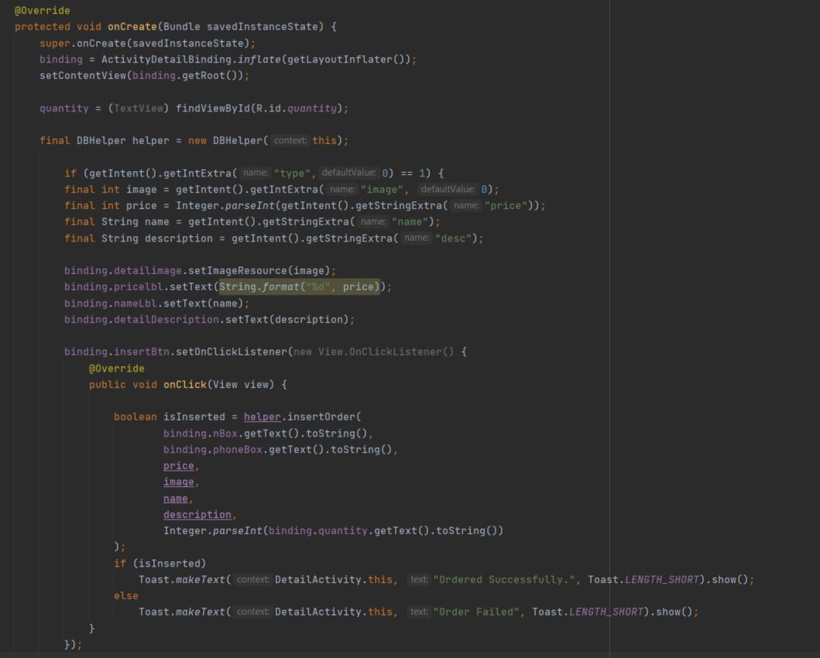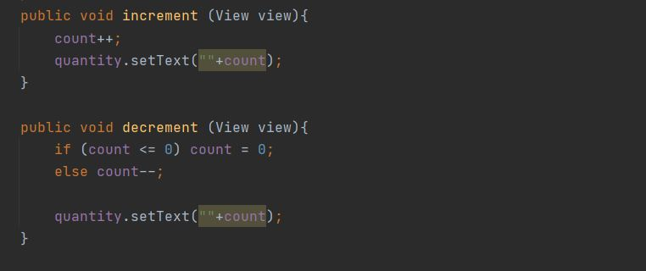

**VIEW**- After selecting the items customer can view them by clicking the “My Orders” option. In case if the customer wants to UPDATE or DELETE the orders, they have to click on the item that is been displayed in the “My Orders” page.

**UPDATE-** When customer click an item in the “My Orders” page they will be directed to the item edit page and there they can update their details and after updating they needs to click on the “Update Order” button and if the order is updated successfully a toast message will appear saying “Updated successfully”. Else display “Update Failed”.

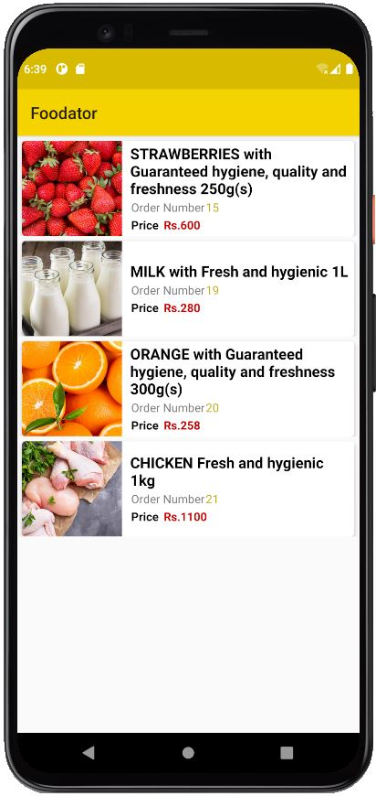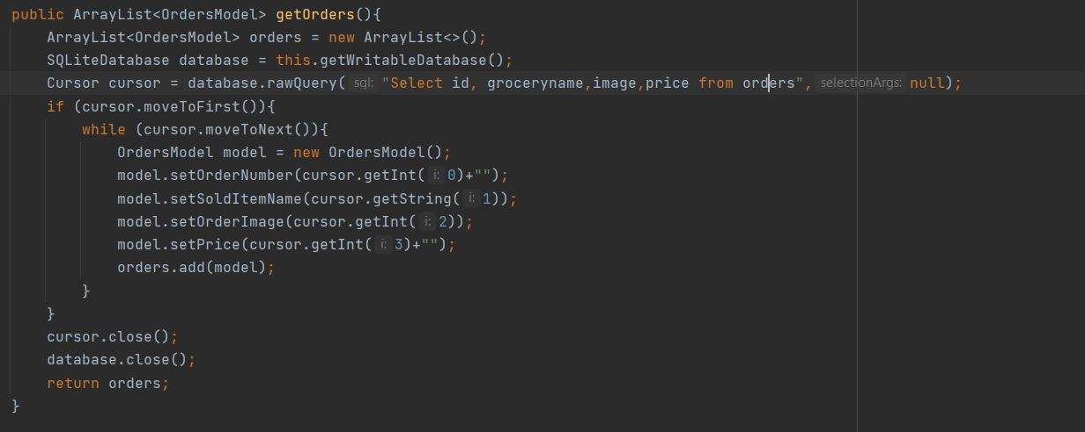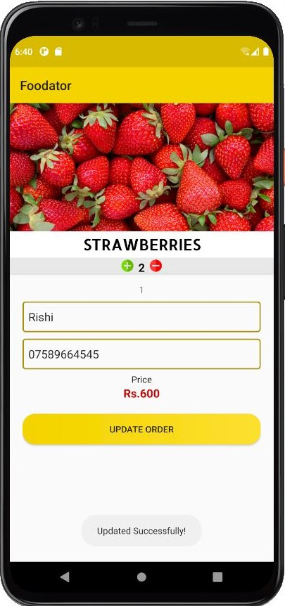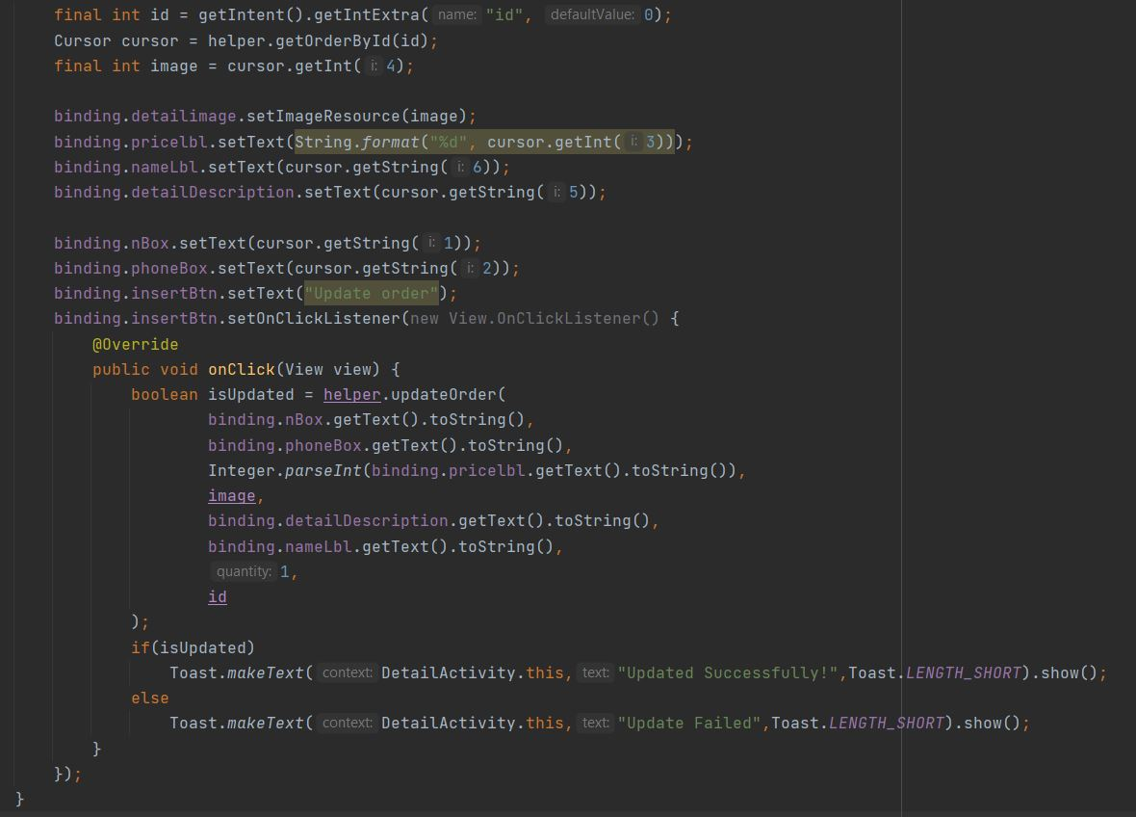

UPDATE

**DELETE-** If Customer wants to delete the order they have to long press the item in the “My Order” page and then an alert box will appear asking if they are sure and by clicking “Yes” the order will be deleted. If the order is deleted successfully a toast message will appear saying “Item deleted”.

Else display an “Error message”.

Test cases-

* Success message will be displayed when ordering, updating, deleting operations occur successfully.
* Error message will be displayed if those operations are not correctly occurred.
* Toast message of “Please input required details” will be displayed when clicks on button without providing details.

