  MINISTERIO  DE ECONOMÍA  Y COMPETITIVIDAD |  | 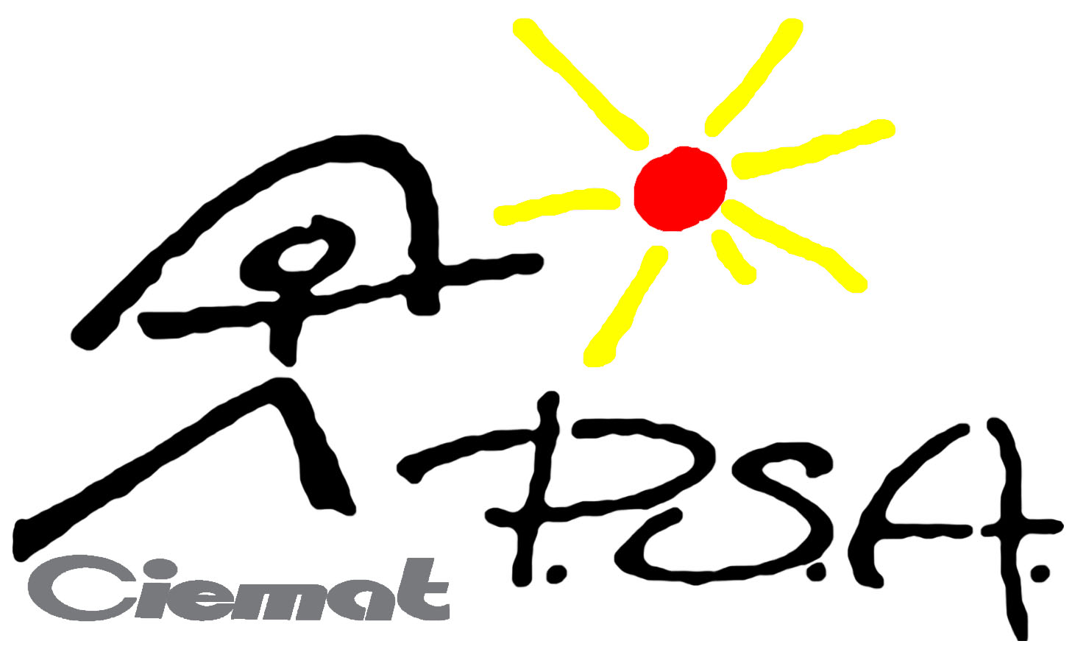

Project Summary Report
For PSA Facilities
Please send this form to cmontesinos.serviciosexternos@psa.es as a MS-Word file no later than 2 weeks after your stay.
Do not exceed 4 MB file size for transmission success.

Title of the project: Experimental validation of a Modelica-based dynamic parabolic trough collector model
Acronym: EVDPTCM
Infrastructure used: PTTL facility (with the Eurotrough collectors)
Group Leader: Rémi Dickes
Home organization: University of Liège
Leader email: rdickes@ulg.ac.be

Participant (Name, first name) | Organization | Working Stay period
Dickes, Rémi | University of Liège | From: 27/06/2016  To: 09/07/2016
Desideri, Adriano | University of Liège | From: 29/06/2016  To: 06/07/2016
Quoilin, Sylvain | University of Liège | From: /  To: /

1 - Summary of the situation and the objectives of the project (Please do not exceed 10 to 15 lines)
Among the different technologies of solar collectors used in CSP systems, the parabolic trough collector (PTC) is the most widespread and accounts for 95% of the installed capacity. The intermittent nature of the solar insolation (day/night, but also unforeseeable cloudiness) is an inherent characteristics of CSP systems which must continuously adapt their operating conditions to the atmospheric conditions. Dynamic models of the different system components are therefore deemed to properly perform performance predictions under realistic conditions or for the implementation and testing of more advanced control strategies. The solar field is one of the key component and the Thermodynamics Laboratory of the University of Liège …

The Thermodynamics Laboratory of the University of Liège has been working on the dynamic modelling of thermal systems since 2009 and it has created ThermoCycle . Besides.

The goal of this project is to run an experimental campaign on a field of parabolic trough collectors in order to characterize its performance and behavior under strong transient operating conditions. The data collected will be used to validate the dynamic models of PTCs developed by the University of Liège.

Note: Please, use a different sheet for each one of sections 2 to 6

2 – Main achievements and difficulties encountered at SFERA-II (Please do not exceed 1 page)

3 – Presentation and analysis of the results (Please do not exceed 1 page)

4 – Prospects, publications (Please do not exceed 1 page)

5 – Comments, if any (Please do not exceed 1 page)

