|  |
| --- |
| Jonathan Luong, Robert Dinh, Colin LeDonne |

NFC Inventory Management System

Status

/1 Hardware present?

/1 Title Page

/1 Declaration of Joint Authorship

/1 Proposal (500 words)

/1 Executive Summary

# Declaration of Joint Authorship

We, Jonathan Luong, Robert Dinh, and Collin LeDonne, confirm that this work submitted is the joint work of our group and is expressed our own words. Any uses made within it of the works of any other author, in any form (ideas, equations, figures, texts, tables, programs), are properly acknowledged at the point of use. A list of the references used is included. The work breakdown is as follows: Each of us provided functioning, documented hardware for a sensor or effector. Student A provided the Adafruit HD44780 LCD. Student B provided the Adafruit PN532 NFC/RFID Controller. Student C provided the Adafruit VCNL 4010 Proximity Sensor. In the integration effort Student A is the lead for further development of our mobile application, Student B is the lead for the Hardware, and Student C is the lead for connecting the two via the Database.

# Proposal

We have created a mobile application, worked with databases, completed a software engineering course, and prototyped a small embedded system with a custom PCB as well as an enclosure (3D printed/laser cut). Our Internet of Things (IoT) capstone project uses a distributed computing model of a smart phone application, a database accessible via the internet, an enterprise wireless (capable of storing certificates) connected embedded system prototype with a custom PCB as well as an enclosure (3D printed/laser cut), and are documented via this technical report targeting OACETT certification guidelines.

Intended project key component descriptions and part numbers:  
Development platform: Raspberry Pi 3 B+  
Sensor/Effector 1: Adafruit HD44780 LCD  
Sensor/Effector 2: Adafruit PN532 NFC/RFID Controller  
Sensor/Effector 3: Adafruit VCNL 4010 Proximity Sensor

We will continue to develop skills to configure operating systems, networks, and embedded systems using these key components to create a functional device that will trigger a proximity sensor to enable a RFID controller in read mode and turn on an LCD display. This device will be used to read an NFC NDEF message from a phone application to identify the student and their requested parts. The Android application that we will develop will allow students to select the parts they need and the application will also generate the NDEF message to be scanned over NFC using dedicated protocols. Also, a web browser application will also be developed mainly to monitor requests and inventory. It will also act as an alternative method for requesting parts. These three components will create an inventory management system that will benefit both the students and the staff. It will seamlessly allow students to request items and pick their parts up without the hassle of purchasing bags and RFID tags for individual students.

Our project description/specifications will be reviewed by, Professor Kristian Medri and Vlad Porcila (Both within the Faculty of Applied Sciences and Technology at Humber College), ideally an employer in a position to potentially hire once we graduate. They will also ideally attend the ICT Capstone Expo to see the outcome and be eligible to apply for NSERC funded extension projects. This typically means that they are from a Canadian company that has been revenue generating for a minimum of two years and have a minimum of two full time employees.

The small physical prototypes that we build are to be small and safe enough to be brought to class every week as well as be worked on at home. In alignment with the space below the tray in the Humber North Campus Electronics Parts kit the overall project maximum dimensions are 12 13/16" x 6" x 2 7/8" = 32.5cm x 15.25cm x 7.25cm.

Keeping safety and Z462 in mind, the highest AC voltage that will be used is 16Vrms from a wall adapter from which +/- 15V or as high as 45 VDC can be obtained. Maximum power consumption will not exceed 20 Watts. We are working with prototypes and that prototypes are not to be left powered unattended despite the connectivity that we develop.

# Executive Summary

The purpose of this document is to lay out the requirements and specifications for the hardware and the client-side application for the NFC Inventory Management System. This system will work in conjunction with an online management interface to maintain inventory in an efficient and organized manner. This product will mainly be developed as a Parts Crib solution at Humber College North Campus but it can also be utilized by other companies for their own purposes. This product will allow the client’s customers(students) to request items through a mobile or online interface and sign the items out with their phones as a form of identification through NFC. This removes the hassle of providing a card as a form of ID and eliminates the use of RFID tags that have to be individually programmed for each person. All the data that needs to be organized and managed to make the system work flawlessly, will be handled by the database with an online interface, which allow clients to audit their inventory and manage their customer’s information.

Contents

Declaration of Joint Authorship 3

Proposal 5

Executive Summary 7

List of Figures 11

1.0 Introduction 13

1.1 Scope and Requirements 15

2.0 Background 17

3.0 Methodology 19

3.1 Required Resources 19

3.1.1 Parts, Components, Materials 19

3.1.2 Manufacturing 19

3.1.3 Tools and Facilities 19

3.1.4 Shipping, duty, taxes 19

3.1.5 Time expenditure 19

3.2 Development Platform 19

3.2.1 Mobile Application 19

3.2.2 Image/firmware 21

3.2.3 Breadboard/Independent PCBs 21

3.2.4 Printed Circuit Board 23

3.2.5 Enclosure 24

3.3 Integration 25

3.3.1 Wireless Connectivity 26

3.3.2 Database Configuration 26

3.3.3 Security and Testing 26

4.0 Results and Discussions 27

5.0 Conclusions 29

6.0 References 31

7.0 Appendix 33

7.1 Firmware code 33

7.2 Application code 33

# List of Figures

Figure 7. By Android Studio - https://developer.android.com/studio/, CC BY-SA 4.0, https://commons.wikimedia.org/w/index.php?curid=74094999 18

Figure 1. Initial schematic. This work is a derivative of "http://fritzing.org/parts/" by Fritzing, used under CC:BY-SA 3.0. 19

Figure 2. This work is a derivative of "http://fritzing.org/parts/" by Fritzing, used under CC:BY-SA 3.0. 20

Figure 3. Breadboard prototype. 20

Figure 4. PCB design This work is a derivative of "http://fritzing.org/parts/" by Fritzing, used under CC:BY-SA 3.0. 21

Figure 5. Humber Sense Hat Prototype PCB. 21

Figure 6. Example enclosure. 22

# Introduction

Report

/1 Hardware present?

/1 Introduction (500 words)

/1 Scope and Requirements

/1 Background (500 words)

/1 References

The idea for this project is to create a solution to the current sign in and out feature at the parts crib at Humber College. The current system has the user download buggy software that is not very intuitive and rather difficult to use without instruction. One must download the software from a dropbox and then the software may need to be loaded several times to work properly.

Our goal is to create a solution to this problem by creating a smart phone application that uses HTTP protocol to send and receive data from a server along with hardware to make the process of borrowing parts easier. The server currently being used is the Humber Apollo Server (apollo.humber.ca) under a student’s profile for testing, but can be moved elsewhere for deployment elsewhere. The mySQL database on the server has 3 dedicated tables for accounts, inventory, and transactions. Each table has one field or more that will be able to relate to another table.

The Android application is designed to interact with the database. It has a graphical user interface to allow students to create a user, sign in, request items and to view previous requests. The process has the user queue the parts they require from the mobile application, which operates like an e-commerce store, which will then notify the employee at the parts crib via web application. When the user queues up parts, this will create a unique NFC code for the user to scan at the parts crib. The employee will then prepare the order for the user to pick-up. When the user arrives at the parts crib, they will scan their phone on the NFC reader which will then update the status of the unique transaction on the database that the employee can see. This will then update the order status on the database until the user scans their phone again on the NFC reader when items have been returned.

The web application will give the employee at the parts crib the ability to release orders, see the contents of the orders, and any relevant information requiring the order. The hardware includes a VCNL 4010 proximity sensor, Adafruit PN532 NFC Sensor, and a 16x2 HD44780 LCD Display. The NFC reader is responsible for receiving the information from the users phone, the LCD display is responsible for displaying the information from the NFC reader to the user, and the proximity sensor will turn up the brightness of the LCD screen when the user puts their phone near the NFC reader. We will be designing a PCB with the intention that the sensors will be placed next to each other to reduce the size of the case. All the components will fit into a case that will be laser cut and the layout of the components will be important so it will be easier to use and understand.

## 1.1 Scope and Requirements

**Product Scope**

The purpose of our project is to create an inventory management system that permits equipment provisioning for the Parts Crib that provides a friendly user experience for students and employees. The process will interact with a database through requests and finalize transactions through an interaction between a user’s mobile device and our NFC reader located at the crib. The system will implement functionality from the current system as well as provide features for both parties to stay informed regarding items pertaining to them to ensure users are updated accordingly per use.

The database will contain user account information and inventory that range from various tools and equipment. The goal of our project is to create an easy experience for the users of our product and intuitive enough for new users so it is simple and convenient for students to check out equipment.

Our IoT capstone project will implement a distributed computing model comprised of a smart phone application, and a database accessible via PHP scripts using a web browser or our NFC reader embedded system prototype with a custom PCB along with enclosure. The process will be documented via an OACETT certification acceptable technical report.

The project will be limited to the database we have created and will only be tested through simulation of the process. Requiring the Parts Crib for our test is not necessary if we are able to simulate high volume periods. Also, because the application will have personal information of the user there are security clearances that we do not have but we will be implementing secure practices in the handling of our account database involving unique IDs and hashed passwords (Hasing Security, 2019).

**Requirements and Specifications**

**Application**

* developed for android mobile devices starting at API 21
* requires internet connection over WiFi
* mobile device must be NFC-equipped

**Hardware**

* Requires wall outlet for power
* Wi-Fi to communicate with database
* Raspberry Pi 3 B+ with WiFi and I2C enabled

**Database**

* MySQL Database to read/write/store data
* Requires use of PHP scripts and/or web browser to communicate to the database stored on student account in Humber College servers

# 2.0 Background

# Radio frequency identification, also known as RFID, is the utilization of tags with integrated chips and coiled wire that can be activated using radio signals to retrieve their unique identification number or other information. Tags that are often passive, do not require a power source as its main source is from a reader that sends out an electromagnetic signal (Butterfield & Szymanski, 2018). These RFID tags are commonly found in everyday activities such as tapping a membership card to get into a car wash, to make a payment for food or to get a bus/train(transit).

Near Field Communication, also known as NFC, is a subset of RFID. NFC operates at a frequency of 13.56MHz and transfers data at a rate of 106k-424k bits per second (Butterfield & Szymanski, 2018). NFC capable devices can be switched to emulate passive or active states, such as smartphones to read and write to each other. To standardize the flow of information from device to device, NXP Semiconductors, Sony, Nokia and Philips have joined together to create protocols that are found under the NFC Forum name (Vanderkay, 2004)Currently, NFC Forum has 5 different specifications for tags, each unique for their own purposes. For this project, the Type 4 Forum Tag (ISO/IEC 14443) specification will be used to communicate between the hardware and an Android mobile device which. This involves 4 parts: physical characteristics, radio frequency power and signal interface, and initialization and anti-collision (Sabella, 2016). The Type 4 tag was selected due to the ability to hold large amounts of data in NFC Data Exchange Format (NDEF). This will be furthered explained in conjunction with Application Protocol Data Unit(APDU) commands specified in ISO/IEC 7816-4 (Organization, security and commands for interchange) to show how one device can access data on another device .

# Modern day smartphones, capable of doing many tasks, have been very convenient for everyday users. With the ability to perform host card emulation on these Android devices, contactless payment and other data transactions are made possible through NFC from one device to another. This type of technology can be applied to modern day inventory management problems such as the Parts Crib. The Parts Crib currently uses RFID tags that are individually scanned in and out for each incoming student, costing precious time and money. Having a contactless transaction of information with a mobile device will allow the Parts Crib to operate efficiently and effectively without requiring any extra manpower. Since students carry around their phones every day, it is simpler to just tap their phones than to rummage through purses and wallets. This system will allow students to securely transfer their information to the Parts Crib for easy access.

# 3.0 Methodology

## 3.1 Required Resources

Report

/1 Parts/components/materials (500 words)

/1 PCB, case (500 words)

/1 Tools, facilities (500 words)

/1 Shipping, duty, taxes (250 words)

/1 Working time versus lead time (250 words)

### 3.1.1 Parts, Components, Materials

### 3.1.2 Manufacturing

### 3.1.3 Tools and Facilities

### 3.1.4 Shipping, duty, taxes

### 3.1.5 Time expenditure

Working time versus lead time.

## 3.2 Development Platform

### 3.2.1 Mobile Application

Status

/1 Hardware present?

/1 Memo by student A + How did you make your Mobile Application? (500 words)

/1 Login activity

/1 Data visualization activity

/1 Action control activity

Include screenshots such as Figure 1. Testing. Progress.

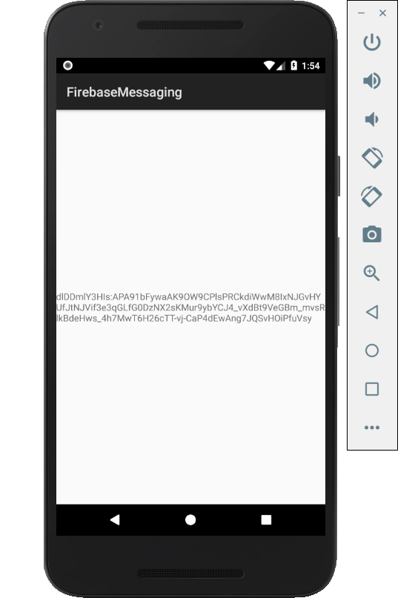

Figure 1. By Android Studio - https://developer.android.com/studio/, CC BY-SA 4.0, https://commons.wikimedia.org/w/index.php?curid=74094999

### 3.2.2 Image/firmware

Status

/1 Hardware present?

/1 Memo by student B + How did you make your Image/firmware? (500 words)

/1 Code can be run via serial or remote desktop

/1 Wireless connectivity

/1 Sensor/effector code on repository

### 3.2.3 Breadboard/Independent PCBs

Status

/1 Hardware present?

/1 Memo by student C + How did you make your hardware? (500 words)

/1 Sensor/effector 1 functional

/1 Sensor/effector 2 functional

/1 Sensor/effector 3 functional

The initial schematic design, Figure 2, based on datasheets (Bosch Sensortec, 2019) led to a breadboard layout Figure 3 that was realized Figure 4.

How did you build your Prototype: Breadboard?

Then a PCB was designed, Figure 5, and populated (Figure 6). Bill of Materials, Case, Time commitment. Testing. Progress.

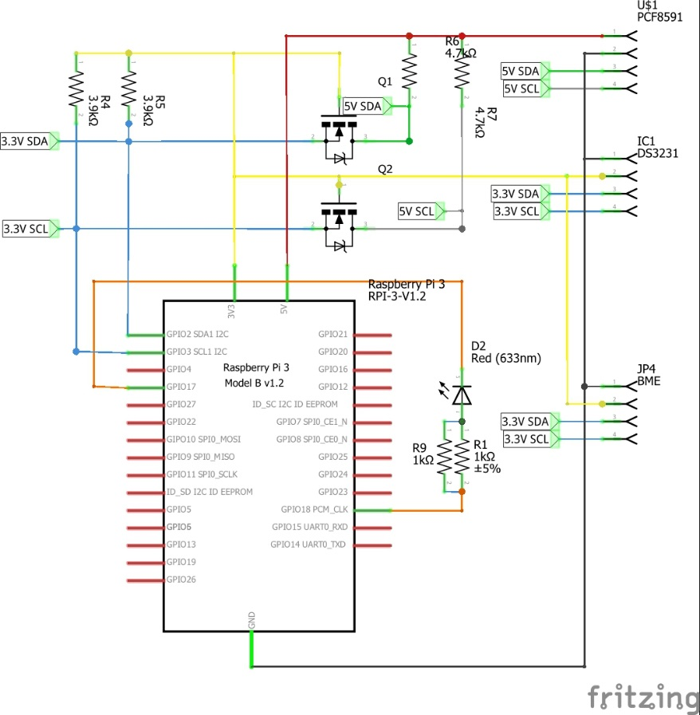

Figure 2. Initial schematic. This work is a derivative of "http://fritzing.org/parts/" by Fritzing, used under CC:BY-SA 3.0.

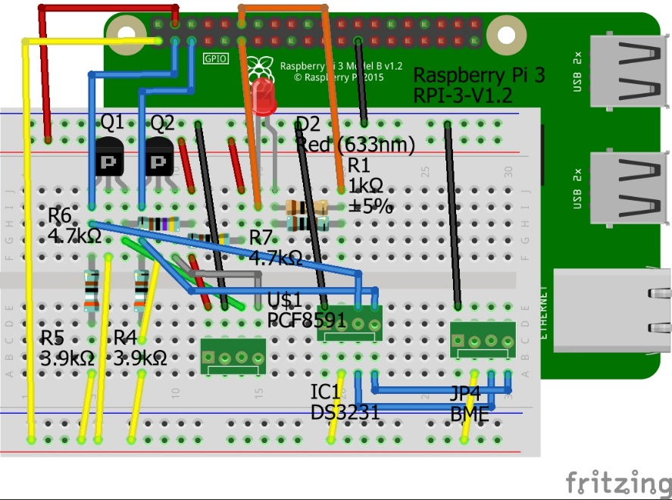

Figure 3. This work is a derivative of "http://fritzing.org/parts/" by Fritzing, used under CC:BY-SA 3.0.

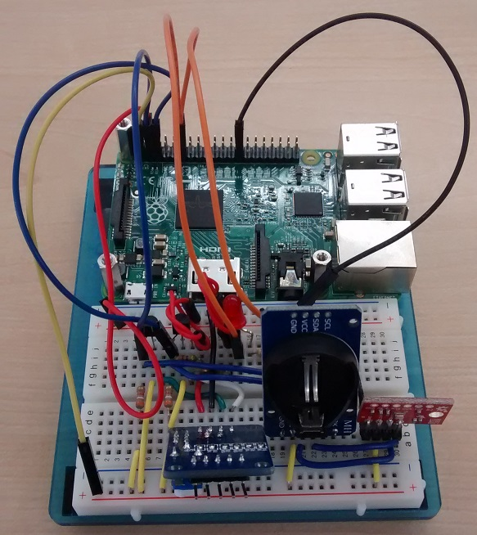

Figure 4. Breadboard prototype.

### 3.2.4 Printed Circuit Board

Demo

/1 Hardware present?

/1 PCB Complete and correct

/1 PCB Soldered wire visible but trim, no holes or vacancies

/1 PCB Tested with multimeter

/1 PCB Powered up

How did you build your Prototype: PCB?

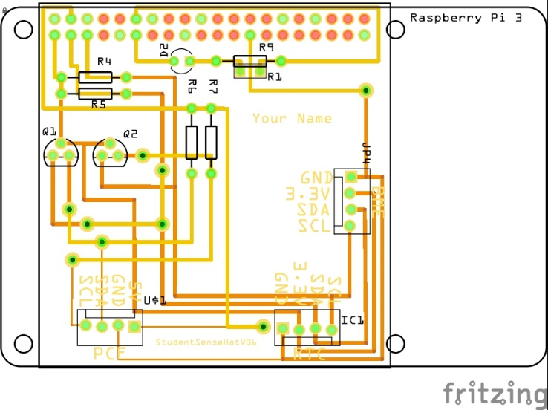

Figure 5. PCB design This work is a derivative of "http://fritzing.org/parts/" by Fritzing, used under CC:BY-SA 3.0.

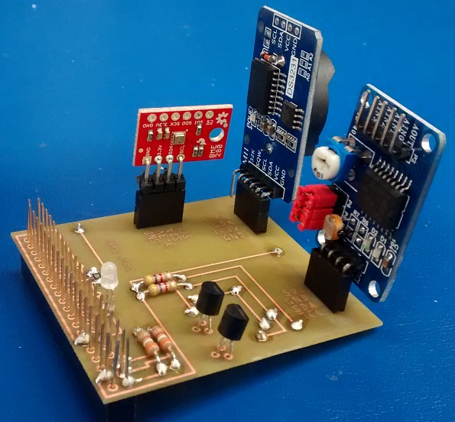

Figure 6. Humber Sense Hat Prototype PCB.

### 3.2.5 Enclosure

Demo

/1 Hardware present?

/1 Case encloses development platform and custom PCB.

/1 Appropriate parts securely attached.

/1 Appropriate parts accessible.

/1 Design file in repository, photo in report.

How did you build your Prototype: Case?

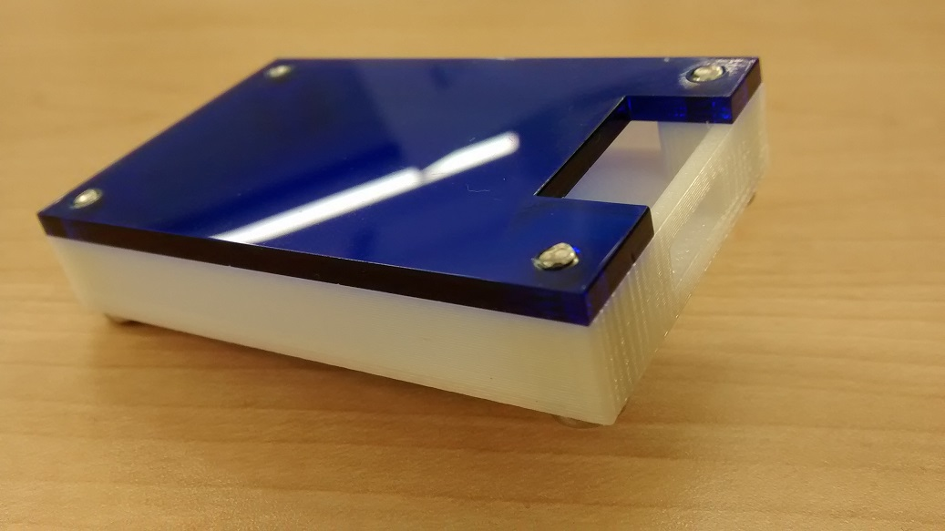

Figure . Example enclosure.

## 3.3 Integration

Demo

/1 Hardware present?

/1 Data sent by hardware

/1 Data retrieved by mobile application

/1 Action initiated by mobile application

/1 Action recieved by hardware

Report

/1 Enterprise wireless connectivity (250)

/1 Database configuration (250 words)

/1 Security considerations (500 words)

/1 Unit testing (900 words)

/1 Production testing (100 words)

### 3.3.1 Enterprise Wireless Connectivity

How did you make a Database accessible by both your Prototype and Mobile Application?

### 3.3.2 Database Configuration

### 3.3.3 Security

### 3.3.4 Testing

Unit testing and Production testing.

# 4.0 Results and Discussions

Is your prototype perfect? What did you learn?

# 5.0 Conclusions

If you were making 1000 of these.

Report

/1 Hardware present?

/1 Checklist truthful

/1 Valid Comments

/1 Results and Discussion (500 words)

/1 Conclusion

# 6.0 References

Bosch Sensortec. (2019, July). *BME680 - Datasheet.* Retrieved from Robert Bosch GmbH: https://ae-bst.resource.bosch.com/media/_tech/media/datasheets/BST-BME680-DS001.pdf

Butterfield, A., & Szymanski, J. (2018). *In A Dictionary of Electronics and Electrical Engineering.* Oxford University Press.

*Hasing Security*. (2019, June 5). Retrieved from Crack Station: https://crackstation.net/hashing-security.htm

OACETT. (2017, March). *I need to Complete a Technology Report*. Retrieved from The Ontario Association of Certified Engineering Technicians and Technologists: https://www.oacett.org/Membership/Technology-Report-and-Seminar

Sabella, R. (2016, April 11). *NFC for dummies*. Retrieved from dummies: https://www.dummies.com/consumer-electronics/nfc-standard-isoiec-14443/

Vanderkay, J. (2004, March 18). *Nokia, Philips And Sony Establish The Near Field Communication (NFC) Forum*. Retrieved from NFC Forum: https://nfc-forum.org/nokia-philips-and-sony-establish-the-near-field-communication-nfc-forum/

# 7.0 Appendix

## 7.1 Firmware code

Demo

/1 Hardware present?

/3 Code runs concurrently for all sensors/effectors

/1 Project repository contains integrated code

Status

/1 Memo including updates

/1 Financial update

/1 Progress update

/1 Modified Code Files in Appendix

/1 Link to Complete Code in Repository

## 7.2 Application code

Demo

/1 Hardware present?

/1 Memo by student A

/1 Login activity

/1 Data visualization activity

/1 Action control activity

Report

/1 Login activity

/1 Data visualization activity

/1 Action control activity

/1 Modified Code Files in Appendix

/1 Link to Complete Code in Repository