Assignment 1

[Get the code prepare .m files yourself!]

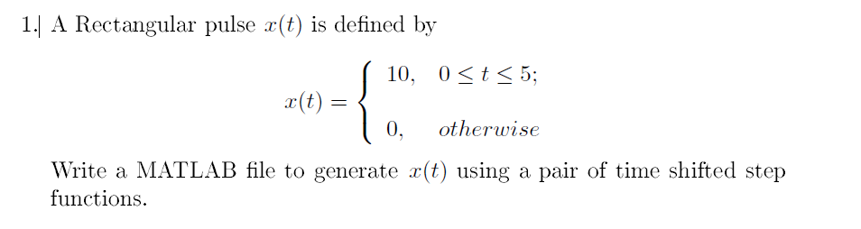

t = (-1:0.01:20);

unitstep = zeros(size(t));

unitstep2 = zeros(size(t));

unitstep(t>=0) = 1;

unitstep2(t>=5)=1;

y=10.*unitstep-10.*unitstep2;

plot(t,y)

xlabel('time')

ylabel('y(t)')

ylim([0 12])



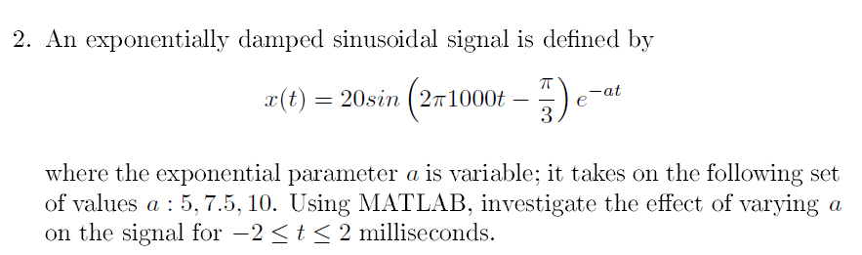

a1 = 5;

t = -2:0.001:2;

x1 = 20*sin(2*pi*1000*t-pi/3).*exp(-a1*t)

plot(t,x1)

axis([0 1 -5 5])

hold on

a2=7.5;

x2 = 20*sin(2*pi*1000.*t-pi/3).*exp(-a2.*t)

plot(t,x2)

hold on

a3=10;

x3 = 20*sin(2*pi*1000.*t-pi/3).*exp(-a3.*t)

plot(t,x3)

legend('a=5','a=7.5','a=10')

hold off



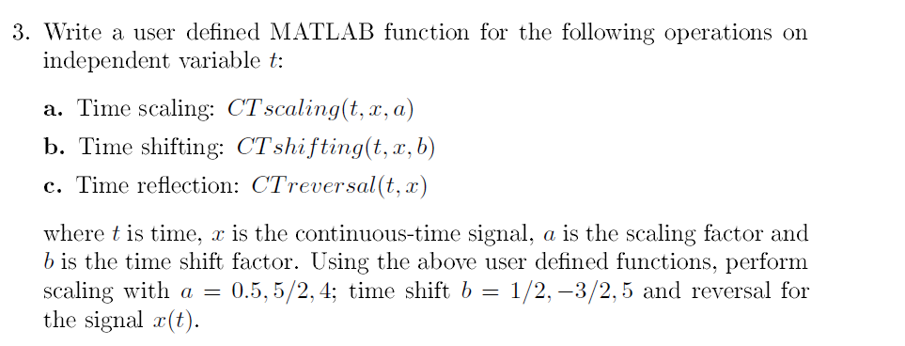

Code

t=input('Enter the range of time for the signal:')

x=input('enter the continous time signal:')

a=input('Enter the scaling factor:')

b=input ('enter the shifting factor')

x=CTscaling(t,x,a)

x1=CTshifting(t,x,b)

x3=CTreversal(t,x)

function x=CTscaling(t,x,a)

figure(1)

subplot(2,1,1)

plot(t,x)

xlabel('time');

ylabel('amplitude');

title('input signal');

u=1/a.*t

subplot(2,1,2);

plot(u,x);

xlabel('time');

ylabel('amplitude');

title('timescaled signal');

display(x);

end

function x1=CTshifting(t,x1,b)

figure(2)

subplot(2,1,1)

plot(t,x1)

xlabel('time');

ylabel('amplitude');

title('input signal');

y=t-b

subplot(2,1,2);

plot(y,x1);

xlabel('time');

ylabel('amplitude');

title('shifted signal');

display(x1);

end

function x3=CTreversal(t,x3)

figure(3)

subplot(2,1,1)

plot(t,x3)

xlabel('time');

ylabel('amplitude');

title('input signal');

r=-t

subplot(2,1,2);

plot(r,x3);

xlabel('time');

ylabel('amplitude');

title('reversed signal');

display(x3);

end

Graph

a)a=0.5



a=2.5



a=4



b)

b=0.5



b=-3/2



b=5



c)



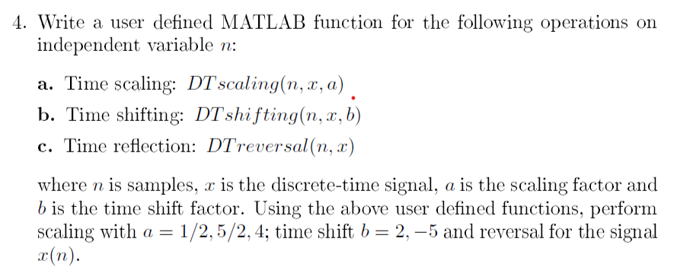

CODE

n=input('Enter the number of samples for the signal:')

x=input('enter the discrete time signal:')

a=input('Enter the scaling factor:')

b=input ('enter the shifting factor')

x=DTscaling(n,x,a)

x1=DTshifting(n,x,b)

x3=DTreversal(n,x)

function x=DTscaling(n,x,a)

n=0:1:n-1

figure(1)

subplot(2,1,1)

stem(n,x)

xlabel('no of samples');

ylabel('amplitude');

title('input signal');

subplot(2,1,2);

stem(u,x);

xlabel('no ofsamples');

ylabel('amplitude');

title('timescaled signal');

display(x);

end

function x1=DTshifting(n,x1,b)

n=0:1:n-1

figure(2)

subplot(2,1,1)

stem(n,x1)

xlabel('no of samples');

ylabel('amplitude');

title('input signal');

y=n-b

subplot(2,1,2);

stem(y,x1);

xlabel('no of samples');

ylabel('amplitude');

title('shifted signal');

display(x1);

end

function x3=DTreversal(n,x3)

n=0:1:n-1

figure(3)

subplot(2,1,1)

stem(n,x3)

xlabel('no of samples');

ylabel('amplitude');

title('input signal');

r=-n

subplot(2,1,2);

stem(r,x3);

xlabel('no of samples');

ylabel('amplitude');

title('reversed signal');

display(x3);

end

GRAPHS

a)

a=0.5



a=5/2



a=4



b)

b=2



b=-5



c)



UNIT - 2

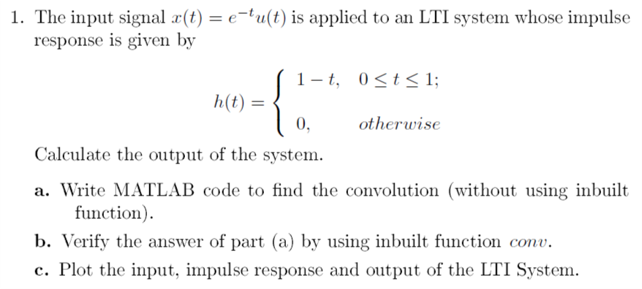

CODE

t=linspace(0,8,20000);

i=t>=0 & t<=8;

x(i)=exp(-2*t(i));

figure(1);

plot(t,x,'linewidth',2);

ylim([0,1.5]);

grid on;

xlabel('t');

ylabel('x(t)');

title('x(t)');

t=linspace(0,6,20000);

i=t>=0 & t<=1;

h(i)=1-t(i);

i=t>1 & t<=6;

h(i)=0;

figure(2);

plot(t,h,'linewidth',2);

ylim([0,3]);

grid on;

xlabel('t');

ylabel('h(t)');

title('h(t)');

z=median(diff(t))*conv(x,h,'same');

figure(3);

plot(t,z,'linewidth',2);

grid on;

xlabel('t');

ylabel('y(t)');

title('Convolved graph');

GRAPH







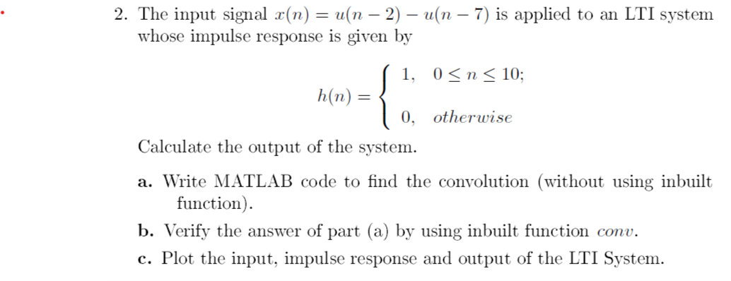

CODE

n= 1:10;

unitstep = zeros(size(n));

unitstep2 = zeros(size(n));

unitstep(n>=2)= 1;

unitstep2(n>7)=1;

x=unitstep-unitstep2;

figure(1)

stem(n,x);

disp(n)

xlabel('n');

ylabel('x(n)');

title('input response')

axis([-1 10 0 2]);

n= 0:12;

unitstep = zeros(size(n));

unitstep2 = zeros(size(n));

unitstep(n>=0)= 1;

unitstep2(n>10)=1;

h=unitstep-unitstep2;

figure(2)

stem(n,h);

xlabel('n');

ylabel('h(n)');

title('impulse response')

axis([-2 12 0 2]);

m=length(x);

n=length(h);

X=[x,zeros(1,n)];

H=[h,zeros(1,m)];

for i=1:n+m-1

Y(i)=0;

for j=1:m

if(i-j+1>0)

Y(i)=Y(i)+X(j)*H(i-j+1);

else

end

end

end

figure(3);

stem(Y);

ylabel('Y[n]');

xlabel('n');

grid on;

title('Convolution of Two Signals without conv function');

figure(4)

stem(conv(x,h))

ylabel('Y[n]');

xlabel('n');

grid on;

title('Convolution of Two Signals with conv function');

GRAPH









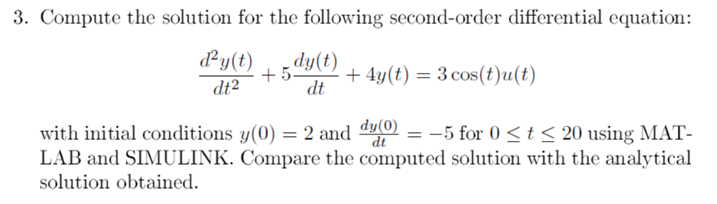

MATLAB PROGRAM

syms y(t)

Dy = diff(y);

%As 0<=t<=20,the value of u(t)=1

ode = diff(y,t,2)+5*diff(y,t)+4*y == 3*cos(t)*1

cond1 = y(0) == 2;

cond2 = Dy(0) == -5;

conds=[cond1 cond2];

ySol(t)=dsolve(ode,conds);

ySol=simplify(ySol)

fplot(ySol)

xlabel('time')

ylabel('y(t)')

COMMAND WINDOW

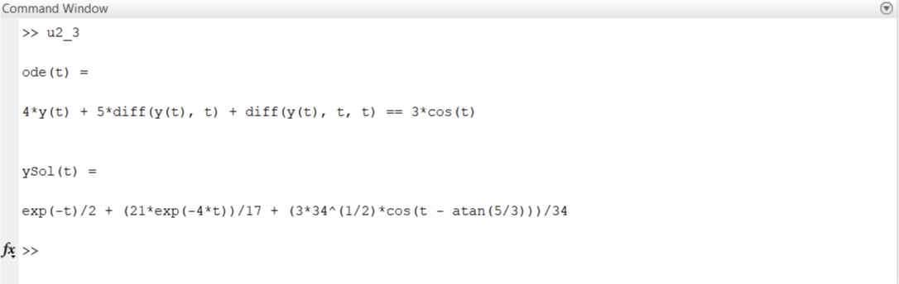

GRAPH



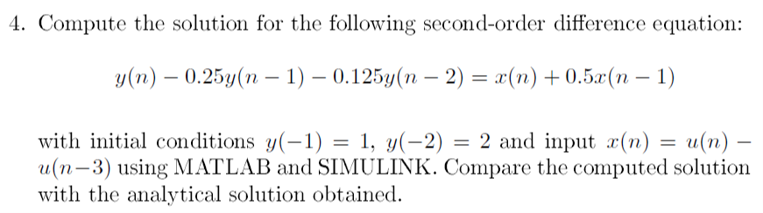

MATLAB CODE

n= -2:10;

unitstep = zeros(size(n));

unitstep2 = zeros(size(n));

unitstep(n>=0) = 1;

unitstep2(n>3)=1;

x=unitstep-unitstep2;

c = [1 2]

y = [c]

for i = 3:13

y(i) = y(i-2)*0.125+y(i-1)*0.25+x(i)+0.5*x(i-1)

end

subplot(1,2,1)

stem(n,x)

ylabel('x[n]')

xlabel('n')

subplot(1,2,2)

stem(n,y)

ylabel('y[n]')

xlabel('n')

GRAPH



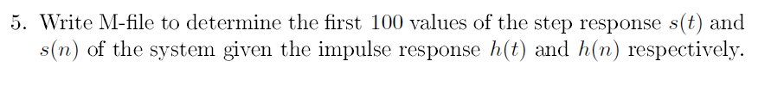

MATLAB PROGRAM

syms ircont(t)irdisc(n)

ircont(t) = input("Enter the impulse response for continuous time:")

irdisc(n) = input("Enter the impulse response for discrete time:")

srcont(t) = int(ircont,t)

syms n

assume(n > 0)

% srdisc(n) = subs(irdisc(n),n,0:100)

srvalue_cont = zeros(10);

count = 1;

for i = 1:10

for j = 1:10

srvalue_cont(i,j) = double(srcont(count));

count = count + 1;

end

end

fprintf("Values of step response s(t) are")

srvalue_cont

fprintf("Values of step response s[n] are")

srdisc(n) = subs(irdisc(n),n,0:100)

COMMAND WINDOW

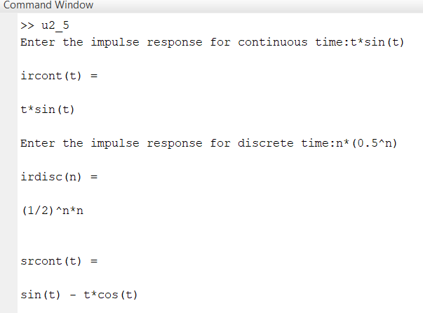

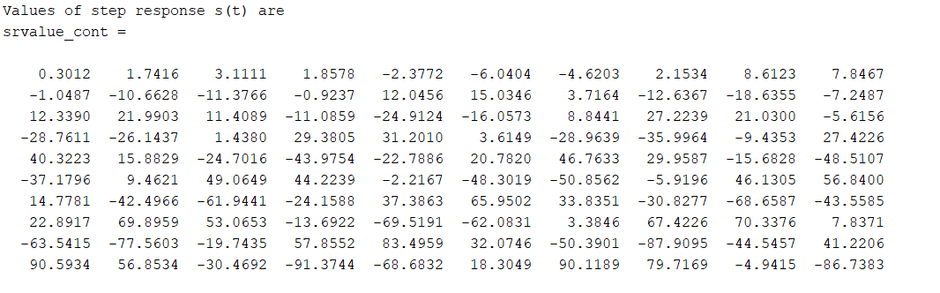

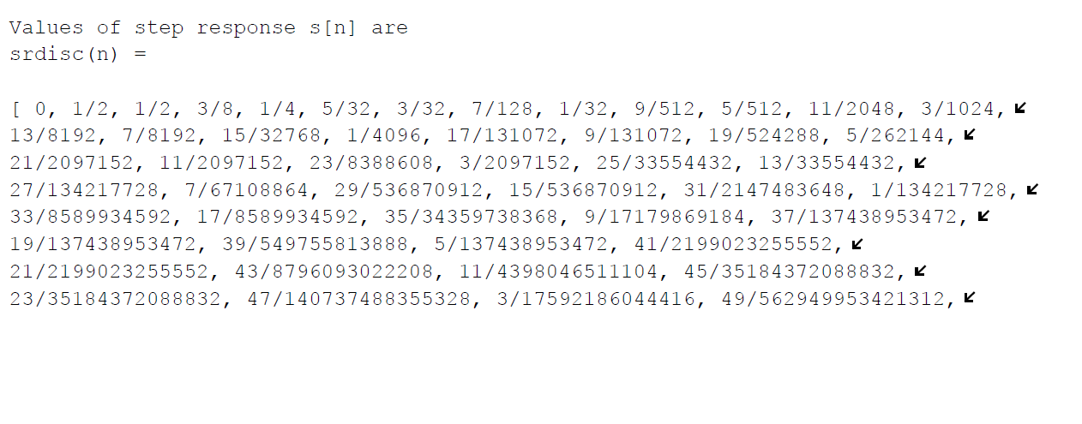

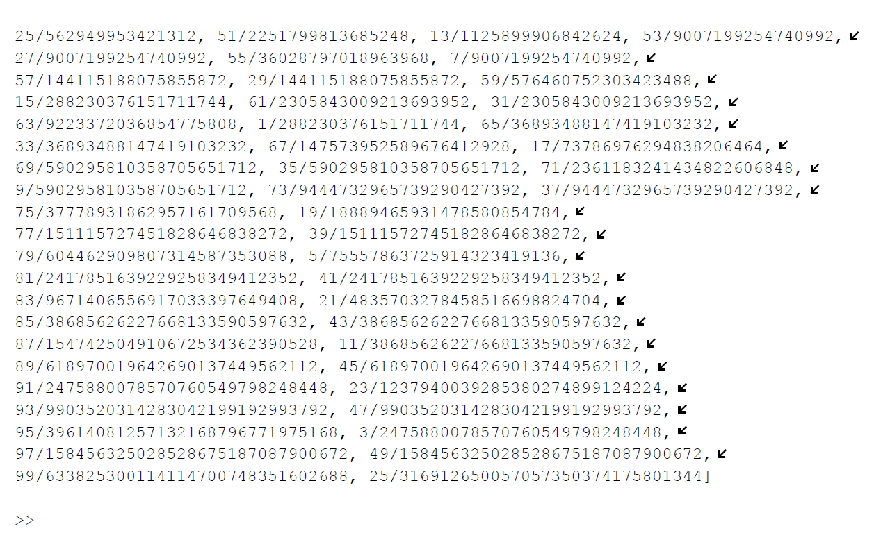

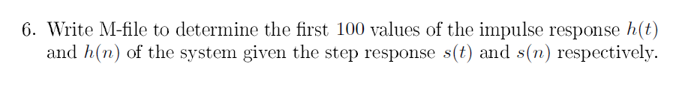

**MATLAB PROGRAM**

syms srcont(t)srdisc(n)

srcont(t) = input("Enter the step response for continuous time:")

srdisc(n) = input( "Enter the step response for discrete time")

ircont(t) = diff(srcont)

irdisc(n) = srdisc(n) - srdisc(n-1)

irvalue_cont=zeros(10);

count = 1;

for i = 1:10

for j = 1:10

irvalue_cont(i,j) = vpa(ircont(count));

count = count + 1;

end

end

fprintf("The first 100 values of impulse response h(t) are")

irvalue_cont

irvalue_disc = zeros(10);

count = 1;

for i = 1:10

for j = 1:10

irvalue_disc(i,j) = vpa(irdisc(count));

count = count + 1;

end

end

fprintf("The first 100 values of impulse response h(n) are")

irvalue_disc

COMMAND WINDOW

