**Assignment Number : 2**

**Q1) For the following signals x(t), write a MATLAB code to find the Fourier coefficients for k = −7 to 7. Plot the magnitude and phase plot of ak. Using these Fourier series coefficients ak, recreate the signal. Plot the estimated and the original signal x(t) on the same plot. Redo the same problem for k = −25 to 25. Comment on the effect of increasing the number of fourier series coefficients on the reconstructed signal x(t). Given one period of the signal x(t),**

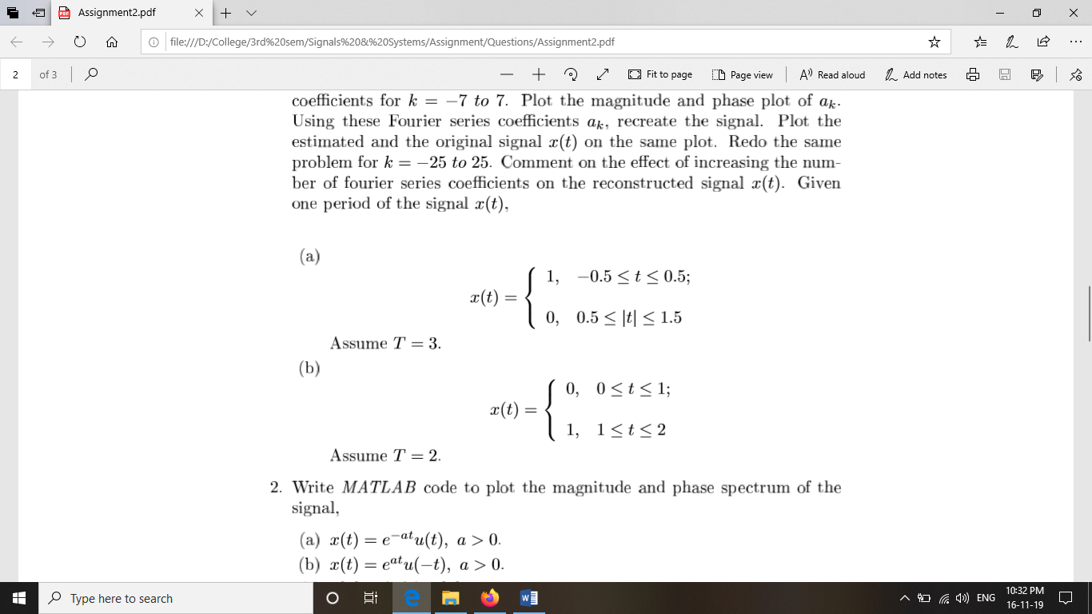

**ANS :**

%Q1)

%a)

% x(t)=1 ,-0.5<=t<=0.5; 0 ,otherwise

%k=-7:7

T=3;

syms x(t) k y(t) n U(t)

x(t)=1;

ak=1/T*int(x*exp(-j*k*2*t*pi/T),t,[-0.5 0.5])

k=-7:7;

ak_val=1/T*int(x*exp(-j*k*2*t*pi/T),t,[-0.5 0.5])

%k=-7:7;

figure(1)

stem(k,abs(ak_val))

xlabel('k')

ylabel('|ak|')

title('Magnitude Plot(k from -7 to 7)')

figure(2)

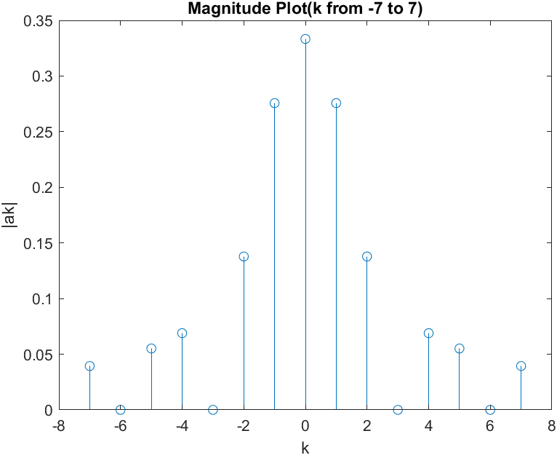

stem(k,angle(ak_val))

ylabel('Phase angle of ak')

xlabel('k')

title('Phase Plot(k from -7 to 7)')

U(t)=piecewise(-1.5<=t<=-0.5,0,-0.5<=t<=0.5,1,0.5<=t<=1.5,0)

ak1=1/T*int(x*exp(-j*n*2*t*pi/T),t,[-0.5 0.5])

V=subs(ak1*exp(j*n*2*pi/T*t),n,-7:-

1)+subs(ak1*exp(j*n*2*pi/T*t),n,1:7)+1/3

y(t)=sum(V)

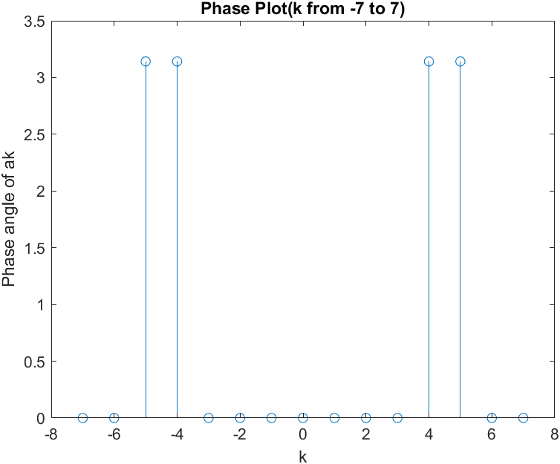

% t=-0.5:0.5

figure(3)

fplot(y-2)

%figure(4)

hold on

fplot(U)

title('estimated signal(k from -7 to 7)')

hold off

xlim([-1.5 1.5])

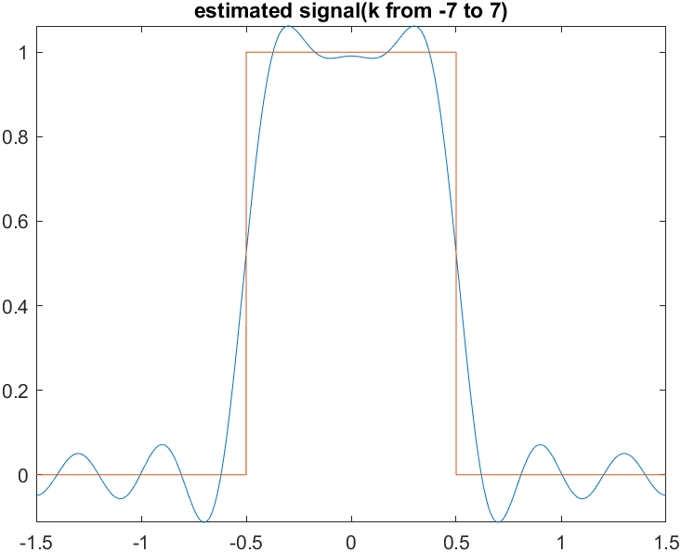

T=3;

syms x(t) k y(t) n U(t)

x(t)=1

ak=1/T*int(x*exp(-j*k*2*t*pi/T),t,[-0.5 0.5])

k=-25:25;

ak_val=1/T*int(x*exp(-j*k*2*t*pi/T),t,[-0.5 0.5])

%k=-7:7;

figure(4)

stem(k,abs(ak_val))

xlabel('k')

ylabel('|ak|')

title('Magnitude Plot(k from -25 to 25)')

figure(5)

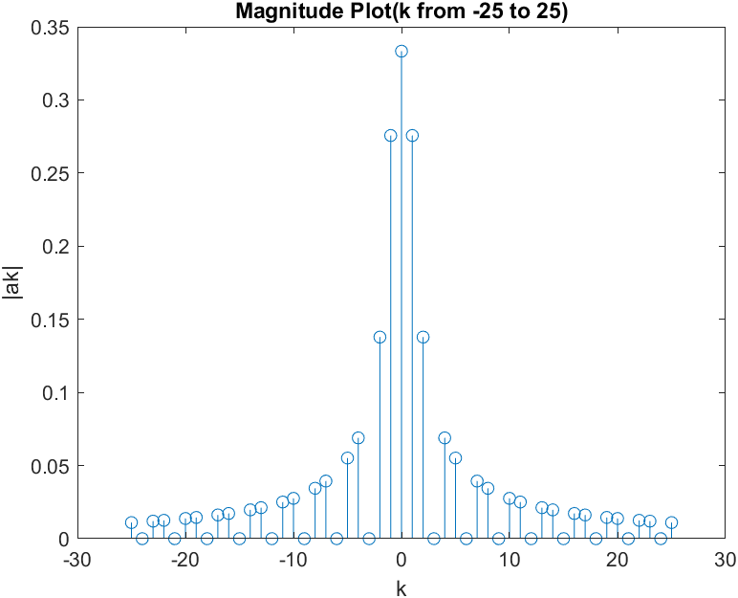

stem(k,angle(ak_val))

ylabel('Phase angle of ak')

xlabel('k')

title('Phase Plot(k from -25 to 25)')

U(t)=piecewise(-1.5<=t<=-0.5,0,-0.5<=t<=0.5,1,0.5<=t<=1.5,0)

ak1=1/T*int(x*exp(-j*n*2*t*pi/T),t,[-0.5 0.5])

V=subs(ak1*exp(j*n*2*pi/T*t),n,-25:-1)+subs(ak1*exp(j*n*2*pi/T*t),n,1:25)+1/3

y(t)=sum(V)

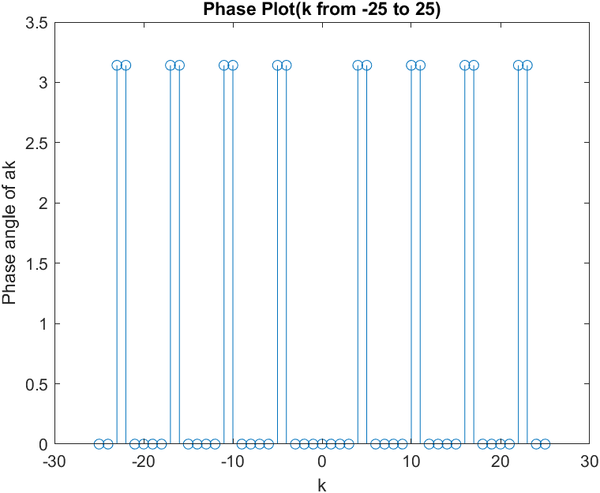

% t=-0.5:0.5

figure(6)

fplot(y-8)

%figure(4)

hold on

fplot(U)

title('estimated signal(k from -25 to 25)')

hold off

xlim([-1.5 1.5])

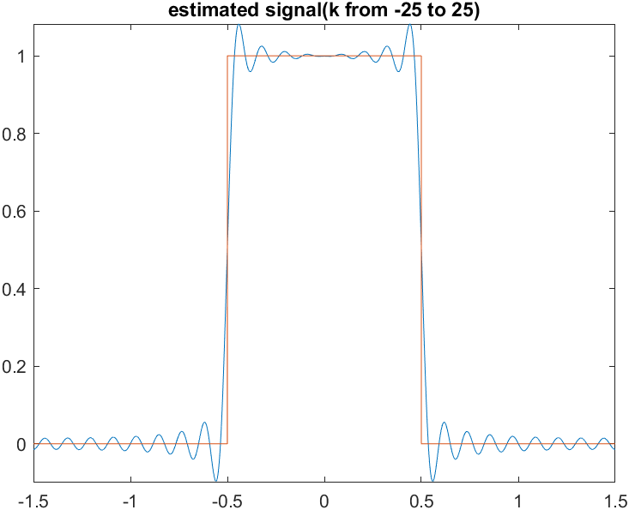

%b)

% x(t)=1 ,-0.5<=t<=0.5; 0 ,otherwise

%k=-7:7

T=2;

syms x(t) k y(t) n U(t)

x(t)=1

ak=1/T*int(x*exp(-j*k*2*t*pi/T),t,[1 2])

k=-7:7;

ak_val=1/T*int(x*exp(-j*k*2*t*pi/T),t,[1 2])

%k=-7:7;

figure(1)

stem(k,abs(ak_val))

% hold on

% stem(k,imag(ak_val))

xlabel('k')

ylabel('|ak|')

% legend('real values','imaginary values')

title('Magnitude Plot(k from -7 to 7)')

figure(2)

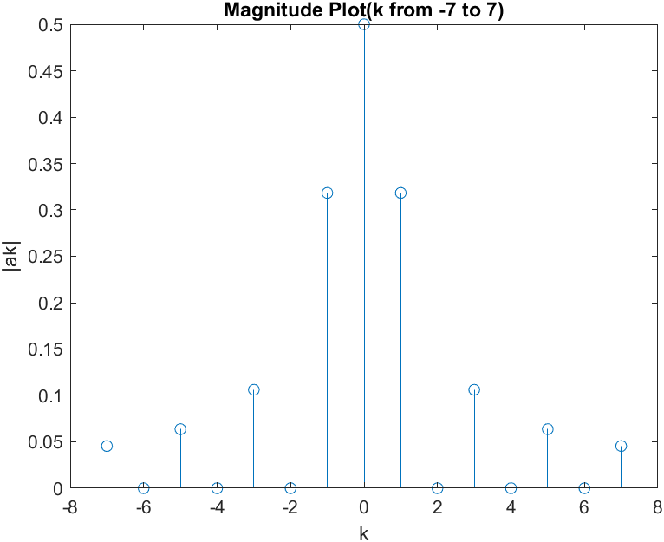

stem(k,angle(ak_val))

ylabel('Phase angle of ak')

xlabel('k')

title('Phase Plot(k from -7 to 7)')

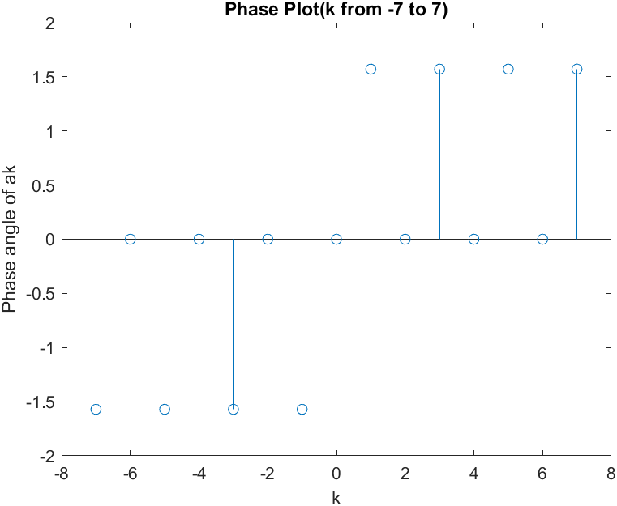

U(t)=piecewise(0<=t<=1,0,1<=t<=2,1)

ak1=1/T*int(x*exp(-j*n*2*t*pi/T),t,[1 2])

V=subs(ak1*exp(j*n*2*pi/T*t),n,-7:-1)+subs(ak1*exp(j*n*2*pi/T*t),n,1:7)+1/2

y(t)=sum(V)

figure(3)

fplot(y-3)

hold on

fplot(U)

title('estimated signal(k from -7 to 7)')

hold off

xlim([-0 3])

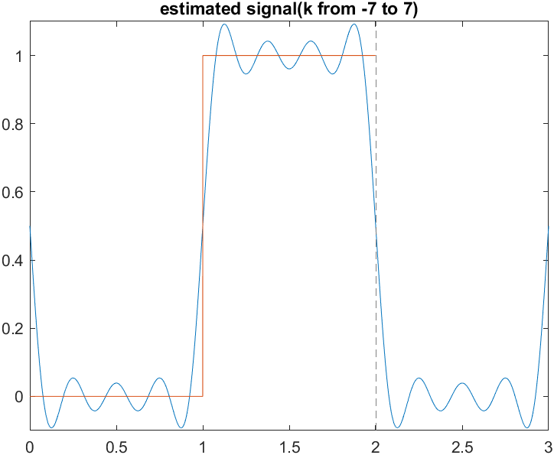

T=2

syms x(t) k y(t) n U(t)

x(t)=1

ak=1/T*int(x*exp(-j*k*2*t*pi/T),t,[1 2])

k=-25:25;

ak_val=1/T*int(x*exp(-j*k*2*t*pi/T),t,[1 2])

%k=-7:7;

figure(4)

stem(k,abs(ak_val))

xlabel('k')

ylabel('|ak|')

title('Magnitude Plot(k from -25 to 25)')

figure(5)

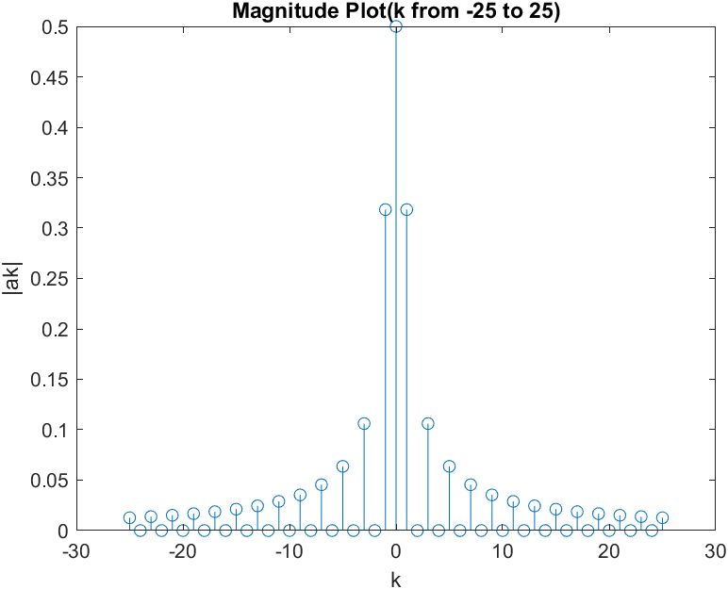

stem(k,angle(ak_val))

ylabel('Phase angle of ak')

xlabel('k')

title('Phase Plot(k from -25 to 25)')

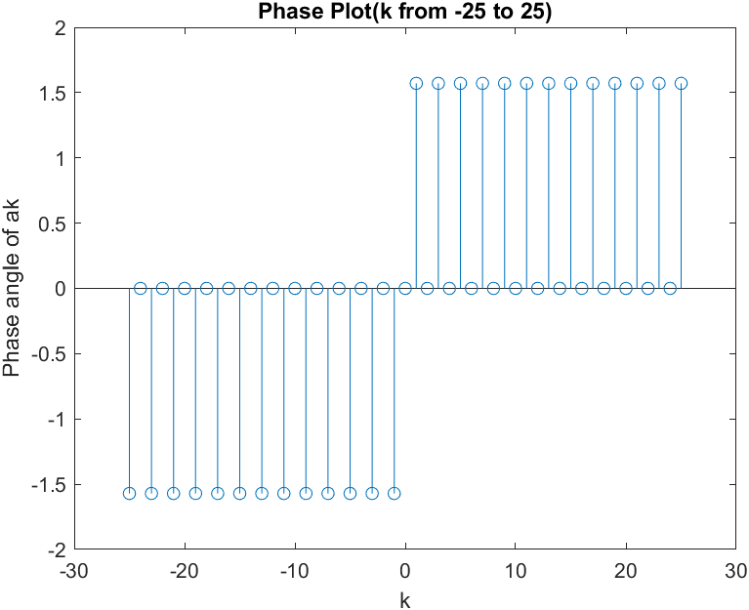

U(t)=piecewise(0<=t<=1,0,1<=t<=2,1)

ak1=1/T*int(x*exp(-j*n*2*t*pi/T),t,[1 2])

V=subs(ak1*exp(j*n*2*pi/T*t),n,-25:-1)+subs(ak1*exp(j*n*2*pi/T*t),n,1:25)+1/2

y(t)=sum(V)

figure(6)

fplot(y-12)

hold on

fplot(U)

title('estimated signal(k from -25 to 25)')

hold off

xlim([-0 3])

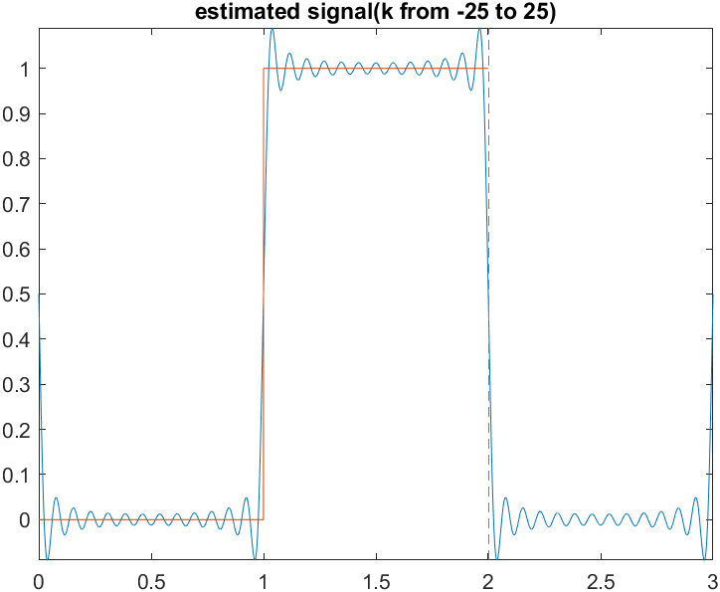

**Q2) Write MATLAB code to plot the magnitude and phase spectrum of the signal,**

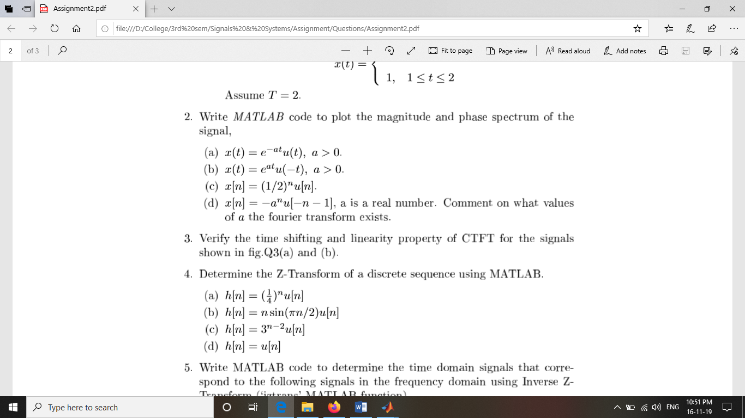

ANS: %Q2)

%a)

t=0:0.01:10;

x=exp(-2*t);

w=-10:0.01:10;

for j=1:length(w)

Xjw(j)=(sum(x.*exp(-i*w(j)*t)))*0.01;

end

%plot x(t)

subplot(311);

plot(t,x);

title('x(t)=e^(at)u(-t), a>0');

%plot magnitude spectrum

subplot(312);

plot(w,abs(Xjw));

title('Magnitude spectrum');

xlabel('frequency w');

ylabel('|X(jw)|');

%plot phase spectrum

subplot(313);

plot(w,angle(Xjw));

title('Phase spectrum');

xlabel('frequency w');

ylabel('Phase (X(jw))');

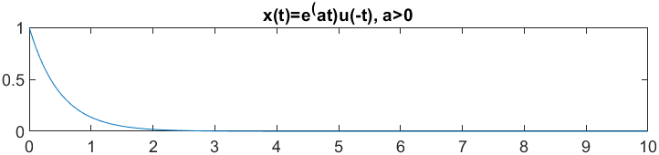

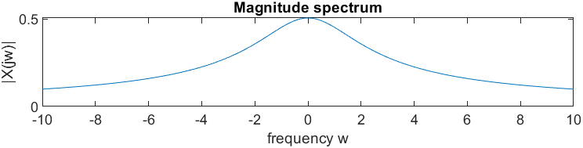

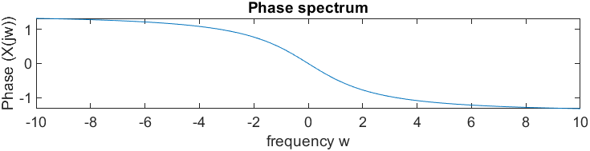

% b)

t=-10:0.01:0;

x=exp(2*t);

w=-10:0.01:10;

for j=1:length(w)

Xjw(j)=(sum(x.*exp(-i*w(j)*t)))*0.01;

end

%plot x(t)

subplot(311);

plot(t,x);

title('x(t)=e^(at)u(-t), a>0');

%plot magnitude spectrum

subplot(312);

plot(w,abs(Xjw));

title('Magnitude spectrum');

xlabel('frequency w');

ylabel('|X(jw)|');

%plot phase spectrum

subplot(313);

plot(w,angle(Xjw));

title('Phase spectrum');

xlabel('frequency w');

ylabel('Phase (X(jw))');

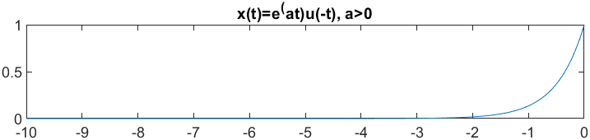



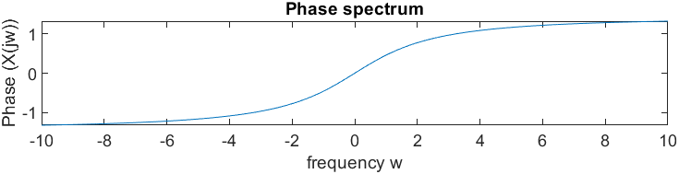

%(c)

t=0:1/100:10-1/100;

x= ((0.5).^t).*heaviside(t);

y=fft(x);

disp(y);

m=abs(y);

y(m<1e-6) =0;

p= unwrap(angle(y));

f= (0:length(y)-1)*100/length(y);

subplot(2,1,1)

plot(f,m)

title('Magnitude')

ax=gca;

ax.XTick=[15 40 60 85];

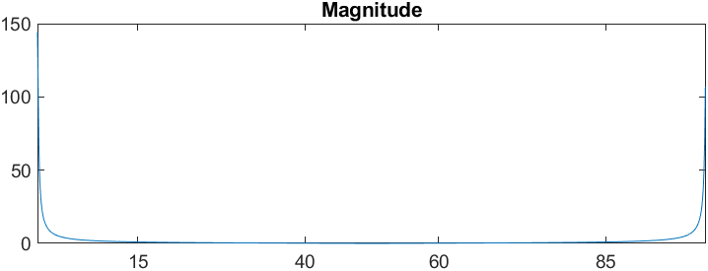

subplot(2,1,2)

plot(f,p*180/pi)

title('Phase')

ax=gca;

ax.XTick = [15 40 60 85];

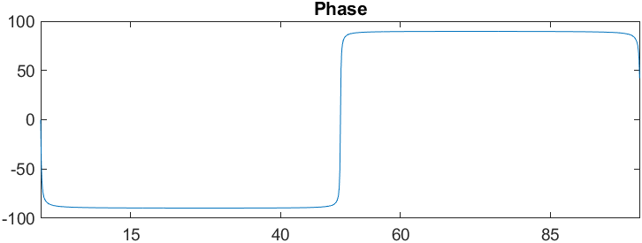

%(d)

t=-(10-1/50):1/50:0;

%taking a as 0.5

x=-((0.5).^t).*heaviside(-t-1);

y=fft(x);

disp(y);

m=abs(y);

y(m<1e-6)=0;

p=unwrap(angle(y));

f=(0:length(y)-1)*100/length(y);

subplot(2,1,1)

plot(f,m);

title('Magnitude')

ax=gca;

ax.XTick=[15 40 60 85];

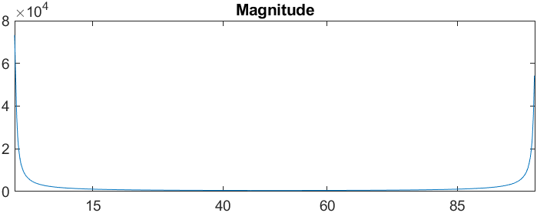

subplot(2,1,2)

plot(f,p*180/pi)

title('Phase');

ax=gca;

ax.XTick=[15 40 60 85];

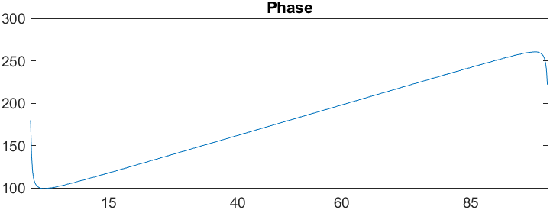

**Q3)** **Verify the time shifting and linearity property of CTFT for the signals shown in g.Q3(a) and (b).**

ANS: syms t

x=(exp(-t)*(heaviside(t)-heaviside(t-1)))+(exp(-t)*(heaviside(t-1)-heaviside(t-2)));

fplot(t,x);

subplot(3,1,1);

y=(exp(t)*(heaviside(t)-heaviside(t-1)))+(exp(-t)*(heaviside(t-1)-heaviside(t-2)));

fplot(t,y);

X=fourier(x);

Y=fourier(y);

%Assuming a=3 & b=4%

z=(3*x)+(4*y);

Z=fourier(z);

disp(X);

disp(Y);

disp(Z);

%Time Shift 3A)

%Shift factor =1

x_shift=(exp(-(t-1))*(heaviside(t-1)-heaviside(t-2)))+(exp(-(t-1))*(heaviside(t-2)-heaviside(t-3)));

X_S=fourier(x_shift);

disp(X_S)

y_shift=(exp((t-1))*(heaviside(t-1)-heaviside(t-2)))+(exp(-(t-1))*(heaviside(t-2)-heaviside(t-3)));

Y_S=fourier(y_shift);

disp(Y_S)

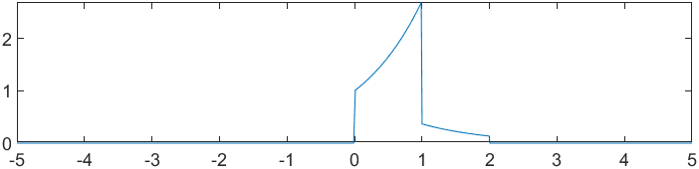

**Q4) Determine the Z-Transform of a discrete sequence using MATLAB**

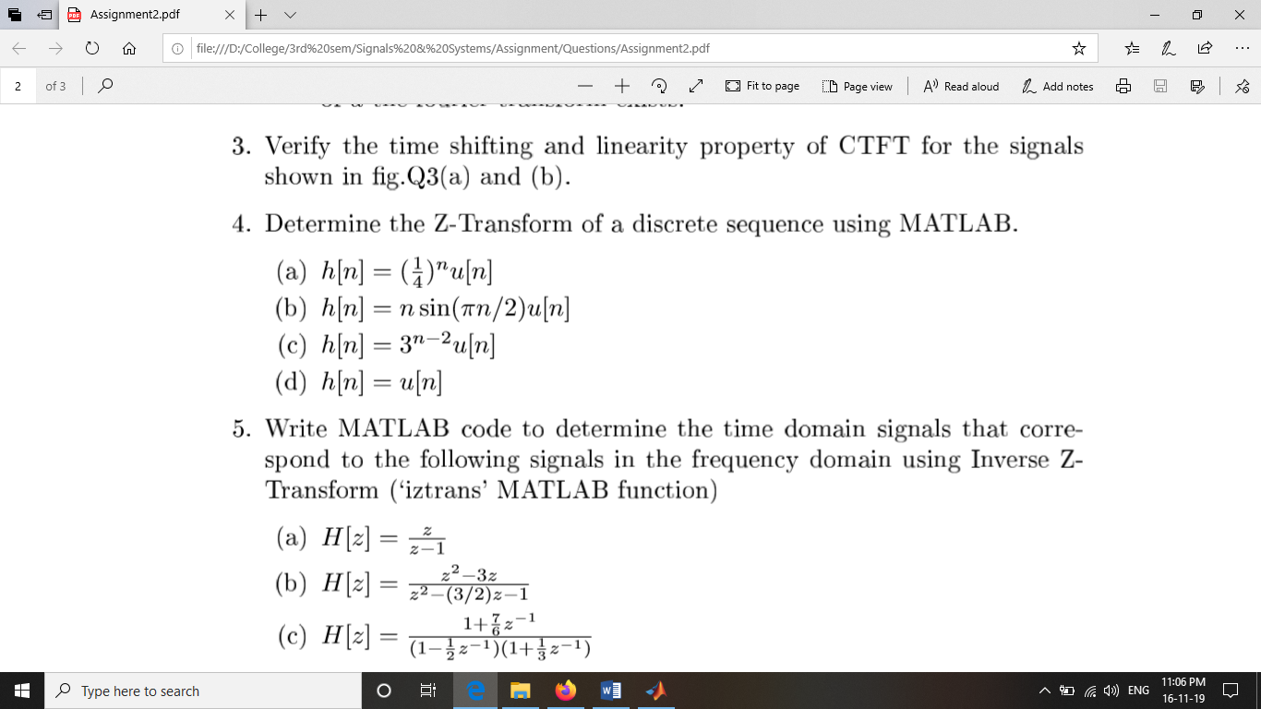

ANS:

%(a)

syms n

oldparam=sympref('HeavisideAtorigin',1);

h2=(((1/4)^n)*heaviside(n));

H2=ztrans(h2);

disp('z transform is');

disp(H2);

**z transform is**

**1/(4*z - 1) + 1**

%(b)

syms n

oldparam=sympref('HeavisideAtorigin',1);

h2=(n*sin((pi*n)/2)*heaviside(n));

H2=ztrans(h2);

H22=simplify(H2);

disp('z transform is');

disp(H22);

**z transform is**

**-(- z^3 + z)/(z^2 + 1)^2**

%(c)

syms n

oldparam=sympref('HeavisideAtorigin',1);

h3=((3^(n-2))*heaviside(n));

H3=ztrans(h3);

disp('z transform is');

disp(H3);

**z transform is**

**1/(3*(z - 3)) + 1/9**

%(d)

syms n

oldparam=sympref('HeavisideAtorigin',1);

h4=heaviside(n);

H4=ztrans(h4);

disp('z transform is');

disp(H4);

**z transform is**

**1/(z - 1) + 1**

**Q5) Write MATLAB code to determine the time domain signals that correspond to the following signals in the frequency domain using Inverse ZTransform (`iztrans' MATLAB function)**

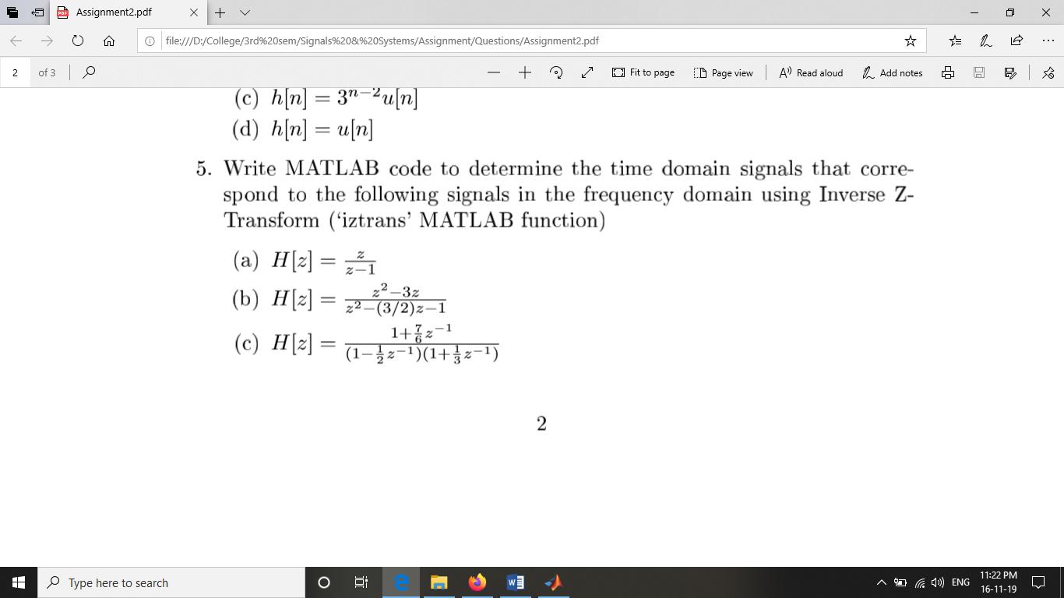

ANS:

syms z n

%a

H1=(z/(z-1));

h1=iztrans(H1);

disp('inverse z transform is:');

disp(h1);

**inverse z transform is:**

**1**

%b

syms z n

H2=((z^2-3*z)/((z^2)-(1.5*z)-1));

h1=iztrans(H2);

disp('inverse z transform is:');

disp(h1);

**inverse z transform is:**

**(7*(-1/2)^n)/5 - (2*2^n)/5**

%c

syms z n

H3=((1+(7/(6*z)))/((1-(1/(2*z)))*(1+(1/(3*z)))));

h1=iztrans(H3);

disp('inverse z transform is:');

disp(h1);

**inverse z transform is:**

**2*(1/2)^n - (-1/3)^n**