HOW TO RUN THE SCRIPT

1. Open the file KoboToPaperForm.Rmd
2. Then Run All

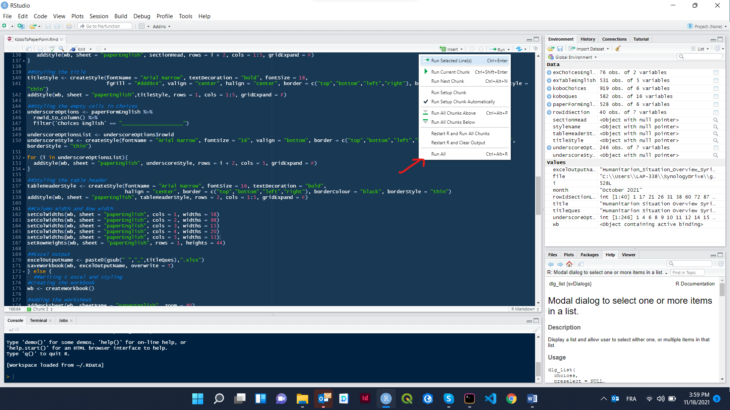

1. The script will ask you to choose the Kobo Form
2. Then it will ask you if you want to include the Relevancy column or not.

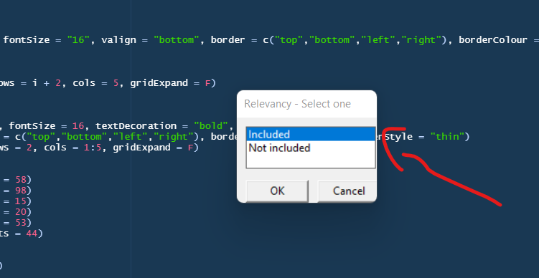

1. Then you can choose your Research Cycle Assessment

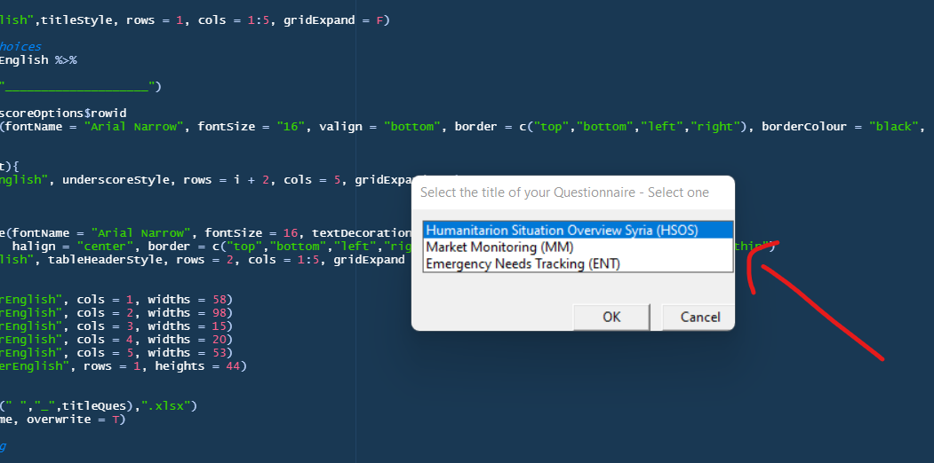

1. After that you have to write the Month and Year in the input pop up

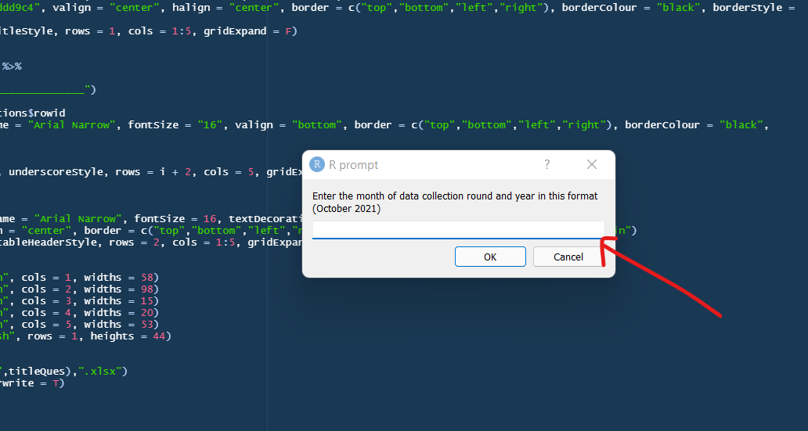

1. Once done, you will find the excel file of the questionnaire in the same directory you saved the script in.
2. The repo also include a file named scriptXlsxToPDF.py. This script automated saving the excel file you just produced to PDF in the right format. You can change the name of the input file xlsx in number 1, and the name of the output PDF file in number 2

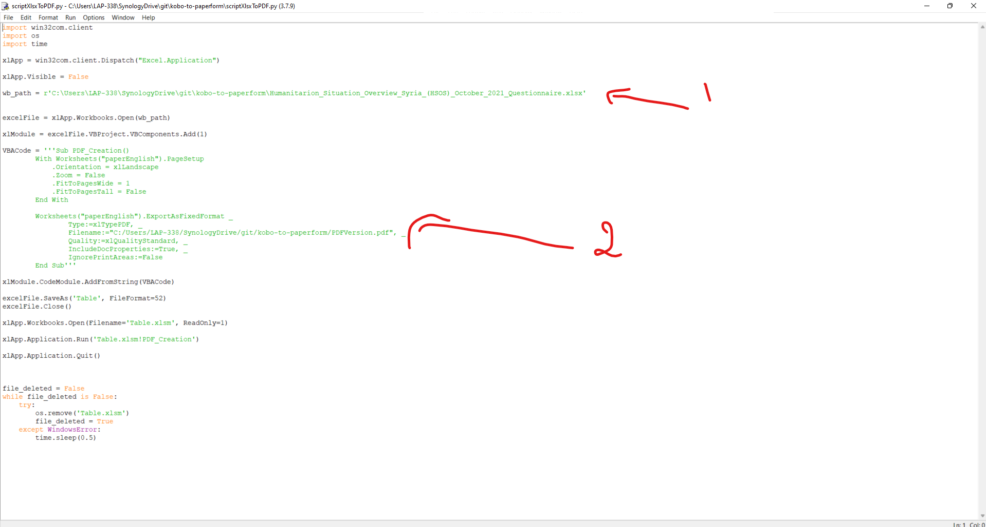

Enjoy ☺