
PROJECT REPORT
Movie Review Sentiment
Classification
Natural Language Processing | TF-IDF | Binary Classification
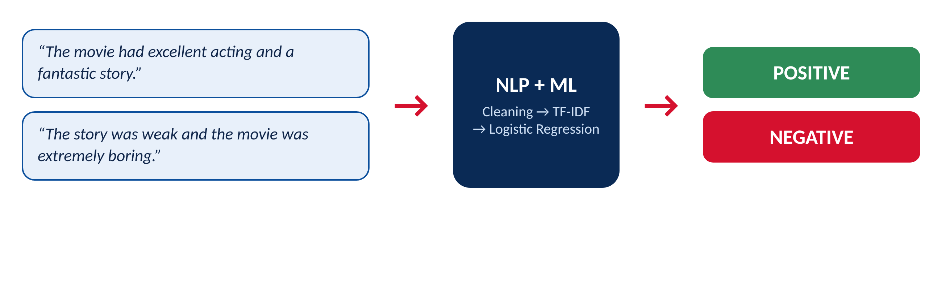
PROGRAM CODE | BCA_AI_ML_08
PROGRAM NAME | Machine Learning
MENTOR NAME | Mr. Sahil Kasaudhan
DEPARTMENT | Bachelors of Computer Application
COURSE NAME | BCA (AI)
SECTION | B
Invertis University, Bareilly [ UP ]
Session 2026-27
TEAM MEMBERS
Movie Review Sentiment Classification | BCA_AI_ML_08
S.No | Name | Student ID | CREDIT
1 | Shreya Sharma | BCAI2025172 | 100%
2 | Utkarsh Kumar | BCAI2025167 | 100%
3 | Drasti Singhal | BCAI2025189 | 100%
4 | Deepti Gangwar | BCAI2025191 | 100%
5 | Abhisar Kumar | BCAI2025171 | 100%
6 | Manish Kumar Gautam | BCAI2025166 | 100%
7 | Pawan Kushwaha | BCAI2025169 | 100%
8 | Vanshika | BCAI2025176 | 100%
9 | Aashish Pandey | BCAI2025177 | 100%
10 | Devvrat Kushwaha | BCAI2025182 | 100%
11 | Jagat Singh | BCAI2025186 | 100%
12 | Anubhav Kumar | BCAI2025179 | 100%
MENTOR
Mr. Sahil Kasaudhan
Department of Bachelors of Computer Application, Invertis University, Bareilly
INDEX
S.NO TOPIC PAGE NO.
1. Abstract i
2. Acknowledgement ii
3. Introduction 1
4. Problem Statement 2
5. Existing System and Proposed System 3
6. Objectives of the Project 4
7. Literature Review 5
8. Dataset Description 6
9. Methodology 7
10. System Architecture Diagram 8
11. Workflow 9
12. Text Preprocessing 10
13. Feature Extraction (TF-IDF) 11
14. Machine Learning Models 13
15. Explanation of Project (Working) 14
16. Program (Source Code) 15
17. Results and Discussion 17
18. Snippets of UI 21
19. Business Applications 22
20. Future Scope 23
21. Conclusion 24
22. References 25

ABSTRACT
Movie Review Sentiment Classification is a Natural Language Processing (NLP) and Machine Learning project that automatically identifies whether a movie review expresses a positive or a negative opinion. Online platforms receive thousands of reviews every day, and reading them manually is slow and inconsistent. This project provides an automated solution.
The project uses the IMDB Movie Review Dataset, a standard benchmark for sentiment analysis. From the original 50,000 labelled reviews, a balanced subset of 10,000 reviews (5,000 positive and 5,000 negative) was used. The reviews were cleaned (lowercase conversion, HTML-tag removal, special-character and extra-space removal, tokenization and stopword removal), split 80:20 into 8,000 training and 2,000 test reviews, and converted into numerical vectors with TF-IDF (5,000 features, single words and word pairs).
Three classifiers were trained and compared: Logistic Regression, Multinomial Naive Bayes and Linear Support Vector Machine. Logistic Regression performed best, reaching an accuracy of 86.25% and an F1-score of 0.8628 on the unseen test set, with 1,725 of 2,000 reviews classified correctly. Performance was evaluated with accuracy, precision, recall, F1-score and a confusion matrix, and the model was tested on custom reviews (6 of 7 correct).
The errors of the model were analysed: most mistakes come from mixed opinions, double negatives such as “not bad at all”, sarcasm and reviews that describe a film without stating an opinion. Finally, a live demonstration was built with Gradio, in which a user types a review and receives the predicted sentiment with its probability. The project shows how classical machine learning with TF-IDF gives a fast, simple and reliable base for review analytics, customer-feedback analysis and social-media monitoring.

ACKNOWLEDGEMENT
We would like to express our sincere gratitude to Mr. Sahil Kasaudhan, our project mentor, for his valuable guidance, continuous encouragement and constant support throughout the development of the “Movie Review Sentiment Classification” project. His suggestions and technical knowledge helped us complete this project successfully.
We are also thankful to the Department of Bachelors of Computer Application, Invertis University, Bareilly, for providing the opportunity, resources and learning environment needed to carry out this work.
We extend our heartfelt thanks to all our team members for their cooperation, dedication and teamwork. Their contributions, discussions and support played an important role in completing this project.
Finally, we express our gratitude to our parents, friends and everyone who encouraged and motivated us throughout this project.

Team ML-008
Movie Review Sentiment Classification
BCA (AI), Section B, Invertis University, Bareilly

1. INTRODUCTION
The rapid growth of the internet and online entertainment platforms has led to an enormous increase in user-generated movie reviews. Websites such as IMDb and Rotten Tomatoes, and streaming platforms, receive thousands of reviews every day. These reviews contain valuable information about audience opinion: they help viewers decide what to watch and help production companies understand audience satisfaction. However, reading and analysing so many reviews by hand is time-consuming and inefficient.
Sentiment analysis is the part of Natural Language Processing (NLP) that identifies the opinion expressed in a piece of text. In this project the task is binary: a movie review must be classified as Positive or Negative. A machine learning model learns from thousands of labelled reviews which words and phrases signal each opinion, and then predicts the sentiment of reviews it has never seen.
Figure 1.1: Idea of the project: a review goes in, a sentiment comes out
The project follows a complete machine learning pipeline. The review text is cleaned, converted into numerical features with TF-IDF (Term Frequency–Inverse Document Frequency), and used to train three classifiers: Logistic Regression, Naive Bayes and Linear SVM. The models are compared with standard metrics, the best one is tested on custom reviews, its mistakes are analysed, and a small web demo is built so that anyone can try the model.
Scope of this report
- Understanding the problem and the dataset used.
- Text preprocessing and TF-IDF feature extraction, with real examples.
- Training, evaluating and comparing the three models using the results produced in our own experiments.
- Custom testing, error analysis, business applications and future scope.
2. PROBLEM STATEMENT
Entertainment platforms can receive thousands or even millions of user reviews. Reading every review manually makes it difficult to quickly understand the overall audience sentiment. Manual analysis is slow, expensive, and inconsistent, because different readers may judge the same review differently.
The objective of this project is to develop a sentiment-classification model that can automatically identify whether a movie review expresses a positive or negative opinion. The system should:
- accept raw review text, including noise such as HTML tags and punctuation;
- clean the text and convert it to numerical features;
- predict Positive or Negative with good accuracy on reviews it has not seen;
- report its performance honestly with standard metrics, and show where it fails.

In short: given the text of a movie review, predict whether the reviewer liked the movie (Positive) or disliked it (Negative).
3. EXISTING SYSTEM AND PROPOSED SYSTEM
Existing system
In the traditional approach, movie reviews are read by users, critics or analysts who decide whether the audience response is positive or negative. As the number of reviews grows, manual analysis becomes slow and difficult to manage, and results vary from person to person.
Parameter | Existing system
Review analysis | Performed manually by humans
Processing speed | Slow and time-consuming
Accuracy and consistency | Depends on individual judgment
Large data handling | Difficult for thousands of reviews
Cost | High time and human effort
Scalability | Poor for large datasets
Proposed system
The proposed system uses NLP and machine learning to classify reviews automatically. Reviews are cleaned, converted to TF-IDF vectors and passed to a trained classifier. In our experiments the best model, Logistic Regression, classified 86.25% of unseen reviews correctly, and can score thousands of reviews within seconds.
Parameter | Existing system | Proposed system
Review analysis | Manual | Automatic (NLP + ML)
Speed | Slow | Fast: seconds
Consistency | Varies by person | Same rules every time
Large data | Difficult | Easily handled
Cost | High effort | Low once trained
Scalability | Poor | Suitable for large datasets
Advantages of the proposed system
- Classifies reviews into Positive or Negative automatically.
- Saves time and reduces manual effort.
- Gives consistent results and handles large volumes.
- Can be extended to product reviews, customer feedback and social-media posts.
4. OBJECTIVES OF THE PROJECT
The main objective is to develop a machine learning model that classifies movie reviews as Positive or Negative using NLP techniques. The specific objectives are:
- To collect and load a labelled movie-review dataset (IMDB) with positive and negative reviews.
- To clean and preprocess the review text: lowercase conversion, HTML-tag removal, special-character and extra-space removal, tokenization and stopword removal.
- To convert the text into numerical features using TF-IDF vectorization.
- To train binary classification models: Logistic Regression, Naive Bayes and Linear SVM.
- To evaluate the models using accuracy, precision, recall, F1-score and the confusion matrix.
- To test the trained model with custom movie reviews written by the team.
- To analyse incorrect predictions and understand why the model fails.
- To demonstrate the model through a live web demo and discuss real-world uses.
5. LITERATURE REVIEW
Sentiment analysis is one of the most widely studied applications of NLP. It is used to identify opinions in text such as movie reviews, product reviews, customer feedback and social-media posts. Early work by Pang, Lee and Vaithyanathan (2002) showed that standard machine learning classifiers such as Naive Bayes and Support Vector Machines can classify movie reviews by sentiment far better than simple rule-based methods.
A widely used benchmark is the Large Movie Review Dataset of Maas et al. (2011), containing 50,000 labelled IMDB reviews split equally between positive and negative classes, with 25,000 for training and 25,000 for testing. Its balanced classes and clean labels have made it a standard dataset for comparing sentiment-classification methods.
To feed text to a classifier, it must be turned into numbers. TF-IDF weighting, introduced in the information-retrieval literature (Salton and Buckley, 1988), gives high weight to words that are frequent in one document but rare in the collection. Combined with linear classifiers such as Logistic Regression and Linear SVM, TF-IDF remains a strong, fast and interpretable baseline, and it is implemented in the scikit-learn library (Pedregosa et al., 2011).
More recent transformer-based models such as BERT (Devlin et al., 2019) can capture word order and context and usually reach higher accuracy, but they need far more computing power and data. For a student project, TF-IDF with classical classifiers is easier to build, explain and run, and still gives reliable results.
Key findings from previous studies
- Machine learning classifies reviews more consistently than manual analysis.
- The IMDB dataset is a standard benchmark for sentiment analysis.
- TF-IDF is an effective feature representation for text classification.
- Logistic Regression, Naive Bayes and SVM perform well on binary sentiment classification.
- Good preprocessing improves accuracy, while sarcasm, negation and mixed opinions remain difficult for bag-of-words models.
The full list of references is given at the end of this report.
6. DATASET DESCRIPTION
The project uses the IMDB Movie Review Dataset. The original dataset has 50,000 labelled reviews (25,000 for training and 25,000 for testing). For this project a balanced subset of 10,000 reviews was used to keep training fast: 5,000 positive and 5,000 negative reviews. Each record has a review text and a sentiment label.
Feature | Description
Dataset name | IMDB Movie Review Dataset
Domain | Entertainment / Natural Language Processing
Type | Labelled text dataset
Original size | 50,000 reviews (25,000 train + 25,000 test)
Project dataset | 10,000 reviews (balanced subset)
Attributes | review (text), sentiment (positive / negative)
Classes | Positive: 5,000 | Negative: 5,000
Average review length | about 230 words (median 173; shortest 8; longest 2,108)
Sample records
Review | Sentiment
The movie had excellent acting and a fantastic story. | Positive
The movie was boring and the story was disappointing. | Negative
Class balance and review length
Figure 6.1 (left) confirms that both classes contain exactly 5,000 reviews, so the model is not biased by an uneven class distribution and accuracy is a fair measure. Figure 6.1 (right) shows that most reviews are between about 100 and 300 words long, with a long tail of very long reviews. Positive and negative reviews have similar length distributions, so length alone does not reveal the sentiment.
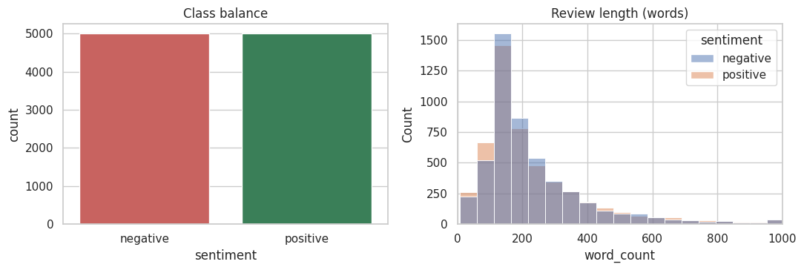
Figure 6.1: Class balance (left) and review length in words (right)
Advantages of the dataset
- Large, well-labelled and widely used benchmark.
- Perfectly balanced classes.
- Suitable for machine learning and NLP applications.
7. METHODOLOGY
The project follows a systematic eight-stage process, from raw reviews to analysis of results.
- Data collection. The IMDB dataset (50,000 reviews) is used. A balanced subset of 10,000 reviews (5,000 positive and 5,000 negative) is taken.
- Text preprocessing. Each review is cleaned: lowercase conversion, HTML-tag removal, special-character and number removal, extra-space removal, tokenization and stopword removal. Negation words (not, no, nor, never) are kept on purpose. No stemming or lemmatization was applied.
- Train-test split. The cleaned reviews are divided into 80% training (8,000) and 20% testing (2,000) using train_test_split with random_state = 42 and stratification, so both sets keep a 50:50 class ratio.
- Feature extraction. TF-IDF converts text into 5,000 numerical features (single words and word pairs). The vectorizer is fitted on the training set only, to avoid data leakage.
- Model training. Logistic Regression, Multinomial Naive Bayes and Linear SVM are trained on the training set.
- Model evaluation. Each model predicts the unseen test set. Accuracy, precision, recall, F1-score and the confusion matrix are calculated, and the best model is selected by F1-score.
- Sentiment prediction. The best model predicts the sentiment of new reviews typed by the user, through a notebook cell and a Gradio web demo.
- Result analysis. Predictions are compared with the true labels, wrong predictions are studied, and improvements are proposed.

Methodology flow: IMDB Dataset → Text Preprocessing → Train-Test Split → TF-IDF → Model Training → Model Evaluation → Sentiment Prediction → Result Analysis
8. SYSTEM ARCHITECTURE DIAGRAM
The system is organised in layers. Each layer receives the output of the layer above it, which keeps the design simple and makes every stage easy to test and improve independently.
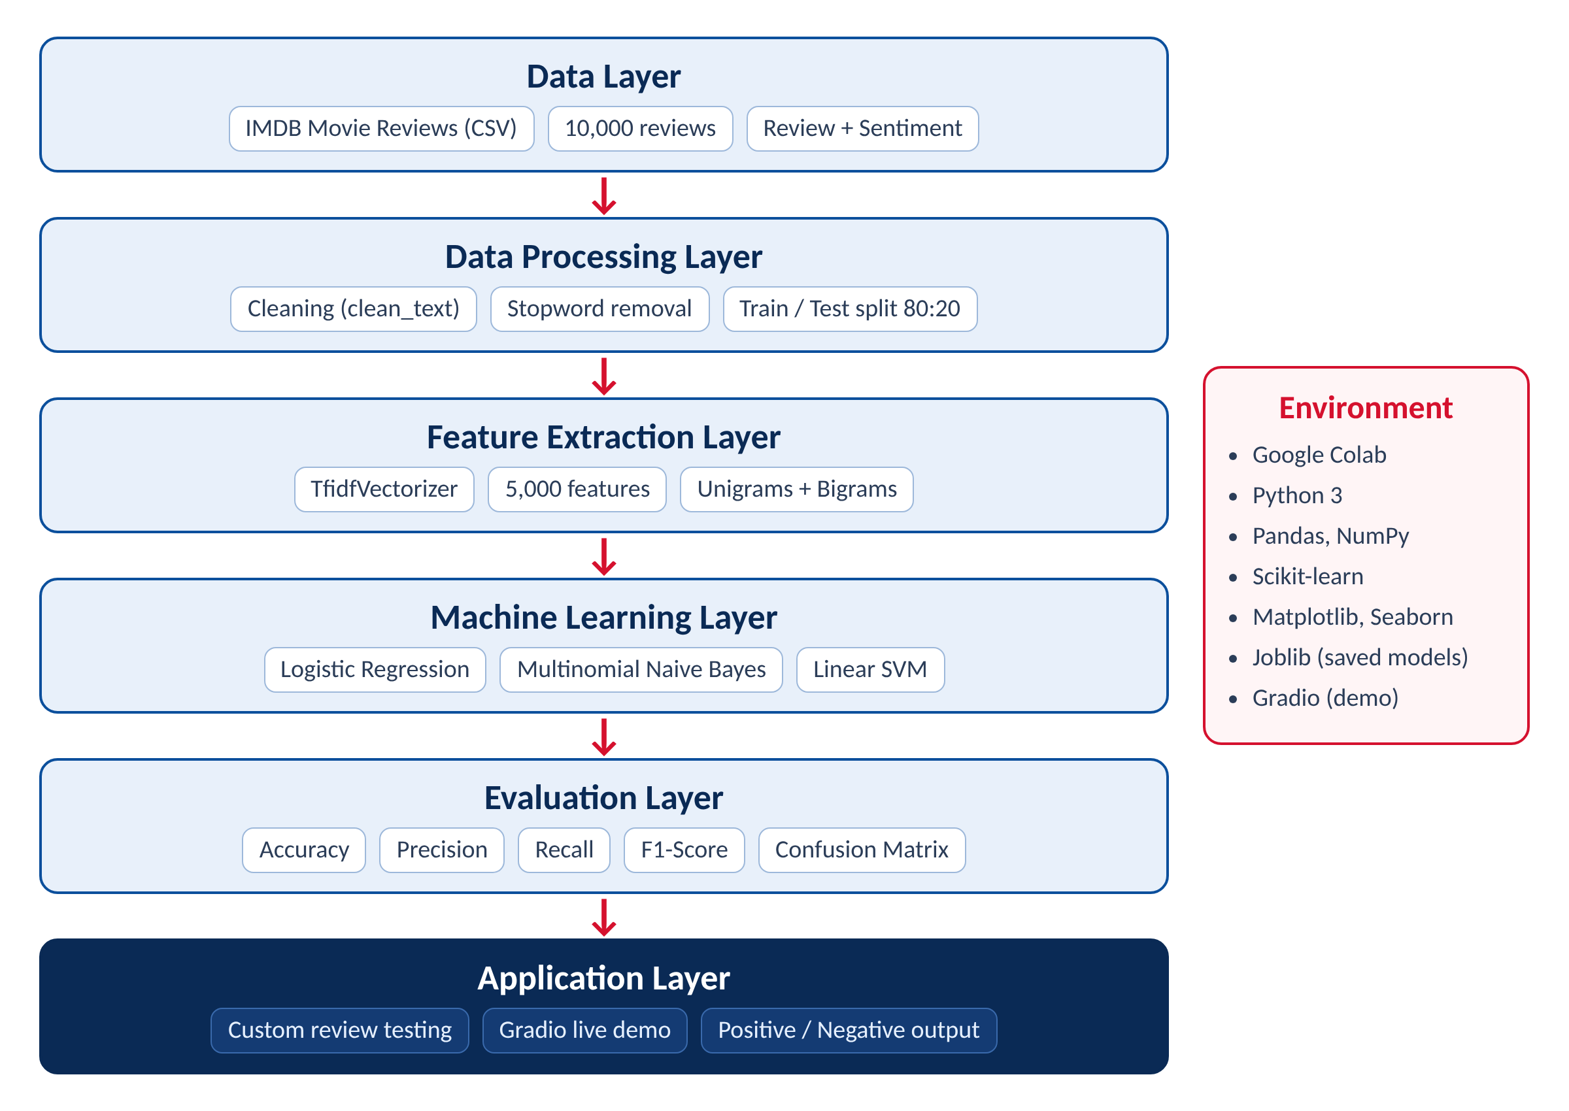
Figure 8.1: Layered system architecture of the sentiment classification system
9. WORKFLOW
Figure 9.1 shows the complete workflow of the project from the dataset to the final analysis. Steps 1 to 4 prepare the data and features, steps 5 and 6 build and test the models, and steps 7 and 8 use the best model and study its behaviour.
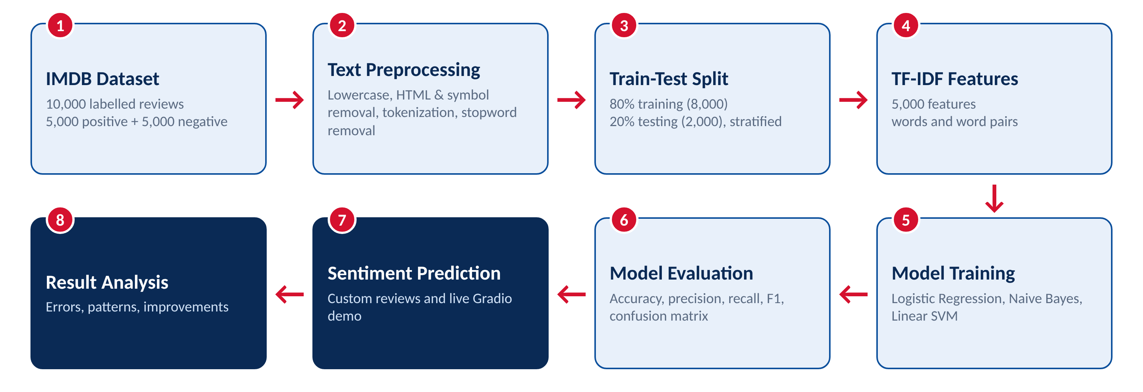
Figure 9.1: Workflow of the Movie Review Sentiment Classification project
Summary of the stages
Step | Stage | Output
1 | IMDB dataset | 10,000 labelled reviews (5,000 + 5,000)
2 | Text preprocessing | clean_review column (lowercase text without tags, symbols and stopwords)
3 | Train-test split | 8,000 training and 2,000 test reviews
4 | TF-IDF | Matrices of shape (8000, 5000) and (2000, 5000)
5 | Model training | Three trained classifiers
6 | Model evaluation | Accuracy, precision, recall, F1, confusion matrix
7 | Sentiment prediction | Positive / Negative with probability
8 | Result analysis | Error patterns and improvement ideas
10. TEXT PREPROCESSING
Raw movie reviews contain HTML tags, punctuation, digits, extra spaces and very common words that carry no sentiment. These elements add noise and reduce model performance, so the text is cleaned before feature extraction. Figure 10.1 shows each step applied to one sample review.
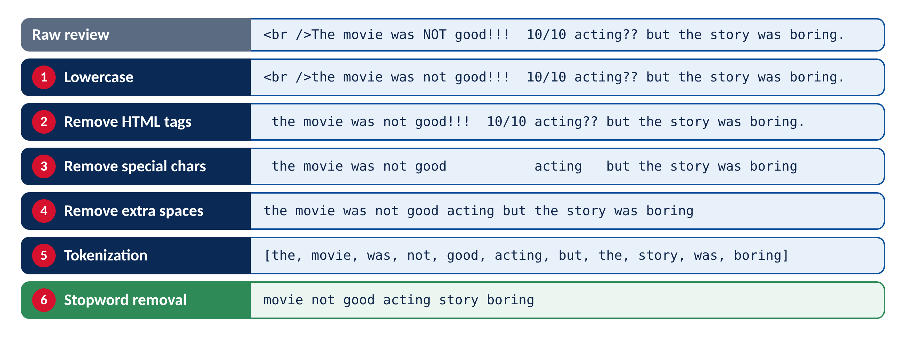
Figure 10.1: Preprocessing steps applied to a sample review (actual output of the project code)
Steps involved
- Lowercase conversion. All text is converted to lowercase so that “Movie”, “movie” and “MOVIE” are the same word.
- HTML tag removal. Tags such as <br /> that appear in IMDB reviews are removed with a regular expression.
- Special-character removal. Punctuation, symbols and digits are replaced by spaces, keeping only letters.
- Extra-space removal. Multiple spaces are reduced to one and the ends are trimmed.
- Tokenization. The sentence is split into individual words (tokens).
- Stopword removal. Common words such as “the”, “was”, “and” and “but” are removed using scikit-learn’s English stopword list. Words of one letter are also dropped.
Important design choices
- Negation words are kept. The words not, no, nor, never and cannot are removed from the stopword list, because “not good” and “good” have opposite meanings. The word “no” even appears among the strongest negative words learned by the model (Chapter 15).
- No stemming or lemmatization was applied, to keep the pipeline simple. It is listed as a possible improvement in Chapter 18.
- Digits are removed, so a rating such as “10/10” disappears. This is a limitation, because such ratings are strong sentiment signals.
Benefits of preprocessing
- Removes noise and reduces the number of useless features.
- Makes TF-IDF features more meaningful and reduces memory and time.
11. FEATURE EXTRACTION (TF-IDF)
Machine learning models cannot read text, so each cleaned review is converted into a vector of numbers. This project uses TF-IDF (Term Frequency–Inverse Document Frequency). A word gets a high score when it appears often in one review but in few reviews overall, so distinctive words such as “boring” or “brilliant” count more than common words such as “movie”.
The idea
- Term frequency: TF(t, d) = number of times term t appears in review d (divided by the number of words in d)
- Inverse document frequency: IDF(t) = log(N / n_t), where N is the number of reviews and n_t the number containing t. Rare words get a larger IDF. Scikit-learn uses the smoothed form ln((1 + N) / (1 + n_t)) + 1.
- Score: TF-IDF = TF × IDF, and each review vector is then scaled to unit length (L2 normalisation).
Worked example from the trained vectorizer
The review “The movie had excellent acting and a fantastic story.” becomes “movie excellent acting fantastic story” after cleaning. The values below were produced by the TF-IDF vectorizer fitted on the training reviews:
Term | IDF | TF-IDF score | Meaning
fantastic | 4.669 | 0.670 | rare, strong opinion word
excellent | 3.659 | 0.525 | fairly rare, strong
acting | 2.517 | 0.361 | common topic word
story | 2.205 | 0.316 | very common
movie | 1.496 | 0.215 | most common, lowest weight

As expected, the rare and opinionated words “fantastic” and “excellent” receive the highest weights, while the very common word “movie” receives the lowest.
TF-IDF settings used
Parameter | Value and meaning
max_features = 5000 | Keep only the 5,000 most useful words and word pairs
ngram_range = (1, 2) | Use single words and pairs of words, so “not good” is a feature of its own
min_df = 2 | Ignore terms appearing in fewer than 2 reviews (mostly typing mistakes)
Fitted on | Training reviews only (8,000), then applied to the test reviews
Output shapes | Training (8000, 5000); test (2000, 5000)

Of the 5,000 features, 725 are word pairs (bigrams) such as “absolutely no” and “academy award”, and the rest are single words. Fitting on the training data only is important: learning the vocabulary from the test reviews would leak information from the test set into training (data leakage) and make the results look better than they really are.
12. MACHINE LEARNING MODELS
Three supervised classification algorithms were trained on the same TF-IDF features and compared on the same unseen test set.
1. Logistic Regression
A linear model that learns one weight for each of the 5,000 features. For a review, it adds up weight × TF-IDF score for all its words and converts the sum into a probability of being Positive. Words like “excellent” receive large positive weights and words like “boring” large negative ones, which makes the model easy to interpret. Settings: max_iter = 1000, random_state = 42.
- Accurate and fast on text data; easy to interpret; gives probabilities (used by the Gradio demo).
2. Multinomial Naive Bayes
A probabilistic model based on Bayes’ theorem. It records how strongly each word is associated with each class and combines these probabilities, assuming words are independent of each other. This assumption is unrealistic (hence “naive”) but works well for text. It uses default settings.
- Very fast to train; a strong baseline.
3. Linear Support Vector Machine (LinearSVC)
Finds the boundary between positive and negative reviews that leaves the widest possible margin between the two classes. It works well with high-dimensional sparse data such as TF-IDF vectors. It outputs only the class label and no probabilities. Setting: random_state = 42.
- Effective on high-dimensional text; good accuracy.
Training and prediction
Each model is trained with fit() on the 8,000 training vectors and their labels, and then predict() labels the 2,000 test reviews. The predictions are compared with the true labels to calculate the evaluation metrics (Chapter 15).
Model | Idea | Strength
Logistic Regression | Weighted sum of word scores → probability | Accurate, interpretable
Naive Bayes | Word-class probabilities combined | Fast baseline
Linear SVM | Widest-margin boundary | Strong on sparse text
13. EXPLANATION OF PROJECT (WORKING)
The working of the project can be explained step by step as follows.
- Loading data. The system loads the CSV file of IMDB reviews and keeps the review text and the sentiment label. Duplicates and empty rows are removed, and a balanced sample of 5,000 positive and 5,000 negative reviews is selected and shuffled.
- Cleaning. Each review passes through the clean_text() function, which lowercases the text, removes HTML tags, symbols, digits and extra spaces, splits it into words and drops stopwords. The result is stored in the clean_review column.
- Splitting. The cleaned reviews are split into 8,000 training and 2,000 test reviews, keeping 50% positive and 50% negative in each.
- Feature extraction. The TF-IDF vectorizer learns its 5,000-term vocabulary from the training reviews and converts both sets into numeric matrices.
- Training. Logistic Regression, Naive Bayes and Linear SVM learn from the training matrix. Each then predicts the labels of the test matrix.
- Evaluation. The system calculates accuracy, precision, recall and F1-score, draws the model-comparison chart and the confusion matrix, and selects Logistic Regression as the best model.
- Analysis. The strongest positive and negative words are read from the Logistic Regression weights, custom reviews are tested, and the wrong predictions are studied.
- Prediction and demo. The trained vectorizer and model are saved with joblib. A Gradio page lets a user type any review and see the predicted sentiment and probability.
14. PROGRAM (SOURCE CODE)
The complete project was written in Python in a Google Colab notebook. The main parts of the code are shown below.
1. Imports and settings
import re, joblib
import numpy as np, pandas as pd
import matplotlib.pyplot as plt, seaborn as sns
from sklearn.model_selection import train_test_split
from sklearn.feature_extraction.text import TfidfVectorizer, ENGLISH_STOP_WORDS
from sklearn.linear_model import LogisticRegression
from sklearn.naive_bayes import MultinomialNB
from sklearn.svm import LinearSVC
from sklearn.metrics import (accuracy_score, precision_score, recall_score,
f1_score, confusion_matrix, classification_report)
RANDOM_STATE = 42
2. Load and balance the dataset
df = pd.read_csv(DATA_PATH)
df = df[["review", "sentiment"]].dropna().drop_duplicates().reset_index(drop=True)
n = min(SAMPLE_PER_CLASS, df["sentiment"].value_counts().min()) # 5000
df = pd.concat([df[df["sentiment"] == "positive"].sample(n, random_state=RANDOM_STATE),
df[df["sentiment"] == "negative"].sample(n, random_state=RANDOM_STATE)])
df = df.sample(frac=1, random_state=RANDOM_STATE).reset_index(drop=True)
df["label"] = (df["sentiment"] == "positive").astype(int) # 1 = positive, 0 = negative
3. Text preprocessing
KEEP = {"not", "no", "nor", "never", "cannot", "n't"}
STOPWORDS = set(ENGLISH_STOP_WORDS) - KEEP

def clean_text(text):
text = text.lower() # lowercase
text = re.sub(r"<[^>]+>", " ", text) # remove HTML tags
text = re.sub(r"[^a-z\s]", " ", text) # remove special characters and digits
text = re.sub(r"\s+", " ", text).strip() # remove extra spaces
tokens = text.split() # tokenization
tokens = [t for t in tokens if t not in STOPWORDS and len(t) > 1] # stopwords
return " ".join(tokens)

df["clean_review"] = df["review"].apply(clean_text)
4. Train-test split and TF-IDF
X_train_text, X_test_text, y_train, y_test = train_test_split(
df["clean_review"], df["label"],
test_size=0.2, random_state=RANDOM_STATE, stratify=df["label"])

tfidf = TfidfVectorizer(max_features=5000, ngram_range=(1, 2), min_df=2)
X_train = tfidf.fit_transform(X_train_text) # fit on training data only
X_test = tfidf.transform(X_test_text)
5. Train and compare the models
models = {
"Logistic Regression": LogisticRegression(max_iter=1000, random_state=RANDOM_STATE),
"Naive Bayes": MultinomialNB(),
"Linear SVM": LinearSVC(random_state=RANDOM_STATE),
}
results, preds = [], {}
for name, model in models.items():
model.fit(X_train, y_train)
p = model.predict(X_test)
preds[name] = p
results.append({"Model": name,
"Accuracy": accuracy_score(y_test, p), "Precision": precision_score(y_test, p),
"Recall": recall_score(y_test, p), "F1-Score": f1_score(y_test, p)})
results_df = pd.DataFrame(results).set_index("Model").round(4)
best_name = results_df["F1-Score"].idxmax()
best_model = models[best_name]
6. Evaluation of the best model
y_pred = preds[best_name]
print(classification_report(y_test, y_pred, target_names=["Negative", "Positive"]))
cm = confusion_matrix(y_test, y_pred)
sns.heatmap(cm, annot=True, fmt="d", cmap="Blues",
xticklabels=["Negative", "Positive"], yticklabels=["Negative", "Positive"])
7. Most influential words (Logistic Regression weights)
lr = models["Logistic Regression"]
feat = np.array(tfidf.get_feature_names_out())
order = np.argsort(lr.coef_[0])
top_neg, top_pos = feat[order[:15]], feat[order[-15:]][::-1]
8. Predict the sentiment of a custom review
def predict_sentiment(review, model=best_model):
vec = tfidf.transform([clean_text(review)])
return "Positive" if model.predict(vec)[0] == 1 else "Negative"

print(predict_sentiment("The movie had excellent acting and a fantastic story.")) # Positive
9. Save the models
joblib.dump(tfidf, "outputs/tfidf.pkl")
joblib.dump(best_model, "outputs/best_model.pkl")
results_df.to_csv("outputs/model_results.csv")
10. Gradio live demo
import gradio as gr
demo_model = models["Logistic Regression"]

def predict(review):
if not review or not review.strip():
return {}
p = demo_model.predict_proba(tfidf.transform([clean_text(review)]))[0]
return {"Negative": float(p[0]), "Positive": float(p[1])}

demo = gr.Interface(fn=predict,
inputs=gr.Textbox(lines=4, label="Type a movie review"),
outputs=gr.Label(num_top_classes=2, label="Sentiment"),
title="Movie Review Sentiment Classifier")
demo.launch(share=True)
15. RESULTS AND DISCUSSION
15.1 Experimental setup
Item | Value
Dataset used | 10,000 reviews (5,000 positive + 5,000 negative)
Training set | 8,000 reviews (4,000 positive, 4,000 negative)
Test set | 2,000 reviews (1,000 positive, 1,000 negative)
Features | TF-IDF, 5,000 features, unigrams and bigrams
Random state | 42
Platform | Google Colab, Python, scikit-learn
15.2 Model comparison
All three models were evaluated on the same 2,000 unseen test reviews. Table 15.1 and Figure 15.1 compare them.
Model | Accuracy | Precision | Recall | F1-Score
Logistic Regression | 0.8625 | 0.8607 | 0.8650 | 0.8628
Naive Bayes | 0.8325 | 0.8328 | 0.8320 | 0.8324
Linear SVM | 0.8545 | 0.8563 | 0.8520 | 0.8541
Table 15.1: Performance of the three models on the test set
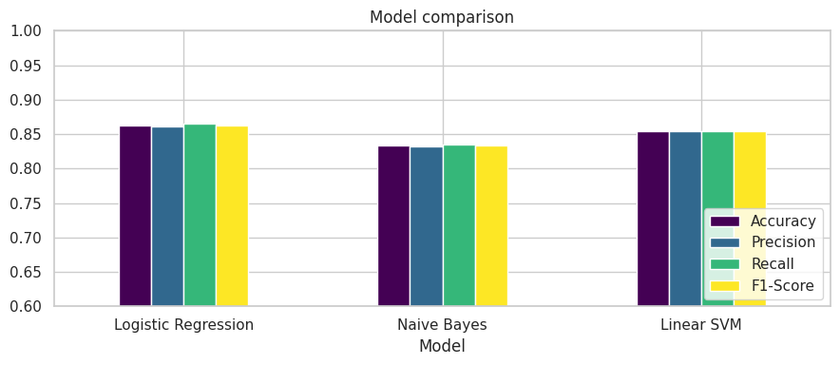
Figure 15.1: Model comparison (accuracy, precision, recall and F1-score)
Logistic Regression achieved the best score on every metric (accuracy 86.25%, F1 0.8628), followed by Linear SVM (85.45%) and Naive Bayes (83.25%). The gap between Logistic Regression and Linear SVM is less than one percentage point, so these two are close in quality, while Naive Bayes is clearly behind. Logistic Regression was selected as the final model because it scored highest, is easy to interpret, and also supplies probabilities for the live demo.
15.3 Confusion matrix of the best model
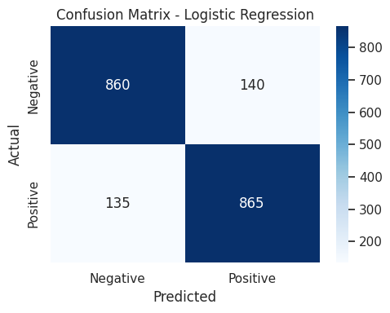
Figure 15.2: Confusion matrix of Logistic Regression on the 2,000 test reviews
 | Predicted Negative | Predicted Positive
Actual Negative | TN = 860 | FP = 140
Actual Positive | FN = 135 | TP = 865

Of 2,000 test reviews, 1,725 were classified correctly (860 negative and 865 positive). A false positive (FP) is a negative review wrongly called positive; a false negative (FN) is a positive review wrongly called negative. The two error types are almost equal (140 and 135), so the model is not biased towards either class.
15.4 Detailed metrics of Logistic Regression
Class | Precision | Recall | F1-Score | Support
Negative | 0.8643 | 0.8600 | 0.8622 | 1,000
Positive | 0.8607 | 0.8650 | 0.8628 | 1,000
Overall accuracy |  |  | 0.8625 | 2,000

- Accuracy = (860 + 865) / 2000 = 0.8625
- Precision (positive) = 865 / (865 + 140) = 0.8607: of reviews predicted positive, 86.07% truly are.
- Recall (positive) = 865 / (865 + 135) = 0.8650: of truly positive reviews, 86.50% were found.
- F1-score = 2 × P × R / (P + R) = 0.8628: the balance of precision and recall.
15.5 Words that drive the prediction
Because Logistic Regression assigns a weight to every feature, the largest positive and negative weights show which words push a review towards each class (Figure 15.3).
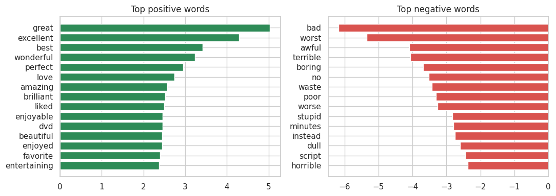
Figure 15.3: Top 15 positive words (left) and top 15 negative words (right)
- Strongest positive words: great, excellent, best, wonderful, perfect, love, amazing, brilliant, liked, enjoyable, beautiful, enjoyed, favorite, entertaining (and “dvd”).
- Strongest negative words: bad, worst, awful, terrible, boring, no, waste, poor, worse, stupid, minutes, instead, dull, script, horrible.
The words make sense: strong opinion words dominate on both sides. The word “no” is a strong negative signal, which supports keeping negation words during preprocessing. A few words are less obvious, such as “dvd” (reviewers praising a DVD edition), and “minutes”, “instead” and “script” (as in “waste of minutes”, “instead of” and “weak script”), which shows that the model learns how reviewers actually write.
15.6 Custom testing
The trained model was tested on seven new reviews written by the team that were not part of the dataset.
Review | Expected | Predicted | Result
The movie had excellent acting and a fantastic story. | Positive | Positive | Correct
The story was weak and the movie was extremely boring. | Negative | Negative | Correct
A brilliant film with a touching ending, I loved every minute. | Positive | Positive | Correct
Terrible script, wooden acting and a complete waste of time. | Negative | Negative | Correct
It was not good at all. | Negative | Negative | Correct
Not bad at all, I actually enjoyed it. | Positive | Negative | Wrong
Oh great, another two hours of my life wasted. | Negative | Negative | Correct

Six of seven reviews were classified correctly. The wrong one, “Not bad at all, I actually enjoyed it”, is a double negative that expresses a positive opinion; the model reacts to the strong negative word “bad” and does not understand the phrase. The sarcastic review was classified correctly, probably because of the word “wasted” and not because the model understands sarcasm.
15.7 Analysis of incorrect predictions
The model misclassified 275 of 2,000 test reviews (13.75%): 140 negative reviews predicted positive (14.0% of all negative reviews) and 135 positive reviews predicted negative (13.5% of all positive reviews). Reading a sample of the wrong predictions shows these patterns:
- Mixed or delayed opinion: The review starts with praise (“has a great premise…”) and turns negative later, so the positive words outweigh the negative ones.
- Description instead of opinion: Reviews that spend most of their length on plot, cast or production history use few opinion words, so the model has little to go on.
- Quoted criticism: A positive review that quotes what others criticised, or discusses what failed in other versions, contains negative words that push the prediction down.
- Double negatives and sarcasm: Phrases such as “not bad at all” express a positive opinion with negative words.
- Indirect or short praise: Short reviews with little emotional vocabulary, such as a recommendation to a niche audience.
These patterns show the main limitation of a bag-of-words model: it counts words but does not understand context, word order, irony or contrast.
15.8 Discussion
- Logistic Regression with TF-IDF reached about 86% accuracy and F1 on balanced, unseen reviews, a solid result for a simple and fast model.
- The two linear models (Logistic Regression and Linear SVM) were within one percentage point of each other, and Naive Bayes was about three points lower.
- Errors are balanced between the two classes, and they come mainly from language that needs context to understand.
- Results come from a 10,000-review subset. Using all 50,000 reviews, lemmatization or a transformer model such as BERT is expected to improve accuracy (Chapter 18).
16. SNIPPETS OF UI
To demonstrate the model, a live web interface was built with Gradio. The user types a movie review into the text box and presses Submit. The page cleans the text, applies the saved TF-IDF vectorizer, and shows the predicted sentiment with the probability of each class. The screenshots below show the interface with the two example reviews from the project brief.
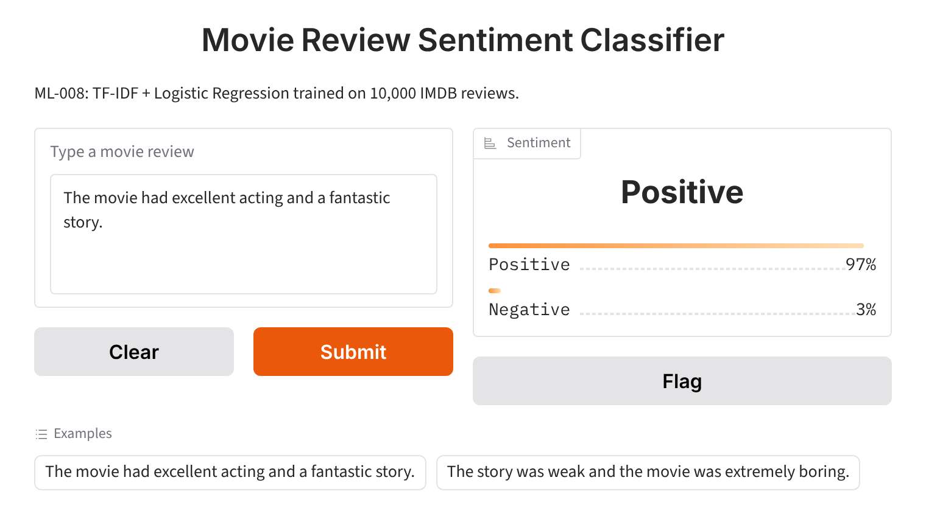
Figure 16.1: Gradio interface: a positive review is classified as Positive
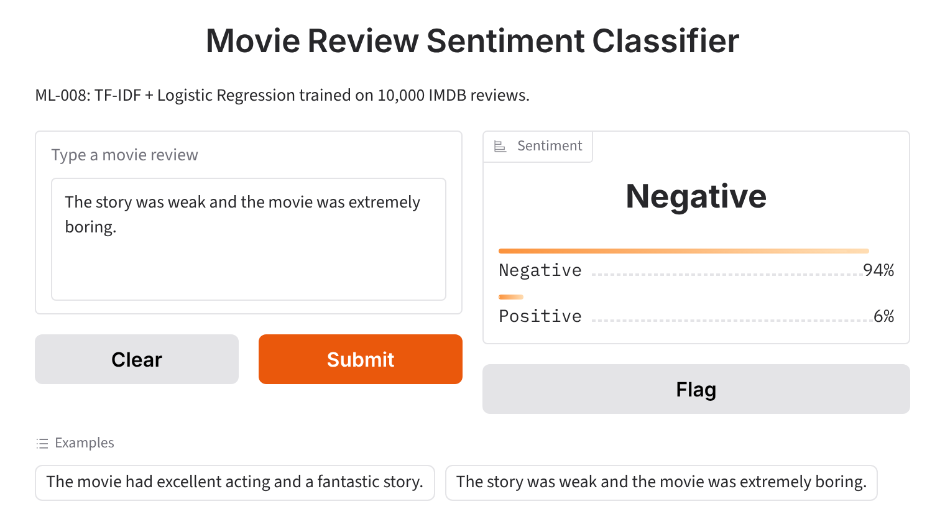
Figure 16.2: Gradio interface: a negative review is classified as Negative
17. BUSINESS APPLICATIONS
Sentiment analysis helps organisations understand opinions and make data-driven decisions. The same approach used here can serve many businesses.
Application | How it helps
OTT platforms | Streaming services receive thousands of viewer reviews. Sentiment classification shows audience reaction to new releases and improves recommendations.
Movie-review websites | Reviews can be sorted automatically into positive and negative, giving visitors a quick overall opinion of a film.
Entertainment companies | Studios and production houses can measure audience feedback after release and improve future films and marketing.
Audience-feedback analysis | Thousands of comments are processed in seconds to find popular titles and common complaints.
Social-media monitoring | Posts about films can be tracked in real time to follow public opinion and trends.
Customer-review analytics | The same model can classify product, hotel and restaurant reviews and flag negative ones for quick action.

Benefits to businesses
- Less manual effort and faster insight into customer opinion.
- Consistent results at any scale.
- Better marketing and business decisions based on data.
18. FUTURE SCOPE
The current system performs well for binary sentiment classification, and there are many ways to improve and extend it.
- Deep learning models. Use LSTM, GRU or BERT-based models to understand context, word order and sarcasm.
- More data. Train on the complete 50,000-review dataset for higher accuracy.
- Better text processing. Add lemmatization, keep rating-like numbers, and use n-grams up to three words or word embeddings.
- Hyper-parameter tuning. Tune hyper-parameters such as C and max_features with grid search and cross-validation.
- Multi-class sentiment. Classify reviews as Very Positive, Positive, Neutral, Negative or Very Negative.
- Multilingual support. Support Hindi and other regional languages.
- Real-time analysis. Connect the model to movie sites and social media to analyse reviews as they arrive.
- Web and mobile app. Deploy the model as a permanent web or mobile application.
- Recommendation systems. Combine sentiment with a movie recommendation system.
- Wider applications. Apply the model to product, hotel and restaurant reviews.
19. CONCLUSION
The Movie Review Sentiment Classification project successfully demonstrates how NLP and machine learning can classify movie reviews as Positive or Negative. A balanced dataset of 10,000 IMDB reviews was cleaned, converted into 5,000 TF-IDF features and split into 8,000 training and 2,000 test reviews. Three classifiers were trained and compared.
Logistic Regression gave the best results, with an accuracy of 86.25% and an F1-score of 0.8628, correctly classifying 1,725 of 2,000 unseen reviews. Linear SVM (85.45%) and Naive Bayes (83.25%) followed. The confusion matrix showed balanced errors between the two classes, and the most influential words learned by the model were sensible opinion words such as “excellent”, “great”, “worst” and “boring”.
Custom testing gave 6 correct predictions out of 7. The error analysis showed that the model struggles with mixed opinions, double negatives, sarcasm and reviews that describe rather than judge, because a bag-of-words model does not understand context. A Gradio demo made the model easy to try.
In conclusion, the project achieves its objective of building an automated, fast and reliable sentiment-analysis system. It provides a strong base that can be improved with more data, better preprocessing and deep learning models, and it can be applied to many real-world review-analysis problems.
20. REFERENCES
- Maas, A. L., Daly, R. E., Pham, P. T., Huang, D., Ng, A. Y., & Potts, C. (2011). Learning Word Vectors for Sentiment Analysis. Proceedings of the 49th Annual Meeting of the Association for Computational Linguistics (ACL).
- Pang, B., Lee, L., & Vaithyanathan, S. (2002). Thumbs up? Sentiment Classification using Machine Learning Techniques. Proceedings of EMNLP.
- Salton, G., & Buckley, C. (1988). Term-weighting approaches in automatic text retrieval. Information Processing & Management, 24(5), 513–523.
- Pedregosa, F., et al. (2011). Scikit-learn: Machine Learning in Python. Journal of Machine Learning Research, 12, 2825–2830.
- Jurafsky, D., & Martin, J. H. Speech and Language Processing. Pearson Education.
- Devlin, J., Chang, M.-W., Lee, K., & Toutanova, K. (2019). BERT: Pre-training of Deep Bidirectional Transformers for Language Understanding. Proceedings of NAACL-HLT.
- Abid, A., et al. (2019). Gradio: Hassle-Free Sharing and Testing of ML Models in the Wild. arXiv:1906.02569.
- IMDB Dataset of 50K Movie Reviews and the Large Movie Review Dataset: https://ai.stanford.edu/~amaas/data/sentiment

