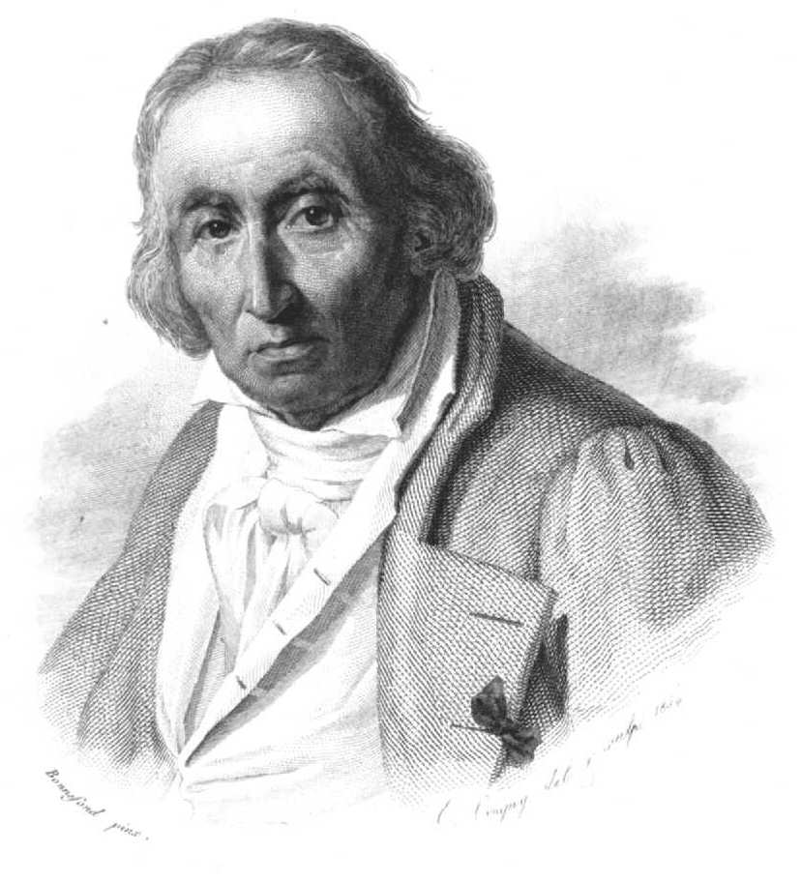 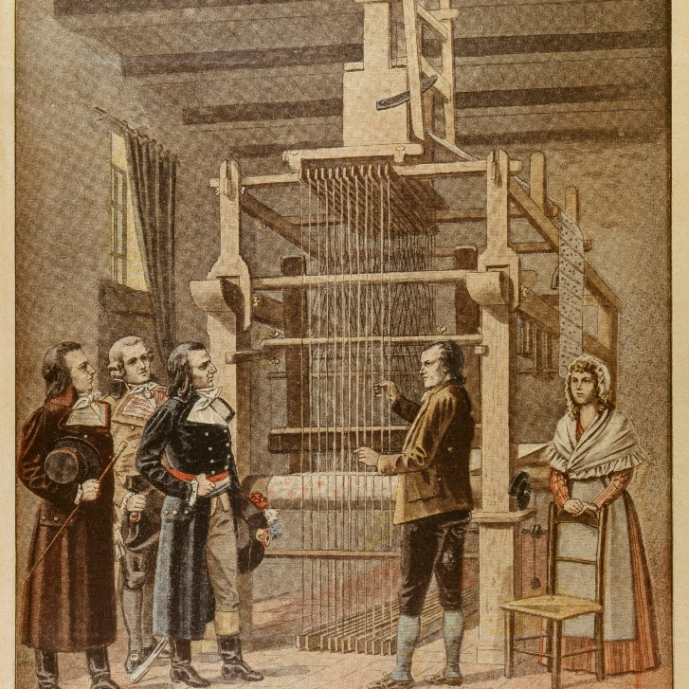

1801: Joseph Marie Jacquard, a French merchant and inventor invents a loom that uses punched wooden cards to automatically weave fabric designs. Early computers would use similar punch cards.

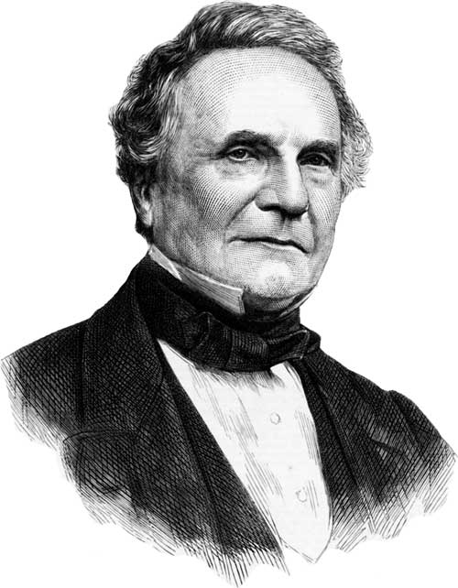 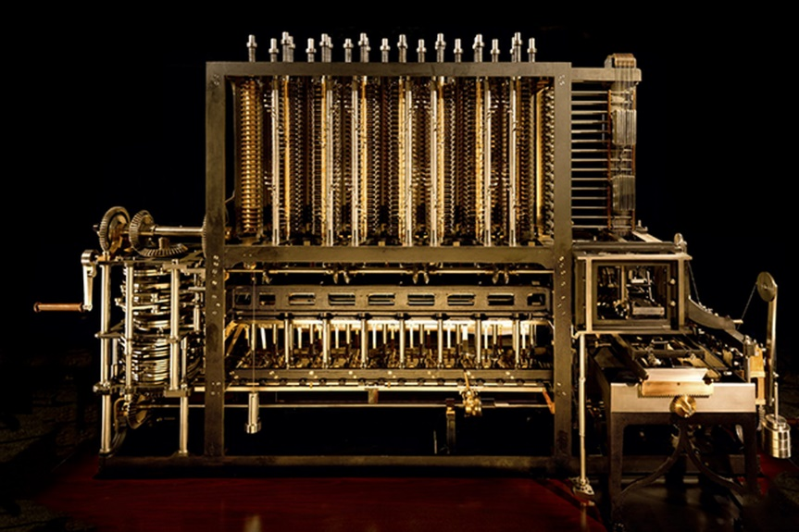

1821: English mathematician Charles Babbage conceives of a steam-driven calculating machine that would be able to compute tables of numbers. Funded by the British government, the project, called the "Difference Engine" fails due to the lack of technology at the time, according to the University of Minnesota.

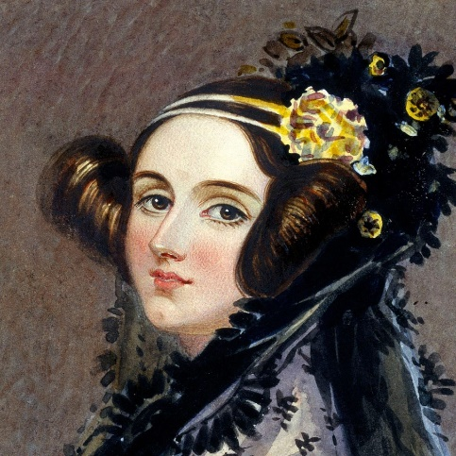 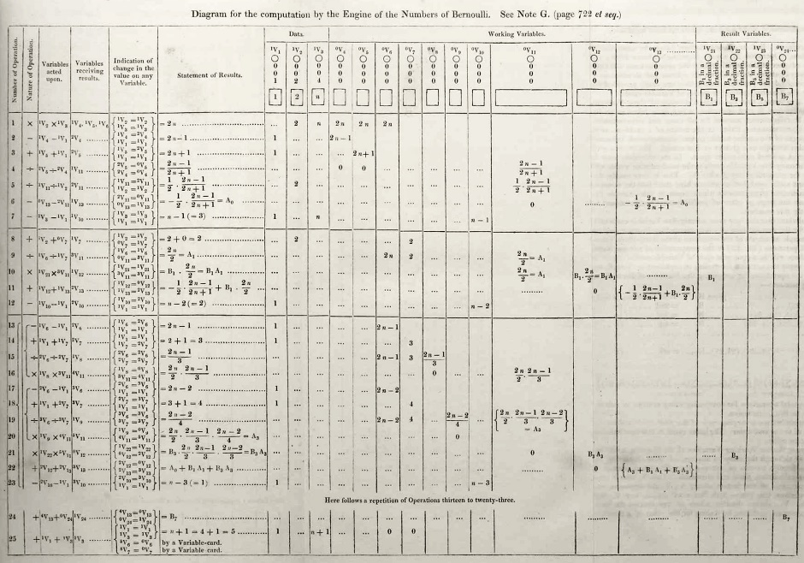

1848: Ada Lovelace, an English mathematician and the daughter of poet Lord Byron, writes the world's first computer program. According to Anna Siffert, a professor of theoretical mathematics at the University of Münster in Germany, Lovelace writes the first program while translating a paper on Babbage's Analytical Engine from French into English. "She also provides her own comments on the text. Her annotations, simply called "notes," turn out to be three times as long as the actual transcript," Siffert wrote in an article for The Max Planck Society. "Lovelace also adds a step-by-step description for computation of Bernoulli numbers with Babbage's machine — basically an algorithm — which, in effect, makes her the world's first computer programmer." Bernoulli numbers are a sequence of rational numbers often used in computation.

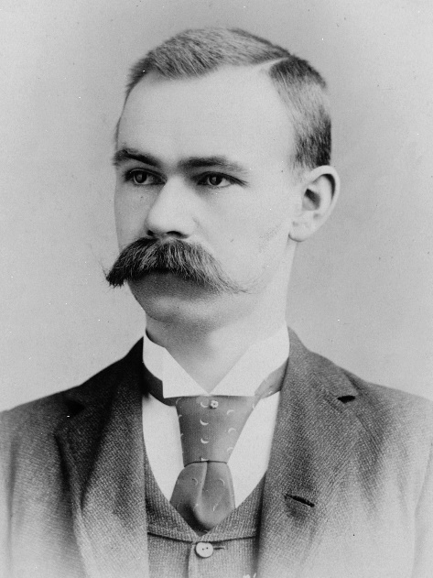 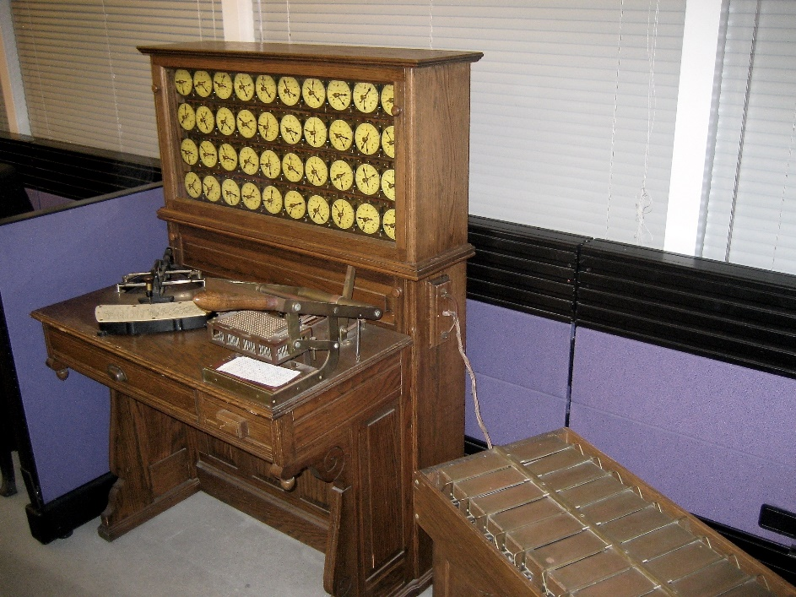

1890: Herman Hollerith designs a punch-card system to help calculate the 1890 U.S. Census. The machine saves the government several years of calculations, and the U.S. taxpayer approximately $5 million. Hollerith later establishes a company that will eventually become International Business Machines Corporation (IBM).

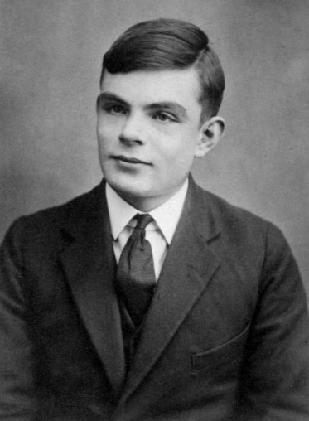 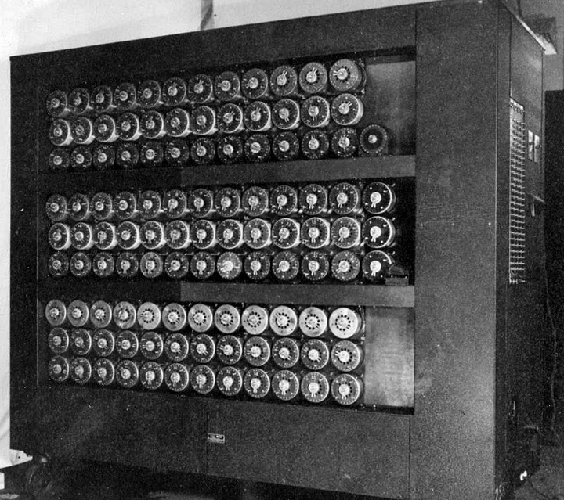

1936: Alan Turing, a British scientist and mathematician, presents the principle of a universal machine, later called the Turing machine, in a paper called "On Computable Numbers…" according to Chris Bernhardt's book "Turing's Vision" (The MIT Press, 2017). Turing machines are capable of computing anything that is computable. The central concept of the modern computer is based on his ideas. Turing is later involved in the development of the Turing-Welchman Bombe, an electro-mechanical device designed to decipher Nazi codes during World War II, according to the UK's National Museum of Computing.

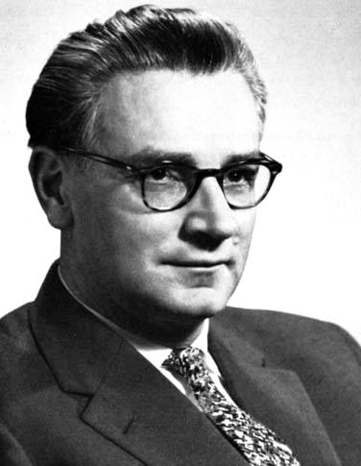 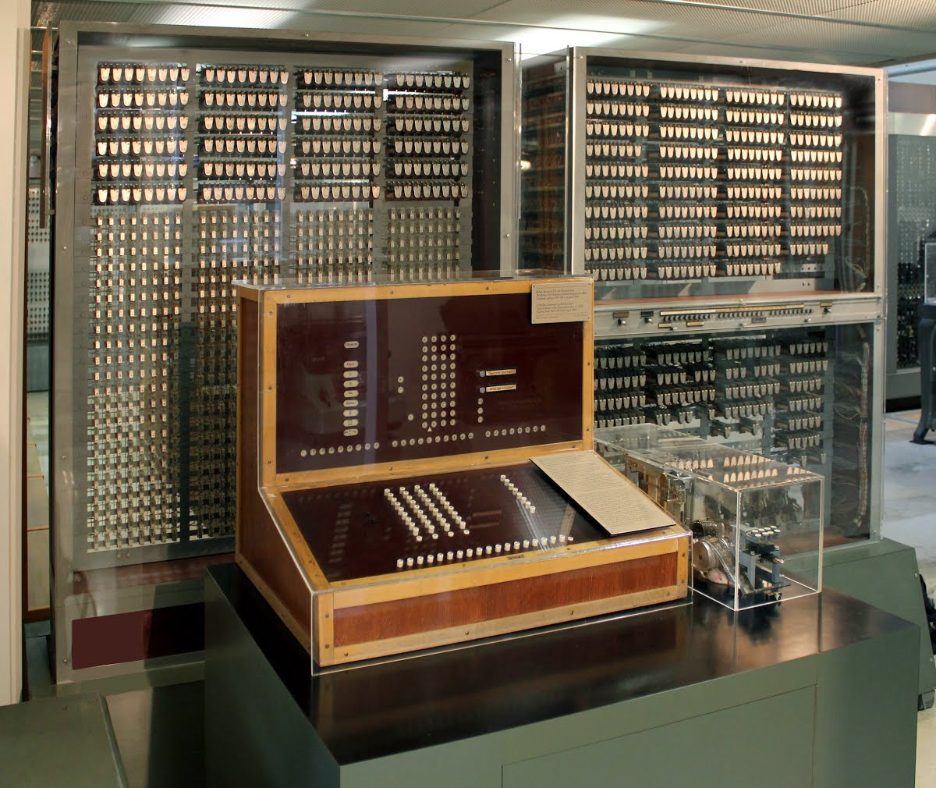

1941: German inventor and engineer Konrad Zuse completes his Z3 machine, the world's earliest digital computer, according to Gerard O'Regan's book "A Brief History of Computing" (Springer, 2021). The machine was destroyed during a bombing raid on Berlin during World War II. Zuse fled the German capital after the defeat of Nazi Germany and later released the world's first commercial digital computer, the Z4, in 1950, according to O'Regan.

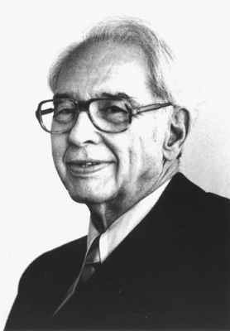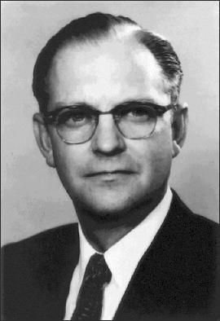 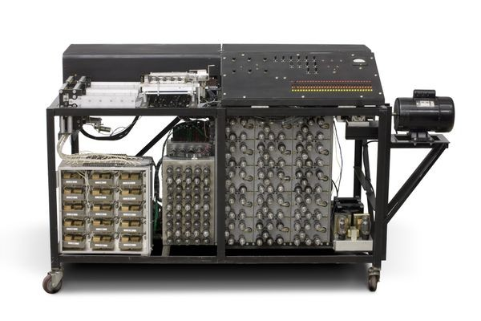

1941: John Atanasoff and his graduate student, Clifford Berry, design the first digital electronic computer in the U.S., called the Atanasoff-Berry Computer (ABC). This marks the first time a computer is able to store information on its main memory, and is capable of performing one operation every 15 seconds, according to the book "Birthing the Computer" (Cambridge Scholars Publishing, 2016)

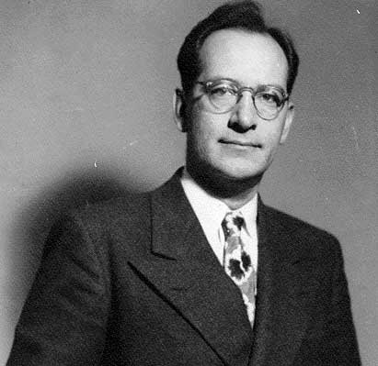 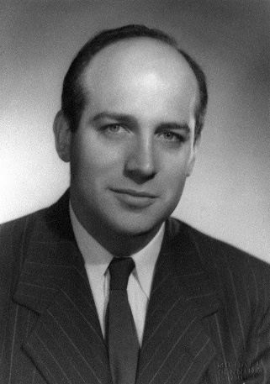 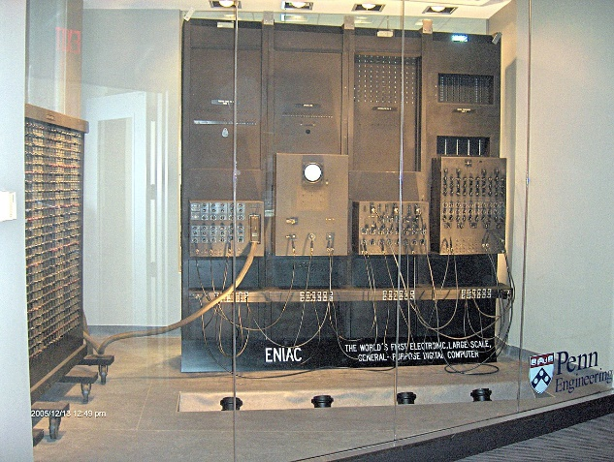

1945: Two professors at the University of Pennsylvania, John Mauchly and J. Presper Eckert, design and build the Electronic Numerical Integrator and Calculator (ENIAC). The machine is the first "automatic, general-purpose, electronic, decimal, digital computer," according to Edwin D. Reilly's book "Milestones in Computer Science and Information Technology" (Greenwood Press, 2003).

----

https://www.livescience.com/20718-computer-history.html#section-early-20th-century