NEWS RELEASE

March 22, 2007

Media Contact: Doug Ramsey, 858-822-5825, dramsey@ucsd.edu

Pacific Rim Researchers to Collaborate on Distributed Bioinformatics Analysis of Avian Flu Using Global Computational Data Grid

TATRC Funding to UC San Diego and University of Hawaii to Foster Stronger Ties for Collaboration with Institutions in China, Japan and Korea

Researchers at the University of California, San Diego and the University of Hawaii will use bioinformatics, grid computing and networking infrastructure, as well as collaborative ties to Asian institutions to learn more about Avian flu, in hopes of helping to head off a much-feared pandemic in the region of the world where the disease has already cost human lives.

“We will use modern high-throughput biology to annotate the biological structures of different subtypes of the avian influenza virus, at the same time as we study their variations,” said principal investigator Peter Arzberger, director of Life Science Initiatives at UC San Diego. “We will also construct a grid infrastructure to support avian flu research – an infrastructure that could one day handle research on other infectious diseases as well.”

Added Arzberger: “Fighting a pandemic will also be easier if we put in place the infrastructure to replicate data, support medical informatics, and even assist in remote diagnosis.”

UC San Diego will lead the one-year project, with more than $350,000 in funding from the Telemedicine and Advanced Technology Research Center (TATRC), part of the U.S. Army Medical Research and Material Command (USAMRMC). TATRC invests in telemedicine and advanced medical technologies in order to deliver world-class health care to military personnel. The increasing frequency of biological events relevant to national security, and current disease surveillance systems in the United States (U.S.) require an integrated computational environment to support easy access to a set of universal tools, novel algorithmic approaches and tracking mechanisms for reproducibility at a global level.

Having Asian researchers involved in the TATRC-funded project lends an added dimension of urgency and depth to the U.S. research program. “Avian flu is very important to sites worldwide, but especially in Asia, where most of the known cases have occurred,” said Wilfred Li, executive director of the UC San Diego-based National Biomedical Computation Resource (NBCR). “This partnership will give U.S. researchers enhanced access to new genomic information as it becomes available in the region. It will also promote global cooperation in case of a flu pandemic.”

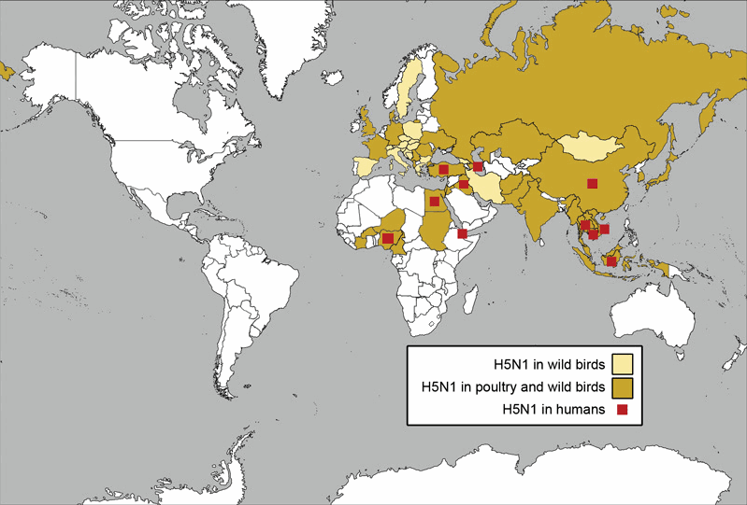
Countries with confirmed H5N1 incidences as of Feb. 2007 (Source: http://pandemicflu.gov)

Institutions in three Asian nations will leverage TATRC’s investment by funding their own researchers to work with their counterparts in California and Hawaii, as part of their ongoing collaboration in the National Science Foundation-funded Pacific Rim Applications and Grid Middleware Assembly (PRAGMA).

“We could not be successful in this project without the substantial prior investment in partnerships with our friends and colleagues across the Pacific,” said Arzberger, who directs the five-year-old PRAGMA initiative. “We will be able to hit the ground running thanks to the shared expertise, interconnected cyberinfrastructure, grid-enabled software tools and student exchange programs that have emerged out of PRAGMA.”

Pacific Rim institutions collaborate in PRAGMA to develop grid-enabled applications and coordinate deployment of the needed infrastructure throughout the Pacific region to allow data, computing, and other resource sharing. The announcement of the TATRC award coincides with PRAGMA 12, which runs March 20-22 in Bangkok, Thailand. The meeting is hosted by Thailand’s National Electronics and Computer Technology Center (NECTEC), and the Thai National Grid Center (TGNC).

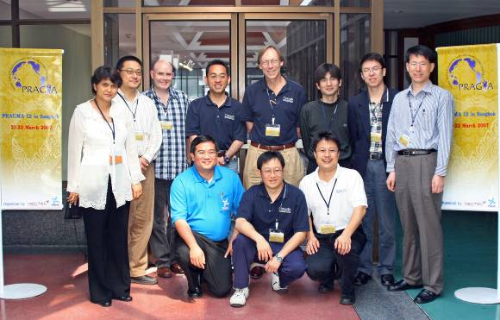
PRAGMA workshops spawn international collaborations in the Asian Pacific Rim. Members of the Biosciences and Resources Working Groups involved in the TATRC award activities gather with the PRAGMA 12 hosts for a group photo. Left to right: Habibah Wahab (USM), Satoshi Sekiguchi (AIST), Neil Gemmell (U. Canterbury), Putchong Uthayopas (TGNC), Yoshio Tanaka (AIST), Piyawut Srichakul (NECTEC), Peter W. Arzberger (UCSD), Wilfred W. Li (UCSD), Osamu Tatebe (U. Tsukuba), Xiaohui Wei (JLU), Kum Won Cho (KISTI). Not available at time of photo: Kai Nan (CNIC), Karpjoo Jeong (KU), Maqs Alam (UH). (Photo Courtsey: Teri Simas).

Five non-U.S. partners have pledged to fund collaboration on the avian flu virus project: Japan’s National Institute for Advanced Industrial Science and Technology (AIST); China’s Jilin University (JLU) and Computer Network Information Center (CNIC); as well as the Korea Institute for Science and Technology Information (KISTI) and Konkuk University (KU). Significantly, Malaysia’s University Sains Malaysia (USM) has pledged new funding for the collaborative project at the PRAGMA 12 workshop.

Flu vaccines are usually developed using attenuated viruses, but the new focus is on the use of reverse genetics techniques to combat emerging bird flu pandemic threats. To that end, researchers intend to:
- Characterize the function of the influenza viruses using a structure-based approach;
- Develop simulations of the molecular dynamics involving interactions among major factors that may determine the virulence of a virus; and
- Test whether the multinational collaboration can establish a successful, large-scale, distributed computational data grid.

Scientists at UC San Diego, the California Institute for Telecommunications and Information Technology (Calit2) and San Diego Supercomputer Center (SDSC) will use bioinformatics software, including the integrated Genome Analysis Pipeline (iGAP), to analyze avian flu genomes. (The iGAP suite of bioinformatics applications are designed specifically for protein structural homology recognition and functional annotation.) The San Diego-based researchers will also develop a robust production environment for routine computational analysis, using PRAGMA member-developed tools, including Grid Datafarm (Gfarm) and Community Scheduler Framework (CSF4), while making any new software publicly available through open-source licenses.

The funding to the University of Hawaii will allow it to become a node in the computational grid – allowing it to access data for molecular-dynamics simulations using high-performance computing. “We need a better way to gain insight into the interactions among factors determining how virulent a particular type of flu might be, and this will require a lot of raw computing power,” said Maqsudul Alam, director at the Advance Studies in Genomics, Proteomics and Bioinformatics, College of Natural Sciences, University of Hawaii. “This will allow us to analyze the biosynthetic pathways of viruses as well as the signal transduction pathways for clues to understanding how avian flu interferes with human metabolism.”

The Asian institutions – all members of PRAGMA – will host some U.S. students and researchers, while taking responsibility for specific tasks:
- JLU will support the scheduling of multiple clusters (CSF4) to distribute jobs transparently at multiple sites around the region;
- AIST will support the deployment of Gfarm in conjunction with researchers at the University of Tsukuba;
- KISTI in conjunction with researchers at KU in Korea will create an integrated portal environment for the computational pipeline using results of Korea National e-Science Project by the Korean Ministry of Science and Technology (MOST); and
- CNIC will develop a transparent web service layer for data access.
- USM will contribute its natural compound database for use in virtual screening for new inhibitors and drug discovery.

CNIC will also become the central repository for the project’s research data. The database will be distributed through the computational data grid, and accessible through web portals mirrored at partner sites. “The availability of a central repository that is built upon distributed information and data storage not only allows one to collect information more effectively, but also makes the data immediately available to researchers worldwide,” said Kai Nan, director of CNIC’s Network Technology and Applications Research Laboratory. “The end result is a dynamic research community response network that can meet the needs of a global response to a global threat such as the avian flu.”
 |  | 
Maqs Alam  U Hawaii | Kai Nan  CNIC | Karpjoo Jeong  KU

Much of the nitty-gritty work on the avian flu project will be done by students, at both the graduate and undergraduate level. “We’ll be engaging students from the above institutions as an international research team,” said NBCR’s Li. “We will also send U.S. students and graduate researchers to work in the labs of our partners around Asia – giving those students an experience that will equip them to do ongoing research in this field.” This activity also leverages NSF’s investment in the Pacific Rim undergraduate Education (PRIME) project, an undergraduate research abroad program awarded to UCSD.

“The next step for PRAGMA is a pragmatic one – to demonstrate that international team science can address pressing challenges in a way that might not be possible in one institution or just one country,” said Arzberger. “We expect that this project to engage other researchers, both in other PRAGMA sites, e.g., the University Sains Malaysia (USM), and at the National Biomedical Computation Resource, through the complementary, ongoing Avian flu Drug Discovery project led by Profs. J. Andrew McCammon and Art Olson of NBCR by sharing expertise and resources.”

Related Links

TATRC http://www.tatrc.org
PRAGMA http://www.pragma-grid.net/
PRAGMA 12 http://pragma12.thai-research.net/pragma12/index.php/Main_Page NECTEC http://www.nectec.or.th/
TGNC http://www.thaigrid.or.th/index.php
NBCR http://nbcr.net
PRIME http://prime.ucsd.edu
Calit2 http://www.calit2.net
SDSC http://www.sdsc.edu
UCSD http://www.ucsd.edu
University of Hawaii http://cgpbr.hawaii.edu/
Jilin University http://en.jlu.edu.cn
AIST http://www.gtrc.aist.go.jp/en
University of Tsukuba http://www.tsukuba.ac.jp/eng/
KISTI http://kisti.re.ac.kr/english
MOST http://www.most.go.kr
CNIC http://www.cnic.ac.cn/english/
Konkuk University http://www.konkuk.ac.kr:8001/eng/
USM http://www.usm.my
U. Canterbury http://www.canterbuy.ac.nz

