1. Retrieve all columns from the product table.

QUERY : select * from Products ;

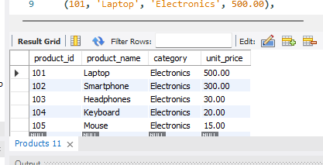

2. Retrieve the product_name and unit_price from the Products table.

QUERY : select product_name ,unit_price from Products ;

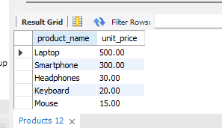

3. Filter the Products table to show only products in the Electronicscategory.

QUERY : select product_name from Products where category='Electronics';

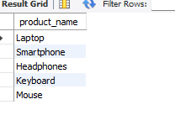

4. Retrieve the product_id and product_name from the Products table for products with a unit_price greater than $100.

QUERY : select product_id , product_name from Products where unit_price > 100;

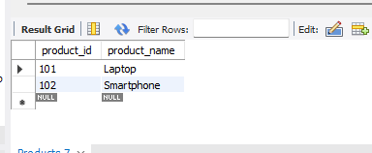

5. Calculate the average unit_price of products in the Products table.

QUERY : select avg(unit_price) from Products ;

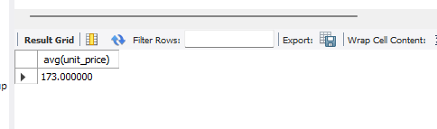

7. Retrieve the product_name and unit_price from the Products table, ordering the results by

unit_price in descending order.

QUERY : select product_name, unit_price from Products order by unit_price DESC;

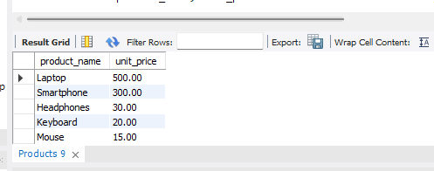

8. Retrieve the product_name and unit_price from the Products table, filtering the unit_price to

show only values between $20 and $600.

QUERY : select product_name, unit_price from Products where unit_price >20 and unit_price<600;

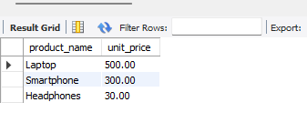

9. Retrieve the product_name and category from the Products table, ordering the results by

category in ascending order.

