1.Retrieve all columns from the Sales table.

Query : select *from sales;

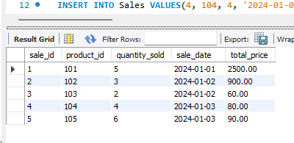

2. Retrieve the sale_id and sale_date from the Sales table.

Query : SELECT sale_id,sale_date from Sales;

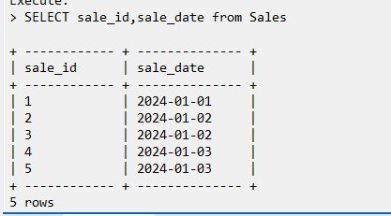

3.Filter the Sales table to show only sales with a total_price greater than $100.

Query :select * from sales where total_price >100;

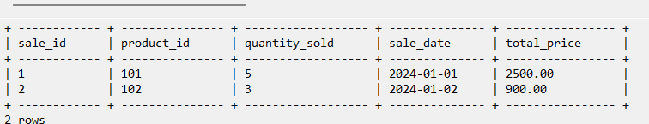

4. Retrieve the sale_id and total_price from the Sales table for sales made on January 3, 2024.

Query :select sale_id,total_price from Sales where sale_date ='2024-01-03';

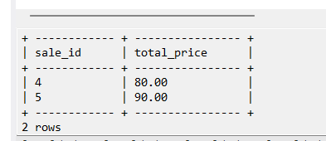

5. Calculate the total revenue generated from all sales in the Sales table.

Query :select sum(total_price)from sales;

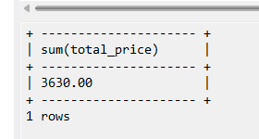

6. Calculate the total quantity_sold from the Sales table.

Query:select sum(quantity_sold)from sales;

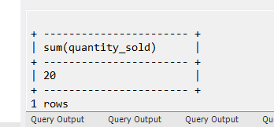

7. Retrieve the sale_id, product_id, and total_price from the Sales table for sales with a

quantity_sold greater than 4.

Query :select sale_id,product_id from Sales where quantity_sold >4;

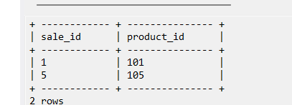

8.  Calculate the average total_price of sales in the Sales table.

Query:select avg(total_price)from sales;

