ROLL NUMBER: 240701365 | NAME: NITHESH G

Experiment - 1

Comparative Study of Low-Code Development versus Traditional Application Development

Aim
To study and compare low-code development with traditional application development, looking at their stages, workflow, and the technical differences between the two.

Introduction to Traditional Approach
Traditional software development is built around manual, line-by-line coding using standard editors and IDEs. Developers handle database schemas, API integrations, and server deployment by hand, and the whole process depends heavily on skill in languages like Java, Python, or C++. It gives full control over the codebase and architecture, but usually comes with longer development cycles, higher budgets, and detailed bug testing.

Introduction to Low-Code Approach
Low-Code Application Platforms (LCAPs) cut down on hand-coding by offering cloud-based, visual development environments instead. They rely on drag-and-drop components, pre-built visual models, and automated deployment pipelines, which lowers the learning curve enough that even "citizen developers" with little or no coding background can put together working applications quickly. Since repetitive programming tasks are automated, low-code shortens time-to-market and reduces initial costs, though it can limit deep customization and tie the project to a particular platform.

Stages in Traditional Approach
The traditional Software Development Life Cycle (SDLC) follows a linear or iterative sequence, with each stage needing dedicated engineering effort:
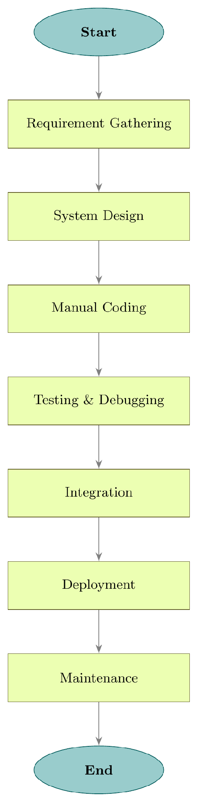

Comparative Analysis
Feature | Traditional Development | Low-Code Development
Development Speed | Slow, since everything is coded from scratch by hand | Fast, cuts development time by roughly 50–70% through pre-built modules
Skill Required | High – needs experienced software engineers | Low – drag-and-drop tools support citizen development
Customization | Full control over every line of code | Limited to what the platform’s components allow
Cost | Higher setup cost, developer salaries, and long-term upkeep | Lower upfront cost, but recurring licensing or subscription fees
Maintenance & Updates | Manual coding and testing needed for every bug fix or update | Updates are handled centrally by the platform provider
Vendor Lock-in | None – business owns the source code fully | High – application depends on the vendor’s ecosystem
Best Use Cases | Complex, high-performance, or highly secure enterprise systems | Prototyping, workflow automation, and internal tools

Result
This comparison shows that traditional development still offers the most flexibility and control, making it suited to mission-critical or highly customized systems, while low-code development gives a faster, cheaper way to build and maintain everyday business applications. In practice, many organizations combine both: using low-code for quick front-end and workflow work, and traditional development for the more complex back-end requirements.

