ROLL NUMBER: 240701365 | NAME: NITHESH G

Setting up a Zoho Creator Account and Exploring the Platform Architecture and Interface

Aim
To set up a Zoho Creator account, create a sample application, explore the creation of forms, reports and dashboards, and understand the Develop, Deploy and Manage sections of the platform.

Setting up Zoho Creator

Step 1: Creating a Zoho Creator Account
- Open a web browser and go to the Zoho Creator website.
- Click on Sign Up to register a new account.
- Enter the required details and verify the email address.
- Log in to the Zoho Creator platform using the new credentials.
- The Zoho Creator home page is displayed after login.

Step 2: Creating a Sample Application
- From the home page, click Create Application.
- Choose the option to build an application from scratch.
- Enter the application name as Student Registration Application.
- Click Create to open the application builder.

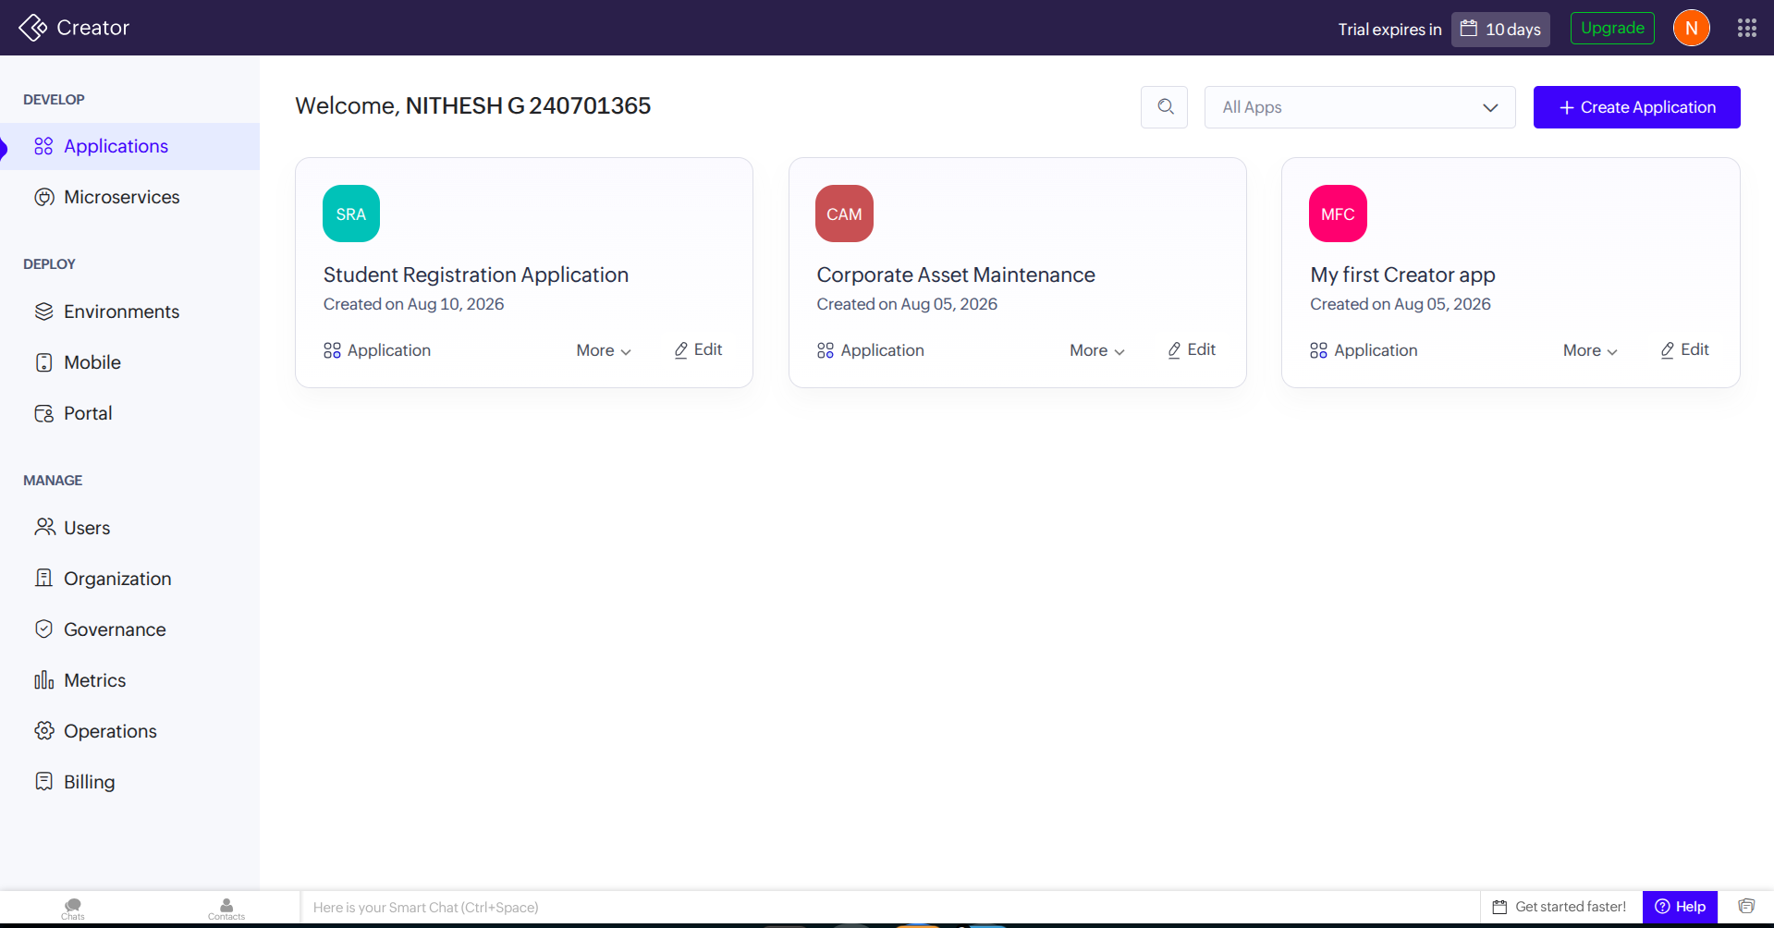
Sample Application (Student Registration Application)

Step 3: Creating the Registration Form
- Open the Student Registration Application.
- Go to the Develop/Build section.
- Select Form and create a new form.
- Name the form Student Details.
- Add the following fields:
  - Student Name
  - Register Number
  - Department
  - Contact Number
  - Email
- Save the form.
Explanation: The form is used to capture student registration details. Every field added here becomes a data column that can later be viewed through reports.
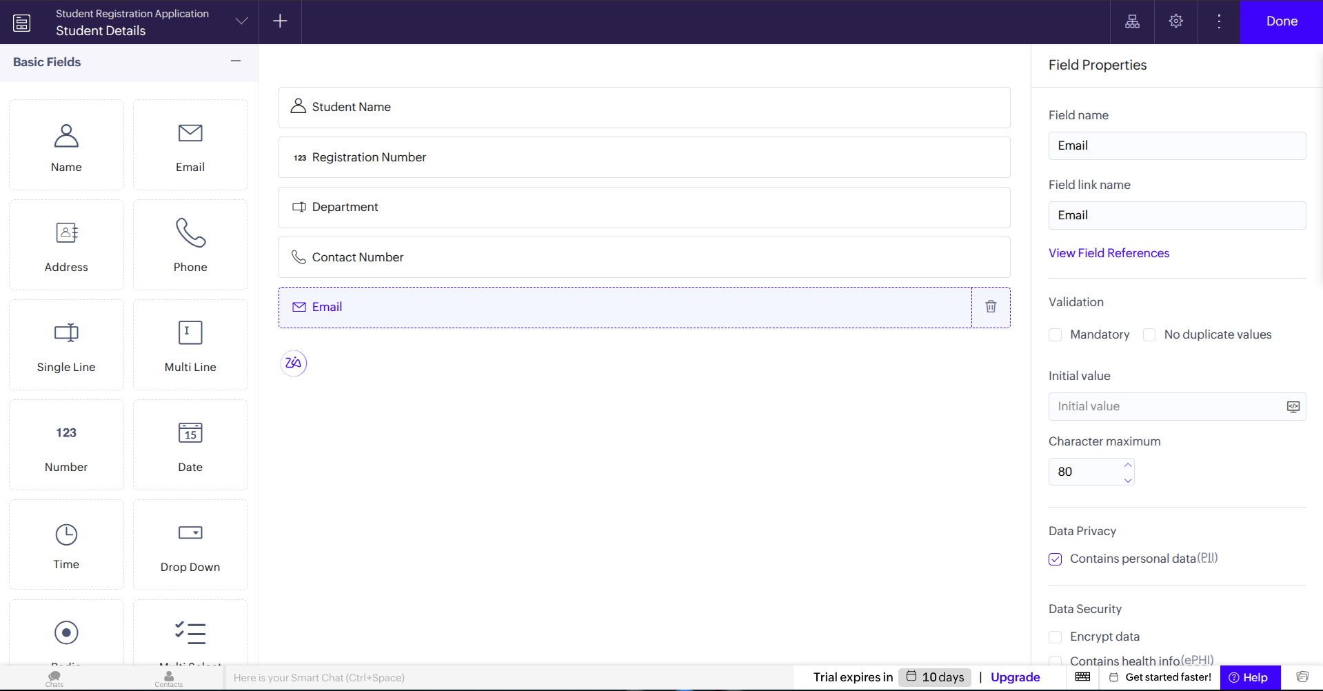
Sample Form (Student Details)

Step 4: Creating the Registration Report
- Open the Student Registration Application application.
- Go to the Develop/Build section.
- Select Report and create a new report.
- Use the Student Details form as the data source.
- Choose a table/list report format.
- Name the report Student Details Report.
- Save the report.
- Add a few sample records through the form.
- Open the report to view the stored records.

Explanation: The report organizes and displays the student details
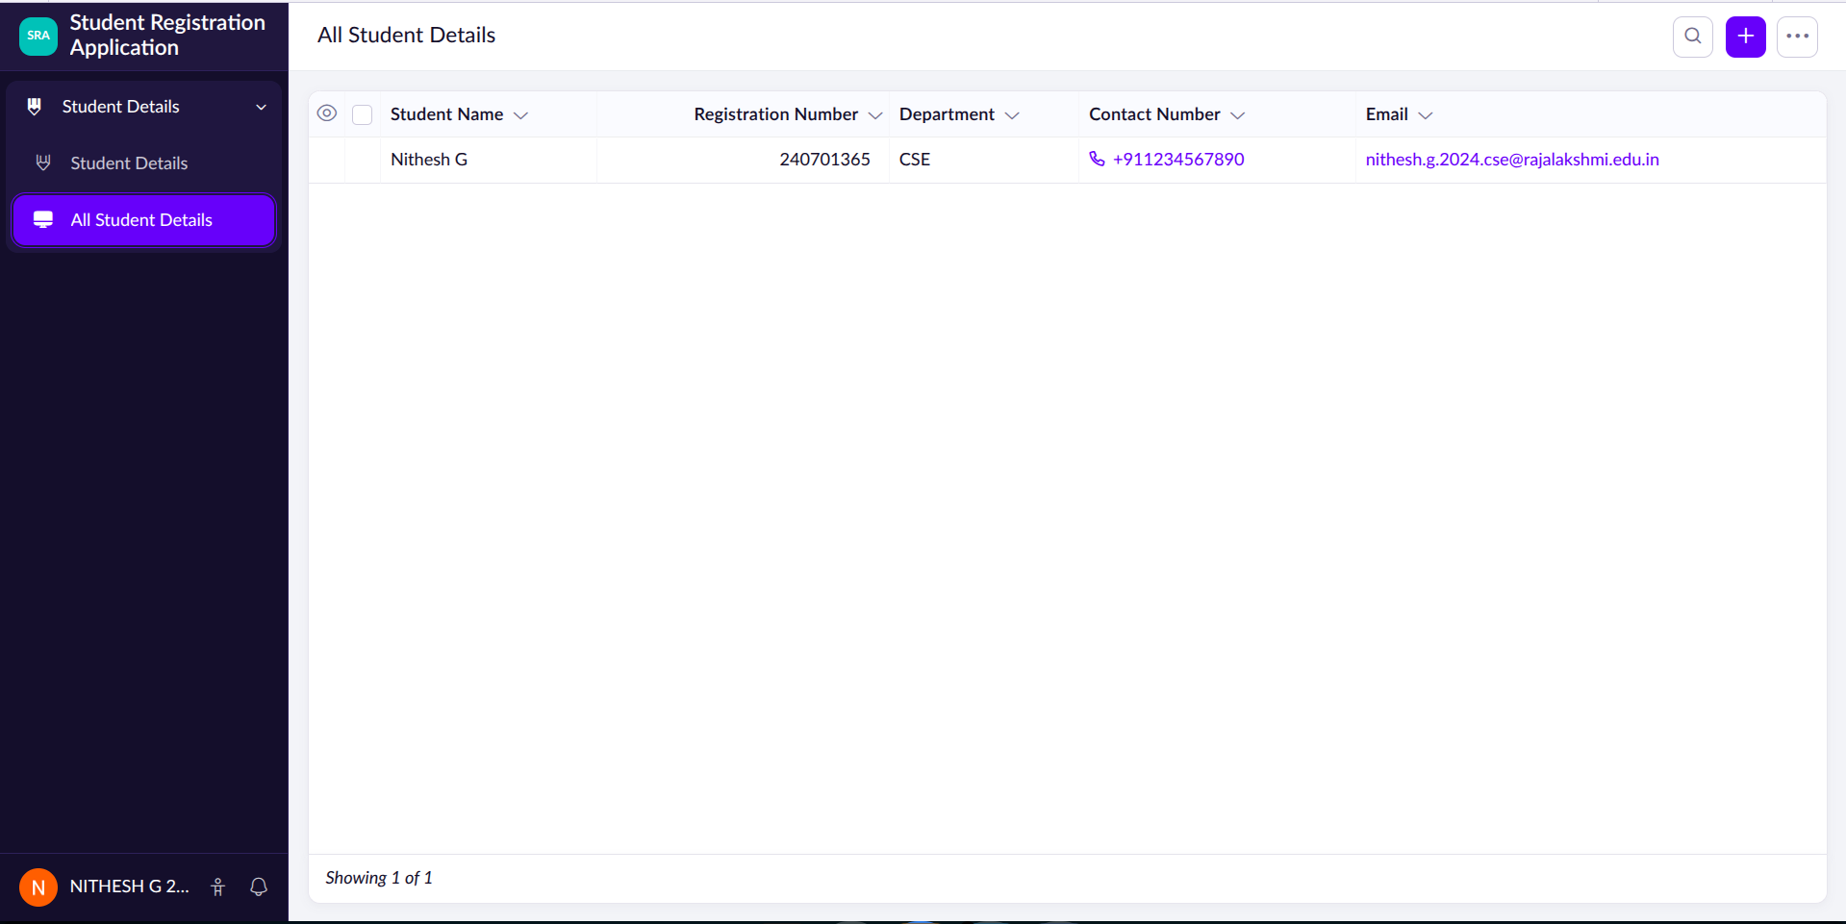
Sample Report (Student Details)

Step 5: Creating the Student Details Dashboard
- Open the Student Registration Application.
- Go to the Develop/Build section.
- Create a new page or dashboard.
- Name it Student Details Dashboard.
- Add report and chart components to the dashboard.
- Create a chart showing Department-wise Participation.
- Arrange the components on the dashboard.
- Save the dashboard.
Explanation: The dashboard gives a quick visual summary of registrations.

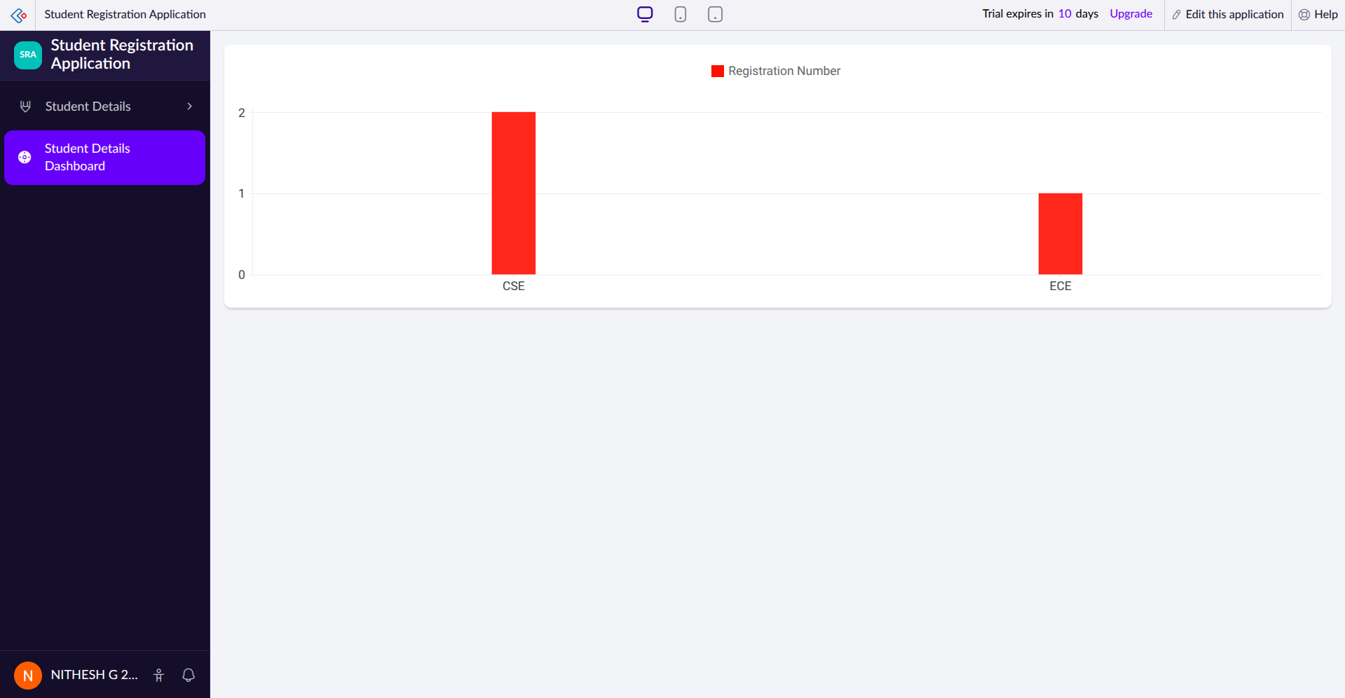
Sample Dashboard (Student Details Dashboard)

Exploring the Platform Architecture and Interface

A) Develop
- The Develop section is used to build and customize the application.
- It provides tools to create forms, reports, pages, and workflows.
- Business logic can be added here using drag-and-drop components and scripting.

B) Deploy
- The Deploy section is used to publish the application for use.
- It allows the app to be tested and made accessible to selected users.
- Deployment lets end users start using the application without any separate hosting setup.

C) Manage
- The Manage section handles administration of the deployed application.
- It provides options to control user roles, permissions, and access.
- It also lets administrators monitor usage and update the application as needed.

Result
Thus, a Zoho Creator account was successfully set up, and the Student Registration Application sample application was created. The Student Details form, report, and dashboard were built successfully, and the Develop, Deploy, and Manage sections of the platform were explored.

