ROLL NUMBER: 240701365 | NAME: NITHESH G
Experiment - 3

Survey Report on Emerging Trends in Low-Code Application Development

Aim
To survey the emerging trends in low-code application development, using the Job Application Form (Recruitment & Job Application Management) built on Zoho Creator as a reference application, and to compare traditional development with current low-code practices.

Traditional Application Development vs Emerging Trends in Low-Code
Traditional development builds every screen and workflow through hand-written code, so a form like the Job Application Form would need custom front-end pages, backend validation logic, and a database schema written from scratch.
Low-code platforms such as Zoho Creator replace this with a visual form builder, ready-made field types (Name, Email, Phone, Date, Multi Select, and so on), and built-in validation rules that can be turned on with a few clicks instead of custom code.
Recent trends are pushing low-code further beyond basic form-building:
- AI-assisted app generation, where prompts or sample data are used to auto-generate forms, workflows, and reports.
- Deeper integration with third-party services (email, calendar, payment, and HR/ATS systems) through built-in connectors instead of manual API coding.
- Citizen development becoming more common, letting HR or business teams build and modify apps like the recruitment form without depending on IT.
- Mobile-first and responsive design being generated automatically, so the same form works on desktop and mobile without separate coding effort.
- Growing use of low-code for automation-heavy workflows, such as auto-sending acknowledgement emails on form submission, rather than just data collection.

Benefits and Challenges in Low-Code

Benefits
- Much faster development - the Job Application Form with 13 field types and validations can be built in hours instead of weeks.
- Lower dependency on specialized developers, since HR staff can maintain and update the form themselves.
- Built-in validation (mandatory fields, email format, number ranges) reduces the need to write custom checks.
- Easier integration of workflows, such as triggering an acknowledgement email automatically on submission.
- Centralized platform updates mean security patches and new features are handled by the vendor.

Challenges
- Customization limits - highly specific validation logic or UI behavior may not always be possible within the platform’s field options.
- Vendor lock-in, since the Candidate_Application_Report and workflow logic are tied to the Zoho Creator ecosystem.
- Scalability concerns for very large applicant volumes or complex reporting needs.
- Data security and compliance responsibility is shared with the platform provider rather than fully controlled in-house.
- Limited flexibility when integrating with legacy HR systems that do not have ready-made connectors.

Comparison of Existing Platforms
Platform | Target Users | Key Strength | Best Suited For
Zoho Creator | Citizen developers, small/mid businesses | Drag-and-drop forms, reports and dashboards with built-in Deluge scripting | Internal business apps like recruitment or asset tracking
Microsoft Power Apps | Business users within Microsoft 365 ecosystem | Tight integration with Excel, SharePoint and Teams | Enterprises already using Microsoft tools
OutSystems | Professional developers, large enterprises | High scalability with support for complex custom logic | Large-scale, mission-critical enterprise applications
Mendix | Both citizen and professional developers | Strong collaborative, model-driven development environment | Enterprise apps needing IT-business collaboration
Appian | Enterprises with heavy process automation needs | Strong workflow and business process automation engine | Complex approval and case-management workflows

Screenshots
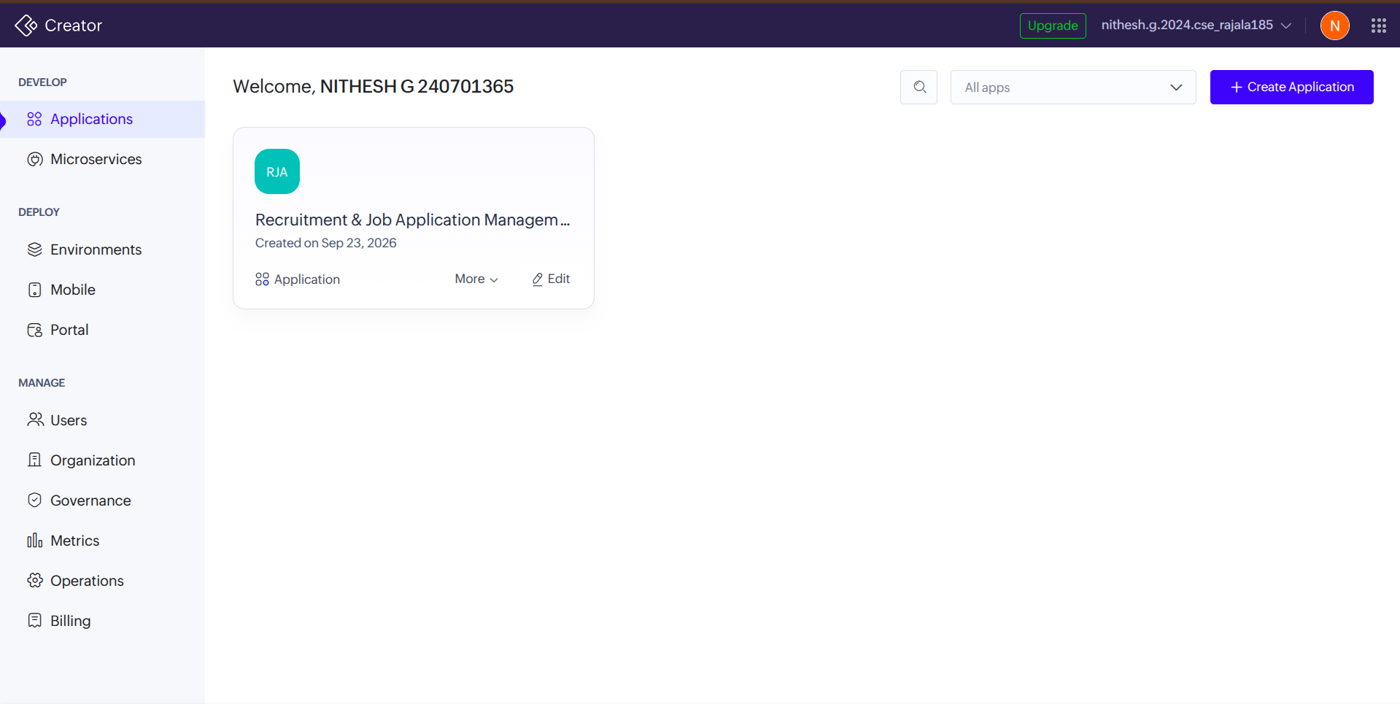
Application Creation (Figure 1)

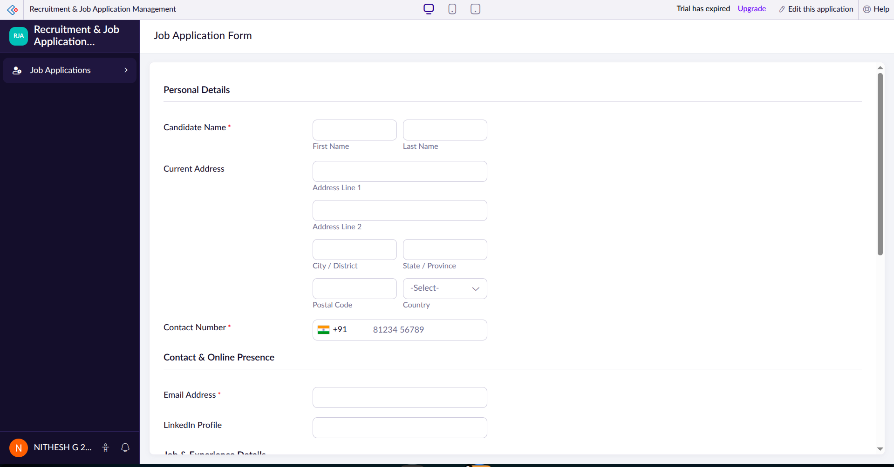

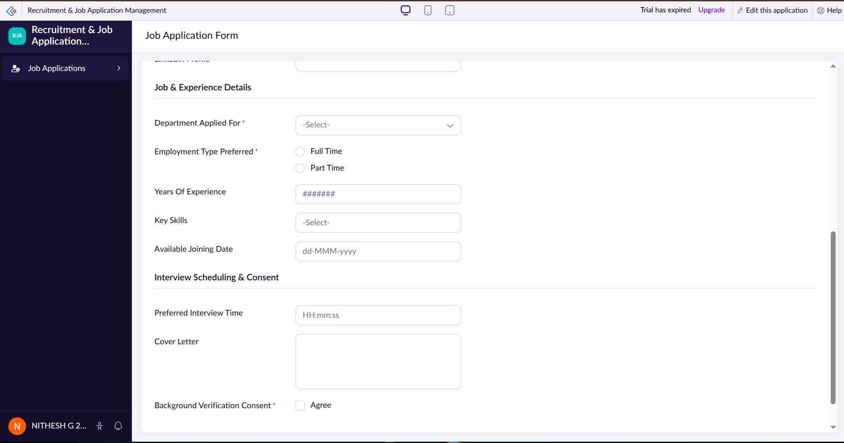
Job Applications Form (Figure 2 and 3)
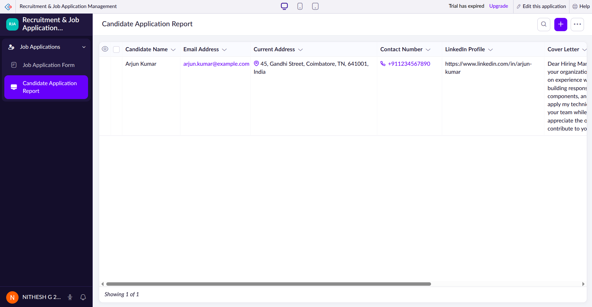
Job Applications Report (Figure 4)

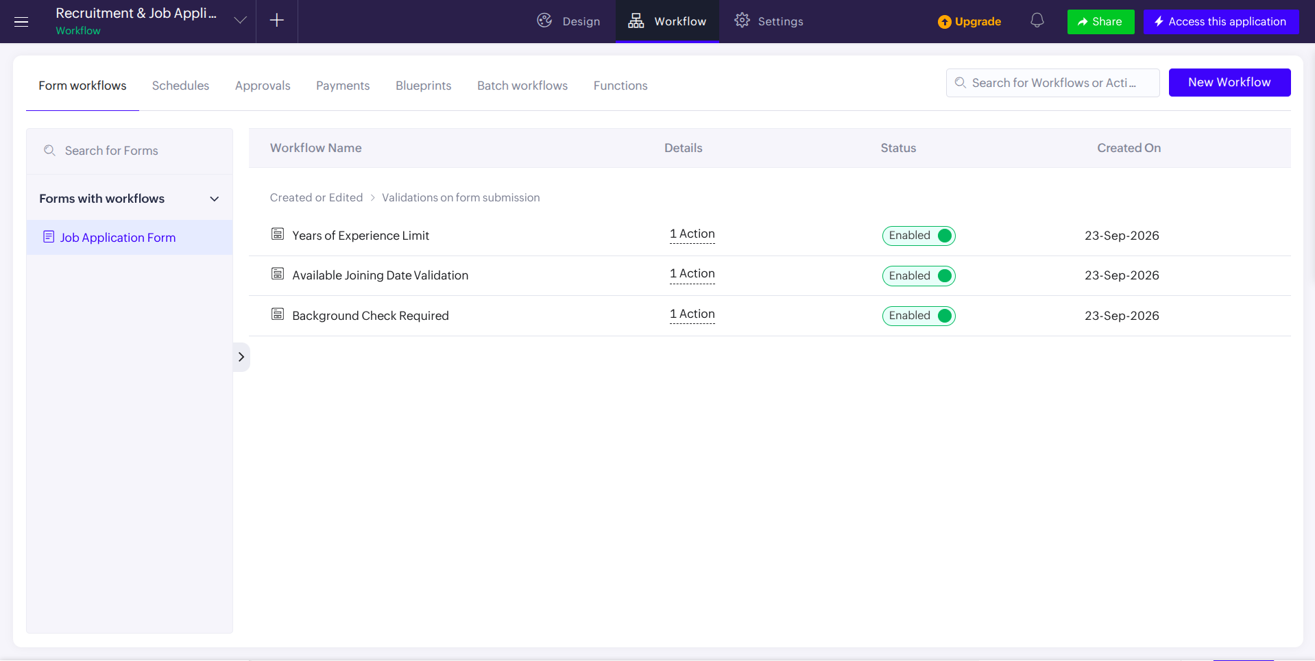
Workflows (Figure 5)

Result
The survey shows that low-code platforms like Zoho Creator make it possible to build a working, validated application such as the Job Application Form in a fraction of the time a traditional build would take, while still meeting a real HR requirement. Emerging trends such as AI-assisted generation, deeper integrations, and citizen development are pushing low-code beyond simple form-building, though platform dependency and customization limits remain the main trade-offs compared to traditional development.

