Week-3-1

# User Id and Attempt

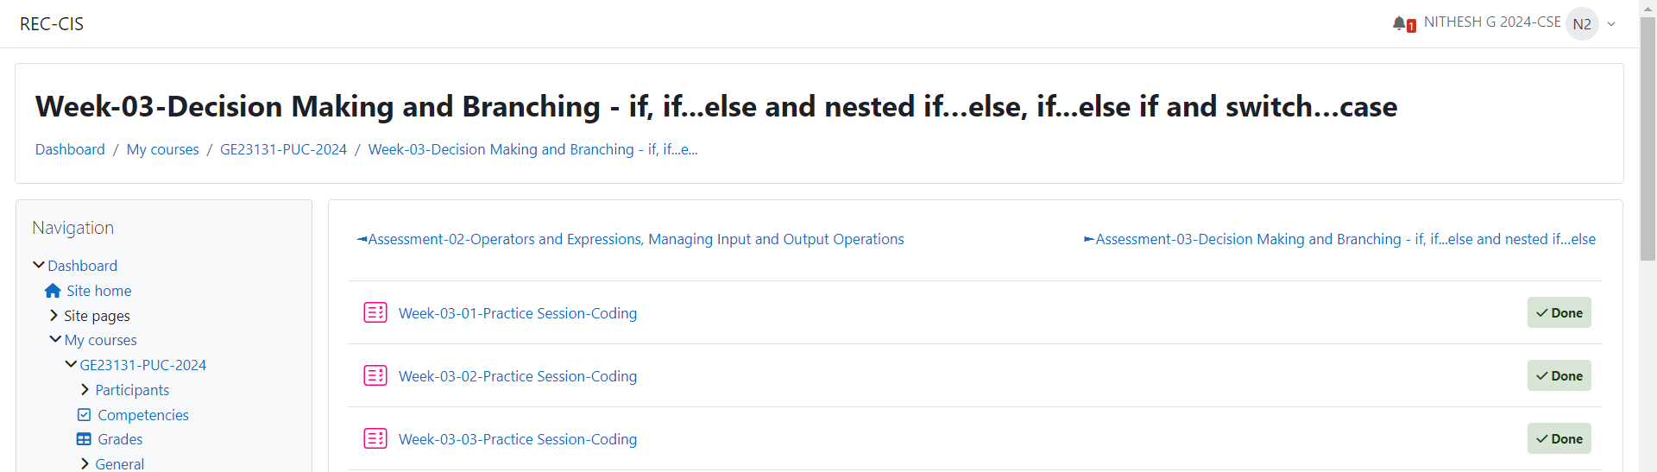 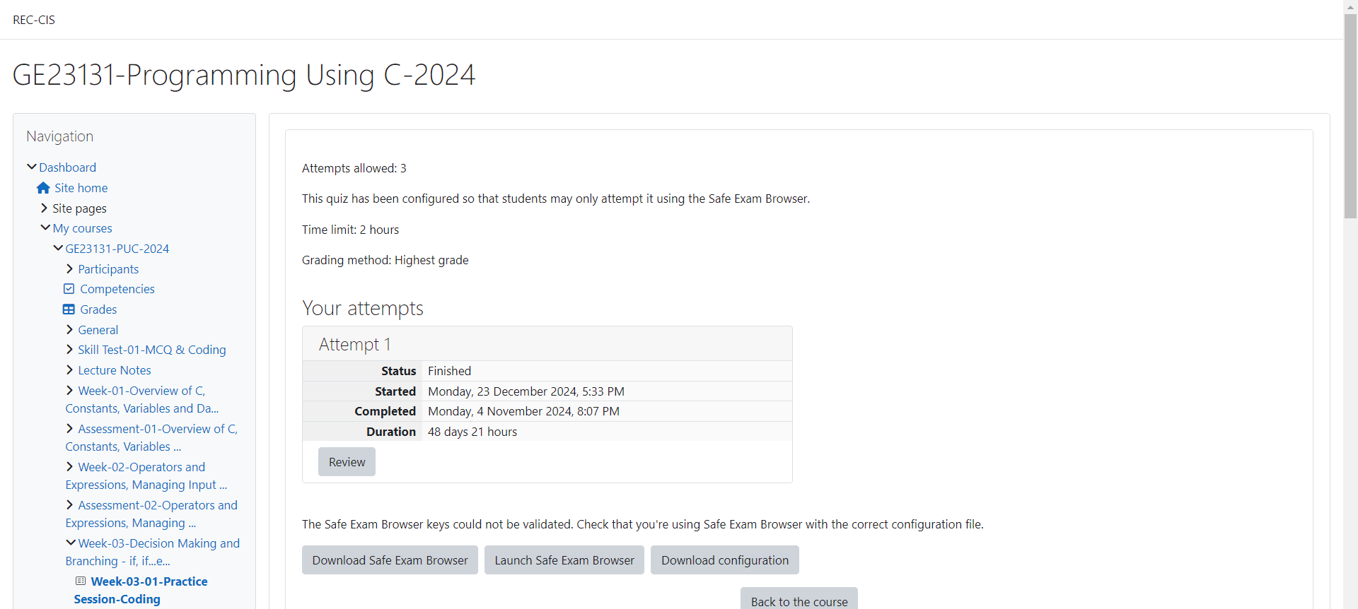

# Program 1:



# Code:

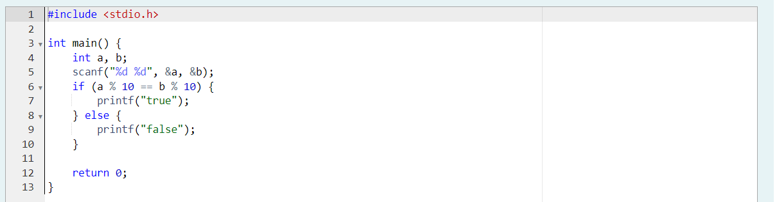

# Output:

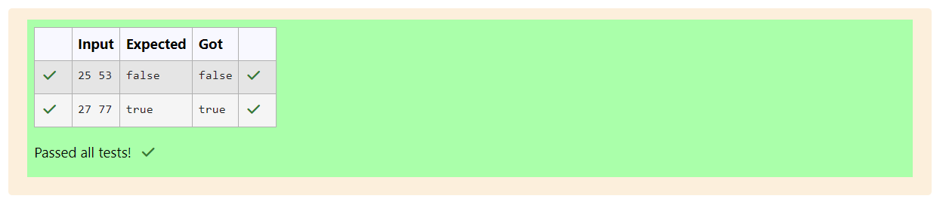

# Program 2:

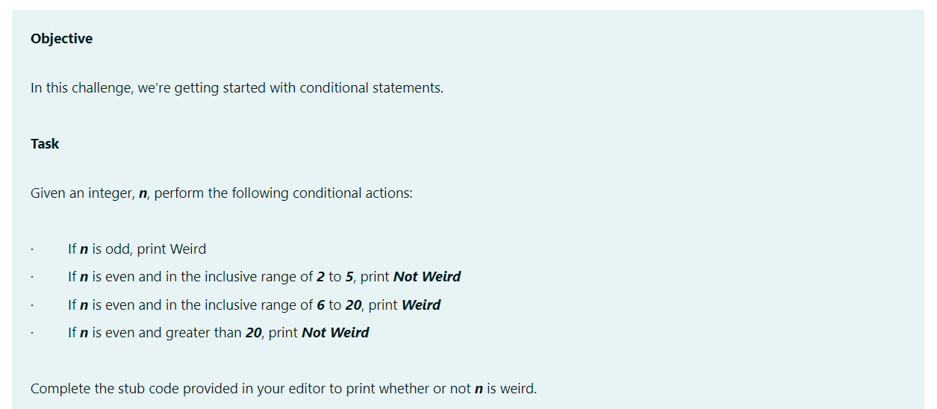

# Code:

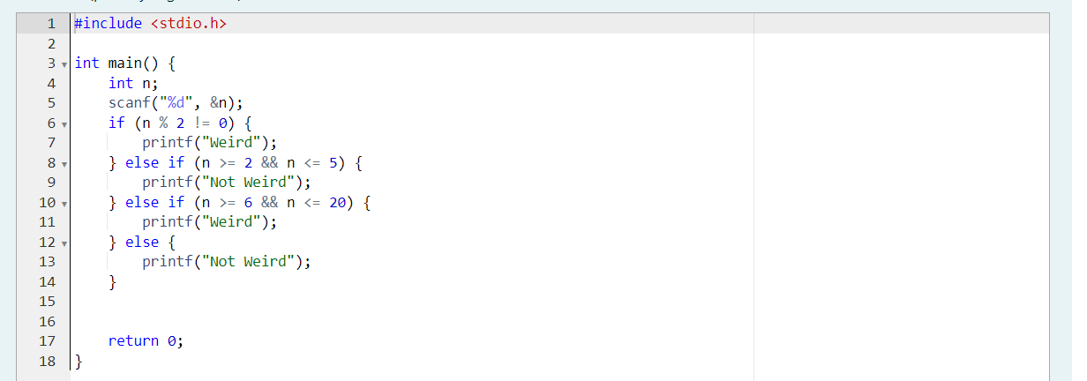

# Output:

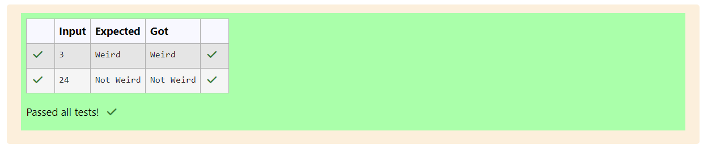

# Program 3:

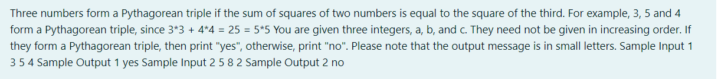

# Code:

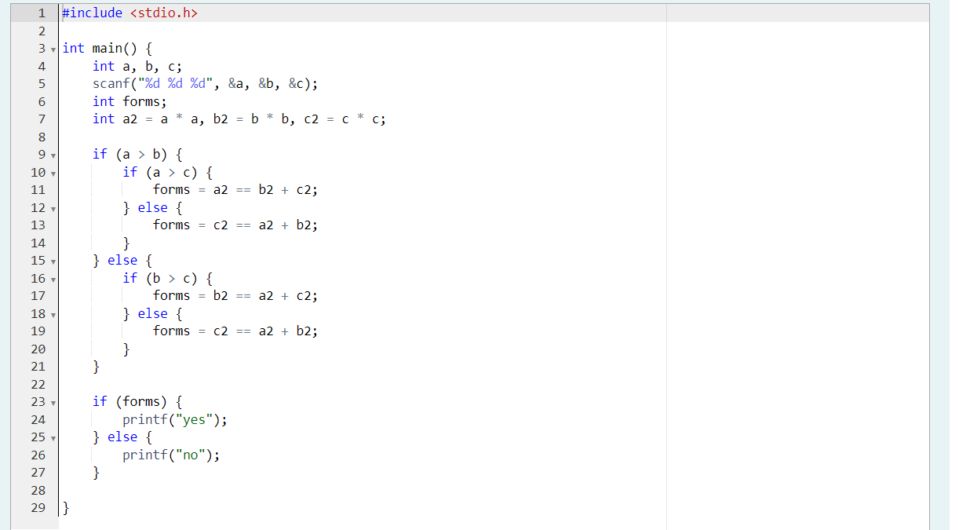

# Output:

