Automated report

23rd March 2018

# Plots

### Number of cases by date of symptoms onset

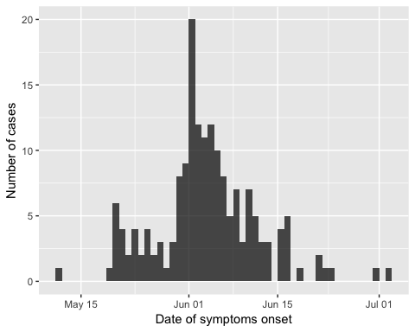

### Number of cases by age groups

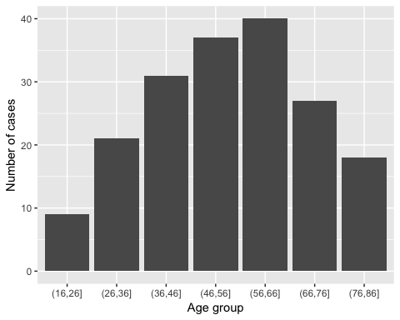

# Tables

### 2X2 table for status vs gender

|  |  |  |
| --- | --- | --- |
|  | Alive | Deceased |
| F | 64 | 12 |
| M | 85 | 24 |