**THE RECOVER DATA PACKAGE TOOLBOX**

The following provides a description and quick tutorial on the use of the tools found in the **RECOVER Data Package Toolbox**. Once you have downloaded and extracted a wildfire Data Package from RECOVER, you will find a toolbox is included in each data package. Within the toolbox you will find two tools; the **Repair Layer Files Sources** and **Percent Distribution within Fire Perimeter** tool.

**Using the REPAIR LAYER FILE SOURCES Tool**

Layer files (.LYRX file extensions in ArcGIS Pro, .LYR file extensions in ArcMap) do not store relative paths for their sources. When a user adds .LYRX files received via download or another source to a map in an ArcGIS Pro project, the layer in the Contents pane will typically be accompanied by a red exclamation markand will not display in the map. This is because the source is "broken." [Repairing .LYRX sources manually](https://pro.arcgis.com/en/pro-app/latest/help/mapping/layer-properties/repair-broken-data-links.htm) can be time consuming, especially if you have to repair many layer files.

This tool is designed to assist users of the NASA RECOVER DSS in their analysis of areas affected by wildfires by automatically repairing the .LYRX files found in each data package. You can then dive right in to analysis without needing to painstakingly repair the data sources for each non-webservice-based .LYRX file.

Steps:

1. Open Catalog pane
2. Expand the Toolboxes
3. Locate and expand the toolbox RECOVERDataPackageTools.atbx

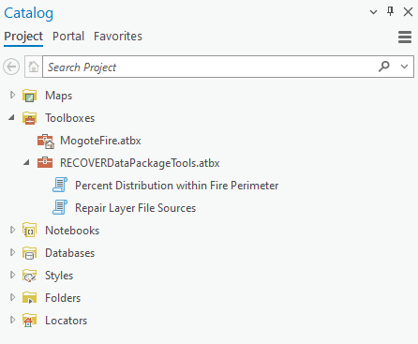

1. Double-click the script Repair Layer File Sources to open it in the Geoprocessing pane.
2. Click on the file selector to navigate to the previously extracted fire folder, then press “OK”. 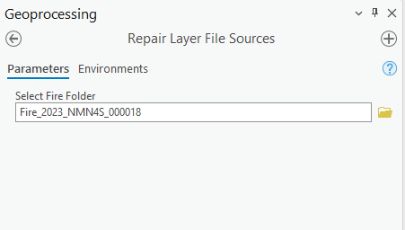

NOTE: the folder name may not be the same as shown above but will be *similar*.

1. Click "Run" in the bottom right corner of the Geoprocessing pane.

The script will fix the source for the "broken" .LYRX files. Once completed, the .LYRX files can be added to your map and the layers will draw with the correct symbology without you needing to deal with those pesky red exclamation points and manually resetting the data source.

**Using the PERCENT DISTRIBUTION WITHIN FIRE PERIMETER Tool**

Knowing the distribution of spatial features within a fire area is a common workflow for users of the NASA RECOVER DSS. For example, if you need to know how much of an area affected by a wildfire is managed by the Bureau of Land Management, you might use the geoprocessing tools of clipping, adding fields, and calculating the new fields for the new clipped feature class. The aim of the **PERCENT DISTRIBUTION WITHIN FIRE PERIMETER** tool is to perform this processing for you using a single tool where all parameters are specified once. This tool produces a new feature class, clipped to the fire perimeter, containing a new field called Distribution within Fire Area. This field gives the percent distribution within the fire area (e.g., the percentage of land managed by each land management agency).

This tool is compatible with the following feature classes found in the Fire.gdb found in each RECOVER data package (more descriptive feature class names in parentheses if applicable):

* SMA (Surface Management Agency)
* Soils_gSSURGO
* Soils_STATSGO
* Geology
* Habitat
* WBD (Watershed Boundary Dataset)
* LandslidePotential
* Wetlands
* Wilderness_Status

NOTE: Early versions of the Percent Distribution Within Fire Perimeter tool (lacking semantic version numbers e.g. 1.0.1) use feature classes as clip features which do not respect selections. The early versions of this tool can be edited to use feature layers as clip features by

Steps:

1. Add the fire perimeter feature class to a map. (NOTE: Fire perimeter feature classes contain fire perimeters at different points in time, indicated by the various date fields in their attribute tables. It is recommended to select one of the fire shapes (example below) to get percent distribution for that fire at that specific point in time. Otherwise, this tool will calculate the percent distribution for the total area of the fire at every point in time.)

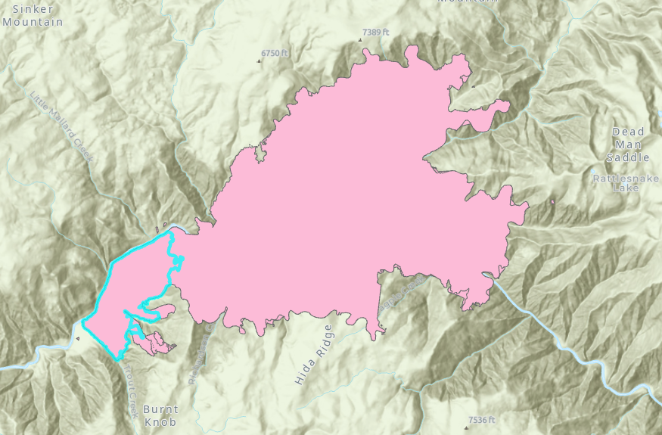

1. Open Catalog pane.
2. Expand Toolboxes.
3. Expand the Toolbox titled RECOVERDataPackageTools.atbx

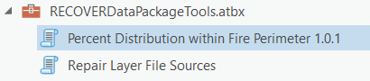

1. Double-click the script Percent Distribution within Fire Perimeter 1.0.1 to open it in the Geoprocessing pane.
2. Complete the input dialog as follows:
   1. Click Browse to navigate to the Fire.gdb geodatabase within the fire folder.
   2. Select the geodatabase and click OK.
   3. Click Browse to navigate to the feature class you wish to clip (NOTE: this feature class needs to be located within the same Fire geodatabase)
   4. Click OK.
   5. Click the dropdown menu to select the fire’s perimeter feature layer from your map’s layers.
   6. Click OK.
   7. The completed tool dialog will look *similar* to that shown below.

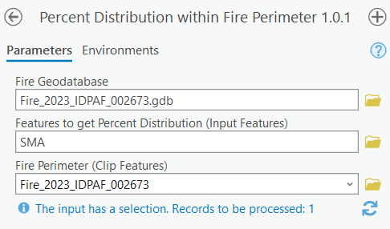

In the example shown above, the SMA feature class is being clipped to the selection within the Fire_2023_IDPAF_002673 feature layer.

* 1. Click the Run button located in the bottom right corner of the Geoprocessing pane.

The new feature class will be automatically added to the geodatabase and to your map with _Distribution added to the end of its name (e.g., SMA_Distribution).

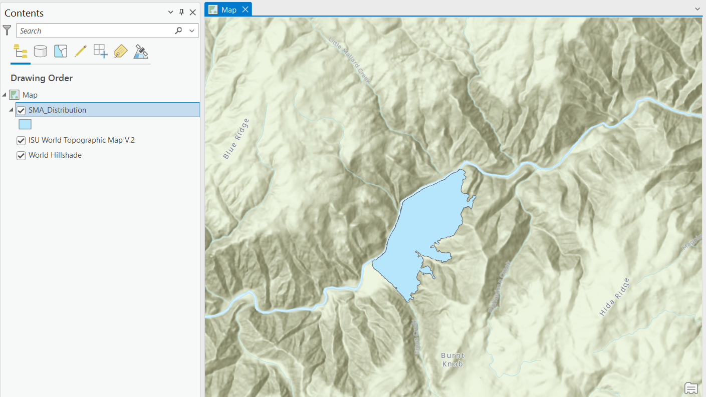

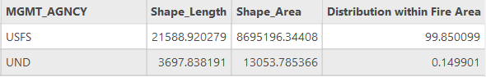

Notice that the SMA feature class has now been clipped to the shape of the selection of the FirePerimeter_2023_NMN4S_000018 feature layer and contains the new Distribution within Fire Area field showing the percentage of each Surface Management Agency present within the perimeter (NOTE: you may wish to change the symbology to show the location of various land management areas).

You can use this tool to calculate other distributions within the fire perimeter as well.

NOTE: Early versions of the Percent Distribution Within Fire Perimeter tool (lacking semantic version numbers e.g. 1.0.1) use feature classes as clip features which do not respect selections. The early versions of this tool can be edited to use feature layers as clip features by following these steps:

1. Right-click the tool and select Properties.

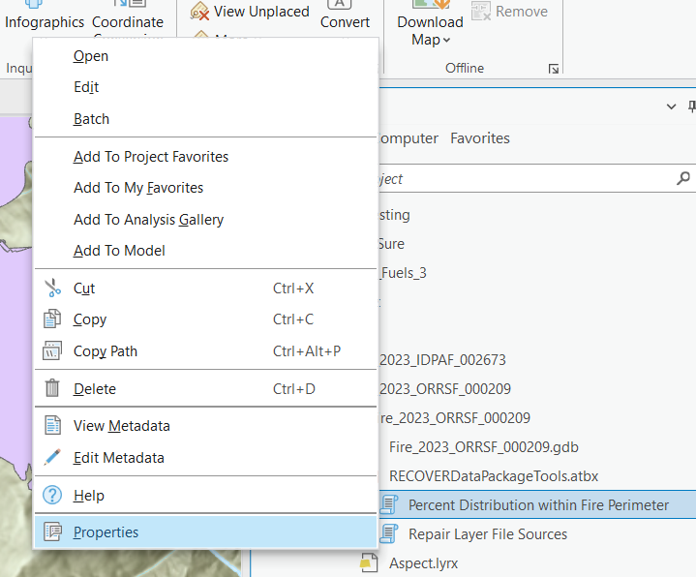

1. Click Parameters in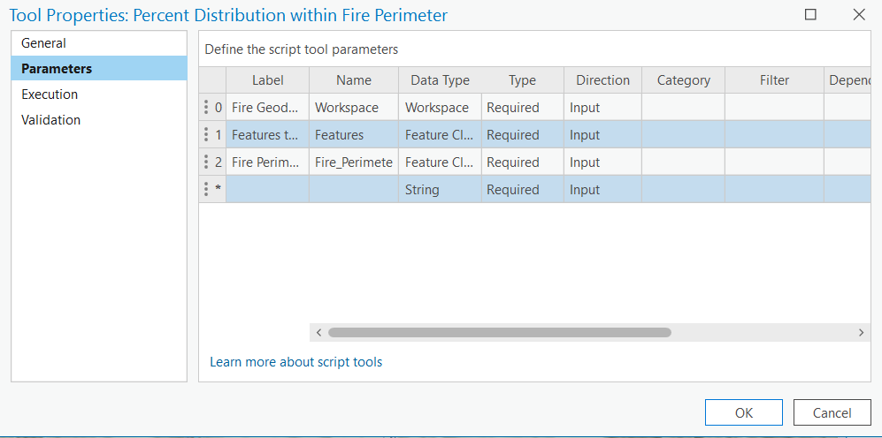 the Tool Properties dialog.
2. Click the three dots next to Feature Class in the Data Type field to open the Parameter Data Type dialog. Change the Data Type of the Fire Perimeter parameter to Feature Layer using the dropdown menu. Click OK

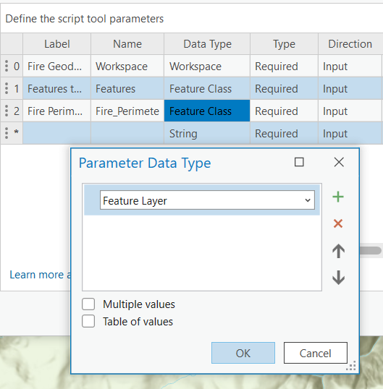

1. Click OK in the Tool Properties dialog to finalize the changes.

The tool will now use a feature layer as the clip features, allowing selections to be made on different fire perimeters within the same feature class.

END