Sentiment Analysis on a Sentient Creation: Generative AI

Ekaum Soni, Eshaan Mehta, Reema Sharma, Reddy Prasad Rayalam

# Abstract

This project aimed to analyze news articles’ overall sentiment on generative AI. Through extensive research and analysis, we aimed to understand the sentiment surrounding this emerging technology comprehensively. We collected and analyzed numerous news articles throughout the project, applying NLP techniques and sentiment analysis algorithms to garner a deeper understanding of sentiment patterns. Our findings provided valuable insights into the public perception of Generative AI technology: we found a generally positive trend of sentiments over the last two years on such news articles. We also analyzed business cases of generative AI being implemented for better customer experiences; from our analysis, we predict that more businesses will be integrating new technology to offer distinguished value to customers.

# Introduction

The project’s premise is to explore the public’s response to generative AI and its portrayal in the media. By examining news articles, we seek to uncover the attitudes and concerns surrounding this evolving technology. We also explore the shift in public attitude towards generative AI over time and its various aspects through detailed analyses and visualizations. This analysis will contribute to a deeper understanding of the ethical, social, and technological implications associated with Generative AI.

This project's key features and use cases include analyzing overall sentiment in publications, identifying media coverage trends, understanding public perception, and facilitating informed discussions. Through this research, we aim to answer questions about the acceptance, concerns, and potential impacts of Generative AI on society for the foreseeable future.

# Data Sources and Methods

Our data was sourced from the AYLIEN API[1] that offers a range of competencies such as analyzing and extracting information from textual data, including text analysis, sentiment analysis, summarization, and language detection. With a business email, our group was able to gain access to a free 14-day trial. From there, we inputted “generative AI” as our keyword, filtered to only include English articles, and selectively accessed articles in the fields of business crime, business ethics, science and technology, and finance. We hoped that this cluster of topics would offer a more

business-oriented perspective on generative AI. We adjusted our period of interest to as far back as possible within our account limit, which came out to around a 2 year timeframe. The initial search resulted in over 50,000 articles from a plethora of news sources. In the end, it was very easy to export the top 1000 article results to a .jsonl file.

# Analysis

## Word Clouds:

In our project, the primary focus of analysis was placed on the titles of the articles rather than their content. This approach was adopted considering that a substantial portion of readers tends to skim through articles, making titles more significant in capturing attention. As users of media ourselves, we knew as readers, admittedly so, we tend to read the headlines instead of the actual content so we felt that the titles were more likely to shape community perception and mindset more than anything. Moreover, titles are often the most polarizing elements of an article, as their purpose is to engage users effectively.

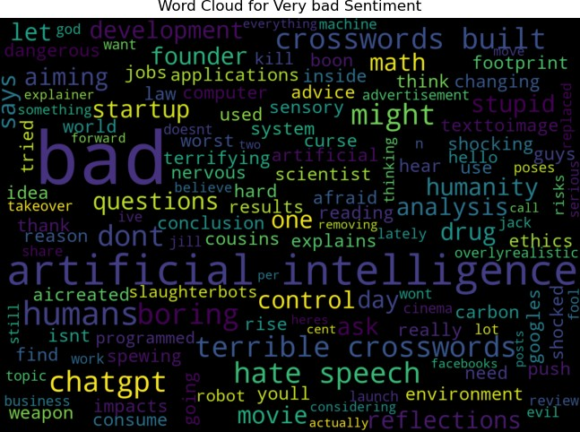

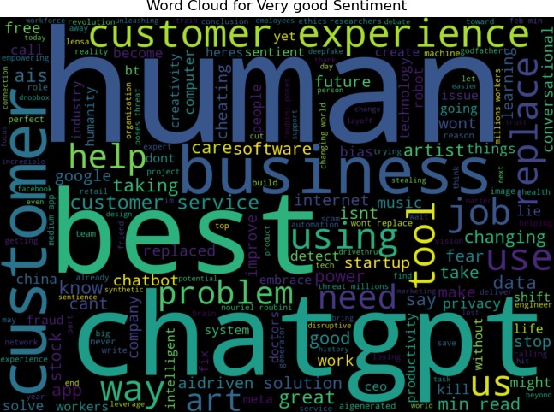

We generated word clouds based on these titles and categorized them into distinct sentiment ranges, namely very bad (-1 to -0.5), bad (-0.5 to 0), good (0 to 0.5), and very good (0.5 to 1).

However, upon analyzing the resulting word clouds, we observed that the larger, more prominent words did not provide as much contextual information as the smaller words. Interestingly, the smaller words in the good sentiment range included terms such as "change" and "creative," while the smaller words in the bad sentiment range consisted of words like "fake", “drug”, "stealing job."

This finding underscores the importance of considering both the prominence and significance of words in word cloud visualizations, as the smaller, less prominent words can often contribute crucial contextual nuances.

## Moving Average:

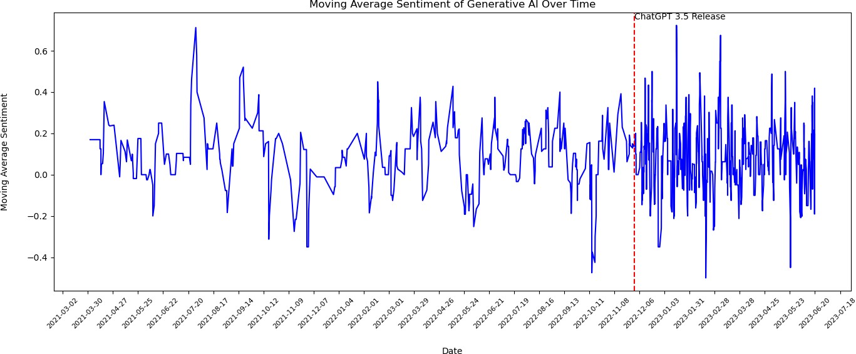

This visualization depicted the aggregate sentiment over the years through a line graph, utilizing news article data starting from March 2021. Immediately, our team’s attention was drawn to the sudden surge in the significant oscillations in polarity. Upon further investigation, we

cross-referenced the dates and discovered that this spike coincided with the release of Chat GPT 3.5. This finding prompted us to delve deeper into the escalating article volumes and present them through an additional visualization where we showed the number of articles that from 2021-2023 and as expected, after Nov 2022, there was a clear jump in engagement and publication count.

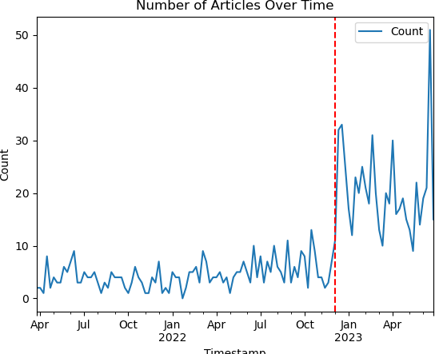

It should be noted that although the count on the y-axis says 50, this is only due to the size of our dataset. We assume that the true population news count follows a similar pattern.

## Monthly Average Polarity:

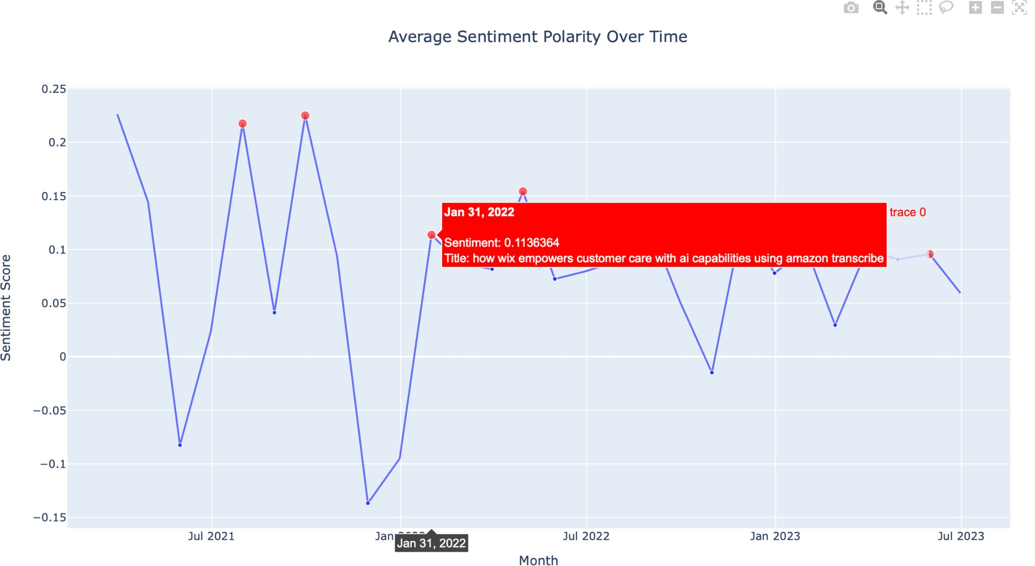

The visualization above showcases various articles and their respective sentiment scores across a span of 2 years. Using Plotly’s interactive line plot, we are able to see each data point containing the article title, its date of publication, as well as the respective sentiment score. Within this graph, we notice that the overall trend of sentiment scores vary significantly for each article published across the span of 2 years. Early 2021 and 2022 show a larger variation in sentiment scores—this is expected as the technology came to limelight during this time, leaving the general public skeptical about its implementation. However, as generative AI technology became more prevalent in late 2022 and 2023, it is evident that generative AI sentiments became more contained around a slightly positive outlook.

For future extrapolation, as our dataset focused primarily on business-related media articles, businesses can analyze overall public sentiment around a certain technology and can choose whether or not to integrate those systems to provide greater customer value. In this specific use case, businesses looking to incorporate generative AI in their products have a higher incentive to do so, as the media representation and overall public perception is skewed positively over the last year.

## Seaborn Violin Plot:

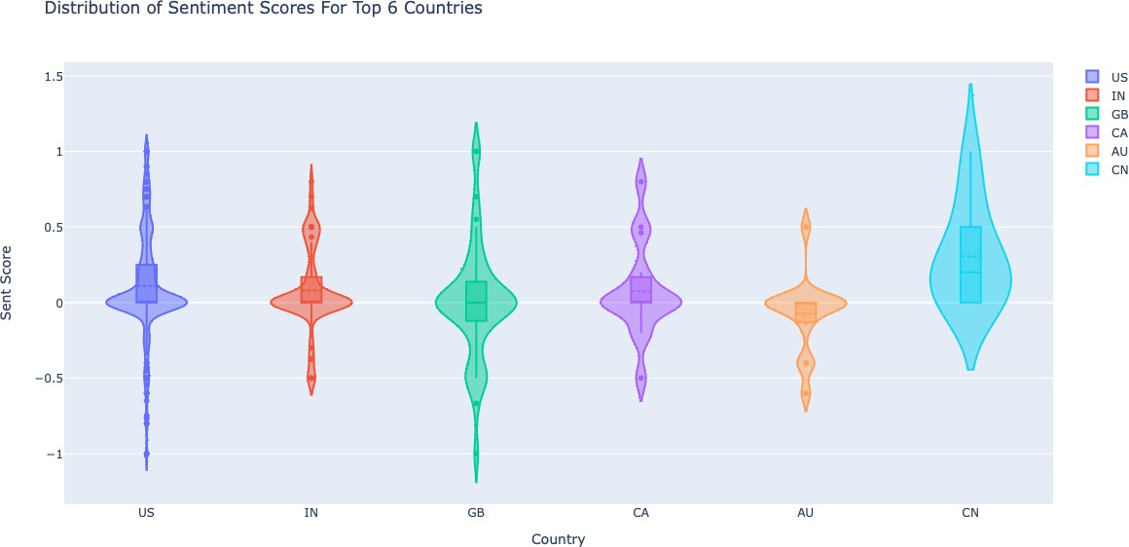

This visualization utilized the interactive Plotly module on a violin plot to effectively showcase the spread and the concentration of sentiment scores per country. By computing the number of articles written in each country, we chose to plot the top 6 countries represented.

Through the plot, we can see that the US and Canada are the most significantly different countries in terms of their general outlook on generative AI. While the US published articles with an average sentiment score of 0.15, the density graph illustrates a general trend of outlier article scores, denoted by the dots on the plot. There’s just as many positive sentiments as there are negatives; meanwhile, Canada doesn’t have any outlier points at all and their lowest sentiment score was neutral polarity. Our most probable prediction would be because the US, known for its conspiracist population, prefers polarizing, eye-catching headlines compared to Canada that had a reputation for being more neutral and more trusting. In a larger context, visualizations like this allow us to formulate conclusions not only about the data at hand, but the behaviors of entire populations.

# Conclusions

The project implemented in the provided Python script successfully reads and processes news data, extracting crucial attributes such as the title, summary, and publication location data. We used this data to conduct sentiment analysis, specifically on the news titles, employing various libraries to compute and visualize each title’s sentiment polarity score. The analysis also includes insightful visualizations such as line graphs illustrating the weekly and monthly average sentiment polarity over time and a moving average of these sentiment scores. Additionally, we were able to identify the most polar news articles, and categorize sentiment scores into bins: 'Very Bad', 'Bad', 'Good', and 'Very Good'. A violin plot is constructed showing sentiment score distributions for the top six countries present in the dataset, facilitating quick inter-country comparisons.

However, the project does come with certain limitations. It assumes that all news titles are in English, potentially compromising the accuracy of sentiment analysis for non-English news. Although a function for removing stop words is defined, it is not as thorough as it needs to be, and some generic words we had not thought of still managed to be shown in the Word Clouds. And finally, the news data we processed is only valid for 2 years, and if we wanted to get more comprehensive results, we would have to find more comprehensive data sets. Due to limitations in our access to data, we weren’t able to draw broader conclusions about the impact of the pandemic on the AI field.