EX. NO: 2
BOOK BANK SYSTEM
Date: 02.11.2026
AIM
To develop a Book Bank system using UML in which the details of the student are verified by the central computer, the approval is given to the book bank office, and the books required by the student are then issued from the office to the student.
PROBLEM STATEMENT
A student requests the books he needs from the book bank. The administrator in the book bank enters the details of the student and provides them to the central computer. The central computer verifies the details of the student and provides its approval to the book bank office. After the approval, the office checks the availability of the books and issues them to the student. If the verification fails, the student is informed of the rejection and no books are issued.
SOFTWARE USED
Umbrello UML Modeller
ACTORS AND THEIR ROLES
Actor / Entity | Role in the system
Student | Requests the books, gives the student details and finally receives the issued books.
Administrator | Enters the student details at the book bank counter and sends them to the central computer.
Central Computer | Verifies the details of the student and provides the approval (or rejection) to the book bank office.
Book Bank Office | Receives the approval, checks the availability of the books, issues the books to the student and updates the book stock.
PROCEDURE
- Open Umbrello UML Modeller and create a new project named “Book Bank System”.
- Identify the actors (Student, Administrator, Central Computer, Book Bank Office) and the use cases, and draw the Use Case Diagram.
- Identify the classes with their attributes and operations, and draw the Class Diagram with associations and multiplicities.
- Draw the Activity Diagram with swimlanes to show the flow of activities among the four actors.
- Draw the Sequence Diagram to show the time-ordered messages exchanged between the objects.
- Draw the Collaboration Diagram to show the same interaction as numbered messages between linked objects.
- Save the diagrams and export them as images.
1. USE CASE DIAGRAM
The use case diagram shows the functions provided by the system and the actors who use them. The Student requests the books, provides his details and receives the books. The Administrator enters the student details and sends them to the central computer. The Central Computer verifies the details of the student and provides the approval to the office. The Book Bank Office receives the approval, checks the availability of the books, issues them and updates the book stock.
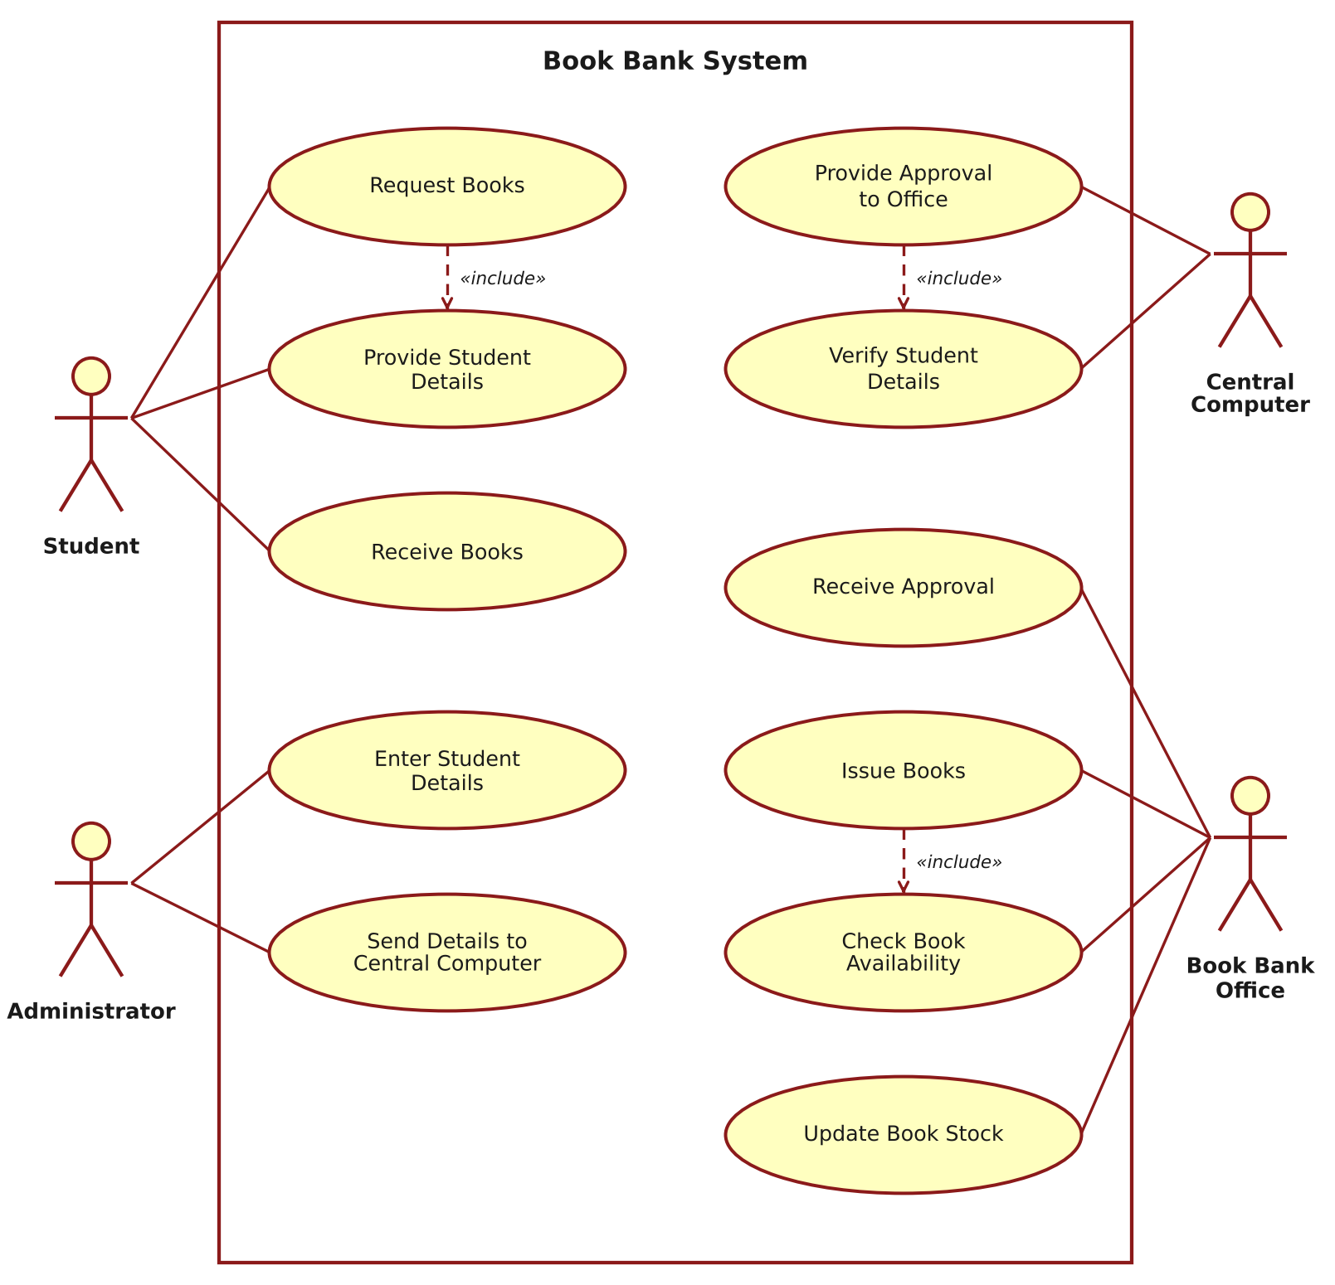
Figure 1: Use Case Diagram – Book Bank System
2. CLASS DIAGRAM
The class diagram shows the static structure of the system. A Student makes many BookRequests, each of which is entered by an Administrator. The Administrator sends the details to the CentralComputer, which approves the BookBankOffice. The BookBankOffice issues the BookIssue records, each of which contains one or more Books and is received by a Student.
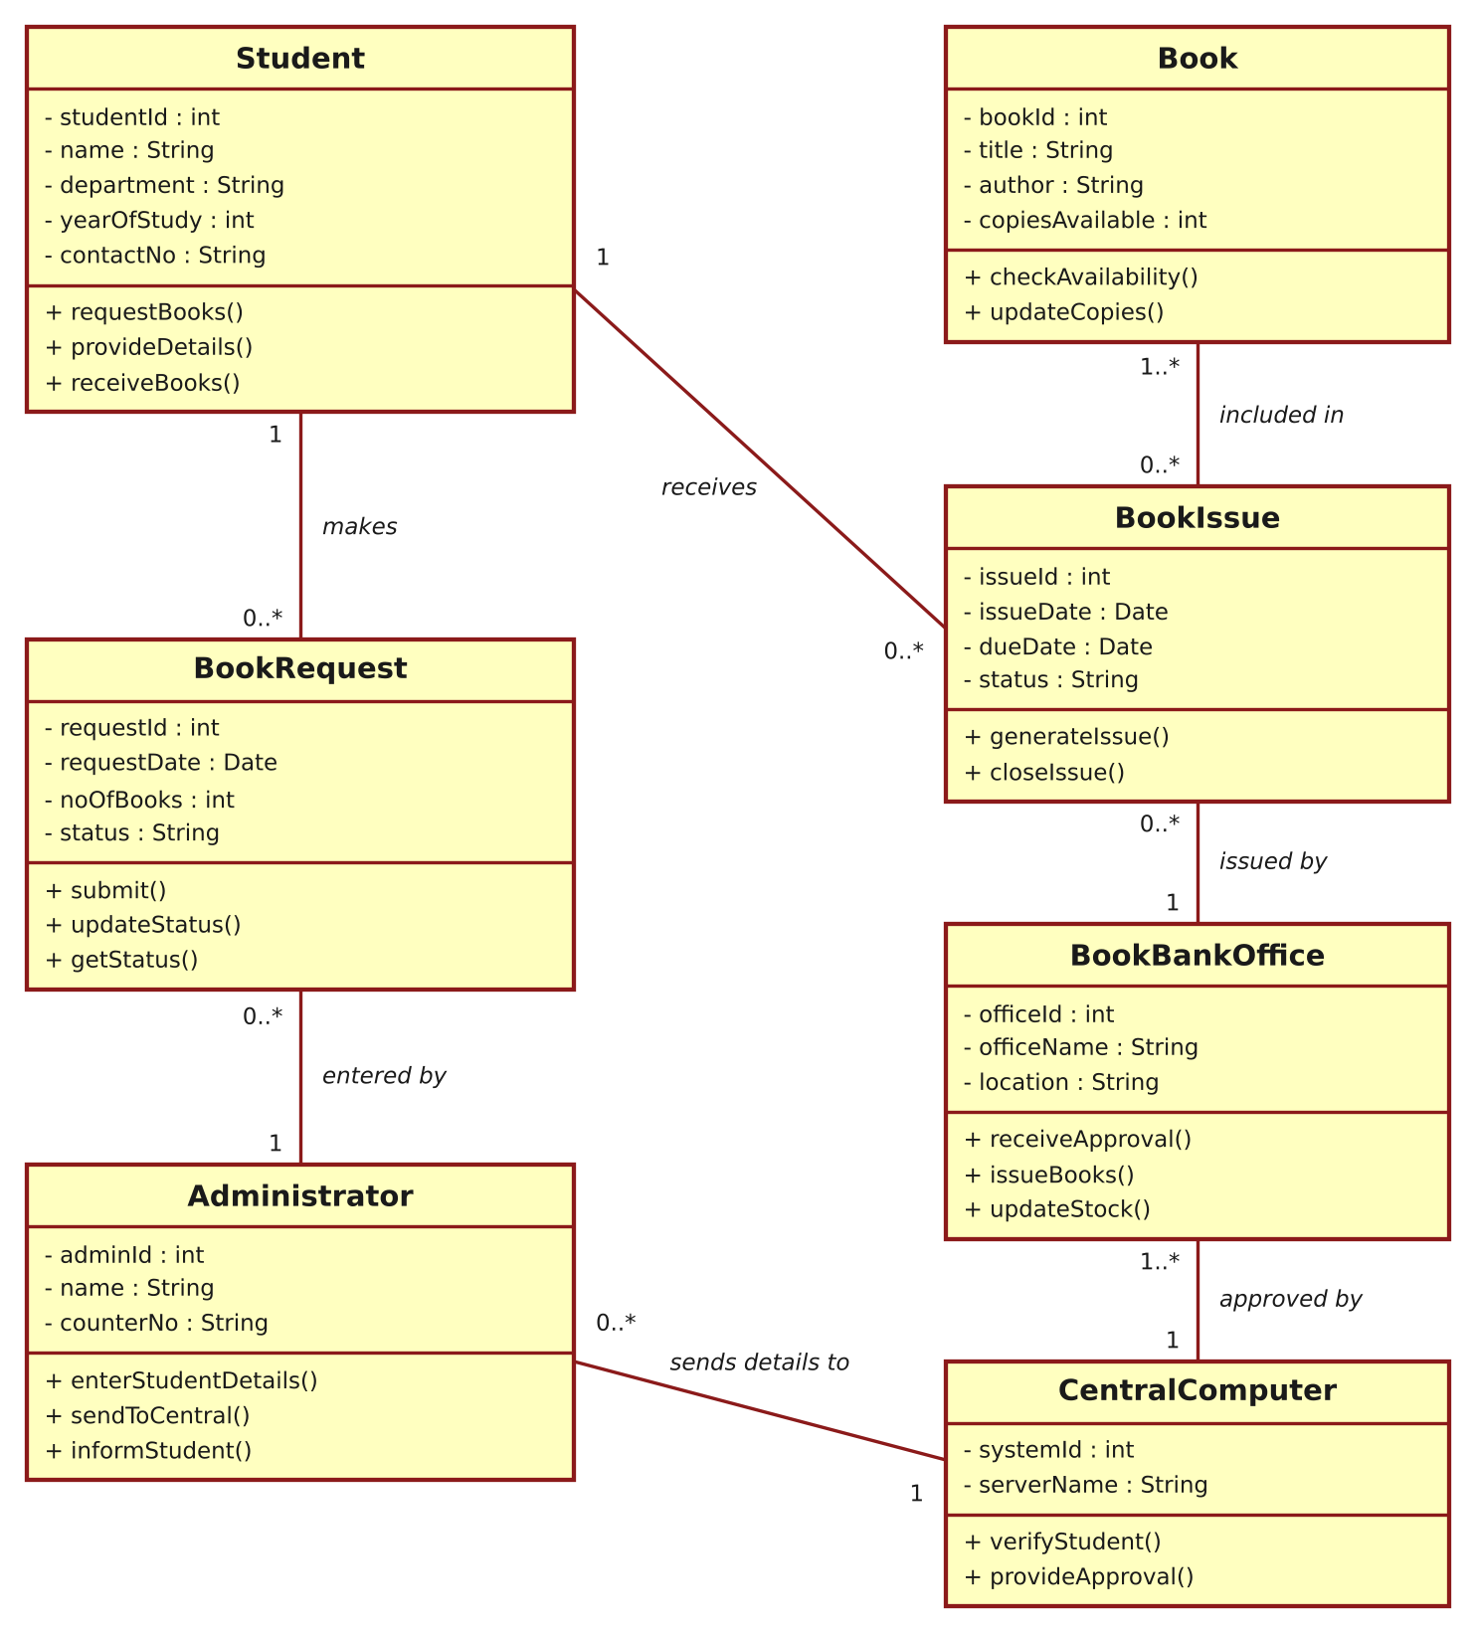
Figure 2: Class Diagram – Book Bank System
3. ACTIVITY DIAGRAM
The activity diagram, drawn with swimlanes, shows the flow of work among the Student, the Administrator, the Central Computer and the Book Bank Office. After the central computer verifies the details, the flow branches: if the details are valid, the approval is sent to the office, which checks the availability of the books and issues them; otherwise the student is informed of the rejection.
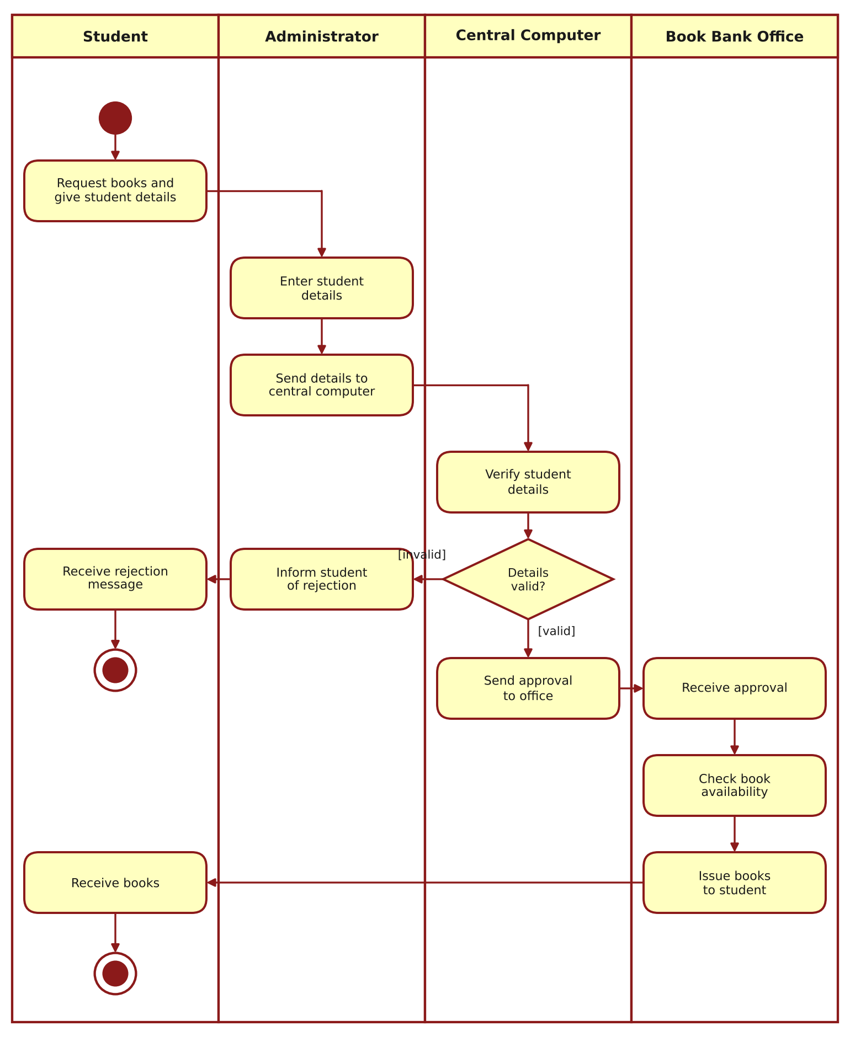
Figure 3: Activity Diagram – Book Bank System
4. SEQUENCE DIAGRAM
The sequence diagram shows the order of messages exchanged between the objects over time. The student requests the books, the administrator enters and sends the student details, the central computer verifies the student and sends the approval to the office, and the office checks the availability, updates the stock and issues the books to the student.
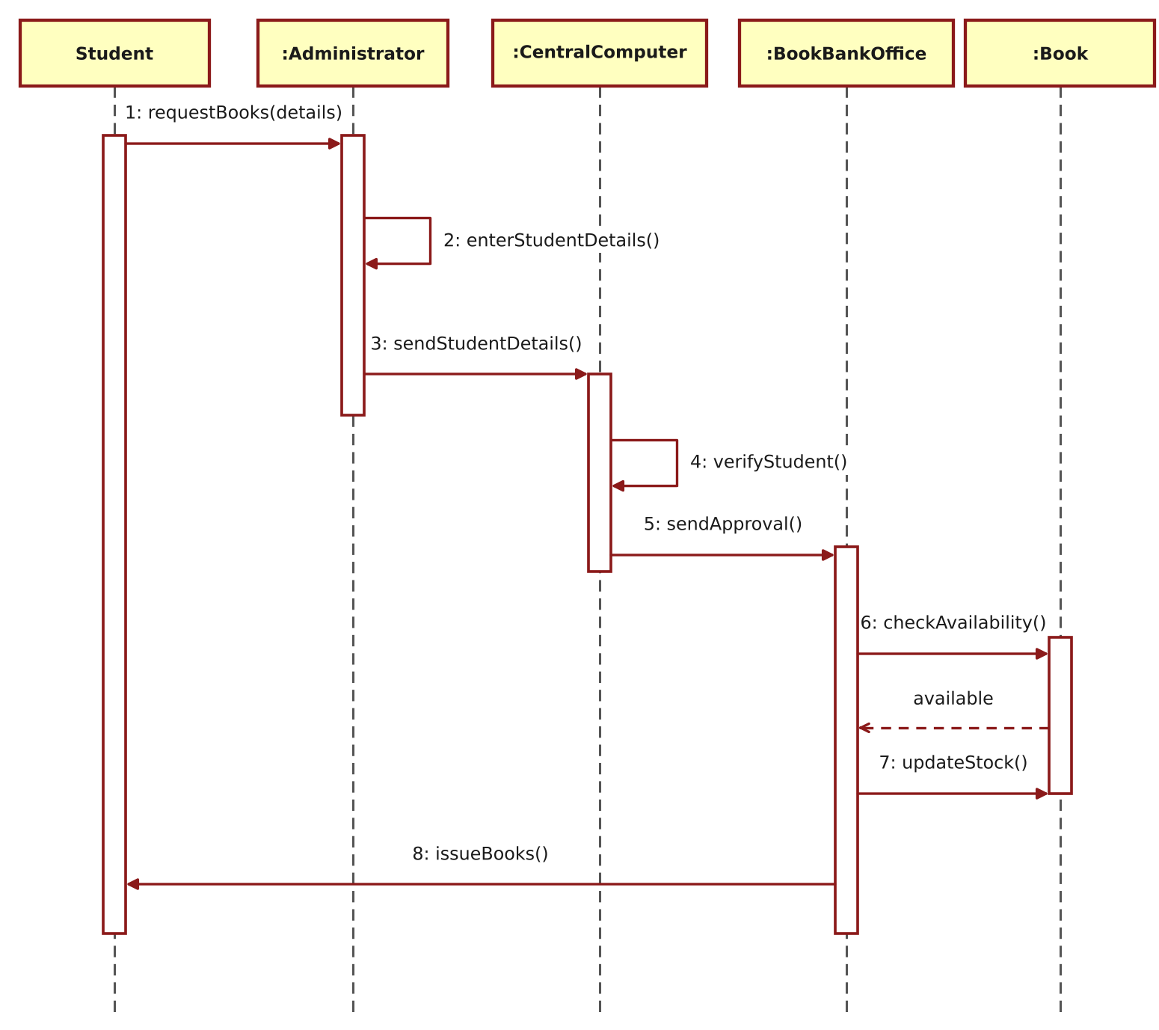
Figure 4: Sequence Diagram – Book Bank System
5. COLLABORATION DIAGRAM
The collaboration diagram shows the same interaction as the sequence diagram, but emphasises the links between the objects. The sequence of messages is indicated by the numbers 1 to 8.
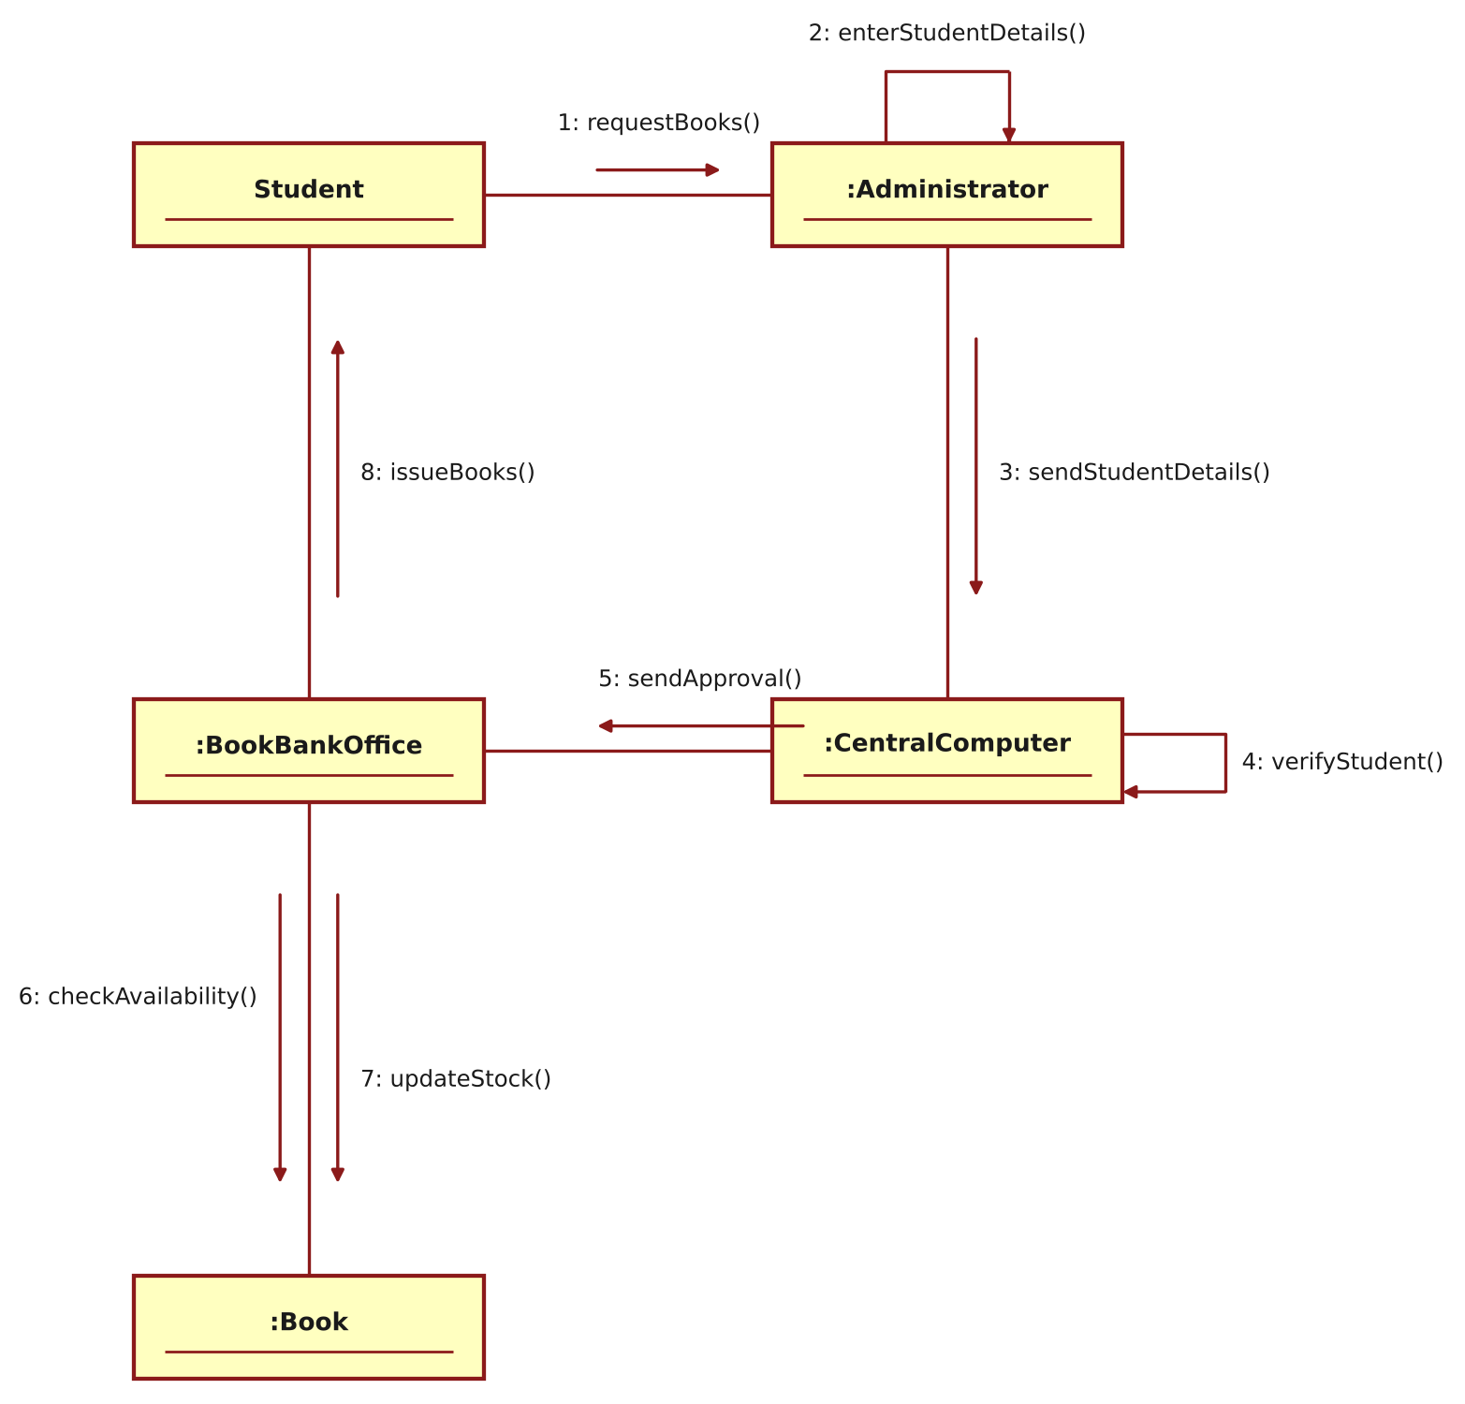
Figure 5: Collaboration Diagram – Book Bank System
RESULT
Thus the Book Bank System was modelled using Umbrello UML Modeller, and the Use Case, Class, Activity, Sequence and Collaboration diagrams were drawn and verified successfully.

