EX. NO: 3
EXAM REGISTRATION PORTAL
Date: 02.11.2026
AIM
To develop an Exam Registration Portal using UML in which the details of the candidate are verified by the central computer, the approval is provided, and the hall ticket is then issued from the office to the candidate.
PROBLEM STATEMENT
A candidate registers for an examination and provides his details. The administrator enters the details of the candidate and provides them to the central computer. The central computer verifies the details of the candidate and provides its approval to the exam office. After the approval, the exam office generates the hall ticket and issues it to the candidate. If the verification fails, the candidate is informed of the rejection and no hall ticket is issued.
SOFTWARE USED
Umbrello UML Modeller
ACTORS AND THEIR ROLES
Actor / Entity | Role in the system
Candidate | Registers for the exam, gives his details and finally receives the hall ticket.
Administrator | Enters the candidate details at the registration counter and sends them to the central computer.
Central Computer | Verifies the details of the candidate and provides the approval (or rejection) to the exam office.
Exam Office | Receives the approval, allocates a seat, generates and issues the hall ticket to the candidate and updates the registration record.
PROCEDURE
- Open Umbrello UML Modeller and create a new project named “Exam Registration Portal”.
- Identify the actors (Candidate, Administrator, Central Computer, Exam Office) and the use cases, and draw the Use Case Diagram.
- Identify the classes with their attributes and operations, and draw the Class Diagram with associations and multiplicities.
- Draw the Activity Diagram with swimlanes to show the flow of activities among the four actors.
- Draw the Sequence Diagram to show the time-ordered messages exchanged between the objects.
- Draw the Collaboration Diagram to show the same interaction as numbered messages between linked objects.
- Save the diagrams and export them as images.
1. USE CASE DIAGRAM
The use case diagram shows the functions provided by the system and the actors who use them. The Candidate registers for the exam, provides his details and receives the hall ticket. The Administrator enters the candidate details and sends them to the central computer. The Central Computer verifies the details of the candidate and provides the approval. The Exam Office receives the approval, generates and issues the hall ticket and updates the registration record.
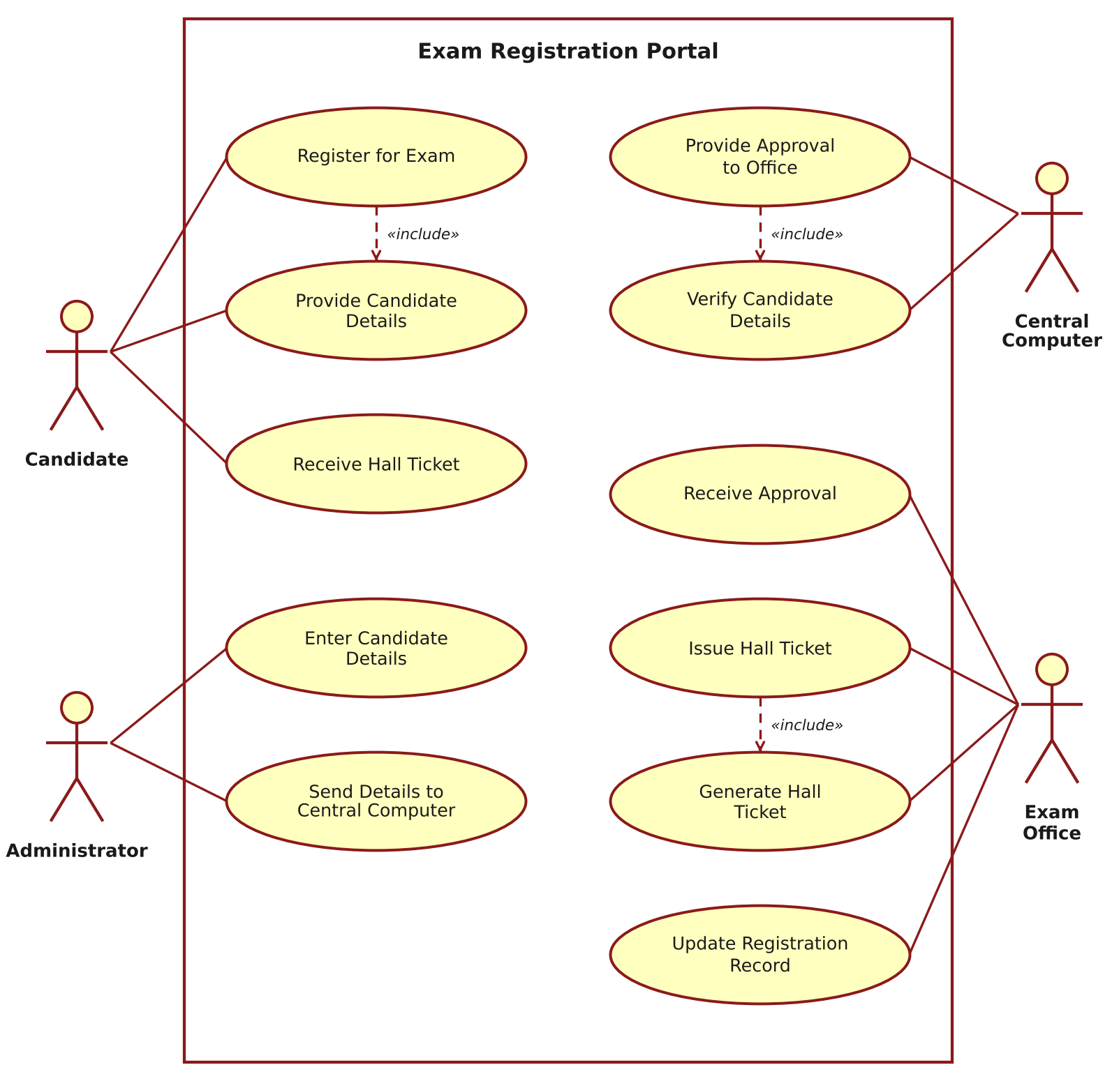
Figure 1: Use Case Diagram – Exam Registration Portal
2. CLASS DIAGRAM
The class diagram shows the static structure of the system. A Candidate makes many Registrations, each of which is entered by an Administrator. The Administrator sends the details to the CentralComputer, which approves the ExamOffice. The ExamOffice issues HallTickets, each of which is assigned for one Exam and is received by a Candidate.
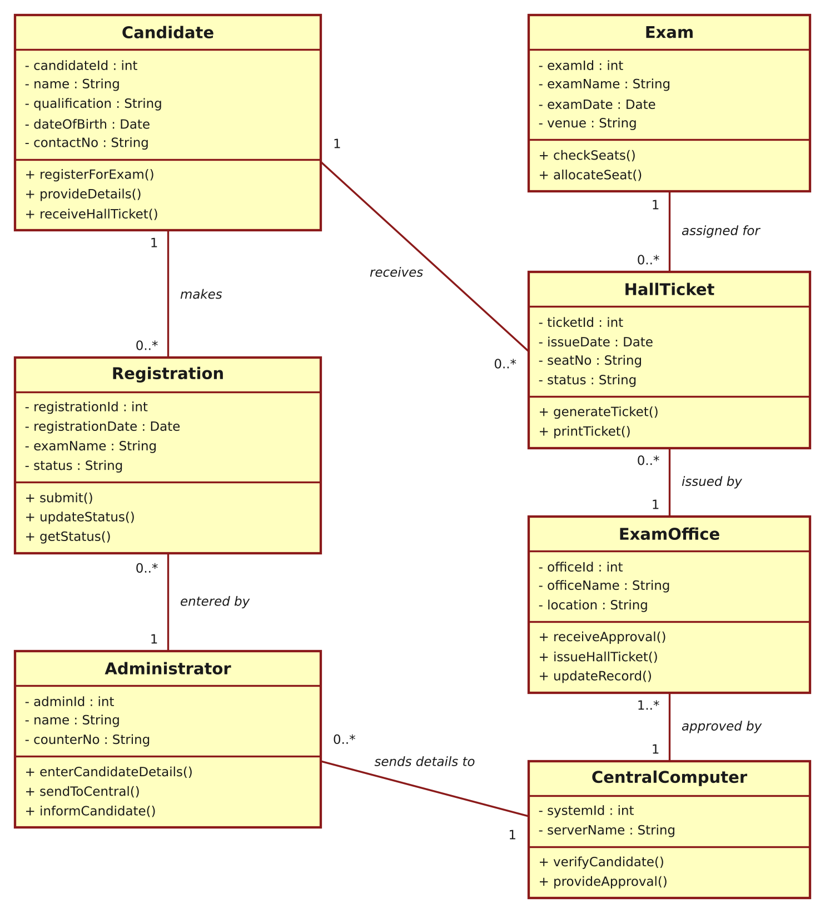
Figure 2: Class Diagram – Exam Registration Portal
3. ACTIVITY DIAGRAM
The activity diagram, drawn with swimlanes, shows the flow of work among the Candidate, the Administrator, the Central Computer and the Exam Office. After the central computer verifies the details, the flow branches: if the details are valid, the approval is sent to the office, which checks the seat availability and issues the hall ticket; otherwise the candidate is informed of the rejection.
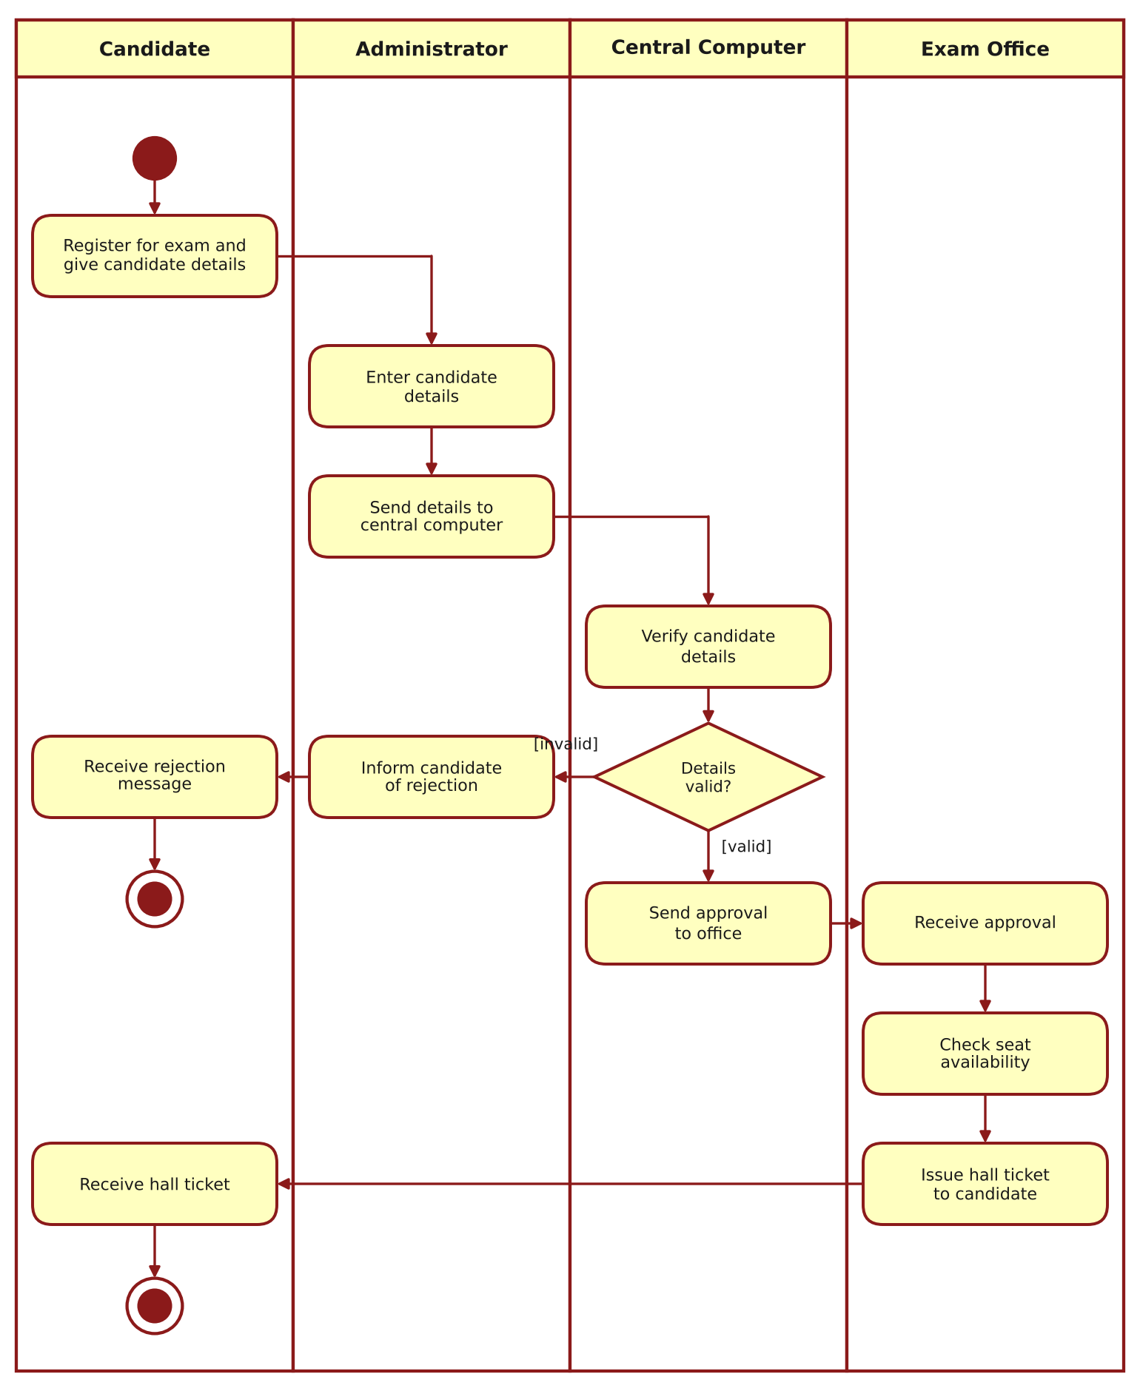
Figure 3: Activity Diagram – Exam Registration Portal
4. SEQUENCE DIAGRAM
The sequence diagram shows the order of messages exchanged between the objects over time. The candidate registers for the exam, the administrator enters and sends the candidate details, the central computer verifies the candidate and sends the approval to the office, and the office checks the seats, allocates a seat and issues the hall ticket to the candidate.
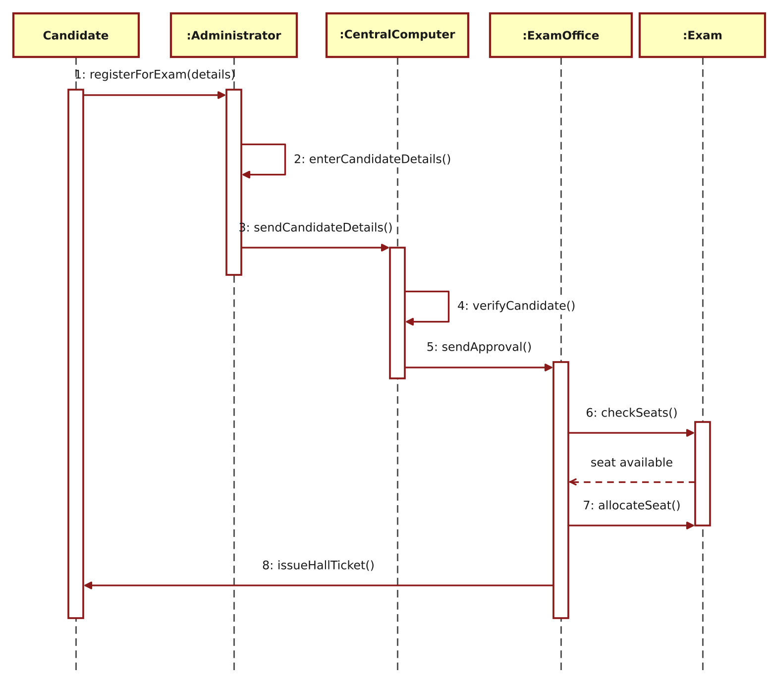
Figure 4: Sequence Diagram – Exam Registration Portal
5. COLLABORATION DIAGRAM
The collaboration diagram shows the same interaction as the sequence diagram, but emphasises the links between the objects. The sequence of messages is indicated by the numbers 1 to 8.
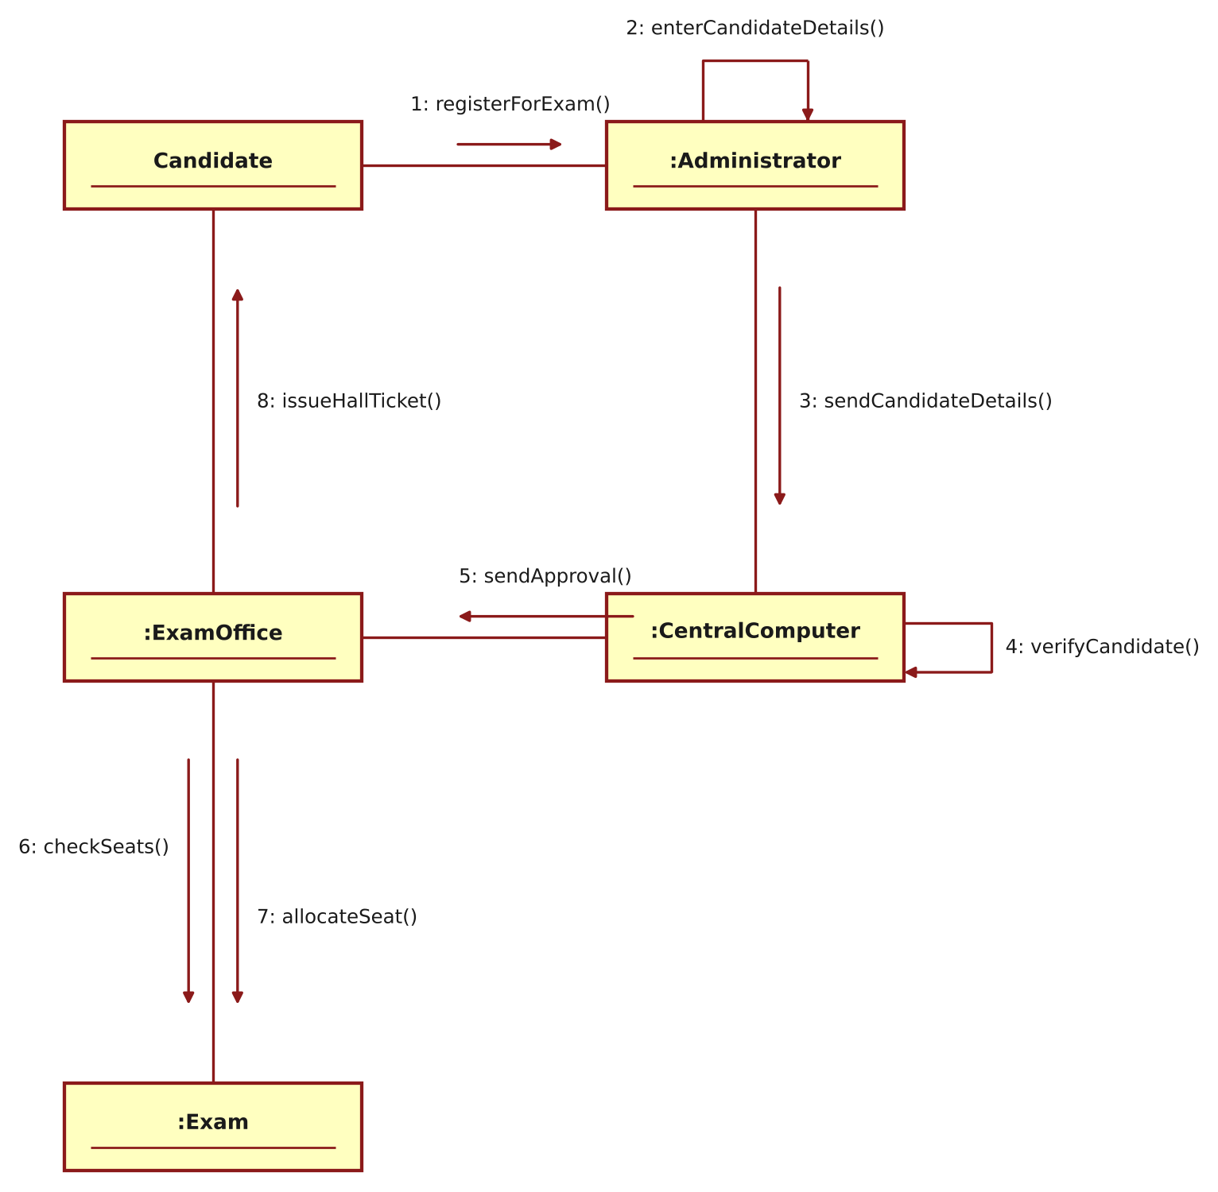
Figure 5: Collaboration Diagram – Exam Registration Portal
RESULT
Thus the Exam Registration Portal was modelled using Umbrello UML Modeller, and the Use Case, Class, Activity, Sequence and Collaboration diagrams were drawn and verified successfully.

