EX. NO: 1
PASSPORT MANAGEMENT SYSTEM
Date: 30.10.2026
AIM
To develop a Passport Management System using UML in which the passport details of the applicant are verified by the central computer, the approval is given to the passport office, and the passport is then issued to the applicant.
PROBLEM STATEMENT
An applicant applies for a passport by submitting the application form, supporting documents and the prescribed fee at the passport office. The passport office sends the applicant’s details to the central computer. The central computer verifies the passport details and the applicant and provides its approval to the office. After the approval, the passport office prepares the passport and issues it to the applicant. If the verification fails, the application is rejected and the applicant is informed.
SOFTWARE USED
Umbrello UML Modeller
ACTORS AND THEIR ROLES
Actor / Entity | Role in the system
Applicant | Fills the application form, submits documents, pays the fee, tracks the status and finally receives the passport.
Passport Office | Receives the application, forwards the details to the central computer, approves the application after verification and issues the passport.
Central Computer | Verifies the passport details and the applicant, and sends the approval (or rejection) to the passport office.
PROCEDURE
- Open Umbrello UML Modeller and create a new project named “Passport Management System”.
- Identify the actors (Applicant, Passport Office, Central Computer) and the use cases, and draw the Use Case Diagram.
- Identify the classes with their attributes and operations, and draw the Class Diagram with associations and multiplicities.
- Draw the Activity Diagram with swimlanes to show the flow of activities among the three actors.
- Draw the Sequence Diagram to show the time-ordered messages exchanged between the objects.
- Draw the Collaboration Diagram to show the same interaction as numbered messages between linked objects.
- Save the diagrams and export them as images.
1. USE CASE DIAGRAM
The use case diagram shows the functions provided by the system and the actors who use them. The Applicant applies for the passport, submits documents, pays the fee, tracks the application status and receives the passport. The Passport Office receives and approves the application and issues the passport. The Central Computer verifies the passport details and the applicant and sends the approval to the office.
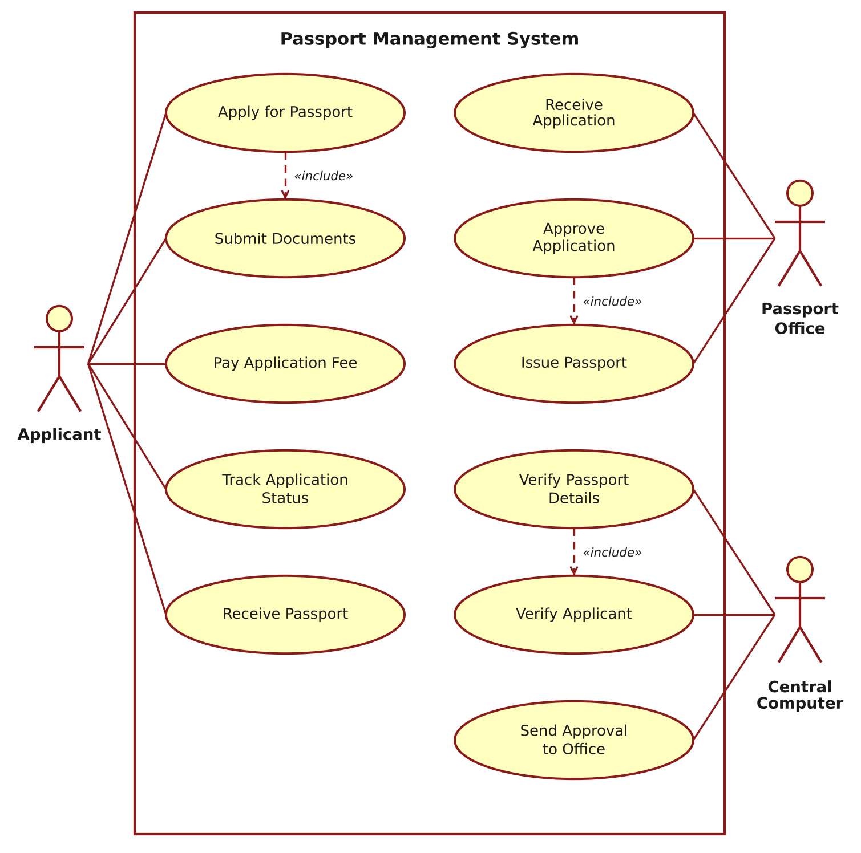
Figure 1: Use Case Diagram – Passport Management System
2. CLASS DIAGRAM
The class diagram shows the static structure of the system. An Applicant submits many Applications; each Application contains one or more Documents, is paid through one Payment, is processed by a PassportOffice and results in at most one Passport. The PassportOffice is verified through the CentralComputer.
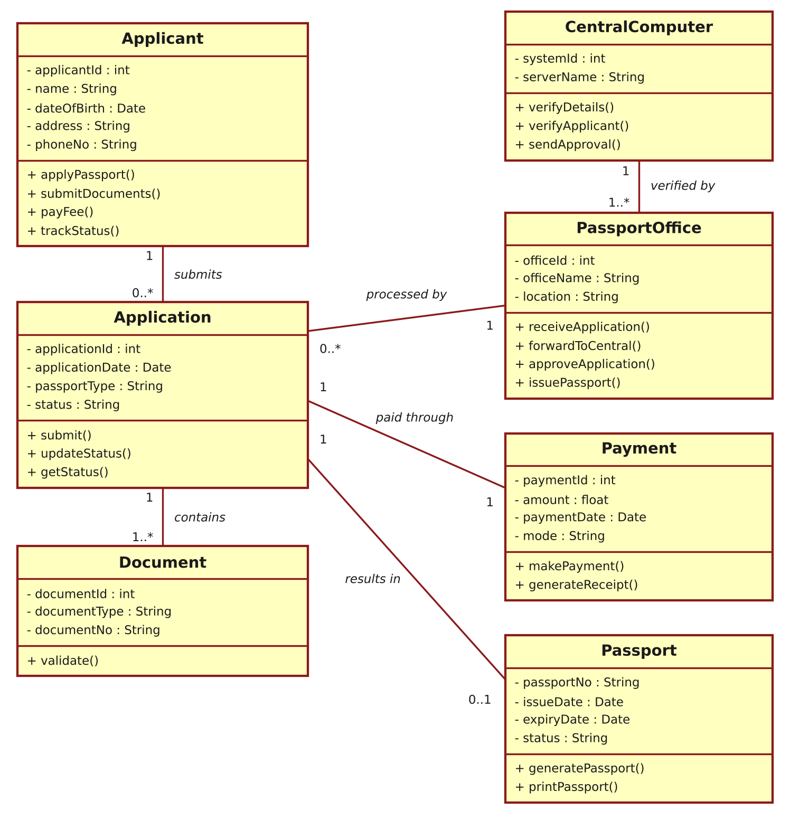
Figure 2: Class Diagram – Passport Management System
3. ACTIVITY DIAGRAM
The activity diagram, drawn with swimlanes, shows the flow of work among the Applicant, the Passport Office and the Central Computer. After the central computer verifies the details, the flow branches: if valid, the approval is sent and the passport is generated and issued; otherwise the application is rejected and the applicant is notified.
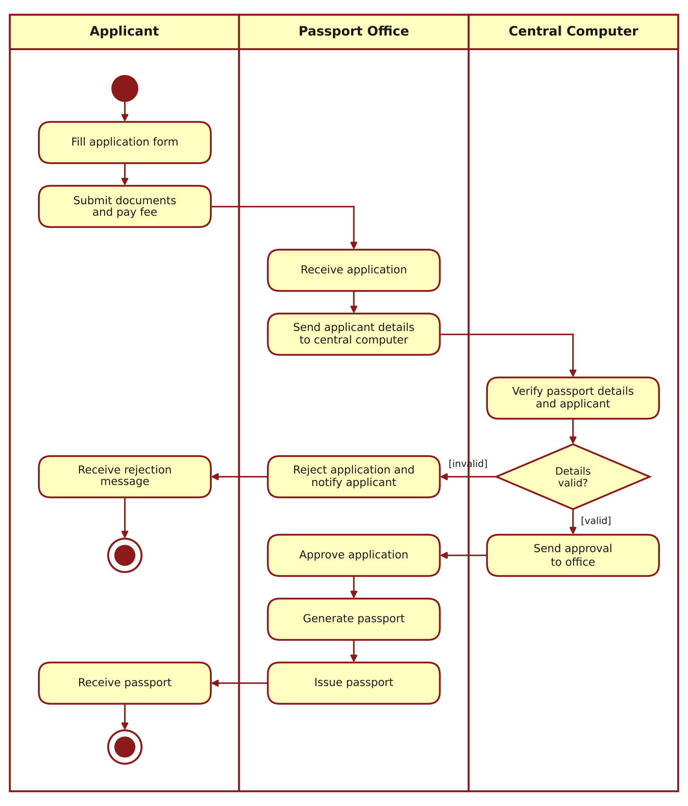
Figure 3: Activity Diagram – Passport Management System
4. SEQUENCE DIAGRAM
The sequence diagram shows the order of messages exchanged between the objects over time. The applicant submits the application, the office forwards the details to the central computer, the central computer verifies and returns the approval, and the office generates and issues the passport to the applicant.
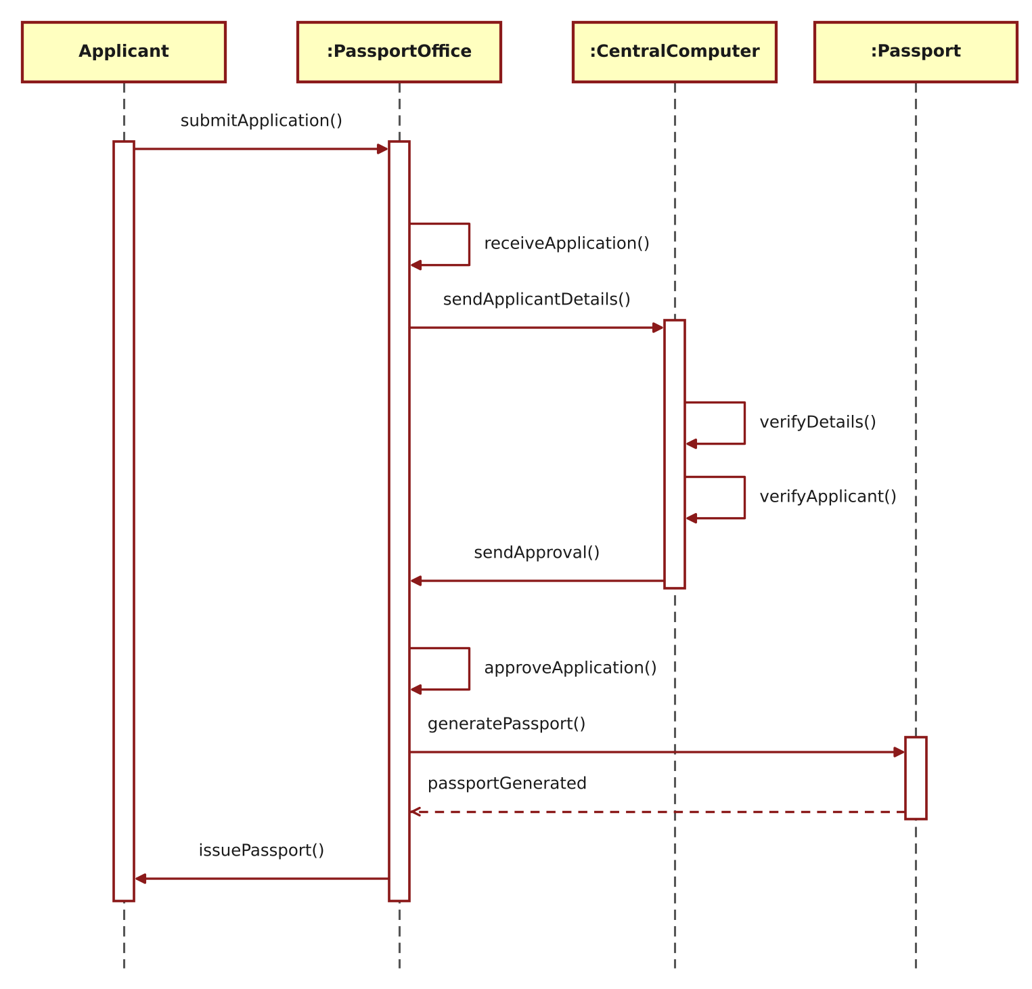
Figure 4: Sequence Diagram – Passport Management System
5. COLLABORATION DIAGRAM
The collaboration diagram shows the same interaction as the sequence diagram, but emphasises the links between the objects. The sequence of messages is indicated by the numbers 1 to 8.
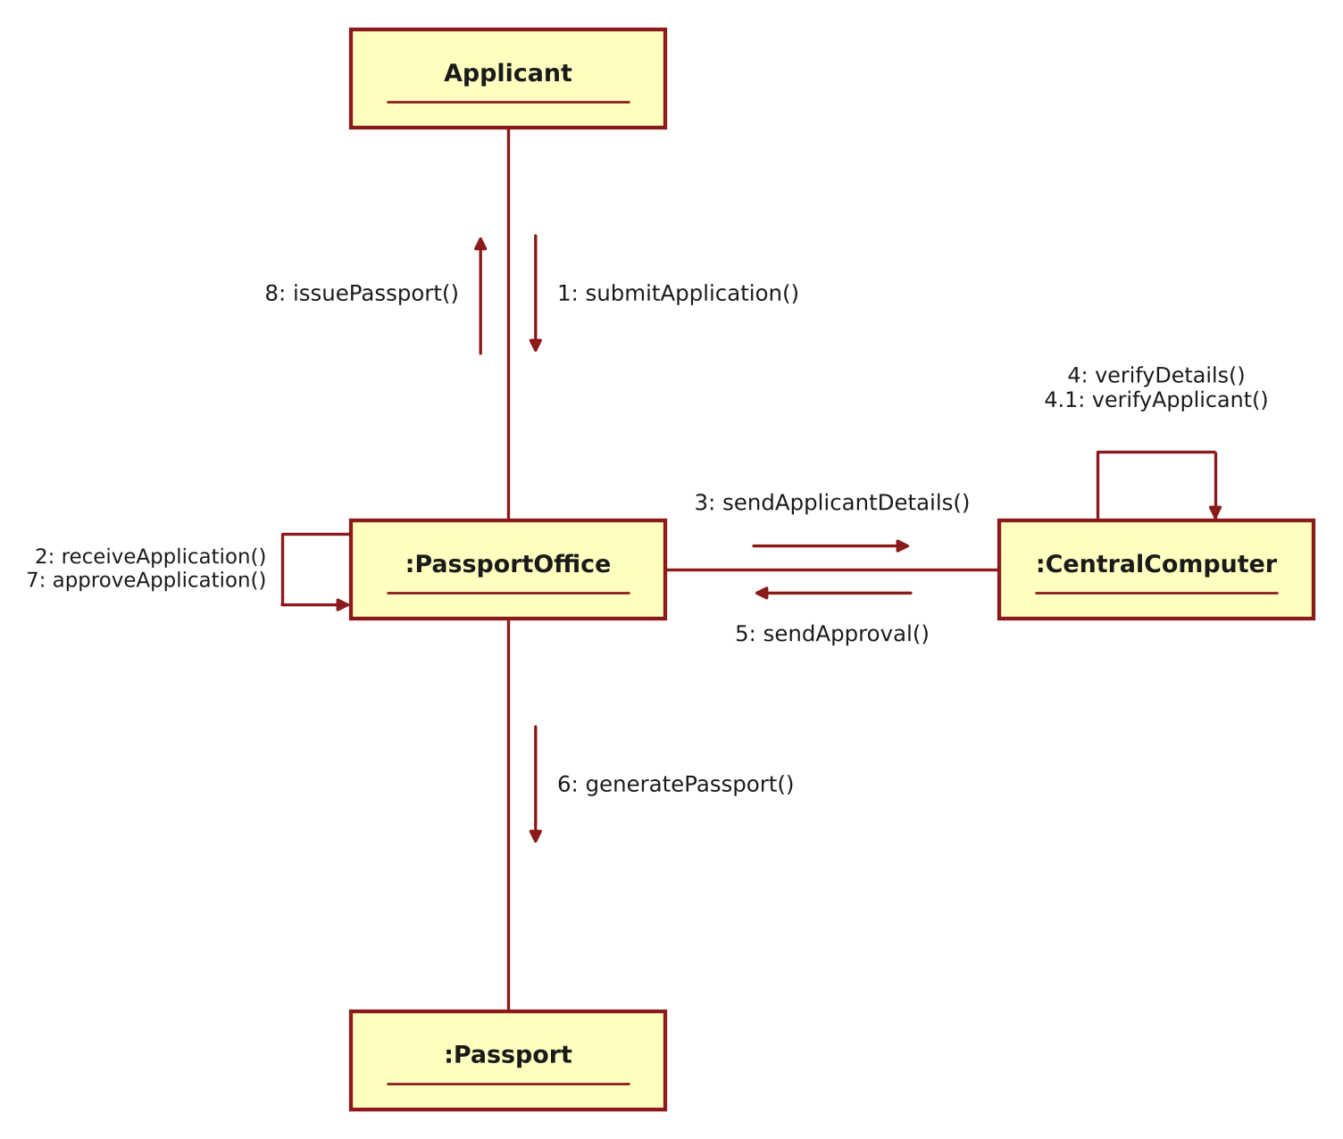
Figure 5: Collaboration Diagram – Passport Management System
RESULT
Thus the Passport Management System was modelled using Umbrello UML Modeller, and the Use Case, Class, Activity, Sequence and Collaboration diagrams were drawn and verified successfully.

