EX. NO: 4
STOCK MAINTENANCE SYSTEM
Date: 02.11.2026
AIM
To develop a Stock Maintenance System using UML in which the customer places orders and purchases items with the aid of the stock dealer and the central stock system, the orders are verified, the items are delivered to the customer, and the stock details are then updated accordingly.
PROBLEM STATEMENT
A customer places an order for the items he wants to purchase through the stock dealer. The stock dealer receives the order, enters the order details and sends the order to the central stock system. The central stock system verifies the order and checks the availability of the items and approves it. The stock dealer then delivers the items to the customer. After the delivery is confirmed, the central stock system updates the stock details accordingly. If the verification fails, the customer is informed of the rejection and no items are delivered.
SOFTWARE USED
Umbrello UML Modeller
ACTORS AND THEIR ROLES
Actor / Entity | Role in the system
Customer | Places the order, purchases the items and finally receives the items.
Stock Dealer | Receives the order, enters the order details, sends it to the central stock system and delivers the approved items to the customer.
Central Stock System | Verifies the order, checks the stock, approves the order and updates the stock details after delivery.
PROCEDURE
- Open Umbrello UML Modeller and create a new project named “Stock Maintenance System”.
- Identify the actors (Customer, Stock Dealer, Central Stock System) and the use cases, and draw the Use Case Diagram.
- Identify the classes with their attributes and operations, and draw the Class Diagram with associations and multiplicities.
- Draw the Activity Diagram with swimlanes to show the flow of activities among the three actors.
- Draw the Sequence Diagram to show the time-ordered messages exchanged between the objects.
- Draw the Collaboration Diagram to show the same interaction as numbered messages between linked objects.
- Save the diagrams and export them as images.
1. USE CASE DIAGRAM
The use case diagram shows the functions provided by the system and the actors who use them. The Customer places an order, selects the items, purchases them and receives the items. The Stock Dealer receives the order, sends it to the central stock system and delivers the items. The Central Stock System verifies the order, checks the stock availability and updates the stock details after delivery.
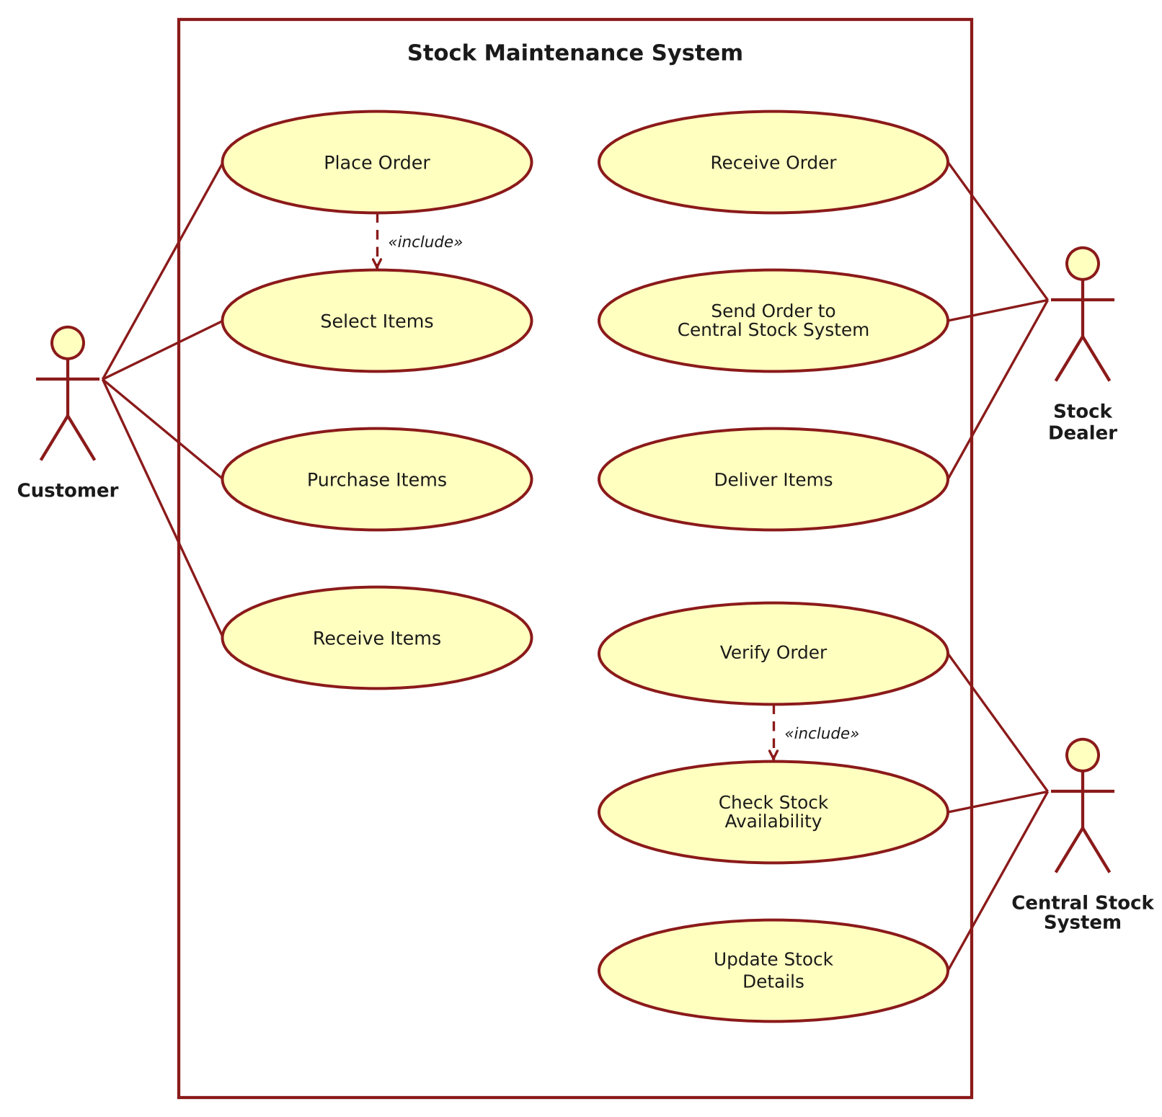
Figure 1: Use Case Diagram – Stock Maintenance System
2. CLASS DIAGRAM
The class diagram shows the static structure of the system. A Customer places many Orders, each of which is handled by a StockDealer. The StockDealer sends the orders to the CentralStockSystem, which updates the Items. A Delivery contains one or more Items, fulfils an Order and is received by the Customer.
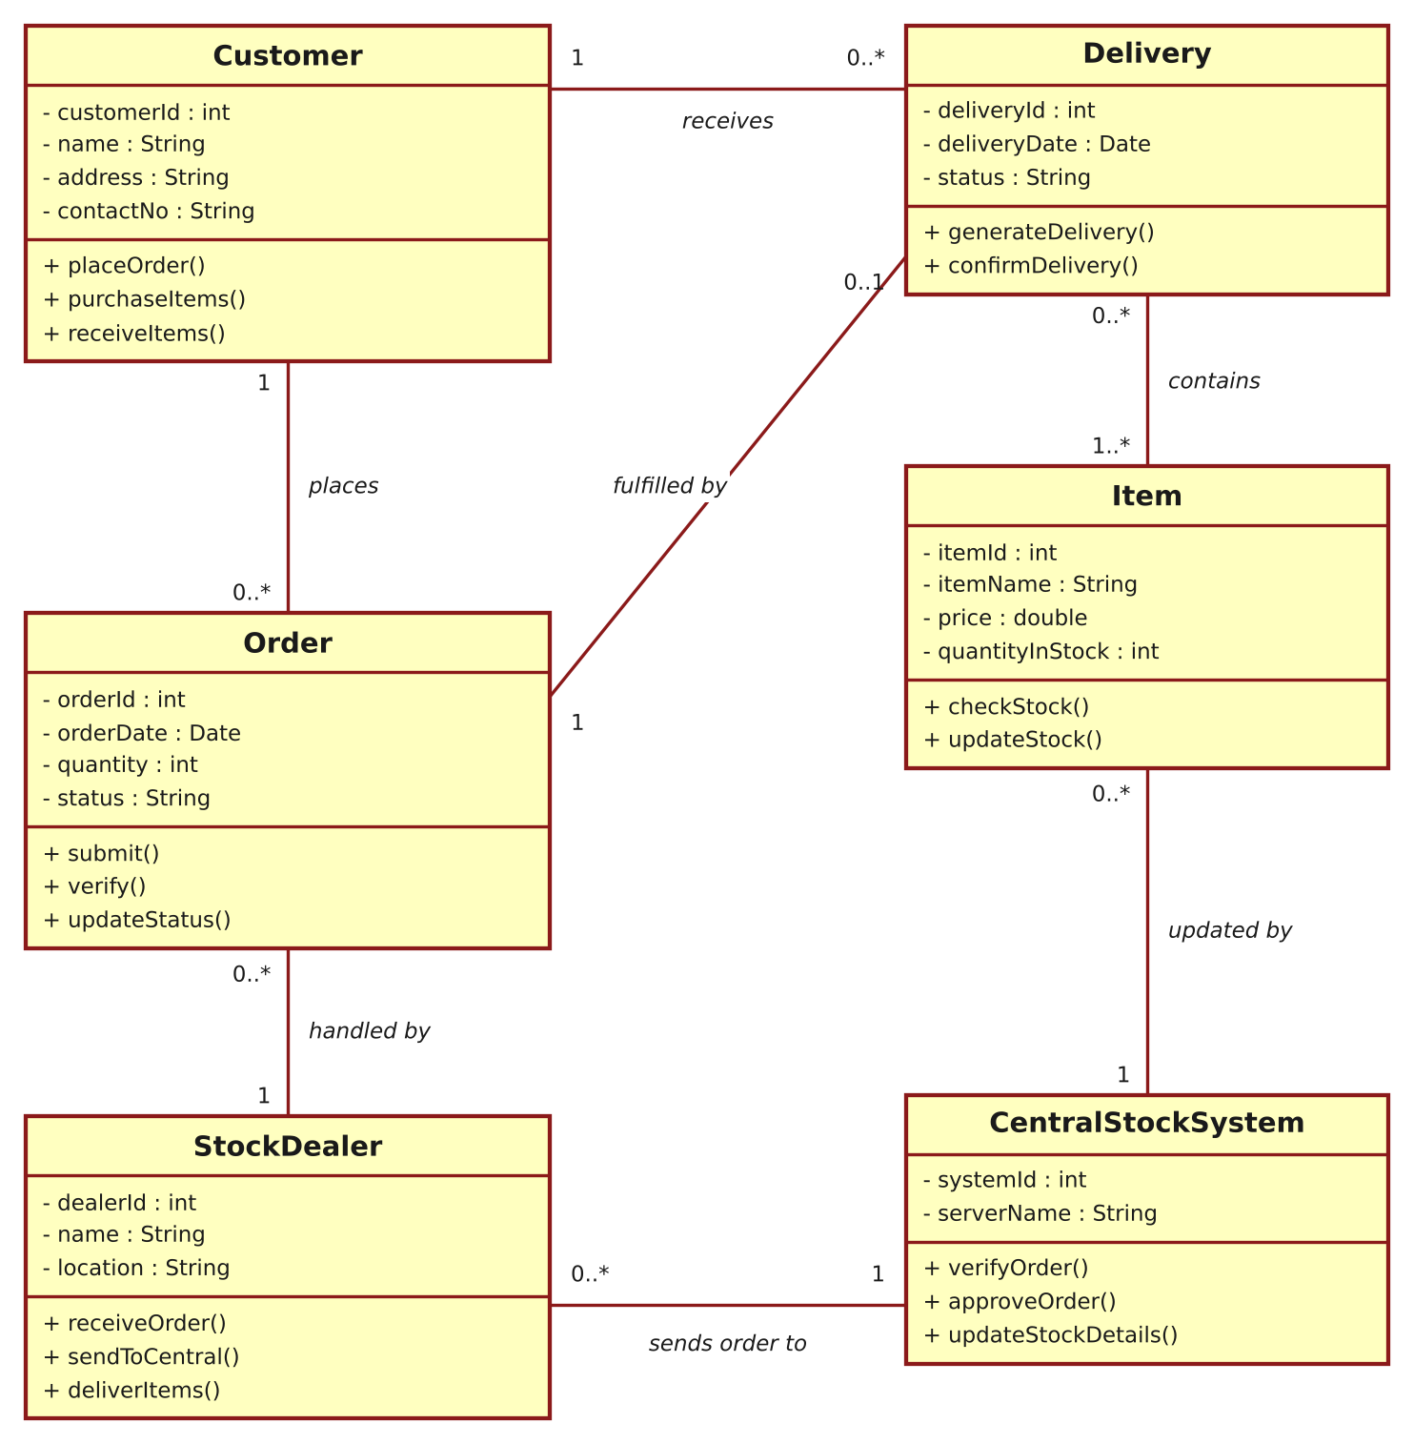
Figure 2: Class Diagram – Stock Maintenance System
3. ACTIVITY DIAGRAM
The activity diagram, drawn with swimlanes, shows the flow of work among the Customer, the Stock Dealer and the Central Stock System. After the central stock system verifies the order, the flow branches: if the order is valid, it is approved, the dealer delivers the items to the customer and the stock details are updated; otherwise the customer is informed of the rejection.
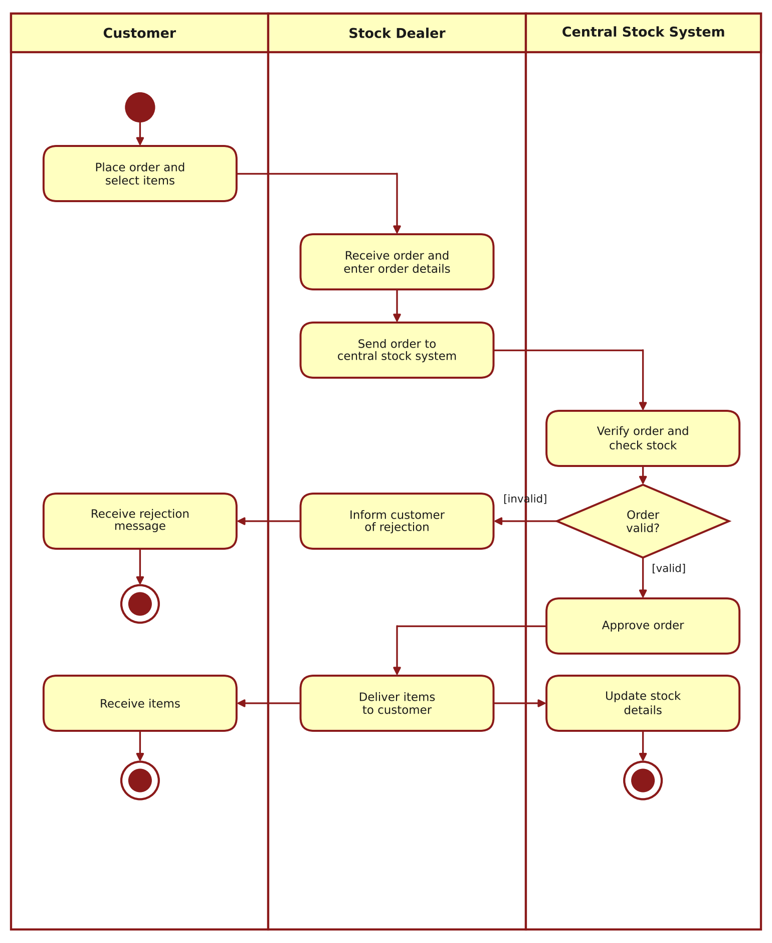
Figure 3: Activity Diagram – Stock Maintenance System
4. SEQUENCE DIAGRAM
The sequence diagram shows the order of messages exchanged between the objects over time. The customer places the order, the stock dealer enters the details and sends the order to the central stock system, which verifies and approves it. The dealer delivers the items to the customer, confirms the delivery, and the central stock system updates the stock of the item.
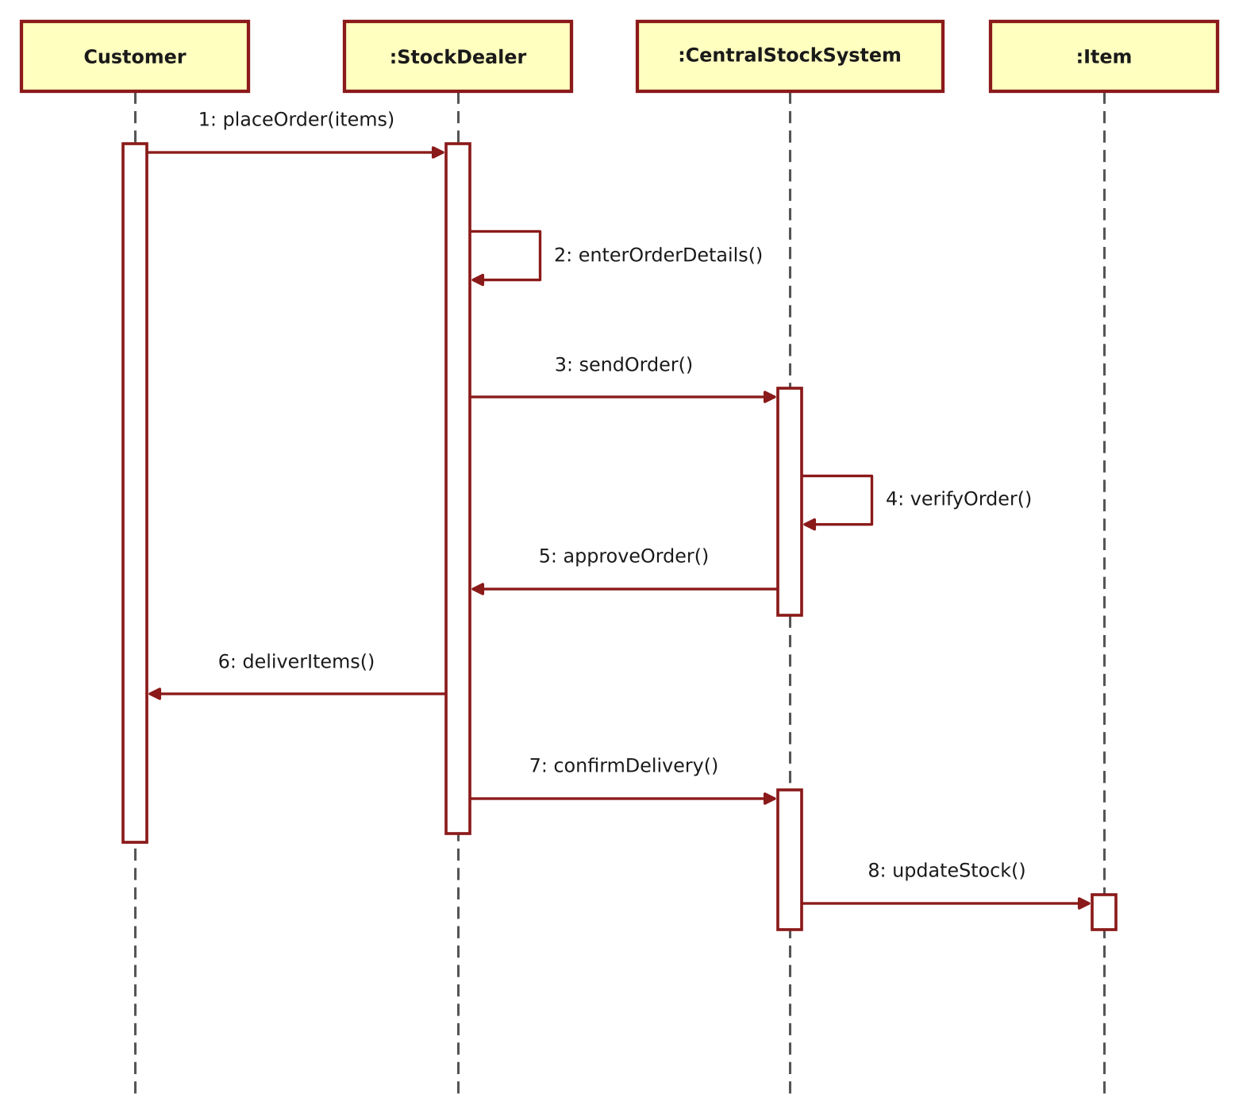
Figure 4: Sequence Diagram – Stock Maintenance System
5. COLLABORATION DIAGRAM
The collaboration diagram shows the same interaction as the sequence diagram, but emphasises the links between the objects. The sequence of messages is indicated by the numbers 1 to 8.
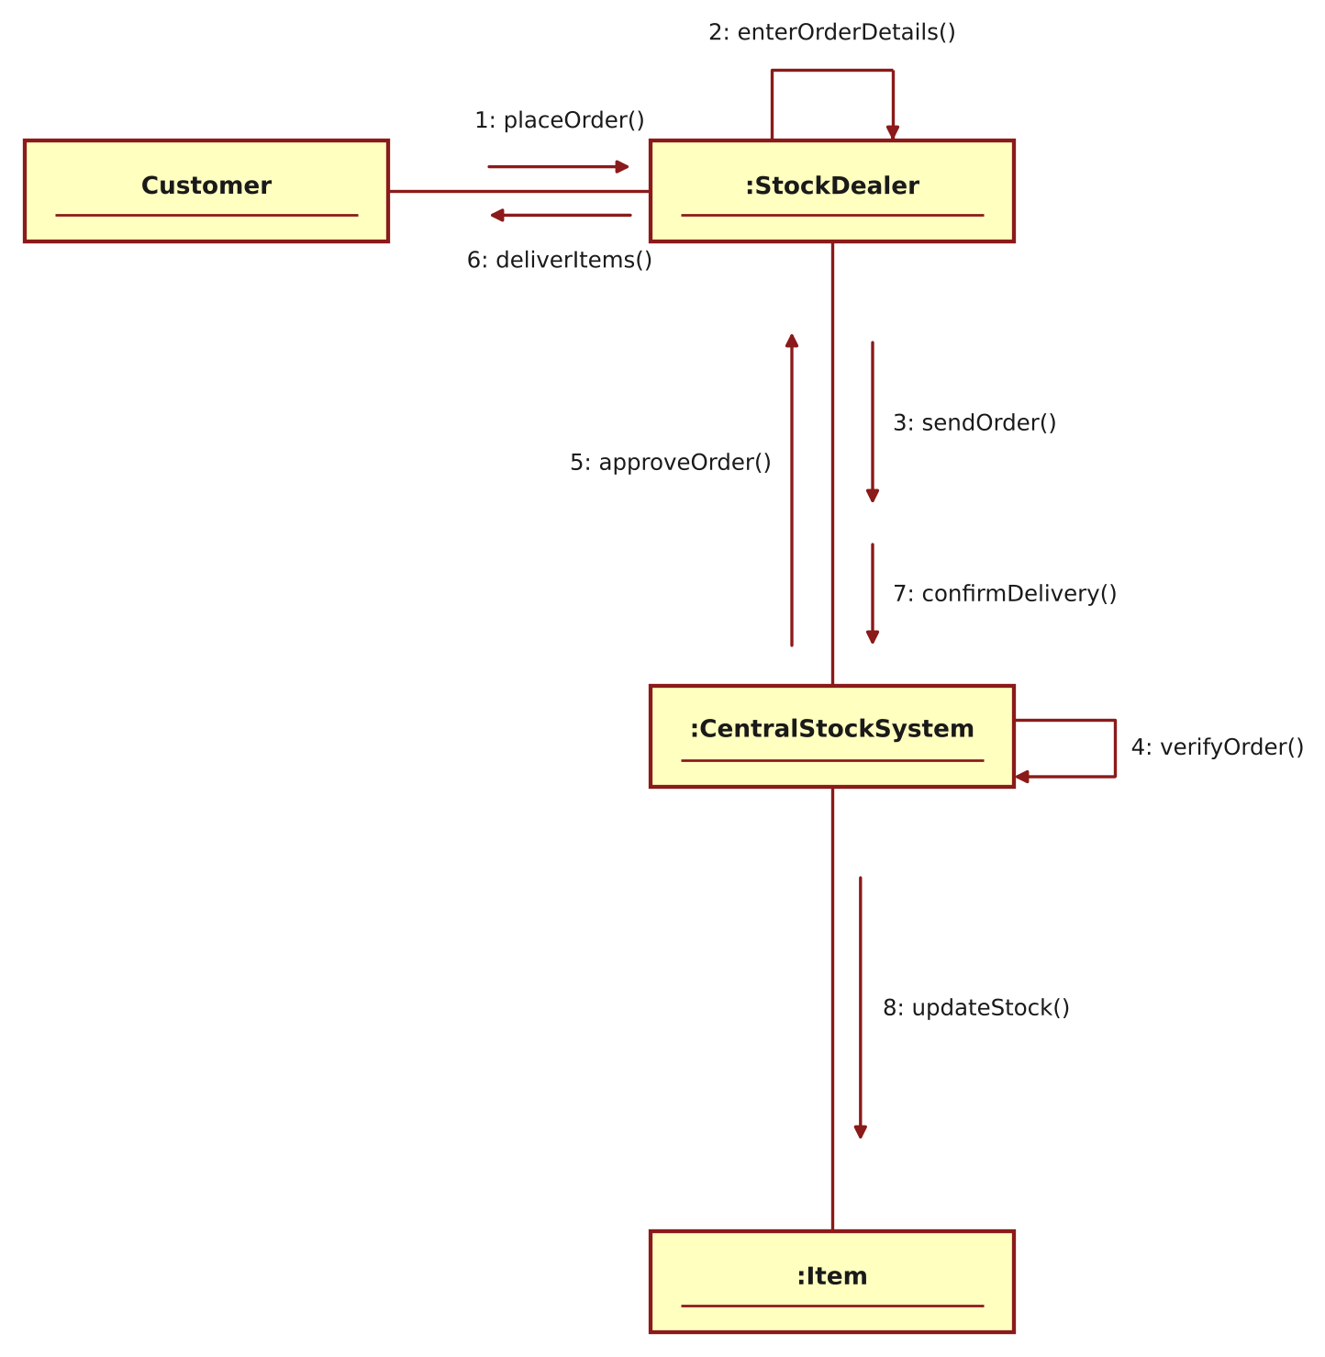
Figure 5: Collaboration Diagram – Stock Maintenance System
RESULT
Thus the Stock Maintenance System was modelled using Umbrello UML Modeller, and the Use Case, Class, Activity, Sequence and Collaboration diagrams were drawn and verified successfully.

