Report

* Author: Gladilin Egor, 211-2
* Supervisor: Sergey Shershakov

**Problem Statement**

Create a Qt application which loads a dataset with 80 types of cereals displaying details of particular cereal brand and adding/removing it to/from cart.

**Individual project specification**

Specification 114

**Implementation details**

Generally, I tried to follow seminar instructions, so, I implemented Storage class similarly to what we did on workshop. Also, I binded 2 more windows with main window, first represents info about the app and logo and the second one allows the user to construct charts, based on sorted and filtered data in my proxy model.

Moreover, user can add new info, save it , separately in file and in current model, and delete info.

**The structure:**

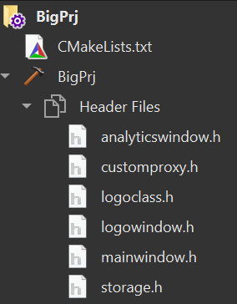

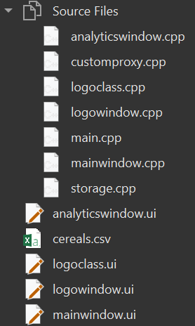

**Usage:**

In the main window the user should firstly open file, after that it’s possible to do any manipulation available.

1. By pressing button “+”, the user adds a new row and delete it by pressing “-”.
2. If the user wishes to choose row and delete, the user can apply button “Delete”.
3. By entering new expression and setting a range it is possible to filter data over a column.
4. Pressing on column’s label the data in the column is sorted.
5. After switching to window with graphs it is possible to construct a chat over a column over data from proxy model.

**Conclusion**

Further improvements could include better CSV handling, because at the moment it seems quite fragile. It was the most painful thing in whole project.