- 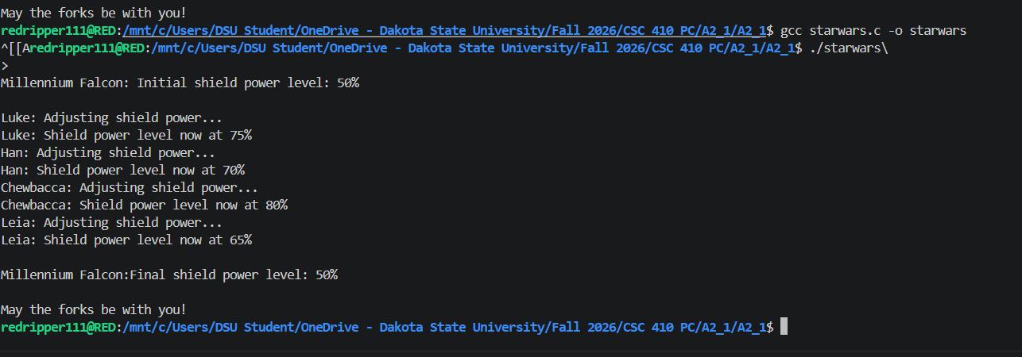

- A. We use fork(). Fork() creates a separate processes with separate memory spaces. It gives each children copy of a global variable. So any changes in the copy cannot affect the parent’s copy. Using waitpid() doesn’t combine nor share the variable with parents.

B. Using fork(), parents and all the children runs independently but the scheduler can run it in different order each time. Each children’s two statement can run in order but sometimes another process can run between them that leads to some message appearing in different order.

- 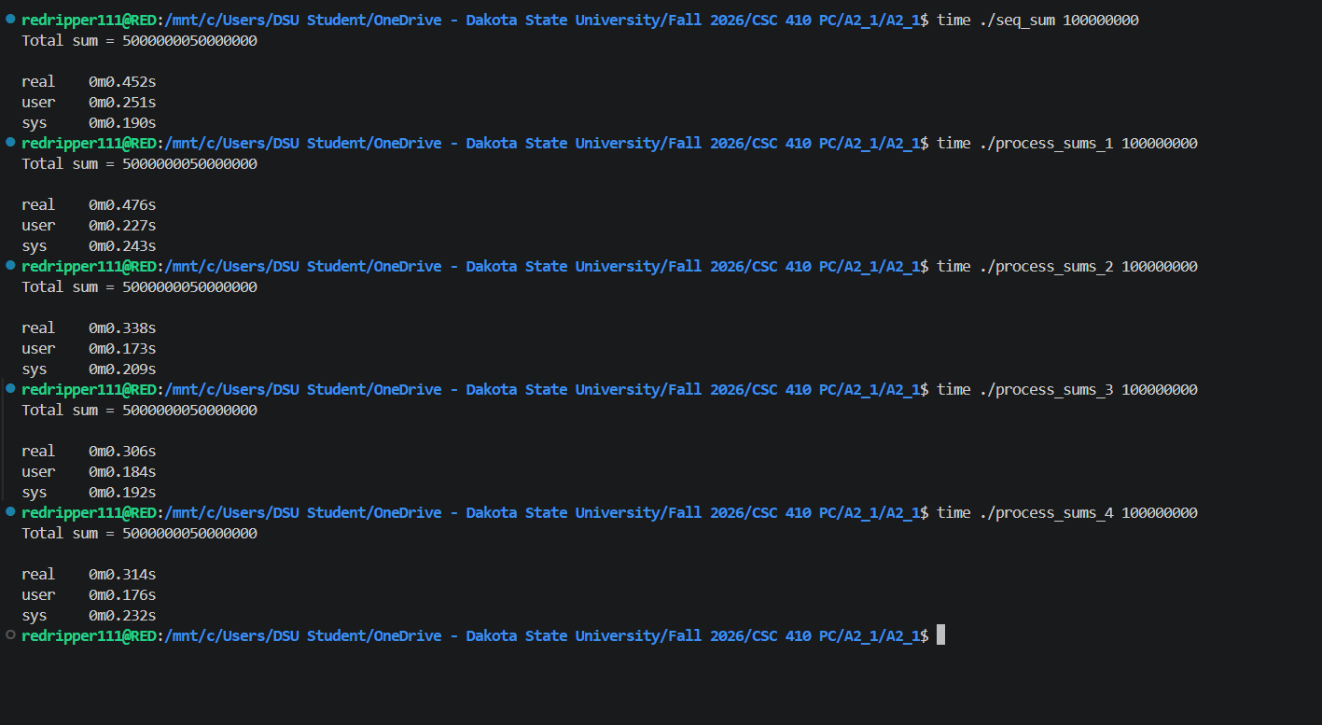

We can see that the 2 process function was the fastest reducing the time from 0.227 to 0.173. The workload is divided among every child and it works as each child perform similar amount of addition which also improved performance on system with multi core CPU.
The challenge here is that each child needs its own pipe and the pipe that isn’t used must be closed here.

