

2023-24

CMSE114222023-4SS1SB3

Game Theory for Business Analytics

Entering the Mechanical Keyboard Market on Amazon US: A Bayesian Game Theory Approach to Competing with Established Brands like Epomaker

B244512

Word count:

1485

## Entering the Mechanical Keyboard Market on Amazon US: A Bayesian Game Theory Approach to Competing with Established Brands like Epomaker

## **Introduction**

**根据(Streams, 2024)在2024年1月的报道，中国机械键盘品牌Keychron旗下的V3，V5和V6由于其the best typing experience and the most extra features for their surprisingly reasonable prices成为了海外市场上竞争力最高的一批产品。以Keychron为代表的中国机械键盘厂商已经成为海外市场上的当红销量明星。然而，根据亚马逊US站以及UK站的信息显示，在机械键盘类目下售卖一些中国新兴品牌高竞争力键盘的卖家数量极少，往往只有2家：1是该品牌的旗舰店，2是一家对原品牌进行联名/贴牌的机械键盘专营店，叫Epomaker. 认识到这种潜在商机之后，我计划开展Amazon跨境电商业务进入机械键盘市场。**

**为了避免额外竞争，本文基于Amazon US上真实的包括FBA等的成本数据，模拟新进入者进入那些只有Epomaker垄断的商品类目市场，进行A Bayesian Game Theory Analysis讨论低成本,高成本两种不同belief下的竞争者的行动倾向，并得出纳什均衡，以确定我进入后此市场的获利情况，来assist decision-making以确认是否要进驻此市场.**

## Background

### Amazon机械键盘市场的现状

Amazon作为名气十足的online shopping platform，凭借其low prices, fast deliveries, superior customer service， continuous innovation 能够ahead of its competitors(Oberoi, 2020)，形成了差异化的市场，是中国商家从事跨境电商业务的主要选择之一。

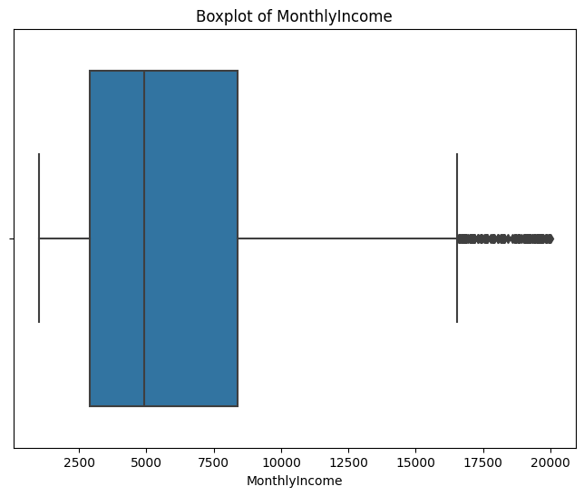**Figure 1.** Box-Whisker Plot of Monthly Income

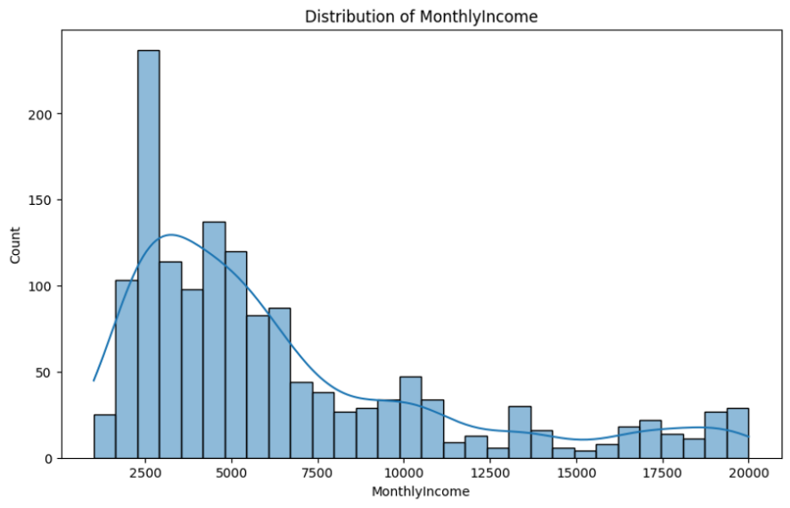

**Figure 2.** Distribution of Monthly Income

## Analysis of the Testing Result of Outlier Detection Approaches

**ow:**

**Table 1.** Outlier Detection Results

|  |  |  |  |
| --- | --- | --- | --- |
| **Method** | **Initial R2** | **Number of Outliers Detected** | **R2 After Removal or Replacement** |
| Z-score | 0.9433 | 0 | 0.9433 |
| Robust Z-score | 0.9433 | 118 | 0.8787 |
| IQR method (the method we used) | 0.9433 | 114 | 0.8823 |
| Winsorization method | 0.9433 | 146 | 0.9409 |
| DBSCAN Clustering | 0.9433 | 198 | 0.9324 |
| Isolation Forest | 0.9433 | 15 | 0.9385 |

We can easily notice a general decrease in model’s R2 after outlier handling, except for the Winsorization method, which sustained a higher R2. We don’t consider the Z-score although it had the highest R2 after removal, because it didn’t detect any outliers.

Next, I dived into Winsorization and further investigated its differences from IQR.

## IQR Method’s Strengths and Weaknesses When Compared with Winsorization

Wins

### Potential Loss of Information

Whi

### Overemphasis on Central Tendency at the Expense of Variability

InThe

## Conclusion

In this article, we found that the IQR method, while broadly applicable, may remove vital info

## References

OBEROI, M. 2020. *Why Is Amazon So Successful in the Competitive Retail Market?* [Online]. Market Realist. Available: <https://marketrealist.com/p/why-is-amazon-so-succesful/> [Accessed 19 February 2024].

STREAMS, K. 2024. *The Best Mechanical Keyboards* [Online]. The New York Time. Available: <https://www.nytimes.com/wirecutter/reviews/our-favorite-mechanical-keyboards/> [Accessed 18 February 2024].