

2023-24

CMSE114222023-4SS1SB3

Game Theory for Business Analytics

Entering the Mechanical Keyboard Market on Amazon US: A Bayesian Game Theory Approach to Competing with Established Brands like Epomaker

B244512

Word count:

1444

## Entering the Mechanical Keyboard Market on Amazon US: A Bayesian Game Theory Approach to Competing with Established Brands like Epomaker

## **Introduction**

**According to Streams (2024), in January 2024, Keychron's mechanical keyboard models V3, V5, and V6 have become some of the most competitive products in the overseas market due to their superior typing experience and an array of additional features offered at remarkably reasonable prices. Chinese emerging mechanical keyboard manufacturers, represented by Keychron, have emerged as popular sales stars in the overseas market. However, information from Amazon's US and UK sites indicates that there are very few sellers offering high-competition keyboards from emerging Chinese brands in the mechanical keyboard category, typically only two: one is the brand's flagship store, and the other is a mechanical keyboard store engaging in co-branding or private labelling with the original brand, known as Epomaker. Recognizing this potential business opportunity, I plan to venture into the mechanical keyboard market through Amazon's cross-border e-commerce.**

**To avoid additional competition, this paper, based on real cost data from Amazon US, including Fulfillment by Amazon (FBA) costs, simulates the entry of newcomers into product categories monopolized by Epomaker. It conducts a Bayesian game theory analysis to discuss the action tendencies of competitors under low-cost and high-cost beliefs, reaching a Nash equilibrium. This analysis aims to ascertain the profitability after my market entry and assist in decision-making to confirm whether to enter this market.**

## Background

### Amazon Mechanical Keyboard Market Overview

Amazon, a prevalent online shopping platform, differentiates itself in the market with low prices, fast deliveries, superior customer service, and continuous innovation, staying ahead of its competitors (Oberoi, 2020). This has made it one of the primary choices for Chinese merchants engaging in cross-border e-commerce. In the mechanical keyboard category, this paper focuses on customisable mechanical keyboards. These keyboards allow users to personalize them, offering the option to choose fancier appearances and switches that match their preferences better than traditional, non-customizable gaming mechanical keyboards, thus providing stronger product power. Unfortunately, international peripheral giants like Logitech and Razer are extremely slow to follow market trends. Their few customizable mechanical keyboard models, such as the Logitech G PRO, lack competitiveness due to their high pricing. Therefore, it is undoubtedly an optimal time for Chinese customizable mechanical keyboards to accelerate their expansion on overseas e-commerce platforms, including Amazon.

### Application of Bayesian Game in Market Strategy Analysis

Zhou (2017) applied the Bayesian Game to the U.S. Video Game Industry, finding that failing platforms could have survived if appropriate pricing for both buyers and sellers was implemented in a dynamic two-sided market environment. Compared to traditional market entry games, Bayesian games include beliefs about other players' types, making them more aligned with real situations and suitable for this market entry analysis. Kim et al. (2006) examined a scenario in which, in a market with only two companies, consumers are aware of the quality of the products offered by existing businesses but do not know how they compare to the quality of products offered by new foreign entrants. The article subsequently proposed an optimal entry strategy under conditions of incomplete information, involving price distortion upwards by the entering firm. Shang et al. (2010) designed a market transaction mechanism for internet technology giants in the cloud services market, defining a double auction Bayesian game pricing model for the market. This allows users to purchase resources from different companies and exchange idle resources in a more flexible manner.

Based on the literature mentioned, we can ascertain that the Bayesian Game is an appropriate model for this market entry analysis.

## Bayesian Game Analysis

### Model Setting

#### Competitive Strategies

For the entrant, there are two choices: enter or not enter. For the existing competitor, Epomaker(UK, 2024), there are also two choices: accept or fight.

#### Belief

From the entrant's perspective, this paper considers two possible cost types for the existing competitor, Epomaker: ‘high’ or ‘low’, with probabilities p_L and p_H

used in calculations. Since the entrant (my company) is not a well-funded competitor that can engage in price wars or other aggressive competitive strategies, entering the market will not cause sustained losses for the existing competitor, Epomaker. Therefore, it's unnecessary to consider the possibilities of Epomaker choosing to quit or not.

#### Model Parameters

To simulate real-world business scenarios as closely as possible, the model considers the cost information shown in Table 1 (Amazon.com, 2024). The product selected for simulation is the Aula F87 mechanical keyboard. Additionally, payoffs for the New Entrant and Competitor are calculated using formulas (1) and (2). For the Competitor, StartUp_Cost is not calculated since it has already entered the market. For the New Entrant, all costs are set to high options, as I currently do not have any cost advantage benefits. For sales, depending on the game's outcome, one of the following four values is used: EnterSales_F, EnterSales_A_lose, EnterSales_A_win, notEnterSales. For advertisement cost, if the Competitor chooses to fight, its value will be AdvertisementCost_Fight_H_perItem or AdvertisementCost_Fight_L_perItem (L and H representing low cost or high cost).

$New Entrant's Payoff=sales × (Price_PerItem- advertisementCost_H_perItem - iventory_cost_H - AmazonFee_perItem - AverageStorageCost_perItem- FBA_fulfillment_fees_H_perItem - purchasingCost_H_perItem - shipping_cost_H) - StartUp_Cost$ $(1)$

$Competitor's Payoff=sales × [(Price_PerItem - advertisementCost_H_perItem - iventory_cost_H - AmazonFee_perItem - AverageStorageCost_perItem- FBA_fulfillment_fees_H_perItem - purchasingCost_H_perItem - shipping_cost_H) × p_H + (Price_PerItem- advertisementCost_L_perItem - iventory_cost_L - AmazonFee_perItem - AverageStorageCost_perItem- FBA_fulfillment_fees_L_perItem - purchasingCost_L_perItem - shipping_cost_L) × p_L]$ $(2)$

**Table 1.** Variables Explanation

|  |  |  |
| --- | --- | --- |
| **Variable** | **Description** | **Value** |
| p_L | Probability of competitors being low-cost type | 0.7 |
| p_H | Probability of competitors being high-cost type | 0.3 |
| StartUp_Cost | Startup costs | 500 |
| AmazonFee_perItem | Amazon fee per item | 7.39 |
| StorageCost_L | Storage cost option 1 | 0.13 |
| StorageCost_H | Storage cost option 2 | 0.37 |
| AverageStorageCost_perItem | Average storage cost per item | (0.13 + 0.37) / 2 |
| FBA_fulfillment_fees_H_perItem | FBA fulfillment fees for high-cost items | 9.44 |
| FBA_fulfillment_fees_L_perItem | FBA fulfillment fees for low-cost items | 7.44 |
| purchasingCost_H_perItem | Purchasing cost per item for high-cost type, Aula F87 retail price (small batches) (AULA, 2024) | 198 / 7.1 |
| purchasingCost_L_perItem | Purchasing cost per item for low-cost type, Aula F87 retail price (large batches) (AULA, 2024) | 178 / 7.1 |
| ShippingCost_L | Shipping cost for low-cost type (YunExpress, 2024) | 12.8 / 7.1 |
| ShippingCost_H | Shipping cost for high-cost type (YunExpress, 2024) | 13.8 / 7.1 |
| IventoryCost_H | Inventory cost for high-cost type | 0.5 |
| IventoryCost_L | Inventory cost for low-cost type | 0.3 |
| Price_PerItem | Price per item | 79.9 |
| AdvertisementCost_Fight_H_perItem | Advertisement cost for fighting, high-cost type | 1.4 |
| AdvertisementCost_Fight_L_perItem | Advertisement cost for fighting, low-cost type | 1 |
| AdvertisementCost_H_perItem | Advertisement cost per item for high-cost type | 0.5 |
| AdvertisementCost_L_perItem | Advertisement cost per item for low-cost type | 0.4 |
| EnterSales_F | Sales if entering and facing the fight | 100 |
| EnterSales_A_lose | Sales if entering and losing to Amazon | 50 |
| EnterSales_A_win | Sales if entering and winning against Amazon | 150 |
| notEnterSales | Sales if not entering | 200 |

## Model Output Analysis

Following the insertion of relevant data, the results of the model are illustrated in Figure 1.

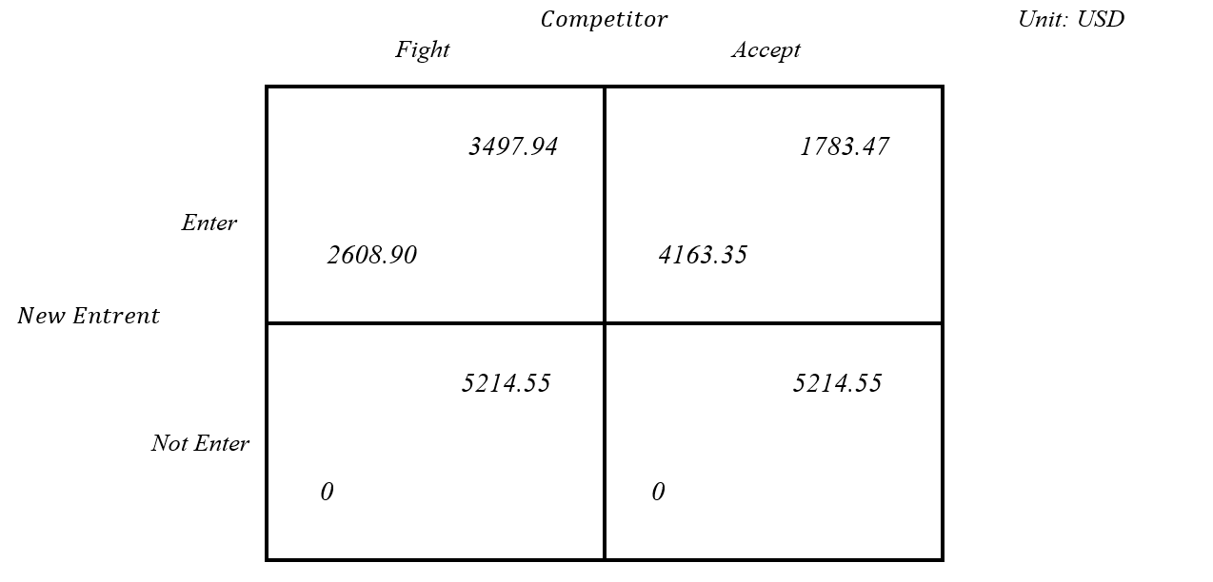When I choose to enter the market (Enter), if the competitor chooses to compete (Fight), my expected profit is $2608.90. If the competitor chooses to accept (Accept), my expected profit is $4163.35. If I choose not to enter the market (Not Enter), no matter what choice the competitor makes, I won't make any profit, reflected as $0 in the matrix.

**Figure 1.** Model Output

### Nash Equilibrium

Clearly, (Enter, Fight) constitutes a Nash equilibrium, as neither party can increase their profit by changing their strategy.

Based on these results, we can deduce that the Competitor is always inclined to adopt the Fight strategy. This necessitates maintaining a higher advertisement cost to stay competitive during the early stages of market entry, else it could easily lead to reduced profits or losses due to the entry of more competitors. Moreover, considering the current market conditions, we should choose to Enter, as it still promises a profit of at least $2608.9.

## Conclusion

In this article, I simulated the competitive landscape my company would face upon entering the Amazon mechanical keyboard market through a Bayesian Game analysis. The analysis indicates that the Competitor is always inclined to adopt the Fight strategy, and we should choose to Enter.

### Limitation

#### Costs could be further refined

Although the data in this paper are based on real internet data, since I have not yet commenced actual operations of my Amazon store, many costs cannot be directly obtained from practice, making them potentially imprecise.

#### Sales estimates may not be accurate

The model divides Sales into four scenarios: lose, win, fight, not Enter, setting data accordingly. However, market demand continuously changes, and due to Amazon's confidentiality regarding store data, I cannot obtain sufficiently precise Sales data, which could lead to bias in the model results.

Future improvements could involve refining the model after obtaining further information using a series of Amazon product selection tools (such as Jungle Scout, and Helium).

## References

AMAZON.COM. 2024. *How much does it cost to sell with Amazon?* [Online]. Available: <https://sell.amazon.com/pricing> [Accessed].

AULA. 2024. *AULA Official Website* [Online]. Available: <https://www.aulacn.com/cn> [Accessed].

KIM, Y.-H., AGGARWAL, P., HA, Y.-M. & CHA, T. H. 2006. Optimal pricing strategy for foreign market entry: a game theoretic approach. *Managerial and Decision Economics,* 27**,** 643-653.

OBEROI, M. 2020. *Why Is Amazon So Successful in the Competitive Retail Market?* [Online]. Market Realist. Available: <https://marketrealist.com/p/why-is-amazon-so-succesful/> [Accessed 19 February 2024].

SHANG, S., JIANG, J., WU, Y., HUANG, Z., YANG, G. & ZHENG, W. DABGPM: A Double Auction Bayesian Game-Based Pricing Model in Cloud Market. 2010 Berlin, Heidelberg. Springer Berlin Heidelberg, 155-164.

STREAMS, K. 2024. *The Best Mechanical Keyboards* [Online]. The New York Time. Available: <https://www.nytimes.com/wirecutter/reviews/our-favorite-mechanical-keyboards/> [Accessed 18 February 2024].

UK, A. 2024. *Product Detail on Amazon UK* [Online]. Available: <https://www.amazon.co.uk/dp/B0CNT2JSDH> [Accessed ASIN: B0CNT2JSDH].

YUNEXPRESS. 2024. *Cross-border B2C Special Line - YunExpress Logistics Product Services* [Online]. Available: <https://www.yunexpress.cn/Home/ProductServices/1> [Accessed].

ZHOU, Y. 2017. Bayesian estimation of a dynamic model of two-sided markets: Application to the US video game industry. *Management Science,* 63**,** 3874-3894.