**PRODUCT SALES ANALYSIS PROJECT-PHASE 1**

**STUDENT NAME**: V.REEMLATHA -210621104040

**COLLEGE NAME:** JEPPIAAR INSTITUTE OF TECHNOLOGY

**COLLEGE CODE:** 2106

**DEPARTMENT**: B.E.COMPUTER SCIENCE AND ENGINEERING

**SEMESTER:**5

**COURSE NAME :** DATA ANALYTICS WITH COGNOS – GROUP 1 (IBM:DAC101)

**TEAM MEMBERS NM ID**

1.A.SHERLIN BRITTO au210621104048

2.V.REEMLATHA au210621104040

3.B.SHAMILA au210621104045

4.P.MOHANAPRIYA au210621104032

5.P.KEERTHIGA au210621104028

**SPOC/MENTOR:** S.RAJESH

**PROJECT TITLE:** PRODUCT SALES ANALYSIS

**PHASE**:1

**PRODUCT SALES ANALYSIS**

Dataset Link: <https://www.kaggle.com/datasets/ksabishek/product-sales-data>

**Phase 1 : Problem Definition and Design Thinking**

**Project Objective:**

The project involves using IBM Cognos to analyze sales data from REC corp LTD., a small-scaled business venture in India that has been selling four products for over ten years. The objective is to help REC corp improve inventory management and marketing strategies by understanding sales trends and customer behavior. This project includes defining analysis objectives, collecting sales data, designing relevant visualizations in IBM Cognos, and deriving actionable insights.



**Problem Definition**:

REC corp LTD. is a small-scaled business venture in India that has been selling four products for over ten years. They have collected sales data from their retail centers and organized it into a CSV file. They need help analyzing this data to answer the following questions:

1. Is there any trend in the sales of all four products during certain months?
2. Out of all four products, which product has seen the highest sales in all the given years?
3. The company has all its retail centers closed on the 31st of December every year. Mr: Hariharan, the CEO, would love to get an estimate on the number of units of each product that could be sold on the 31st of December, every year, if all their retail centers were kept open.
4. The CEO is considering an idea to drop the production of any one of the products. He wants you to analyze the data and suggest whether his idea would result in a massive setback for the company.
5. The CEO would also like to predict the sales and revenues for the year 2024. He wants you to give a yearly estimate with the best possible accuracy.

**Design Thinking:**

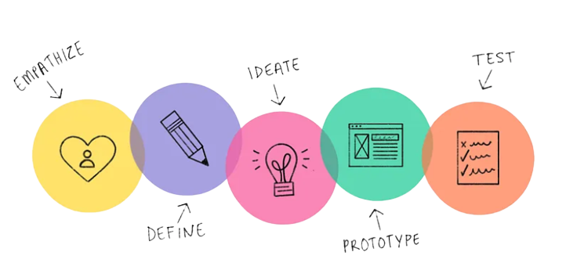

To help REC corp solve these problems, we will use a design thinking approach. The design thinking process has five stages:

1. **Empathize**: We will first empathize with REC corp and their customers to understand their needs and challenges. This will involve reviewing the sales data, interviewing REC corp employees and customers, and conducting other research.
2. **Define**: Once we have a good understanding of the problem, we will define the specific insights we want to extract from the data. This will involve working with REC corp to identify their key priorities and business goals.
3. **Ideate**: Next, we will brainstorm potential solutions to the problem. This will involve generating as many ideas as possible, without worrying about feasibility.
4. **Prototype**: Once we have a list of potential solutions, we will prototype and test them to see which ones are most effective. This may involve creating mockups, simulations, or other prototypes.
5. **Implement**: Finally, we will implement the best solution and monitor its effectiveness. This may involve working with REC corp to develop and deploy new processes, tools, or technologies.

**Analysis Objectives:**

The specific analysis objectives for this project are to:

* Identify trends in sales of all four products during certain months
* Identify the top selling product out of all four products
* Estimate the number of units of each product that could be sold on the 31st of December, every year, if all retail centers were kept open
* Suggest whether dropping the production of any one of the products would result in a massive setback for the company
* Predict the sales and revenues for the year 2024

**Data Collection**:

The data for this project will be collected from the CSV file provided by REC corp. The data file contains the following information:

* Date
* Product
* Unit sales
* Revenue

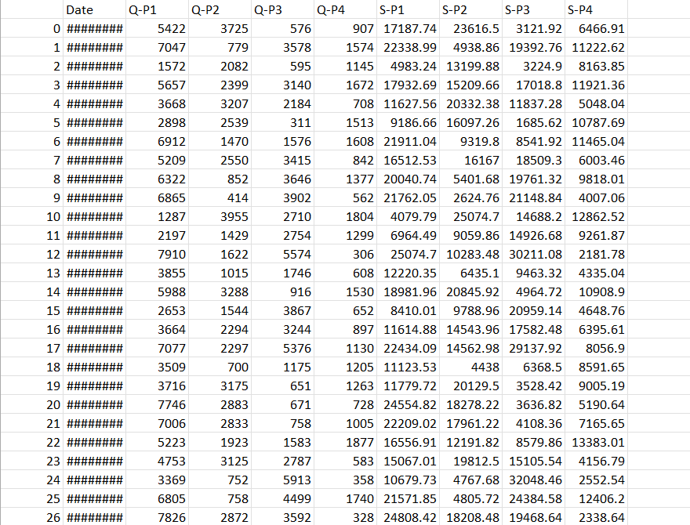

**Dataset Link:** [**https://www.kaggle.com/datasets/ksabishek/product-sales-data**](https://www.kaggle.com/datasets/ksabishek/product-sales-data)

**Visualization Strategies:**

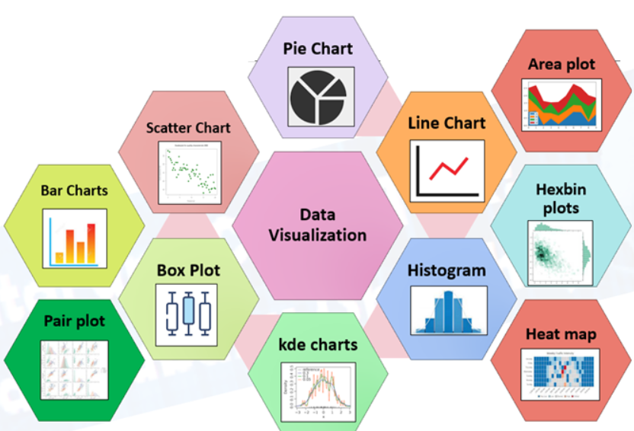

We will use IBM Cognos to create interactive dashboards and reports to visualize the insights extracted from the data. The following are some examples of data visualizations that we may create:

* Line charts showing sales trends over time
* Bar charts showing the top selling products
* Pie charts showing the contribution of each product to total revenue
* Heatmaps showing sales by product and month

We could use a variety of forecasting methods, such as time series analysis or machine learning to predict the sales and revenues for the year 2024. We could also consider factors such as economic growth, industry trends, and competitive factors.

**Actionable Insights**:

The actionable insights that we derive from the data analysis will be used to help REC corp improve their inventory management and marketing strategies. For example, the insights can be used to:

* Identify which products are most popular during certain months of the year
* Identify which products are most profitable
* Determine which products to prioritize in terms of inventory management
* Develop targeted marketing campaigns for specific products and customer segments

**Conclusion:**

By using a design thinking approach and a variety of data analysis techniques, we can help REC corp answer the questions they have about their sales data and use this information to improve their business performance.