**PRODUCT SALES ANALYSIS PROJECT-PHASE 4**

**STUDENT NAME**: Reemlatha V -210621104040

**COLLEGE NAME:** JEPPIAAR INSTITUTE OF TECHNOLOGY

**COLLEGE CODE:** 2106

**DEPARTMENT**: B.E.COMPUTER SCIENCE AND ENGINEERING

**SEMESTER:**5

**COURSE NAME :** DATA ANALYTICS WITH COGNOS – GROUP 1 (IBM:DAC101)

**TEAM MEMBERS NM ID**

1.A.SHERLIN BRITTO au210621104048

2.V.REEMLATHA au210621104040

3.B.SHAMILA au210621104045

4.P.MOHANAPRIYA au210621104032

5.P.KEERTHIGA au210621104028

**PROJECT TITLE:** PRODUCT SALES ANALYSIS

**Phase 4: Development Part -2**

**Given:**

In this part you will continue building your project.

* Continue building the analysis by creating visualizations using IBM Cognos and generating actionable insights.
* Use IBM Cognos to design interactive dashboards and reports that display insights such as top-selling products, sales trends, and customer preferences.
* Derive insights from the visualizations, such as identifying products with the highest sales, peak sales periods, and customer preferences for specific product

**Project Objective**

To analyze and derive actionable insights from a comprehensive sales and revenue dataset. This analysis will focus on identifying top-selling products, understanding sales trends, and uncovering customer preferences, utilizing interactive visualizations and reports created in IBM Cognos. The ultimate goal is to inform strategic decision-making, marketing efforts, and inventory planning based on the extracted insights from the dataset.



**Analysis Objectives :**

The specific analysis objectives for this project are to:

* Sales Trends:To identify trends in sales of all four products during certain months or year and find the peak sales period
* Top Selling Products:To identify the top selling product out of all four products
* Customer Preferences: To investigate which products are preferred by customers.
* Prediction:To predict future sales and revenue in 2024
* Sales on 31st December:To find the no of units that could be sold on 31st dec if all their retail centers are kept open

**i.To identify the top selling product out of all four products**

We used summary charts to display total unit sales and revenue for products P1, P2, P3, and P4. Additionally, column charts were created to visualize the yearly trends in total sales and revenue. This approach provides a clear and concise overview of product performance and annual financial trends .

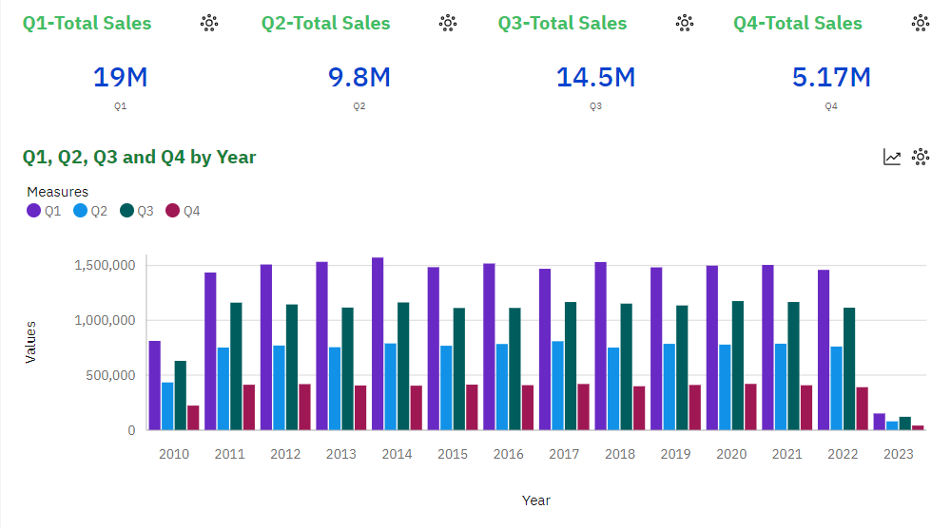**Observation:**

* + We can observe that P1 has the highest unit sales for each year. And it's highest is in year 2014.
  + We can observe that P4 has the lowest unit sales of all the products.

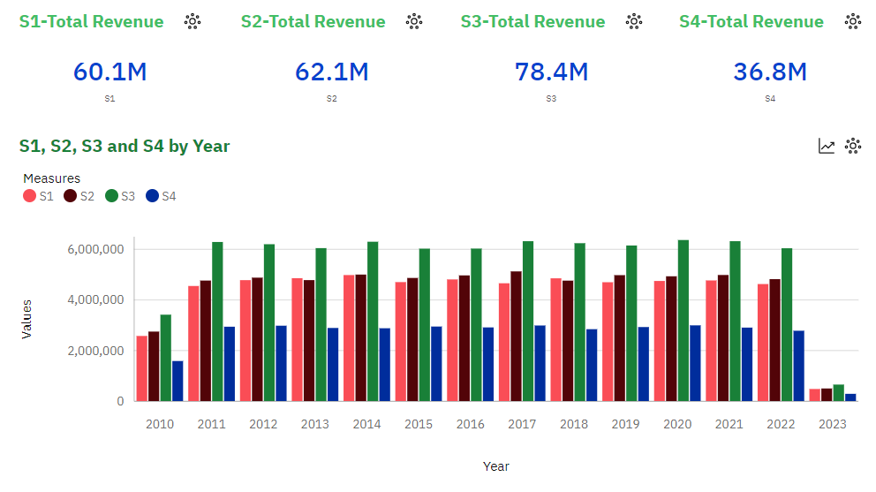

**Observation:**

* We can observe that P3 brought in the most revenue. This could be as a result of multiple things:

-P3 was sold for higher than the rest, as it had the second highest unit sales for each year.

* We can observe than P1 and P2 brought in similar revenues for each year. With P2 bringing in slightly more.

-P1 despite having the most unit sold, brought in the second lowest revenue each year.

**Actionable Insights:**

Based on the observation, here are some actionable insights that can be derived from the data:

**1. Product Focus:**

- Given that P1 consistently has the highest unit sales, it's crucial to focus on maximizing the potential revenue from this product. This might involve pricing strategies, bundling with other products, or marketing campaigns to maintain and potentially increase its revenue contribution.

**2. Revenue Optimization for P3:**

- While P3 generates the most revenue, it's essential to understand why. If it's due to higher prices, consider whether there's room to adjust pricing without sacrificing sales volume. Additionally, explore opportunities to further increase unit sales for P3.

**3. P2 Revenue Enhancement:**

- P2 brings in slightly more revenue than P1. Investigate why P2, with lower unit sales, outperforms P1 in revenue. Consider whether this could be replicated for other products or if there are strategies that can boost P2's revenue further.

**4. P4's Performance:**

- P4 consistently has the lowest unit sales and revenue. Evaluate the viability of this product in your product portfolio. It may be worth considering whether to discontinue or redesign it, or explore marketing strategies to increase its appeal to customers.

**5. Pricing Strategy:**

- Assess the pricing strategy for each product. If P3's high revenue is due to higher prices, evaluate whether similar pricing strategies can be applied to other products. Ensure that the pricing strategy aligns with customer demand and market competition.

**6. Profit Margins:**

- Calculate and analyze the profit margins for each product (revenue generated minus cost of goods sold). Products with lower unit sales but higher profit margins may represent areas for growth.

These actionable insights provide a foundation for making informed decisions to enhance product performance, revenue generation, and overall business strategy. It's important to continually monitor and adjust strategies based on evolving market conditions and customer preferences.

**ii.To identify sales trends and peak sales period**

We employed line charts to track sales trends over months and discern peak sales periods. Additionally, column charts illustrated yearly sales for individual products (P1, P2, P3, P4). To analyze weekday patterns, an area chart showcased sales distribution throughout the week. These visualizations offer valuable insights into sales dynamics .

**Line Chart Showing Monthly Sales Trends**

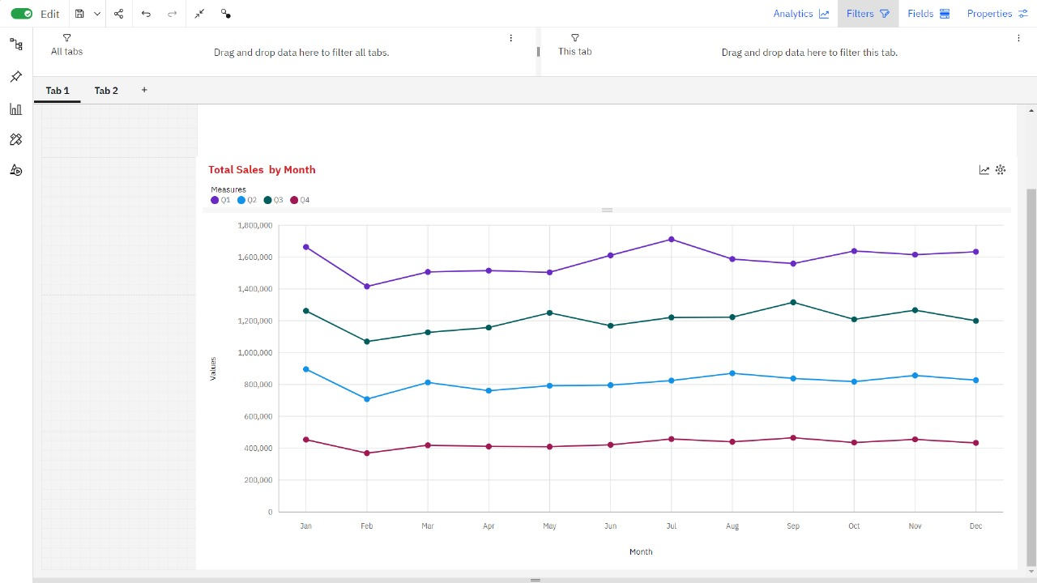

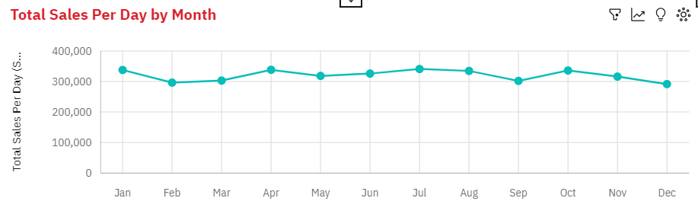

**Observation:**

* Q1 has a strong upward trend.
* Q1 ranges from over 1.4 million, in Feb, to over 1.7 million, in Jul.
* Q2 ranges from nearly 708 thousand, in Feb, to almost 896 thousand, in Jan.
* Q3 ranges from almost 1.1 million, in Feb, to over 1.3 million, in Sep.
* Q4 ranges from nearly 369 thousand, in Feb, to over 465 thousand, in Sep.
* Total Sales Per Day ranges from nearly 3.6 million, in Feb, to almost 4.3 million, in Jan.
* All Products drop in February
* All Products Rise in January

**Column Chart Showing Sales Trends Over Years**

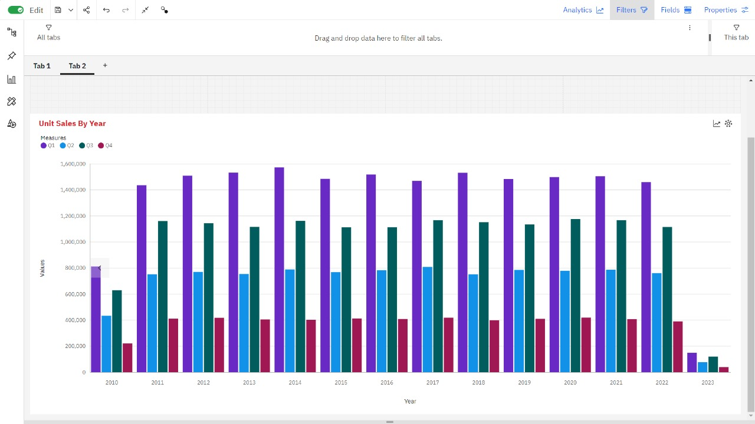

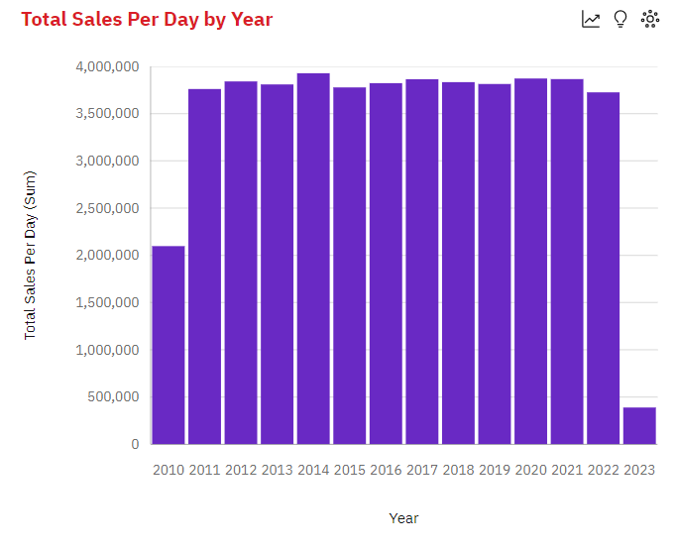**Observation:**

* Q1 ranges from over 150 thousand, in 2023, to nearly 1.6 million, in 2014.
* Q2 ranges from over 78 thousand, in 2023, to nearly 809 thousand, in 2017.
* Q3 ranges from over 120 thousand, in 2023, to nearly 1.2 million, in 2020.
* Q4 ranges from nearly 40 thousand, in 2023, to almost 420 thousand, in 2020.
* Total Sales Per Day has a weak upward trend.
* Total Sales Per Day is unusually low in 2023 and 2010.
* From 2022 to 2023, Total Sales Per Day dropped by 90%.
* Across all years, the sum of Total Sales Per Day is over 48 million.
* Total Sales Per Day ranges from nearly 389 thousand, in 2023, to over 3.9 million, in 2014.
* For Total Sales Per Day, the most significant values of Year are 2014, 2020, 2021, 2017, and 2012, whose respective Total Sales Per Day values add up to over nineteen million, or 40 % of the total.

**Area Chart Showing Sales Trends In Weekdays**

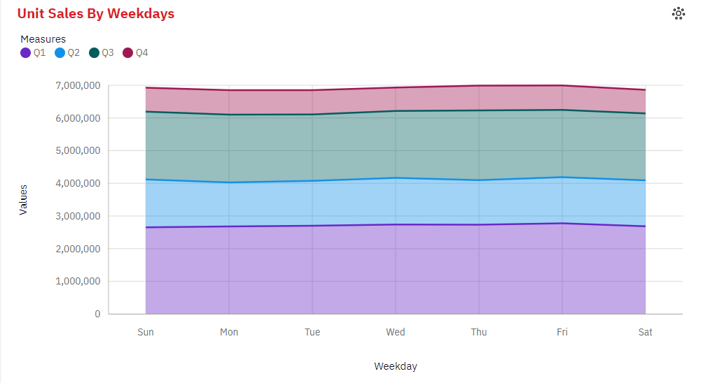

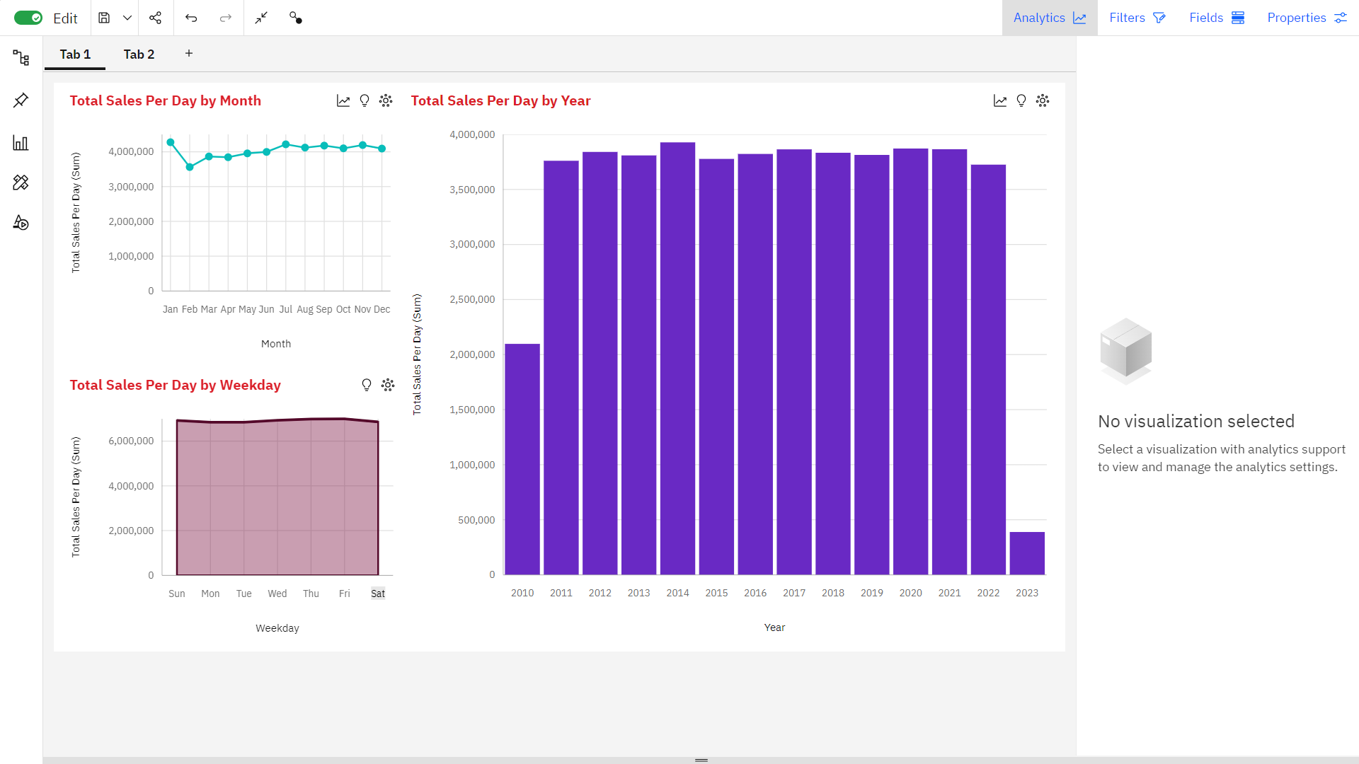

**Observation:**

* Q1 ranges from nearly 2.7 million, when Weekday is Sun, to nearly 2.8 million, when Weekday is Fri.
* Q2 ranges from over 1.3 million, when Weekday is Mon, to nearly 1.5 million, when Weekday is Sun.
* Q3 ranges from over 2.0 million, when Weekday is Tue, to over 2.1 million, when Weekday is Thu.
* Q4 ranges from almost 720 thousand, when Weekday is Wed, to over 756 thousand, when Weekday is Thu.
* Across all weekdays, the sum of Total Sales Per Day is over 48 million.
* Total Sales Per Day ranges from over 6.8 million, when Weekday is Mon, to nearly 7.0 million, when Weekday is Fri.
* For Total Sales Per Day, the most significant values of Weekday are Fri, Thu, Wed, and Sun, whose respective Total Sales Per Day values add up to nearly 28 million, or 57.5 % of the total.

**DASHBOARD:**



**Actionable Insights:**

Based on our observations of monthly sales trends, sales trends over the years, and sales trends in weekdays, we can derive some actionable insights for peak sales periods and overall sales strategy:

**Monthly Sales Trends:**

**1. Q1 Peak:**Q1 consistently shows a strong upward trend. The period from February to July appears to be the peak within Q1. Focus your marketing efforts and inventory management to take advantage of this peak.

**2. February Slump**:All products experience a drop in February. Plan for this dip in sales by perhaps running promotions or clearance sales to maintain revenue.

**3. January Surge:** The sales for all products rise in January. Capitalize on this surge by launching new products or special promotions at the beginning of the year.

**Sales Trends over Years:**

**1. Year 2014**:This year had the highest sales in various quarters. Consider studying what worked in 2014 and attempt to replicate successful strategies.

**2. Total Sales Per Day Trends:**While there's a weak upward trend over the years, be cautious of unusually low years, such as 2010 and 2023. Investigate what caused these low sales and work on strategies to prevent such downturns.

**3. 2022-2023 Drop**:The drastic 90% drop in Total Sales Per Day between 2022 and 2023 is alarming. Investigate the reasons behind this decline, whether it's market-related or internal factors, and develop strategies to reverse the trend.

**Sales Trends in Weekdays:**

1**. Weekday Focus**: The weekdays Fri, Thu, Wed, and Sun account for a significant portion of total sales. Concentrate marketing efforts and special promotions on these days to maximize revenue.

**2. Weekday Differences:**The sales figures for each weekday vary significantly. Make sure to have sufficient staff and resources available on days with the highest sales, such as Monday for Q2, and Sunday for Q1.

**Overall Strategy**:

**1. Peak Season Planning**: Focus your inventory buildup and marketing campaigns for Q1, especially during the months of February to July. Be prepared to handle the increased demand and ensure product availability during these months.

**2. February Strategy:** As February sees a slump, plan for clearance sales, promotions, or other incentives to maintain revenue during this period.

**3. January Kickoff:** Take advantage of the January surge by launching new products, running special promotions, or advertising heavily.

**4. Learn from Successful Years:**Study the successful years, like 2014, and try to identify what strategies and products contributed to high sales. Replicate those strategies in other years.

**5. Address Yearly Declines:** Investigate the reasons behind years with unusually low sales, like 2020 and 2023. Take corrective actions to prevent such declines.

**6. Weekday Targeting**:Concentrate your marketing efforts and resources on weekdays with the highest sales, particularly Fri, Thu, Wed, and Sun.

**7. Maintain Quality and Service:** Ensure that your products and customer service remain consistent across all periods and weekdays to maintain customer satisfaction and loyalty.

By incorporating these insights into your sales and marketing strategy, you can optimize your business for peak sales periods and ensure steady growth over the years.

**iii.To identify customer preferences**

To discern customer preferences, we utilized visualizations in IBM Cognos:

- Line charts depicted yearly unit sales trends, aiding in understanding annual customer inclinations.

- Area charts showcased sales patterns by month, unveiling monthly customer preferences.

- Stacked column charts illustrated sales distribution by weekday, revealing customer buying habits across the week.

- Summary charts provided insights into total and average sales and revenue, facilitating a comprehensive overview of customer engagement and preferences**.**

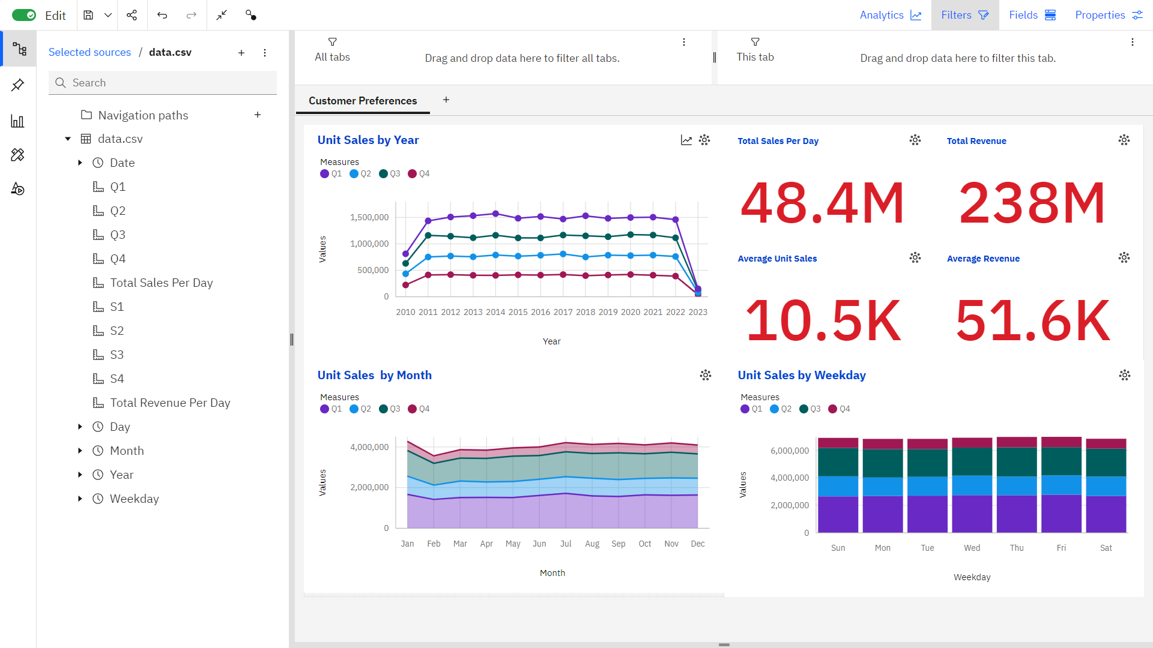

**Observation:**

* July, November, January, September, and October are the most prevalent months across all quarters, representing 43.5% of the total sales counts for each quarter.
* The average sales per month across all quarters are over 4,000 (Q1), over 2,000 (Q2), over 3,000 (Q3), and over 1,000 (Q4).
* The total results for each quarter are over 4,500, emphasizing consistency in dataset entries.
* January consistently displays the highest total sales per day, reaching almost 4.3 million, while February records the lowest figures across both total sales and total revenue per day.
* April has the highest average total sales per day at over 10,600, while May shows the highest average total revenue per day, surpassing 52,300.
* Both total sales and revenue per day are projected to increase by the next month, with estimations exceeding 10,000 for total sales and 51,000 for total revenue per day.

These insights outline seasonal patterns, prevalent months, averages, and trends in sales and revenue, providing a comprehensive understanding of the dataset's dynamics and potential future projections**.**

**Customer Preferences:**

**1. Seasonal Trend and Frequency:**

- Customers exhibit a strong preference for specific months (Jul, Nov, Jan, Sep, Oct) across all quarters (Q1, Q2, Q3, Q4). Focusing on these periods may align with customer buying habits.

**2. Product Specific Preferences:**

- Observing Q1, Q2, Q3, and Q4 trends reveals variations in customer preferences for different products across various timeframes. Analyzing these patterns can guide marketing strategies.

**Actionable Insights based on Customer Preferences:**

**1. Seasonal Marketing Strategy:**

- Tailor marketing campaigns according to the seasonal trends observed in certain months. Leverage this insight to target and engage customers during these periods.

**2. Product Optimization:**

- Develop product-specific marketing and inventory strategies based on the quarterly trends. Addressing product popularity in specific periods could improve sales.

**3. Customer-Centric Approach:**

- Analyze customer preferences across months and quarters to anticipate demands. This approach can guide product development and service enhancements.

**4. Forecast-Driven Strategies:**

- Utilize forecasting insights to prepare for future customer demands. This proactive approach ensures adequate stock and tailored marketing strategies.

**5. Average Sales and Revenue Analysis:**

- Understanding average sales and revenue provides a benchmark to measure performance. Deviations from these averages can signal shifts in customer preferences.

These actionable insights derived from the data provide a roadmap for businesses to better understand customer preferences and align their strategies to meet customer needs effectively. The focus on seasonal trends, product preferences, and proactive planning based on forecasts and averages can significantly impact customer satisfaction and business success.

**iv.to estimate the number of units of each product that could be sold on December 31st of each year if all retail centers were kept open**

The company closes all its retail centers on December 31st each year.Estimating sales on December 31st is crucial for planning and decision-making.

**Methods:**

**Method 1: Use Historical Sales Data from Nearby Dates:**

* Analyze sales data from days immediately before and after December 31st.
* Extrapolate estimates based on observed sales patterns during those adjacent days.
* Provides a rough estimate using nearby historical data, but may not account for unique December 31st factors.

**Method 2: Use Average Monthly Sales Patterns:**

* Calculate the average sales for each product over entire months, excluding December.
* Apply this average to estimate sales on December 31st, assuming consistent sales patterns.
* A more systematic approach that considers overall sales trends throughout the year, accounting for variations.

**Method 3: Find Average of Sales on the 31st of Every Month:**

* Determine the average sales on the 31st day of each month.
* Use this average as an estimate for December 31st sales.
* Assumes uniform sales patterns on all 31st days, which may not accurately represent the unique characteristics of December 31st.

**Recommendation:**

* Method 2, using average monthly sales patterns, is recommended for estimating December 31st sales.
* Acknowledge the limitations of all methods and communicate them to stakeholders.
* Provide regular updates and refined estimates as more data becomes availale
* Accurately estimating sales on December 31st is challenging when retail centers are closed.
* The selected method offers a reasonable approximation for planning and decision-making.
* Continuous monitoring and adjustments to estimates are advised**.**

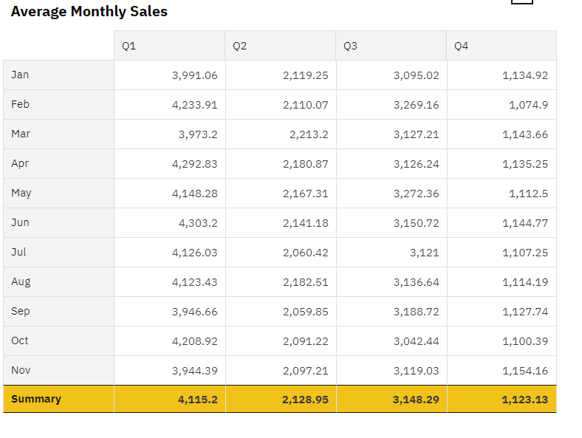

Based on the provided average monthly sales data for each product (P1, P2, P3, and P4), we can estimate the sales for December (excluding December) by simply using the respective average sales for each product.

Assuming that we have average monthly sales data for 11 months (excluding December), we can estimate December sales for each product as follows:

**P1: 4115 units**

**P2: 2128 units**

**P3: 3148 units**

**P4: 1123 units**

These estimates are based on the average monthly sales data you provided, assuming that sales patterns are relatively consistent from month to month. Please keep in mind that these are approximate estimates and may not account for any unique factors or seasonal variations that might affect December sales differently.

**v.to predict future sales in 2024 and revenue**

To predict the future sales ,create a column chart that displays historical sales data up to the present.

* After creating the column chart, navigate to the chart options or properties.Look for the "Forecasting" option.
* Access the forecasting parameters where you can specify the target year, which is 2024 in this case.
* Set the desired forecasting method
* Once you've configured the parameters, trigger the forecast generation.
* IBM Cognos will use the selected method to extrapolate future sales data for 2024 based on the historical data provided in the chart.
* Examine the forecasted values displayed in the chart, which will extend into 2024.
* Interpret the forecast to understand the predicted sales trends for the upcoming year.
* Use the Forecast for Decision-Making
* The generated forecast can help with planning, resource allocation, and making informed decisions for the year 2024 based on predicted sales trends.
* Do the same for predicting the revenue

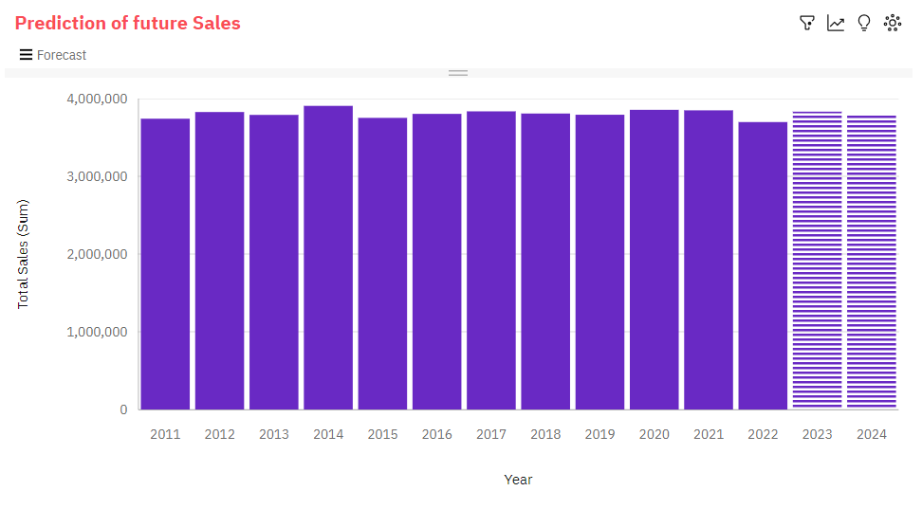

**Observation:**

* Total Sales has a moderate upward trend.
* Based on the current forecasting, Total Sales may reach nearly 3.8 million by Year 2024
* From 2014 to 2015, Total Sales dropped by 4%.
* Total Sales ranges from almost 3.7 million, in 2022, to over 3.9 million, in 2014.

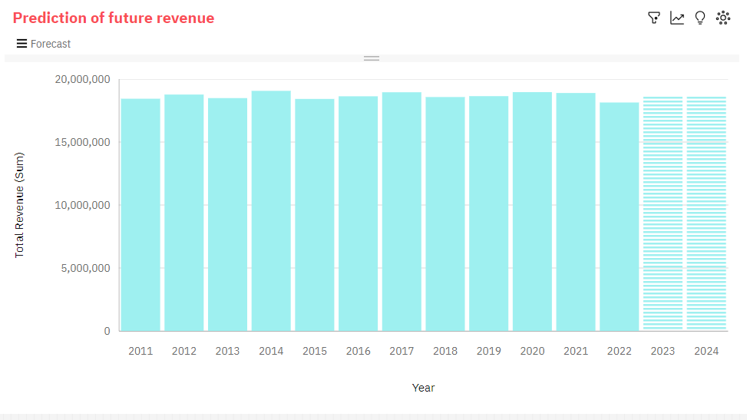

**Observation:**

* Total Revenue has a weak upward trend.
* Based on the current forecasting, Total Revenue may reach nearly nineteen million by Year 2024.
* From 2021 to 2022, Total Revenue dropped by 4%.
* Across all years, the sum of Total Revenue is over 224 million.
* Total Revenue ranges from over eighteen million, in 2022, to over nineteen million, in 2014.
* Total Revenue ranges from over eighteen million, in 2022, to over nineteen million, in 2014.

**Conclusion:**

In this project, we leveraged IBM Cognos Analytics to extract actionable insights from a comprehensive sales and revenue dataset. We identified top-selling products, discerned sales trends, and uncovered customer preferences. The insights obtained, ranging from seasonality and product popularity to monthly and yearly variations, offer a strategic roadmap for optimizing product performance, marketing efforts, and inventory management. These insights empower data-driven decision-making to enhance business outcomes and customer satisfaction.