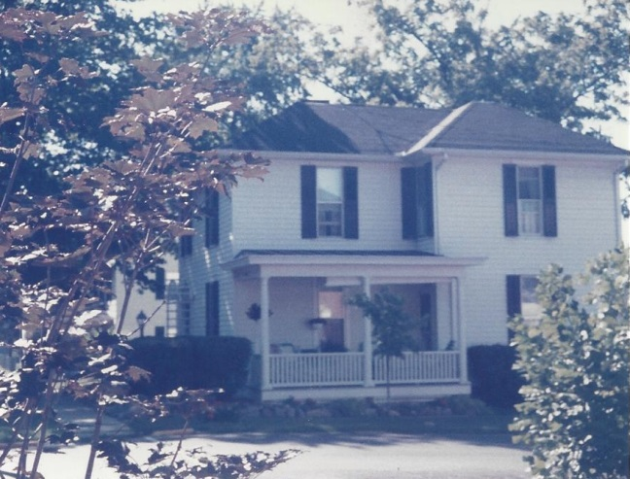

Russell & Mary Wolfe home in Kingston Ohio - Aug 1985

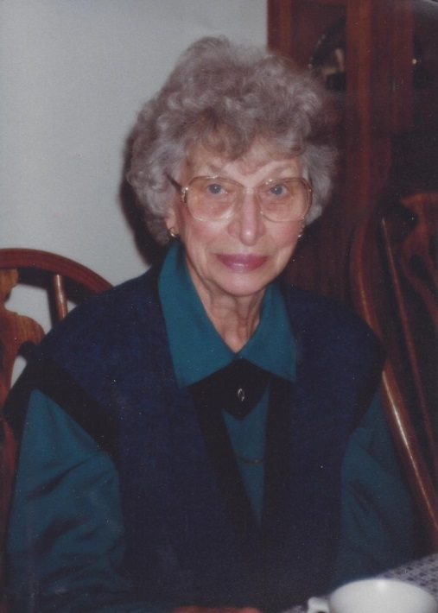

Mary Foster Wolfe, Thanksgiving – 1989