FORMAT 2

Monroe County Chapter of the Ohio Genealogical Society
“Your family quest begins here”

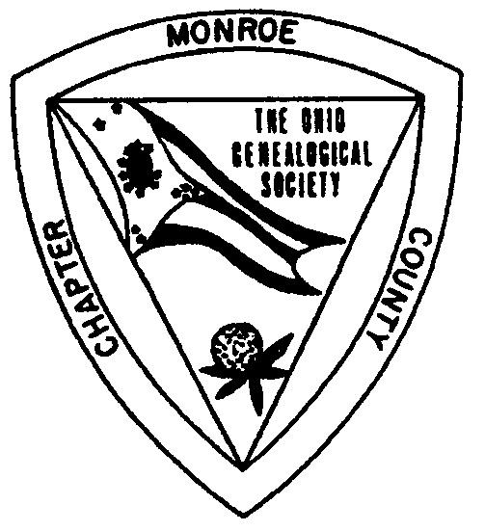
Membership

- Receive the 24-page, award-winning Navigator, filled with local records, genealogies, cemetery records, local history and much more!
- Connect with researchers interested in your family surnames.
- Add your Monroe County surnames to the Surname File.
- Honor your early Monroe County ancestors through First Families and Pioneer Families
- Membership is $7.00 per individual or $10.00 per family for the January to December membership year.

Meetings
- Meet with us the third Sunday of every month at 2:00 p.m. (except December).
- Meetings are held at the Monroe County District Library unless otherwise noted.
- Meetings feature speakers of genealogical or local history interest.
- Connect with other Monroe County researchers.
- All meetings are open to everyone!

Research Room
- The Research Room is located at the Monroe County District Library. It’s your best source for Monroe County research.
- Records from churches, cemeteries, military, marriages, probate, census, family histories, county histories, microfilmed newspapers, CDs and more!
- Open Monday through Saturday.

Publications for Sale
- Check out our publications for sale to expand your personal library.
- Visit our website at http://www.rootsweb.com/~ohmccogs/ for a complete list of publications. Also available on the site are upcoming events, news, more information and downloadable forms.

Contact us at neiswong@1st.net.

