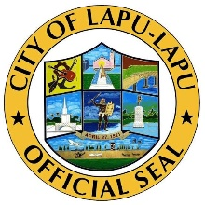Republic of the Philippines

City of Lapu-Lapu

Barangay of Pusok

**OFFICE OF THE PUNONG BARANGAY**

Tel. No.: 340-7771

**CERTIFICATION**

**TO WHOM THIS MAY CONCERN:**

**THIS IS TO CERTIFY** that **${name}** ${gender}, of legal age and a resident of Barangay Pusok, Lapu – Lapu City.

This is to certify further that the above-mentioned person was never reported as PUM or PUI as per verification from Barangay Health Emergency Response Team (BHERT).

This certification is being issued upon request of the aforementioned person as a part of her **${purpose}** requirements.

Issued this ${date}day of ${month}, ${year} at the Barangay Hall of Pusok, Lapu - Lapu City, Cebu Philippines.

JUAN C. DELA CRUZ

Punong Barangay

SANGGUNIANG BARANGAY OF PUSOK

HON. JUAN C. DELA CRUZ Punong Barangay

Barangay Kagawad:

HON. ANNA C. SANCHEZ

HON. CARLITO P. BIBILON

HON. BONIFACIO D. HACINTO

HON. ALVIN A. CALBINO

HON. ATTILANA E. MALAGAPO

HON. ILUMINADA P. MALINAO

HON.CRIS C. TOLINO

HON. LAIKA J. TAMPUS

SK Chairperson

SALVACION N. LINAO

(Barangay Secretary)

MARILYN D. TAN

(Barangay Treasurer)

