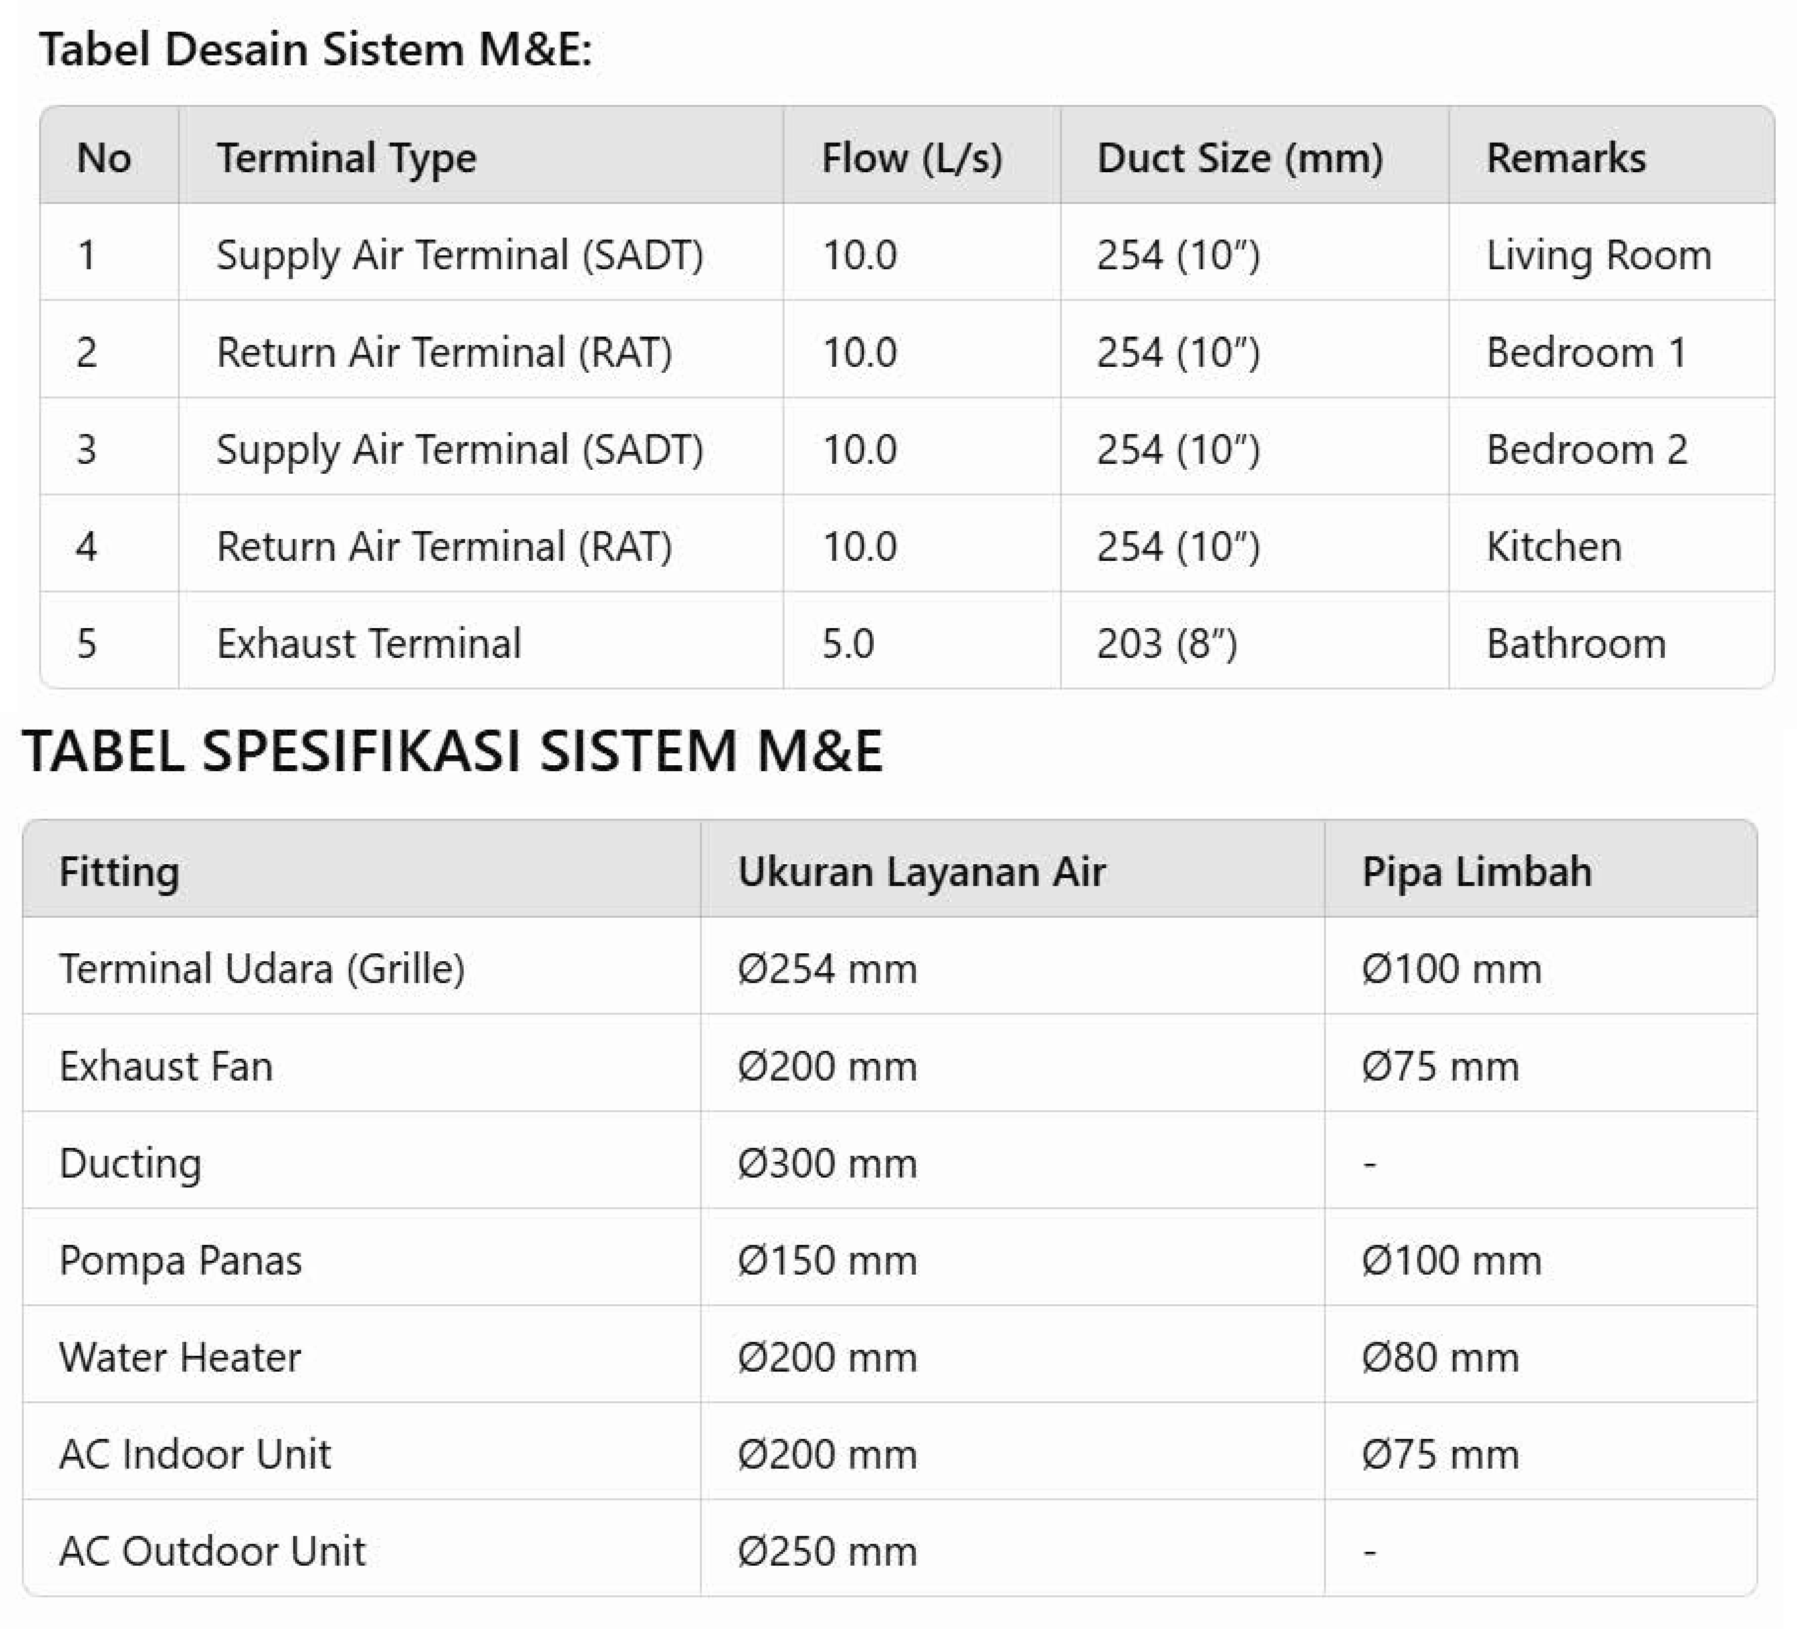

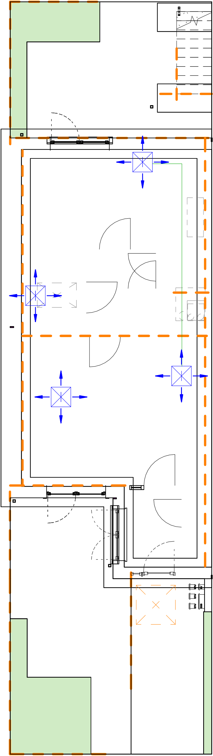

First Floor Structural

1 Framing Plan 1 : 100