CP3405 – Design Thinking 3 (2026)

Assessment 1: Scrum Learning Activities

Weekly Workbook Template (Use One Copy Per Week)

Student name: Ryan Ericson
Student number: 14220594
Week: 1
Topic: ____________________________
Tutor / facilitator:

Overview (Read once, then reuse weekly)
This weekly workbook template is used for Assessment 1: Scrum Learning Activities (40%).
You will complete one copy of this template for each week (Weeks 1–5) and compile all five completed weekly workbooks into one single document for submission in Week 5.
Each weekly workbook is designed to:
- reinforce key Scrum and design thinking concepts,
- support application of learning in seminars, synthesising sessions, and practicals, and
- scaffold reflective practice using Gibbs’ reflective cycle.

Instructions
For the current week:
- Answer all sections concisely and in your own words.
- Follow the indicative word limits.
- Where relevant, refer to seminar, practical, or Sprint Pilot activities.
- AI-generated text must not be pasted into responses. Reflections should focus on insights gained.
This week’s Knowledge Check and Application Task should focus on the core concepts introduced in the self-directed module and explored in seminars/practicals.
Permitted Generative AI use is limited to paraphrasing and grammar only and must be declared at the end of the compiled submission.

1. Knowledge Check (≈40 words)
Answer the key conceptual question(s) for this week, based on the self-directed learning module.
Response:
Doing a bit everyday
Even if its writing a little bit of code, maybe a line or two, still keeps it in the
forefront of my mind.
Even if I dont feel like doing any at all, just thinking of it can change my mind
and it goes from not feeling like doing anything at all today too implementing
whatever prompted the session.

External Reasearch
Reading about it after the sessions, looking at others examples and even logging my feelings after the fact provide an outside perspective of the problem at hand.
Blogs and medium articles have provided countless bursts of inspiration, especially reading not near my computer,unable to do anything but note down the Euraka moment.

2. Application Task (≈40 words + artefact if relevant)
Apply this week’s Scrum or design thinking concept to a practical or project-based context.
You may include:
- short examples,
- diagrams,
- screenshots of artefacts (e.g. backlog items, definitions of done, planning notes).
Response / artefact:
For CP3406 – Mobile Computing, I had the idea of adding shaders to the mobile app (had a working build, but scrapped because of time constraints/readability.) that never actually materialised. A particular challenge was trying to find a way to incoporate moving (dynamic) shader without sacrificing readability and viewing.
Using the sprint review and retrospective to summarise what went, what did’nt and what to improve for the next session.

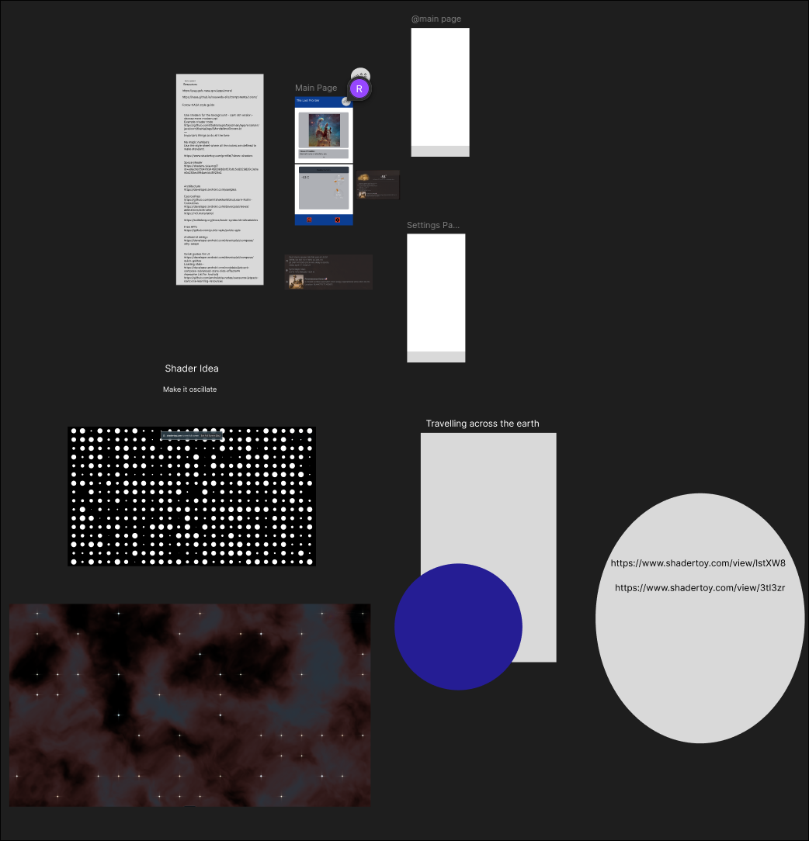

3. AI Conversation Reflection (≈40 words)
Reflect on the AI-supported Socratic or role-play conversations for this week.
In your reflection:
- identify one key insight, and
- explain how it influenced or clarified your understanding.
Do not reproduce AI responses.
Reflection:
An anonoymous idea sharing section would be a great way to equalise loud and quiet voices. More input means more data to work with meaning more possible bases could be accounted for.
More data is always welcome , even if it might not be the best as it can still be valuable in connecting the dots bewteen more valuables pieces of data.

4. Micro Reflection – Gibbs’ Reflective Cycle (≈80 words)
Using Gibbs’ reflective cycle, reflect on one positive or challenging learning experience from this week.
You may briefly address:
- what happened,
- how you felt or responded,
- what you learned, and
- what you would do differently next time.
Reflection:
I noticed uncertainty in my teammate about what the assignment will be. Despite it being very early, we both were apprehensive about what out potential topic and project should be.
I said to him, “It’s only week one, we have plenty of time to figure it out.” which eased his mind up a bit.
Looking at it, I realised that small words of encouragement are enough to shift someones mindset.
Next time, I will probably have a braver face and a more reassured tone to calm down the worry they may have.

Weekly Completion Checklist
☐ All four sections completed
☐ Word limits approximately followed
☐ Responses written in my own words
☐ Artefacts clearly labelled (if included)

Repeat this template for each week (Weeks 1–5), then compile all completed weekly workbooks into one document for submission in Week 5.

