CP3405 – Design Thinking 3 (2026)

Assessment 1: Scrum Learning Activities

Weekly Workbook Template (Use One Copy Per Week)

Student name: Ryan Ericson
Student number: 14220594
Week: 1
Topic: Orientation
Tutor / facilitator:

1. Knowledge Check (≈40 words)
Answer the key conceptual question(s) for this week, based on the self-directed learning module.
Response:
Doing a bit everyday
Even if its writing a little bit of code, maybe a line or two, still keeps it in the
forefront of my mind.
Even if I dont feel like doing any at all, just thinking of it can change my mind
and it goes from not feeling like doing anything at all today too implementing
whatever prompted the session.

External Reasearch
Reading about it after the sessions, looking at others examples and even logging my feelings after the fact provide an outside perspective of the problem at hand.
Blogs and medium articles have provided countless bursts of inspiration, especially reading not near my computer,unable to do anything but note down the Euraka moment.

2. Application Task (≈40 words + artefact if relevant)
Apply this week’s Scrum or design thinking concept to a practical or project-based context.
You may include:
- short examples,
- diagrams,
- screenshots of artefacts (e.g. backlog items, definitions of done, planning notes).
Response / artefact:
For CP3406 – Mobile Computing, I had the idea of adding shaders to the mobile app (had a working build, but scrapped because of time constraints/readability.) that never actually materialised. A particular challenge was trying to find a way to incoporate moving (dynamic) shader without sacrificing readability and viewing.
Using the sprint review and retrospective to summarise what went, what did’nt and what to improve for the next session.

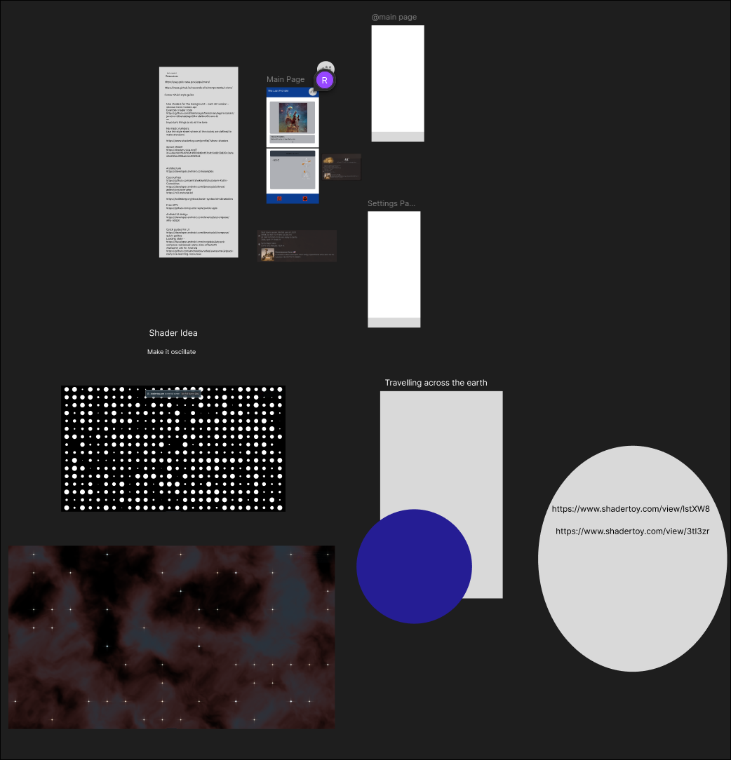

3. AI Conversation Reflection (≈40 words)
Reflect on the AI-supported Socratic or role-play conversations for this week.
In your reflection:
- identify one key insight, and
- explain how it influenced or clarified your understanding.
Do not reproduce AI responses.
Reflection:
An anonoymous idea sharing section would be a great way to equalise loud and quiet voices. More input means more data to work with meaning more possible bases could be accounted for.
More data is always welcome , even if it might not be the best as it can still be valuable in connecting the dots bewteen more valuables pieces of data.

4. Micro Reflection – Gibbs’ Reflective Cycle (≈80 words)
Using Gibbs’ reflective cycle, reflect on one positive or challenging learning experience from this week.
You may briefly address:
- what happened,
- how you felt or responded,
- what you learned, and
- what you would do differently next time.
Reflection:
I noticed uncertainty in my teammate about what the assignment will be. Despite it being very early, we both were apprehensive about what out potential topic and project should be.
I said to him, “It’s only week one, we have plenty of time to figure it out.” which eased his mind up a bit.
Looking at it, I realised that small words of encouragement are enough to shift someones mindset.
Next time, I will probably have a braver face and a more reassured tone to calm down the worry they may have.

Student name: Ryan Ericson
Student number:
Week: 2
Topic: Values, Emporicism and early application
Tutor / facilitator:

1. Knowledge Check (≈40 words)
Answer the key conceptual question(s) for this week, based on the self-directed learning module.
Response:
Transparency
All parties (team-members, stake-holders) involved in are well-informed of the progress of the project. Having all parties in sync allows empowers all team members/stakeholders to actively participate in the development proccess and contribute valuable information and have it be appreciated. Under these conditions, mutual trust and the courage to speak about positive and negative updates will flourish.
Inspection
Consistent and frequent inspection of the projects advancement and the product itself by all party members.
• Continuous Improvement: Inspection drives ongoing enhancements in Scrum.
• Informed Adjustments: Regular checks enable teams to make smart and informed process adjustments.
• Iterative Development: The iterative nature of Scrum ensures that each inspection influences the next sprint.
• Incremental Enhancements: Inspection points lead to step-by-step improvements in the development process.
Adaption
Coming after inspection, adaption allows teams to quickly respond to new stimuli to adjust their strategies to leverage the newfound insights.
• Sprint Backlog Flexibility: In the midst of a sprint, if new insights or changes arise, the team has the flexibility to adjust the sprint backlog accordingly.
• Daily Stand-up Flexibility: In these meetings, team members can adjust their plans for the day, incorporating insights from progress and addressing any encountered impediments.
• Sprint Review Insights: Input collected during the sprint review informs adjustments for sprints.

2. Application Task (≈40 words + artefact if relevant)
Apply this week’s Scrum or design thinking concept to a practical or project-based context.
You may include:
- short examples,
- diagrams,
- screenshots of artefacts (e.g. backlog items, definitions of done, planning notes).
Response / artefact:
Commitment:
The effect would be on the ability to effectively frame what commitment means in the sense of a scrum. It is not the full guarantee of the completion of every task or the rigid adherence to original plans regardless of what introspection reveals but the promise of continuous support to teammates and the commitment to maintaining quality standards.
This affects the day to day experience felt by all team members. Having even a few dedicated members, hopefully those in the leadership roles should inspire the rest of the team to have dedication to the process and ultimately, to the products success.
Commitment to success; Includes both individual achievements and the teams overall success. When everyone is commited to the teams goals, trust and the teams standards should rise.
Commitment to continuous improvement; daily improvement makes it easier to pivot or change direction when new information and feedback is recieved.

During the sprint for the online Design Thinking 2, both sessions lasted well into the night. All team members were exhuasted by the end of the first day. All team members were doing design thinking 2, so no expertise could be given by people doing design thinking 3. However they were moments of individual commitment shown by all team members that inspired us to maintain the quality standards we aimed to achieve.

3. AI Conversation Reflection (≈40 words)
Reflect on the AI-supported Socratic or role-play conversations for this week.
In your reflection:
- identify one key insight, and
- explain how it influenced or clarified your understanding.
Do not reproduce AI responses.
Reflection:
The key insight would be how agile differently shapes what the final product will look like and how it differs from a plan-based development.
Agile development allows stakeholders to be more inclined to contribute continuously through the project, it allows for more active contribution to what the final product will look like. This is because of the continuous discussion throughout the sprints, able to cleanly change priorities for when new information comes in. This flexibility allows the final product/solution to be a perfect fit for the stakeholders.
Individual ownership of the task is just as important as the overall team commitment. When people feel that their own contribution is valued by other team members, their own personal morale and outlook will improve, providing a cascading effect on the other members of the team. There is no best way to work in a team full of very different individuals.
have time to review artifacts and view it in a balanced lens. Some approaches taken, recorded and formed into artifacts could be harshly critiqued when they might be a possible answer to a question/problem further along the design process.
Structure your strategies around the group even if you like a particular way of doing it than an other. An anonomous sharing of ideas could reduce the individual ownership for certain people, reducing the overall quality of the final product/solution.

4. Micro Reflection – Gibbs’ Reflective Cycle (≈80 words)
Using Gibbs’ reflective cycle, reflect on one positive or challenging learning experience from this week.
You may briefly address:
- what happened,
- how you felt or responded,
- what you learned, and
- what you would do differently next time.
Reflection:
1. Description
When discussing the assignment, we focused too much on the delivery mechanism (game/website) than the overall message we wanted to convey. A team member had a plan-based focus on their approach, trying to form the product shape before considering what we were trying to achieve.
2. Feelings
I also felt the nervousness of not having an absolute to cling onto. To not have a concrete idea and to still not feel like anything was achieved in that session felt demoralising as that early morale is compounding. It also felt frustrating to constantly reiterate to myself and team-members to not form the what the product will look like but to first find the meaning behind it.
3. Evaluation
What worked well was the wealth of different discussion and our sharing of the different development experiences we have had. Sharing of both successful and unsuccessful endeavours without fear of judgement was refreshing.

What didn't work well was the constant reiterating of trying to focus on what we are trying to achieve and not on what we are trying to build.

4. Analysis
We have worked as a team before on previous assignments, so sharing what we have achieved and catching up was easier than if we were all new to each other. We also knew how each other liked to work. This was compounded by our shared success and failures from previously working with each other.
A theory about the negative aspect of the constant reiteration, would be our approaches towards previous software building. For most of our own software building, in University or out of it, there has always been a great focus on the technical application and what hard skills we learn from it, rather than finding out and filling in a problem.
5. Conclusion
The key lesson was to consider the different programming/development journeys we have undertaken to reach this current point. Despite similar course content, our approaches and priorities differ greatly. Taking consideration and covering our weaknesses is integral for our success.
6. Action Plan
To acknowledge our different journeys, a deep dive into the individual projects , coded or not and an explanation of our approaches would be an effective learning opportunity. This could help down the line when revisting the artifacts generated after each sprint.

Weekly Workbook Template (Use One Copy Per Week)

Student name: Ryan Ericson
Student number:
Week: 3
Topic: Roles, teamwork and early scrum practice
Tutor / facilitator:

1. Knowledge Check (≈40 words)
Answer the key conceptual question(s) for this week, based on the self-directed learning module.
Response:
As scrum is an iterative framework for development, it allows for continuous feedback and flexibility, this approach emphasises small, self-managing teams as they are able to quickly respond to new stimuli. This approach is formed from the notion of requirement volatility, that stakeholders will change requirements as the project evolves.
Self managing teams do not require a manager to make the final decision, deciding themselves on how to best approach and do not have to be slowed by outside bureaucracy.
Hierarchies and sub-teams delay the flow of information to and from. Information has to flow through many levels to reach the relevant party/individuals. This goes against the scrums goal of fast feedback and change.

2. Application Task (≈40 words + artefact if relevant)
Apply this week’s Scrum or design thinking concept to a practical or project-based context.
You may include:
- short examples,
- diagrams,
- screenshots of artefacts (e.g. backlog items, definitions of done, planning notes).
Response / artefact:
Protecting the purpose of the scrum and helping people understand why the framework exists. Ensures all understand Scrum theory and practice, both within and outside of the team. Fostering the culture of the team, especially around continuous improvement. Leading the retrospection for the team and encouraging discussion about the processes and collaboratively identify improvements.
Servant leader - advocates for the team and ensures all needs are met. Remove external impediments that would impact the smooth development process. Understanding the need for clear and concise Product Backlog items.
Guiding hand that steers the boat through unknown waters to lead them to new lands.

3. AI Conversation Reflection (≈40 words)
Reflect on the AI-supported Socratic or role-play conversations for this week.
In your reflection:
- identify one key insight, and
- explain how it influenced or clarified your understanding.
Do not reproduce AI responses.
Reflection:

Chat 1 - Purpose of a sprint pilot
Insight - the sprint pilot has lower stakes involved in the whole process, this allows for teams to be more experimentive in their approach rather than relying on old and trusted method's.
Despite the lower stakes, it can still be hard for people to experiment with new methods. Ice-breakers and the such can work for getting people out of their comfort room but can be re-hearsed. So changing it to something out of left field like karaoke, which could be very uncomfortable and will be completely new process for some could instill a sense of exploration and broaden people's horizon.

Chat 2 - Sprint planning - Roleplay - one planning practice that i will apply to my team.
"Definition of Done" Shared set of criteria determined among the group/stakeholders of when a product or backlog item is done or completed.
Shared understanding of what the final product will look like to all parties.
Start a collaborative chat, highlighting the key parts and forming them into actionable statements. Stops potential confusion of what needs to be delivered and when.

Inspect and adapt
Checking progress regularly to see if it's heading to the sprint goal and adjusting accordingly if things are not working or new info pops up.

4. Micro Reflection – Gibbs’ Reflective Cycle (≈80 words)
Using Gibbs’ reflective cycle, reflect on one positive or challenging learning experience from this week.
You may briefly address:
- what happened,
- how you felt or responded,
- what you learned, and
- what you would do differently next time.
Reflection:
On negotiating responsibilities, I declared myself the scrum master without much input from my teammates and failed to have an appropriate discussion beforehand. In my defence, one teammate was away and the other did not know too much about the scrum roles.
When I conducted my retrospection of the day, I felt like it was somewhat needed to keep the operation going smoothly and to derail into unneeded conversation. However, I felt guilty in not taking into consideration the input that they would have given.
What worked well was that we had nearly fully completed the assigned tasks of the week, unlike others where external meetings were needed to catch up. What did not go well was that as one teammate was away for the first part of the class, they were unaware of the discussion of the roles and the executive decision that I made. My action also makes it look like I do not value their opinions.
I took the role upon myself to keep the flow of discussion moving forwad, proritising speed and actual fruitful discussion that could have come from it. They were two factors that affected my decision. The absent teammate and the lack of team role knowledge that my other teammate displayed.
The scrum guide tells that a scrum master serves the team. It does not command it. Upon taking the role without agreement, I acted against the principle.
For the next session, a quick explanation of the team-roles and what each entails would go a long way for a fair and democratic process.

