CP2406
Weekly Project Development Journal
Reusable for Emotion Smoother, Football Sustained Risk, Galaxy Simulation and other approved C++ projects

Student name: Ryan Ericson
Student number: 14220594
Project option: Galaxy Simulation
Teaching period: 3
Purpose
Use this journal to show progressive, authentic development of your project. Complete one entry at each required checkpoint. Entries should identify the code you changed, evidence collected, problems solved, tests performed, assistance used and your next step.

Submission Instructions
- Complete the journal during development, not only at the end of the assignment.
- Use specific file, class and function names. For example: main.cpp, EmotionSmoother, risk calculation, simulation update loop or CMake configuration.
- Include dated evidence from your own project. Suitable evidence may include CLion screenshots, terminal output, test results or saved project versions.
- Record generative AI use and other assistance honestly. Explain how suggestions were checked, changed or rejected.
- Submit the completed journal in the format and at the checkpoints specified by your subject coordinator.

Suggested Checkpoints
Entry | Suggested focus | Evidence examples
1 | Understand starter project; plan and begin the first core feature. | Clean build, codebase notes, initial input/output or function.
2 | Implement and test the main algorithm or simulation behaviour. | Changed functions, targeted tests, debugging evidence.
3 | Integrate features; compare settings or scenarios; refactor and test. | Comparison output, edge cases, code-quality changes.
Final reflection | Summarise learning, verification, AI use and readiness to explain the code. | Completed journal, final test summary and submission check.

Weekly Journal Entry 1
Week / dates: 2026-10-03 Sat
Project option: ☐ Emotion Smoother ☐ Football Sustained Risk ☐ Galaxy Simulation ☐ Other: __________
Checkpoint / task focus: ____________________________________________

1. Goals for This Week
What did you plan to complete? State specific functions, features, tests or documentation.
SimulationConfiguration.cpp -validate()
Validating the command line input and outputing guide for correct output if args are incorrect.
Regression Testing – changed validation affects the algorithm and accepts changed commad line args. Testing the upper and lower bounds of program to see if errors in logic are found.
Document
Adding comments and text output to explain why the collision threshold can be zero.

safely parsing command line args - ParseArgument(int argc, char** argv)

Implementing safe two body merge – checkAndMergeCollision()

2. Development Work Completed
File / component | Function or area changed | Summary of your own changes
SimulationConfig.cpp  void SimulationConfig::validate() | If statement for systemsizeAU | Added steps

3. Evidence of Progress
Attach or insert at least one dated item that shows genuine progress, such as a CLion screenshot, program output, test result or version-history copy. Do not include private information.
Evidence filename / link: SimulationConfiguration.cpp -
Explain what the evidence shows and how it relates to this week’s work.
SimulationConfiguration.cpp -validate
Decide and document the min body count
I set the minimum body count to 2 in SimulationConfig::validate(). The collision pass picks two different bodies from the vector. If there is only one body, no pair can exist, so no collision can happen. A body count of 2 is the smallest number that gives a valid pair. The Barnes-Hut octree also works with two bodies, so the tree does not set the limit. I decided not to change the minimum to 3. The reason for the limit comes from the collision operation, not from the tree.
meaning of the zero collision threshold.
I decided that a collision threshold of 0 turns off merging. SimulationConfig::validate() accepts 0, but it rejects a negative value. When the threshold is 0, the collision pass does not merge any bodies. I chose this rule because other settings in the program also use 0 to turn a feature off. It also gives me a simple way to run a baseline experiment with no collisions. I will use the same rule in checkAndMergeCollision and in my tests.

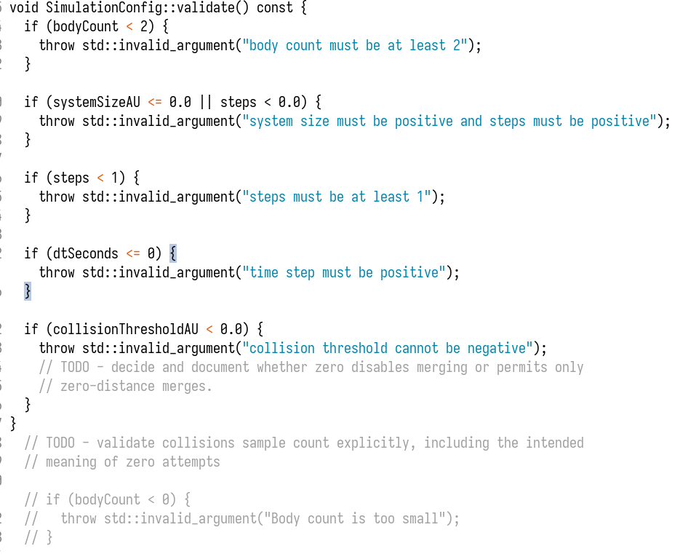

4. Problem-Solving Record
Describe one problem, error or design decision you encountered.
Explain how you investigated it, what you changed, and why the final approach was selected.

5. Testing Performed
Test / input | Expected result | Actual result | Pass / fail and action
--bodies 1 | Error: body count must be at least 2 | Error: body count must be at least 2 | Pass
--bodies 2 | Accepted – lower limit | Accepted | Pass
--system-size 0 | Error: system size must be postive | Error: system size must be positive | Pass
--system-size -1 | Error: system size must be postive | Error: system size must be positive | Pass
--system-size 1 | Compiles | Compiles | Pass
--steps 0 | Error: Steps must be at least one | Error: Steps must be at least one | Pass
--steps 1 | Accepted – lower limit | Compiles – lower limit | Pass
--steps -1 | Error: steps must be at least one | Error: steps must be at least one | Pass
--dt 0 | Error: Time step must be at least positive | Error: time step must be positvie | Pass
--dt -1 | Error – timeStep must be at least positive | Error: time step must be positvie | Pass
--collision-threshold -1 | Error – collision threshold cannot be negative | Error: collision threshold cannot be negative. Input zero to disable collisions | Pass
--collision-threshold 0 | Accepted – Input zero to disable collisions – Merging is off. | Compiles | Pass
Defualt variables (no arguments ) | Accepted (default variables) | Compiles | Pass

6. Generative AI and External Help Log
Record all assistance used this week. If none was used, tick the statement below. Do not paste full AI conversations; summarise the purpose and your verification.
Tool / person | Purpose or question | Suggestion used or rejected | How you checked / changed it
☐ No generative AI or external help was used for this week’s work.

7. Weekly Reflection and Next Step
What did you learn, and which part of the work can you confidently explain or modify?
What is the next specific task you will complete?
Student declaration: This entry accurately records my progress and assistance received.
Student initials / signature: ________________________ Date: ________________________

Weekly Journal Entry 2
Week / dates: ____________________________________________
Project option: ☐ Emotion Smoother ☐ Football Sustained Risk ☐ Galaxy Simulation ☐ Other: __________
Checkpoint / task focus: ____________________________________________

1. Goals for This Week
What did you plan to complete? State specific functions, features, tests or documentation.

2. Development Work Completed
File / component | Function or area changed | Summary of your own changes

3. Evidence of Progress
Attach or insert at least one dated item that shows genuine progress, such as a CLion screenshot, program output, test result or version-history copy. Do not include private information.
Evidence filename / link: ____________________________________________
Explain what the evidence shows and how it relates to this week’s work.

4. Problem-Solving Record
Describe one problem, error or design decision you encountered.
Explain how you investigated it, what you changed, and why the final approach was selected.

5. Testing Performed
Test / input | Expected result | Actual result | Pass / fail and action

6. Generative AI and External Help Log
Record all assistance used this week. If none was used, tick the statement below. Do not paste full AI conversations; summarise the purpose and your verification.
Tool / person | Purpose or question | Suggestion used or rejected | How you checked / changed it
☐ No generative AI or external help was used for this week’s work.

7. Weekly Reflection and Next Step
What did you learn, and which part of the work can you confidently explain or modify?
What is the next specific task you will complete?
Student declaration: This entry accurately records my progress and assistance received.
Student initials / signature: ________________________ Date: ________________________

Weekly Journal Entry 3
Week / dates: ____________________________________________
Project option: ☐ Emotion Smoother ☐ Football Sustained Risk ☐ Galaxy Simulation ☐ Other: __________
Checkpoint / task focus: ____________________________________________

1. Goals for This Week
What did you plan to complete? State specific functions, features, tests or documentation.

2. Development Work Completed
File / component | Function or area changed | Summary of your own changes

3. Evidence of Progress
Attach or insert at least one dated item that shows genuine progress, such as a CLion screenshot, program output, test result or version-history copy. Do not include private information.
Evidence filename / link: ____________________________________________
Explain what the evidence shows and how it relates to this week’s work.

4. Problem-Solving Record
Describe one problem, error or design decision you encountered.
Explain how you investigated it, what you changed, and why the final approach was selected.

5. Testing Performed
Test / input | Expected result | Actual result | Pass / fail and action

6. Generative AI and External Help Log
Record all assistance used this week. If none was used, tick the statement below. Do not paste full AI conversations; summarise the purpose and your verification.
Tool / person | Purpose or question | Suggestion used or rejected | How you checked / changed it
☐ No generative AI or external help was used for this week’s work.

7. Weekly Reflection and Next Step
What did you learn, and which part of the work can you confidently explain or modify?
What is the next specific task you will complete?
Student declaration: This entry accurately records my progress and assistance received.
Student initials / signature: ________________________ Date: ________________________

Final Project Reflection
Project option: ☐ Emotion Smoother ☐ Football Sustained Risk ☐ Galaxy Simulation ☐ Other: __________

1. Development Summary
Summarise how the project developed across the journal checkpoints. Identify the most important features you personally implemented.

2. Most Difficult Problem
Describe the most difficult technical or design problem and how you resolved it.

3. Most Valuable Test
Identify the test that gave you the strongest confidence in the project, including expected and actual results.

4. Code Understanding
Name one function you could explain and modify during a live demonstration. Describe its purpose and key decisions.

5. Final AI-Use Summary
List all generative AI tools used across the assignment, their purpose, and how outputs were verified, modified or rejected. If none were used, state this clearly.

6. Future Improvement
If you continued the project, what would you improve next and why?

Final Submission Check
☐ Journal entries are complete and dated.
☐ Evidence is included and relates to the stated work.
☐ AI and external help are transparently recorded.
☐ Project builds from a clean configuration.
☐ I can explain and modify the submitted code.
☐ Project ZIP excludes build folders, caches and unnecessary generated files.
Student signature: ____________________________ Date: ____________________

