Requirement Traceability Matrix

- Login
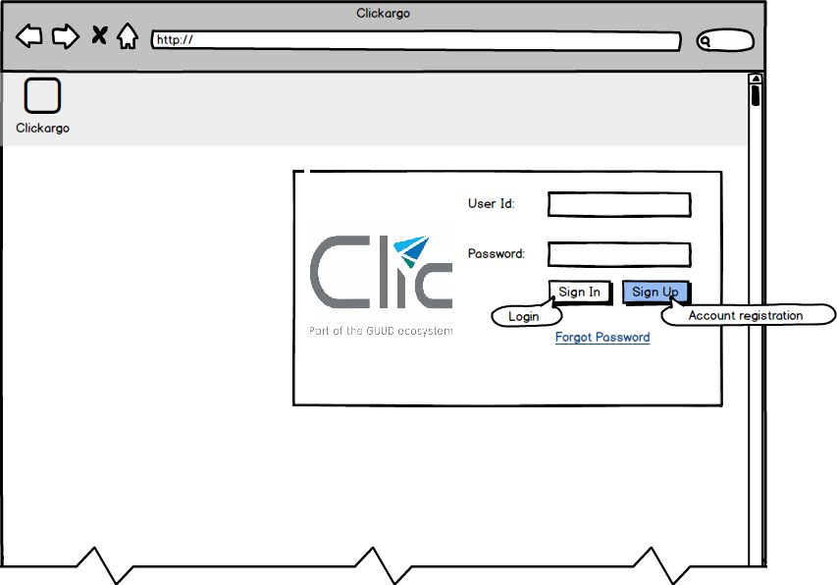

Req No | Req Description | Implementation | Test Case No
R01001 | User and Account must be valid | Validate T_CORE_USR and T_CORE_ACCN
R01002 | User’s account must has subscribed to one or more ClicServices | Validate T_CK_SVC_SUB
R010003 | Forgot password must not repeat the same password for 4 times | Validate T_CORE_USR
R010004 | Password must meet certain criteria in terms of password strength | Refer to PortEDI or SmarteCO implementation for password validation
R010005 | Upon X invalid logins, user will need to reset password | T_CORE_USR  USR_PWD_FORCE  USR_LOGIN_INVCNT
R010006 | User’s account when subscribed to more than one ClicService then show selection, if just one then redirect directly to dashbox page of that module e.g. ClicDO | Validate T_CK_SVC_SUB  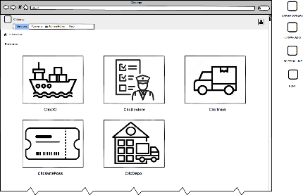

- Cargo Owner Job Listing
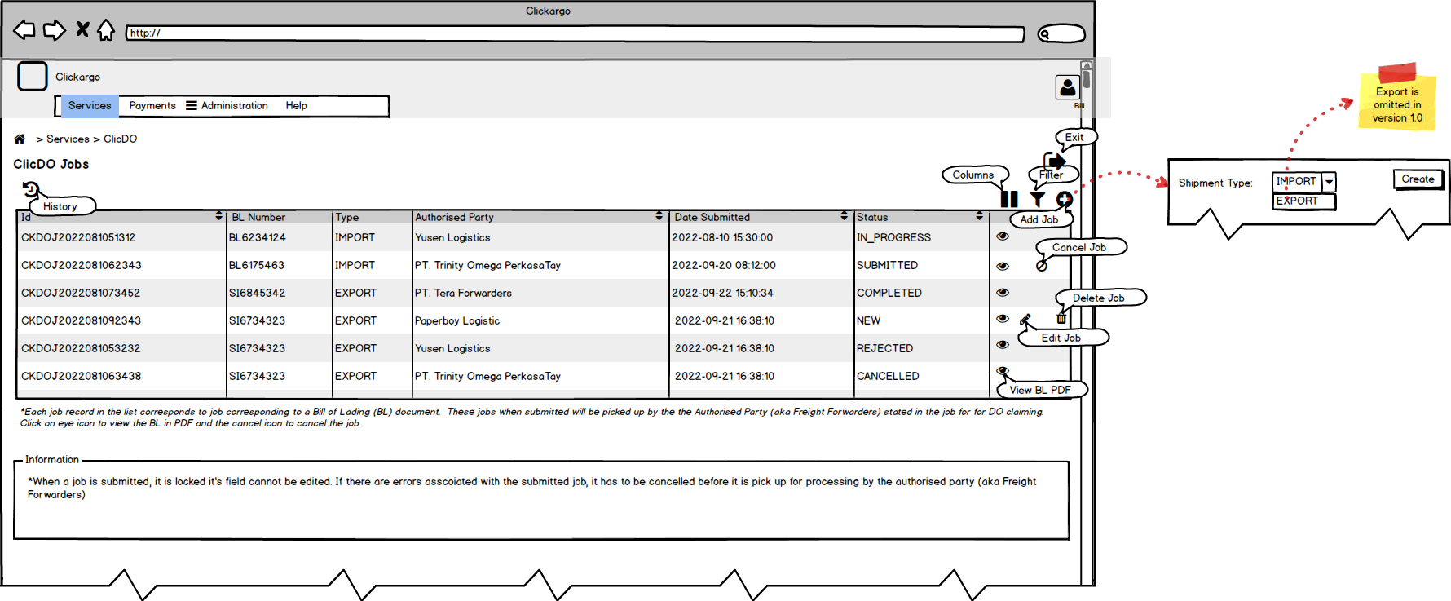
Req No | Req Description | Implementation | Test Case No
R020001 | Account of type ACCN_TYPE_CO has two roles | T_CORE_ROLES  OFFICER  ADMIN
R020002 | ADMIN role has only Administration and Help in menu | Validate T_CORE_USR_ROLE
R020003 | OFFICER role has Services and Help in menu | Validate T_CORE_USR_ROLE
R020004 | All officers of the same company can view and access all jobs.  Criteria of job must not be in R020005 | FilterBy  T_CK_JOB join T_CK_JOB_DOI_CO join T_CK_DOI where T_CK_JOB_DOI_CO .JOB_AUTHORIZER_ACCN = [company account (T_CORE_ACCN) of Principal]
R020005 | History button is a toggle on and off button which filter jobs that are inactive, expired, rejected, deleted and completed | FilterBy  T_CK_JOB join T_CK_JOB_DOI_CO join T_CK_DOI where T_CK_JOB_DOI_CO .JOB_AUTHORIZER_ACCN = [company account (T_CORE_ACCN) of Principal] where  T_CK_JOB_DOI_CO. JOB_PARENT .JOB_STATE in [x,y,z] or T_CK_JOB_DOI_CO. JOB_STATUS = ‘I’
R020006 | Columns and filter buttons do the same as standard | FilterBy
R020007 | Add button creates a new job which is not committed into database until it is saved | Record insertion into the following tables  T_CK_JOB (1)  T_CK_JOB_DOI_CO (3)  T_CK_DOI (2)
R020008 | EYE icon on list shown for Jobs that are in the states of  New, Submitted, In Progress, Completed, Rejected, Cancelled, Deleted | Validate T_CK_JOB_DOI_CO. JOB_PARENT .JOB_STATE
R020009 | Pencil icon on list shown for Jobs that are in the states of  New | Validate T_CK_JOB_DOI_CO. JOB_PARENT .JOB_STATE
R020010 | Cancel icon on list shown for Jobs that are in the states of  Submitted | Validate T_CK_JOB_DOI_CO. JOB_PARENT .JOB_STATE
R020011 | Delete icon on list shown for Jobs that are in the states of  New | Validate T_CK_JOB_DOI_CO. JOB_PARENT .JOB_STATE

- Cargo Owner Job Details
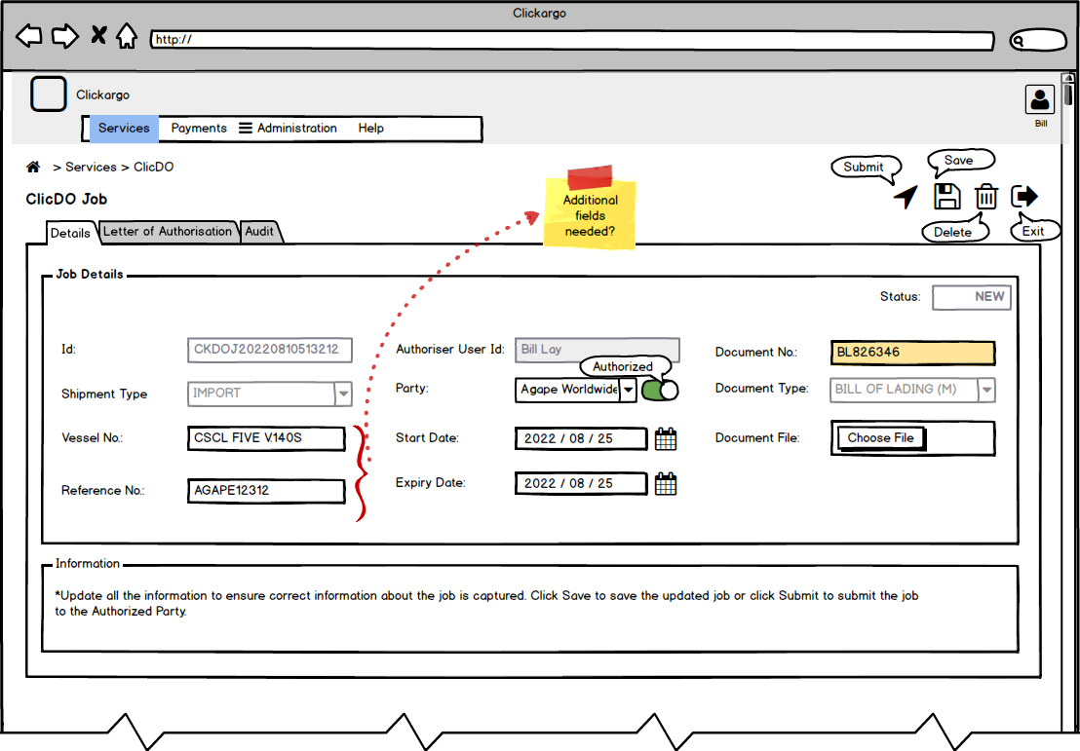
Req No | Req Description | Implementation | Test Case No
R030001 | Job, when added, is in Draft state until it is saved and it will be transitioned to New state | - get /api/v1/clickargo/clicdo/job/doico/-
R030002 | Draft state controls  Save  Exit | - Save -> post /api/v1/clickargo/clicdo/ job/doico/ with json payload to create the job  - Exit -> Just remove json memory object and do not invoke any restful call
R030003 | New state controls  Submit  Save  Delete  Exit | - Submit -> put /api/v1/clickargo/clicdo/job/doico/[id] with action=submit in payload to change it status  - Save -> put /api/v1/clickargo/clicdo/job/doico/[id] with action=save in payload to update the attributes of the job  - Delete -> del /api/v1/clickargo/clicdo/job/doico/[id]  - Exit -> Just remove json memory object and do not invoke any restful call
R030004 | Submitted state controls  Cancel  Exit  Cancel is possible because the job is not in the inprogress state as FF has not selected the CO job | - Cancel -> put /api/v1/clickargo/clicdo/job/doico/[id] with action=cancel in payload to update the attributes of the job  - Exit -> Just remove json memory object and do not invoke any restful call
R030005 | Rejected, Cancelled state controls  Exit | - Exit -> Just remove json memory object and do not invoke any restful call
R030006 | Fields in edit state only for Draft and New | Validate T_CK_JOB_DOI_CO. JOB_PARENT. JOB_STATE
R030007 | Fields constraint  - Id – UUID (non-edit)  - Shipment Type – Import (non-edit)  - Vessel No – Data entry  - Reference – Data Entry  - Authorized User – Infer from Principal  - Party  - Authorized list from FF authorized by CO  - Unauthorized list is the rest of the registered FF  - Start Date – any date >= today  - Expiry Date – today + min days where min is defined in lookup  - Document No – Any alphaunmberic number  - File – Any pdf file | - ID – UUID into T_CK_JOB_DOI_CO. JOB_ID  - Shipment Type into T_CK_JOB_DOI_CO. JOB_PARENT. JOB_SHIPMENT_TYPE  - Vessel No into T_CK_DOI. DOI_VESSEL_NO  - Reference into T_CK_JOB_DOI_CO. JOB_PARENT.JOB_REFERENCE  - Authorized Accn of Principal into T_CK_JOB_DOI_CO. JOB_AUTHORIZER_ACCN whereas user into T_CK_JOB_DOI_CO.JOB_UID_CREATE or T_CK_JOB_DOI_CO.JOB_UID_LUPD  - Party  - Validate T_CK_SVC_AUTH  - T_CORE_ACCN. ACCN_TYPE = ACC_TYPE_FF and not in T_CK_SVC_AUTH where T_CK_SVC_AUTH .SVAU_ACCN_AUTHORIZER = CO ACCN_ID  - Expiry date - T_CORE_SYSPARAM
R030007 | Action Constraint  Save  - BL number must be unique (if same prompt user to change) unless it is inactive (it is set to inactive in T_CK_DOI when FF rejects the CO job)  Submit  - BL must be validated with MSC. If BL cannot be validated from MSC prompt user to change BL number | - Validate T_CK_DOI  - Invoke API to get the DO and Containers associated with BL.  - Update T_CK_DOI  - Update T_CK_CNT  - Update T_CK_DOI_CNT

- Freight Forwarders Bill of Lading
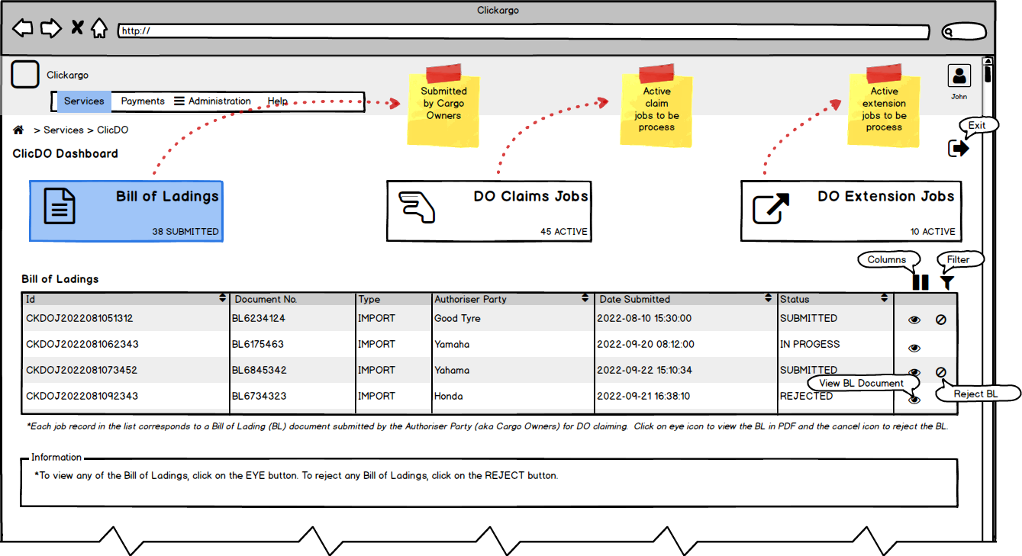
Req No | Req Description | Implementation | Test Case No
R040001 | Account of type ACCN_TYPE_FF has two roles | T_CORE_ROLES  OFFICER  - ADMIN
R040002 | ADMIN role has only Administration and Help in menu | - Validate T_CORE_USR_ROLE
R040003 | OFFICER role has Services and Help in menu | - Validate T_CORE_USR_ROLE
R040004 | All officers of the same company can view and access all jobs assigned to them from the CO and the job state is Submitted and In Progress | FilterBy  T_CK_JOB join T_CK_JOB_DOI_CO join T_CK_DOI where T_CK_JOB_DOI_CO . JOB_AUTHORIZED_PARTY_ACCN= [company account (T_CORE_ACCN) of Principal] and T_CK_JOB. JOB_STATE = [Submitted, In Progress]
R040005 | Columns and filter buttons do the same as standard | FilterBy
R040006 | EYE icon on list shown for Jobs that are in the states of  Submitted and In Progress | Validate T_CK_JOB_DOI_CO. JOB_PARENT .JOB_STATE
R040007 | Reject icon on list shown for Jobs that are in the states of  - Submitted | - Validate T_CK_JOB_DOI_CO. JOB_PARENT. JOB_STATE
R040008 | Action Constraint  View  - For constraint spelt in R040004  - Pop up the PDF of Bill Of Lading in PDF format  Reject  - For constraint spelt in R040004  - Because of concurrent access, the reject action must ensure that the state of the job remains in Submitted  - Update the state of CO Job to rejected and status of T_CK_DOI to invalid  When CO creates another job with the same BL number, another record is created in the T_CK_DOI and the T_CK_DOI_CNT is inserted with [X] records to link this new DOI to the containers that are obtained for the same BL in the previous API call. API call need not to be invoked and no replicated containers will end up in T_CK_CNT | - get /api/v1/clickargo/clicdo/do/doiffdo/[doiId]/pdf  - PDF located in T_CK_DOI.DOI_BL  - Business validation loads T_CK_JOB_DOI_CO and validate current state of T_CK_JOB_DOI_CO.JOB_PARENT.JOB_STATE to ensure that it is still in Submitted and not other state  - Update T_CK_JOB_DOI_CO.JOB_PARENT.JOB_STATE and T_CK_DOI. DOI_STATUS

- Freight Forwarders DO Claim Jobs
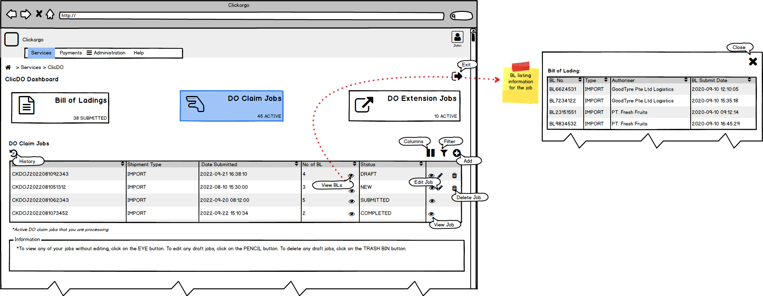
Req No | Req Description | Implementation | Test Case No
R050001 | Account of type ACCN_TYPE_FF has two roles | T_CORE_ROLES  OFFICER  ADMIN
R050002 | ADMIN role has only Administration and Help in menu | Validate T_CORE_USR_ROLE
R050003 | OFFICER role has Services and Help in menu | Validate T_CORE_USR_ROLE
R050004 | All officers of the same company can view and access all claim jobs created by anyone in the company  Jobs must not in state in R050005 | FilterBy  T_CK_JOB join T_CK_JOB_DOI_FF where T_CK_JOB_DOI_FF. JOB_AUTHORIZED_PARTY_ACCN = [company account (T_CORE_ACCN) of Principal]
R050005 | History button is a toggle on and off button which filter jobs that are inactive, deleted and completed | FilterBy  T_CK_JOB join T_CK_JOB_DOI_FF where T_CK_JOB_DOI_FF. JOB_AUTHORIZED_PARTY_ACCN = [company account (T_CORE_ACCN) of Principal] and  T_CK_JOB_DOI_FF. JOB_PARENT.JOB_STATE in [x,y,z] or T_CK_JOB_DOI_FF. JOB_STATUS = ‘I’
R050006 | Columns and filter buttons do the same as standard | FilterBy
R050007 | Add button creates a new FF job which is saved first as Draft state and subsequently once the DO/BL list is confirmed it will become in the New state  If there are no available job co that are intended for the FF hide the Add button | - get /api/v1/clickargo/clicdo/job/doiff/- to get the default template to populate  - Need a new state in T_CK_MST_JOB_STATE call ASSIGNED  - Once the FF adds the CO BL/DO job to his job then T_CK_JOB_DOI_CO.JOB_PARENT.JOB_STATE becomes ASSIGNED  - Once the FF confirms his job then T_CK_JOB_DO_CO.JOB_PARENT.JOB_STATE become IN_PROGRESS  - Then hide or show the Add button by counting number of records from T_CK_JOB_DOI_CO where T_CK_JOB_DOI_CO. JOB_AUTHORIZED_PARTY_ACCN = [company account (T_CORE_ACCN) of Principal] and T_CK_JOB_DOI_CO.JOB_PARENT.JOB_STATE = [Submitted]  - Baseline of the database updated in db_baseline_20221109.sql to carry the new job state
R050008 | Eye icon on No of BL shows the number of BL (DO) that are attached to the FF DO Claim job  Do not show the eye icon in this column when there is no BL selected into FF CO claim job | - get /api/v1/clickargo/clicdo/do/doiffdo/[ffjobId]  Need to join T_CK_JOB_DOI_CO to determine the submission date  - Validate T_CK_JOB_DOI_FF.JOB_NO_DO
R050009 | EYE icon on action column in the states of  Draft, New, Submitted, Paid, Payment Verified, Completed, Deleted | - Validate T_CK_JOB_DOI_FF. JOB_PARENT.JOB_STATE
R050010 | Pencil icon on list shown for Jobs that are in the states of  Draft, New | - Validate T_CK_JOB_DOI_FF. JOB_PARENT .JOB_STATE
R050011 | Delete icon on list shown for Jobs that are in the states of  Draft, New | - Validate T_CK_JOB_DOI_FF. JOB_PARENT .JOB_STATE

- Freight Forwarders DO Claim Job
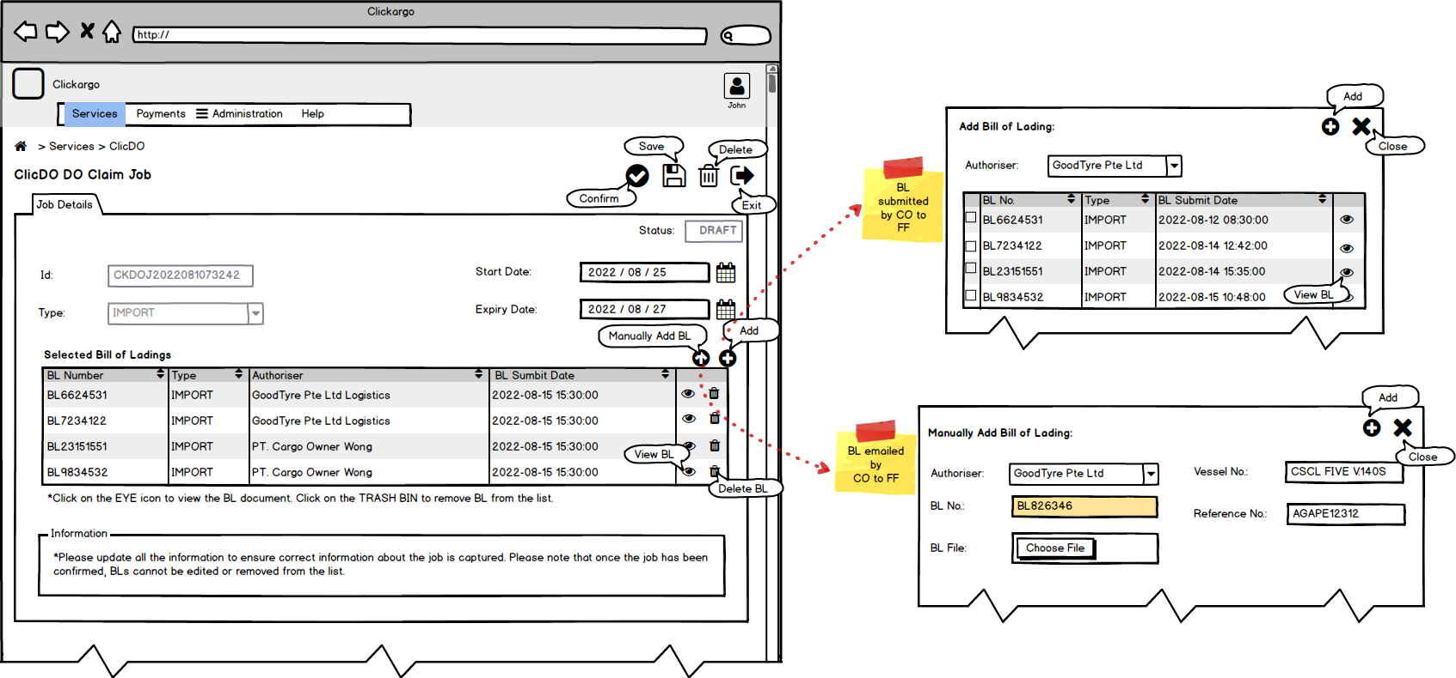
Req No | Req Description | Implementation | Test Case No
R060001 | FF Claim Job, when added, is in Draft state and when is saved and it will be still be in the Draft state | - get /api/v1/clickargo/clicdo/job/doiff/-
R060002 | Draft state controls  Save  *If there is BL/DO items added, concurrency has to be handled to ensure other jobs did not pick up the selected BL/DO  Confirm  *FF job without BL cannot be confirm (confirm button should be disabled)  *Concurrency access check during confirmation ensure even if it another user has confirmed BL into another job this job cannot be confirmed  Delete  *Job CO will change to reject state and DOI linkage to the FF should be removed  Exit  Add BL  *Show the list of authorizers and populate the pop-up  *When count = 0 don’t show the pop-up. Just prompt the user that there is no assigned BL  *User selects one of the authorizer CO accounts list the JobCO that are available. However if the count maybe 0 owing to concurrent users assignment into another JobFF, if so prompt user and remove the CO from the list and start with the first available selection  *User checks the BL  *User closes the Add BL popup. This means that the next time it is open, the checks are already there.  Remove BL  *User removes the BL  Settlement of BL injection into the T_CK_JOB_DOI_FF_DO is taken care by the Save action. There maybe changes to the CO job state between selection and saving.  Manual Add BL | - Save -> post /api/v1/clickargo/clicdo/job/doiff/ with json payload to create the FF claim job or put /api/v1/clickargo/clicdo/job/doiff/ depending if the job is in the database  - Invoke post or put /api/v1/clickargo/clicdo/do/doiffdo/ with the list of BL/DO  - Make sure for all the CO jobs to be assigned T_CK_JOB_DOI_CO.JOB_ASSIGNED_JOB_FF is either null or assigned to this job. If any is not then the operation fails and the user is prompted  - Drop all T_CK_JOB_DOI_FF_DO associated with this job which means T_CK_JOB_DOI_FF_DO.JDO_JOB = current job  - For each BL/DO associated CO job set the state of T_CK_JOB_DOI_CO.JOB_PARENT.JOB_STATE to assigned and T_CK_JOB_DOI_CO.JOB_ASSIGNED_JOB_FF to the current FF job  - Create record in T_CK_JOB_DOI_FF_DO to link FF Job to JDO_JOB_CO and JDO_DO  - Confirm -> put /api/v1/clickargo/clicdo/job/doiff/[id] with action=confirm in payload to change it status  - Check the memory json object in the front end  - Business validation loads the T_CK_JOB_DOI_CO to make sure it is in the assigned state and not in the in progress state. If any job already changed to in progress state prompt the user to remove the CO job from the existing FF job. If the CO job is in the assigned state but not to this FF job prompt the user to drop the CO job. Validate this against T_CK_JOB_DOI_CO.JOB_ASSIGNED_JOB_FF to ensure it is equal to this FF job  - Delete -> del /api/v1/clickargo/clicdo/job/doiff/[id]  - Remove physically dao.remove all entires in T_CK_JOB_DOI_FF_DO where T_CK_JOB_DOI_FF_DO. JDO_JOB = current FF job. For each T_CK_JOB_DOI_FF_DO.JDO_JOB_CO set the T_CK_JOB_DOI_CO.JOB_ASSIGNED_JOB_FF to null and T_CK_JOB_DOI_CO.JOB_PARENT.JOB_STATE to rejected  All these in a singular transaction together with setting the T_CK_JOB_DOI_FF.JOB_PARENT.JOB_STATE to deleted and T_CK_JOB_DOI_FF.JOB_STATUS = ‘I’  - Exit -> Just remove json memory object and do not invoke any restful call  - get /api/v1/clickargo/clicdo/job/doico/?state=Submit &authorized_party=[ff accn id]  - get /api/v1/clickargo/clicdo/job/doico/?state=Submit &authorized_party=[ff accn id]&authorizer=[CO]. Need to join into T_CK_DOI table for BL number extraction as the data is very normalized.  - Put the check ones into an public aggregated memory hashmap. Note that each time the pop-up is shown and the restful get is called there is a need to check that the return list must have all the entries in the hashmap, those that are missing needs to be removed from the hashmap as there are concurrent users that may have assigned it to their FF Job.  - Show the public hashmap contents into the table. Keeping one public hashmap simplifies the implementation otherwise comparison and merges needs to be implemented.  - Remove the entry from the Hashmap  - Need to draw this out to illustrate, it is not simple as we need to create a virtual T_CK_JOB_DOI_CO and T_CK_DOI and tie then together then set the T_CK_JOB_DOI_CO.JOB_ASSIGNED_JOB_FF to the current job FF ID.
R060003 | New state controls  Submit  *Make sure all the CO jobs are assigned to this FF job. This should be taken care of in the draft mode, this is just additional check  *API call to get the charges for the DO  *API failed do not update charges into DO and do not update job state to Submitted. Prompt user for retry indicating that shipping line is not contactable  *API success total charges should be shown  Delete  Exit | - Submit -> put /api/v1/clickargo/clicdo/job/doiff [id] with action=submit in payload to change it status  - Validate all T_CK_JOB_DOI_CO.JOB_ASSIGNED_JOB_FF records that T_CK_JOB_DOI_CO.JOB_PARENT.JOB_STATE = assigned  - Validate T_CK_JOB_DOI_FF.JOB_PARENT.JOB_STATE = New  - Validate all records where T_CK_JOB_DOI_FF_DO.JDO_JOB = current FF Job has T_CK_JOB_DOI_FF_DO.JDO_JOB_CO. JOB_ASSIGNED_JOB_FF = current FF job  - Make API call for the charges to each of the DO, the DO number will be available in T_CK_DOI and the linkage is found in T_CK_JOB_DOI_FF_DO.JDO_JOB = current FF Job and T_CK_JOB_DOI_FF_DO.JDO_DO  - Shipping Line charges and taxes are to be updated into T_CK_DOI.DOI_CARHGES_SL and T_CK_DOI.DOI_TAX_SL  - Platform charges and taxes are to be updated into T_CK_DOI.DOI_CARHGES_PLATFORM and T_CK_DOI.DOI_TAX_PLATFORM. Platform charges are to be generated from table-lookup (to be provided later)  - Others charges and taxes are to be updated into T_CK_DOI.DOI_CARHGES_OTHERS and T_CK_DOI.DOI_TAX_OTHERS (to be provided later)  - Do not update T_CK_DOI.DOI_CHARGES_XX or T_CK_DOI.DOI_TAX_XX  - Do not update T_CK_JOB_DOI_FF_DO.JOB_PARENT.JOB_STATE to Submitted  - Add all T_CK_DOI.DOI_CHARGES_XX or T_CK_DOI.DOI_TAX_XX for all T_CK_DOI where DOI in T_CK_JOB_DOI_FF_DO and T_CK_JOB_DOI_FF_DO.JDO_JOB = current FF Job  - See delete in R060002  - Exit -> Just remove json memory object and do not invoke any restful call
R060004 | Submitted state controls  Pay  *API call to pay total amount  *API call success change state of PENDING_PAYMENT and prompt user to pay using the virtual account number  *API call failed do not change anything, just prompt user to try again  Exit | - Pay -> put /api/v1/clickargo/clicdo/ job/doiff/[id] with action=pay in payload to update the attributes of the job  - The total amount is calculated as illustrated in R060004  - A virtual-account number is provided with success call to the API. To look up the virtual account number again reference T_CK_PAYMENT_LEDGER with PYL_SERVICE_REFERENCE = current FF Job’s JobID  Job ID is to be passed into the API call together with the amount calculated in R060004. Also the merchant bank, Payer Accn, Payer Bank Accn, Payee Accn, Payee Bank Accn. (Where information is stored will be provided later when the API is established)  - Exit -> Just remove json memory object and do not invoke any restful call
R060005 | Payment Callback  *Callback success update the state of FF Job and all the Dos. Notification to be sent for payment success  *Callback failure, set the FF job state to Submitted to allow retry of payment. Notification to be sent for payment failure  *Task cannot be created until the FF Job state becomes Payment Verified | - Payment service will call -> post /api/v1/ clickargo/clicdo/payment/[ref] with a payload where ref is the JobFF.JobID, this URI is provided in the API call to payment see R060004  - For all the DO associated with the FF Job registered in T_CK_JOB_DOI_FF_DO.JDO_DO where T_CK_JOB_DOI_FF_DO.JDO_JOB = JobFF.JobID capture in the URI, update T_CK_DOI.DOI_STATE to Paid. Also update T_CK_JOB_DOI_FF.JOB_PARENT.JOB_STATE to Paid  - Update T_CK_JOB_DOI_FF.JOB_PARENT.JOB_STATE to submitted
R060006 | Deleted state controls  Exit | - Exit -> Just remove json memory object and do not invoke any restful call
R060007 | Fields in edit state only for Draft | - Validate T_CK_JOB_DOI_FF. JOB_PARENT. JOB_STATE
R060008 | Fields constraint  - Id – UUID (non-edit)  - Shipment Type – Import (non-edit)  - Start Date – any date >= today  - Expiry Date – today + min days where min is defined in lookup  - Container claim, ready and unready | - ID – UUID into T_CK_JOB_DOI_FF. JOB_ID  - Shipment Type into T_CK_JOB_DOI_FF. JOB_PARENT. JOB_SHIPMENT_TYPE  - Expiry date - T_CORE_SYSPARAM  - Shown after the Payment Verified state. -> get /api/v1/clickargo/clicdo/do/doiffdo/job/[jobffid] to get the list of DOs by FF job then check the T_CK_DOI.DOI_STATE and DOI_NO_CNT to sum up and calculate. Use the state of Claim, Paid, Ready to compute
R060009 | Action Constraint  *See R060002 – R060006

- Freight Forwarders DO Claim Job Attachments
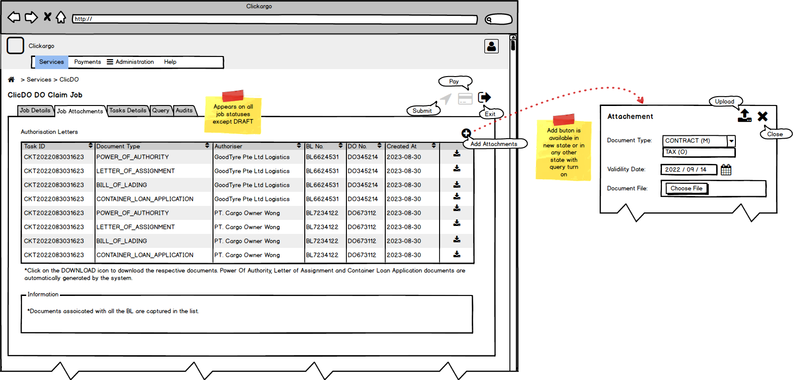

Req No | Req Description | Implementation | Test Case No
R070001 | Account of type ACCN_TYPE_FF has two roles | T_CORE_ROLES  OFFICER  ADMIN
R070002 | ADMIN role has only Administration and Help in menu | Validate T_CORE_USR_ROLE
R070003 | OFFICER role has Services and Help in menu | Validate T_CORE_USR_ROLE
R070004 | FF Job has generally three type of attachments – Power Of Authority, Letter of Assignment and Bill of Lading  *When the job is assigned to FF, it depends if the FF is authorized or unauthorized. For authorized FF, the POA is copied from Service Authorization. The POA is pre-generated when the Service Authorization is approved by the CO  *When the FF is not authorized, LOA is generated when the FF job is confirmed.  *BL pdf is duplicated from the DOI when the FF job is confirmed. | - T_MST_ATT_TYPE holds the master attachment type – BL, LOA, POA  - Duplicate the file from T_CK_SVC_AUTH_ATTACH.ATT_LOC and register the file into T_CK_JOB_ATTACH.ATT_LOC under a new record in T_CK_JOB_ATTACH for the ATT_TYPE of POA and set T_CK_JOB_ATTACH.ATT_JOB = T_CK_JOB_DO_FF.PARENT_JOB.  - Create a new LOA pdf and register the file into T_CK_JOB_ATTACH.ATT_LOC under a new record in T_CK_JOB_ATTACH for the ATT_TYPE of LOA and set T_CK_JOB_ATTACH.ATT_JOB = T_CK_JOB_DOI_FF.PARENT_JOB.  - Duplicate the file from T_CK_DOI.DOI and register the file into T_CK_JOB_ATTACH.ATT_LOC under a new record in T_CK_JOB_ATTACH for the ATT_TYPE of BL and set T_CK_JOB_ATTACH.ATT_JOB = T_CK_JOB_DO_FF.PARENT_JOB. To note T_CK_JOB_ATTACH.ATT_TYPE = POA
R070005 | Filter list is extracted from Job’s attachment | - get /api/v1/clickargo/job/attach/?jobId=[ doiffId.parentId]  - Filter T_CK_JOB_ATTACH where T_CK_JOB_ATTACH.ATT_JOB = T_CK_JOB.JOB_ID and T_CK_JOB_DOI_FF.PARENT_JOB = JOB_ID and T_CK_JOB_ATTACH.ATT_STATUS = ‘A’
R070006 | Add Document  *Adding document is possible only when there is one active query associated with the job that has not been answered by the FF to the query maker SL.  *Add document type is derived from master table. Verify the attachment functionality | - Validate T_CK_JOB_QUERY. QRY_JOB = current FF job and T_CK_QRY_DT_RESPONSE date is not equal null.  - T_MST_ATT_TYPE which is to be determine later
R070007 | Download Document | - get /api/v1/clickargo/job/attach/[attId]  - Retrieve from T_CK_JOB_ATTACH.ATT_LOC where T_CK_JOB_ATTACH.ATT_ID = [attId] and return a PDF binary stream

