

**Docente:** Luis Gavidia

**Tema:** Práctica de Interfaz Gráfica

**Grupo:** 01

**Students**: Ronald Eduardo Mejía Reinosa

**Carné**: MR100823

INDICE

Diagrama de caja negra 3

Diagrama UML 3

Cuadro de controles, propiedades y valores utilizados 3

## Diagrama de caja negra

|  |  |  |
| --- | --- | --- |
| Entrada | Proceso/Solución | Salida |
| BaseTemperature y optionConverter | Clase ConversorTemperaturas | TemperaturaConvertida |

## Diagrama UML

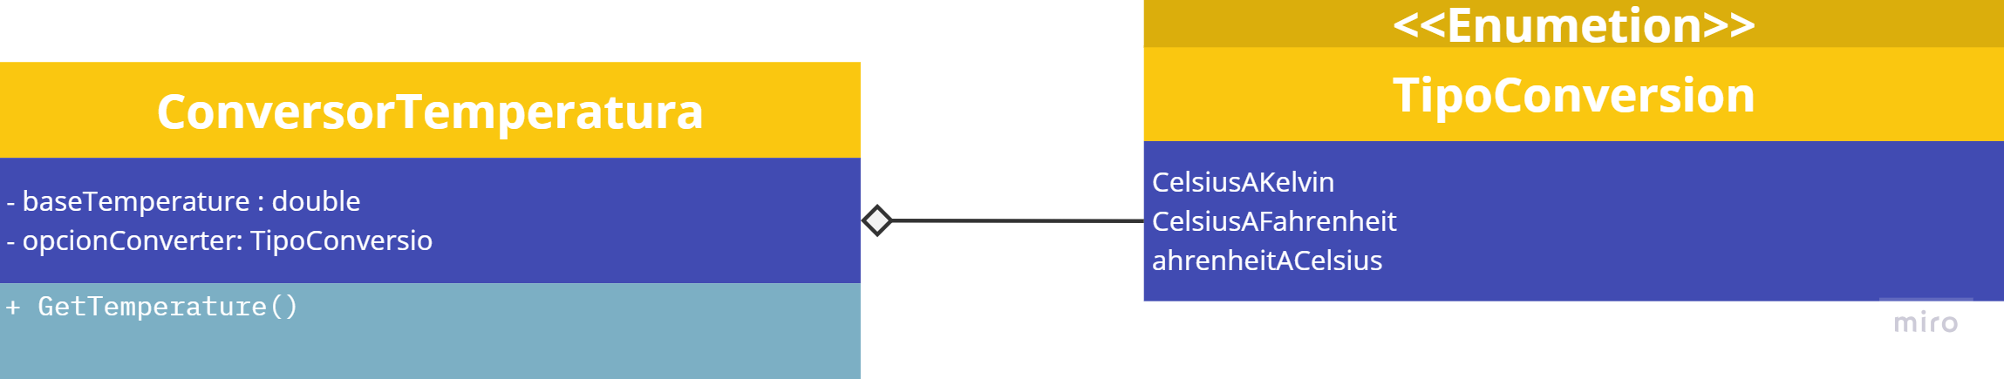

## Cuadro de controles, propiedades y valores utilizados

|  |  |  |
| --- | --- | --- |
| **Objeto** | **Nombre** | **Valor** |
| lblTitle | AutoSize | true |
|  | Font | Microsoft Sans Serif, 20.25F, Bold |
|  | Location | 30, 21 |
|  | Name | lblTitle |
|  | Size | 336, 31 |
|  | TabIndex | 0 |
|  | Text | Proporciona temperatura |
| txtTemperaturaBase | Font | Microsoft Sans Serif, 20.25F, Regular |
|  | Location | 424, 21 |
|  | Name | txtTemperaturaBase |
|  | Size | 184, 38 |
|  | TabIndex | 1 |
|  | Text | 0.0 |
|  | TextAlign | Right |
| rbtnCelsiusAKelvin | AutoSize | true |
|  | Checked | true |
|  | Font | Microsoft Sans Serif, 15F, Regular |
|  | Location | 6, 19 |
|  | Name | rbtnCelsiusAKelvin |
|  | Size | 170, 29 |
|  | TabIndex | 2 |
|  | TabStop | true |
|  | Text | Celsius a Kelvin |
|  | UseVisualStyleBackColor | true |
| rbtnCelsiusAFahrenheit | AutoSize | true |
|  | Font | Microsoft Sans Serif, 15F, Regular |
|  | Location | 6, 54 |
|  | Name | rbtnCelsiusAFahrenheit |
|  | Size | 209, 29 |
|  | TabIndex | 3 |
|  | TabStop | true |
|  | Text | Celsius a Fahrenheit |
|  | Tabbable | true |
|  | UseVisualStyleBackColor | true |
|  | AutoSize | true |
|  | Font | Microsoft Sans Serif, 15F, Regular |
|  | Location | 6, 89 |
|  | Name | rbtnFahrenheitACelsius |
|  | Size | 209, 29 |
|  | TabIndex | 4 |
|  | TabStop | true |
|  | Text | Fahrenheit a Celsius |
|  | Tabbable | true |
|  | UseVisualStyleBackColor | true |
| btnConvertir | BackColor | GreenYellow |
|  | Cursor | Hand |
|  | Font | Microsoft Sans Serif, 9.75F, Bold |
|  | ForeColor | ControlText |
|  | Location | 494, 159 |
|  | Name | btnConvertir |
|  | Size | 114, 38 |
|  | TabIndex | 5 |
|  | Text | Convertir |
|  | UseVisualStyleBackColor | false |
| btnLimpiar | BackColor | FloralWhite |
|  | Cursor | Hand |
|  | BorderStyle | None |
|  | Font | Microsoft Sans Serif, 9.75F, Bold |
|  | ForeColor | ControlText |
|  | Location | 362, 159 |
|  | Name | btnLimpiar |
|  | Size | 114, 38 |
|  | TabIndex | 6 |
|  | Text | Limpiar |
|  | UseVisualStyleBackColor | false |
| lblResult | AutoSize | true |
|  | Font | Microsoft Sans Serif, 20.25F, Bold |
|  | ForeColor | ButtonShadow |
|  | Location | 488, 89 |
|  | Name | lblResult |
|  | Size | 55, 31 |
|  | TabIndex | 1 |
|  | Text | 0.0 |
| gBoxOperaciones | Controls | rbtnCelsiusAKelvin, rbtnCelsiusAFahrenheit, rbtnFahrenheitACelsius |
|  | Location | 36, 70 |
|  | Name | gBoxOperaciones |
|  | Size | 236, 127 |
|  | TabIndex | 7 |
|  | TabStop | true |
|  | Text | Operaciones |