All in Python 2.7, with numpy lib

# NavieBayes.py

## compile environment and method:

* + open terminal
  + cd “folder-address”
  + python NavieBayes.py

the program will automatically add the train and test file in the folder.

pathSet = ['train/ham','train/spam','test/ham','test/spam']

stopWord is in stopword.txt, also will be added automatically

## input guide

the program will ask you to choose remove stopWord or not. you must type yes or no correctly.

## outpout

the program will report the accuracyRate.

## running example

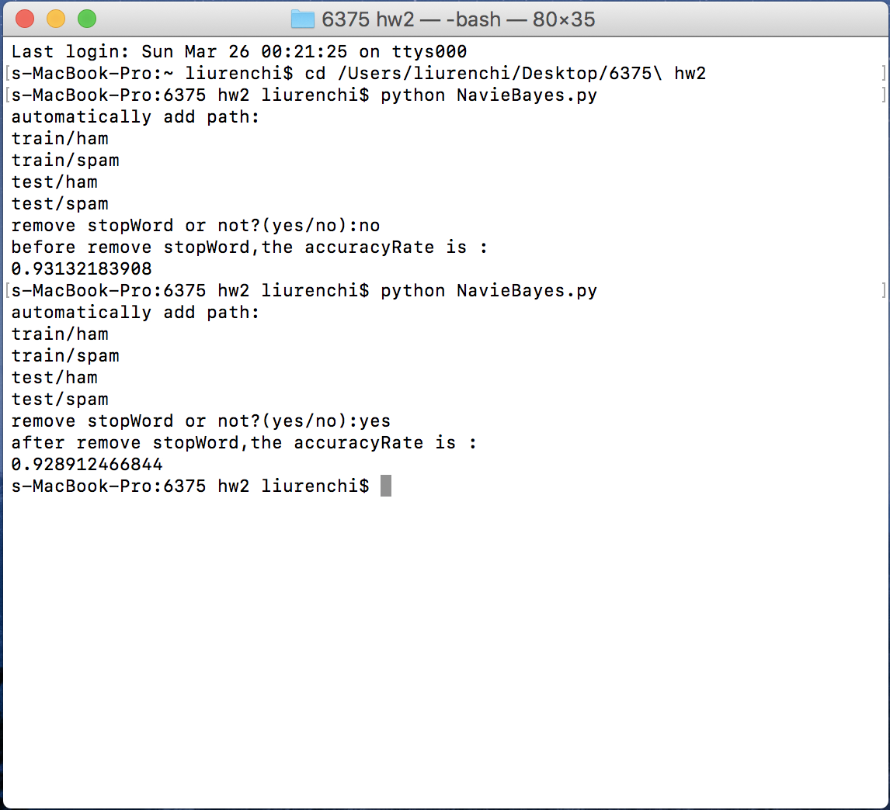

# logisticR.py

## complie method:

* + open terminal
  + cd “floder-address”
  + python logisticR.py

the program will automatically add the train and test file in the folder.

pathSet = ['train/ham','train/spam','test/ham','test/spam']

stopWord is in stopword.txt, also will be added automatically

## input guide

first, the program will ask you to choose remove stopWord or not. you must type yes or no correctly.

second, the program will ask you to input learning rate,running time and lambda_value

## outpout

the program will report the accuracyRate.

## running example

