UrbanNest
Website Project Proposal — Addendum (Part 3 update)
WEDE5020 — Web Development (Introduction) | Rendzo Dawn Rikhotso (ST10510131)
Updated for Part 3: Enhancing Functionality and SEO | October 2026
This addendum expands on the areas of the original Website Project Proposal that were identified in Part 1 feedback as needing further detail: current market analysis, proposed features and functionality, budget, technical requirements, timeline, wireframes, and sitemap. It has now been updated for Part 3 so that it describes the website as it is built: seven pages, JavaScript functionality, search engine optimisation (SEO), validated forms and deployment. It is intended to be read alongside the original proposal, the Part 2 CSS and responsive design submission, and the changelog in the project’s GitHub README.

1. Expanded Current Analysis
The South African urban rental market remains fragmented, with most independent landlords and small agencies relying on informal channels — WhatsApp groups, Facebook Marketplace, and word of mouth — to advertise available units. This creates friction for renters, who must cross-reference multiple unreliable sources to find verified listings, and for landlords, who have no consistent way to present their properties professionally.
UrbanNest’s primary competitors fall into two categories. Large-scale property portals such as Private Property (n.d.) and Property24 (n.d.) list rentals but are optimised for the broader property market rather than specifically for young urban renters and, in the founder’s experience, can include listings that are out of date. Peer-to-peer platforms (for example Facebook Marketplace) offer no verification, no consistent pricing information, and no professional presentation of the property or landlord.
UrbanNest’s competitive gap is verified, in-person-visited listings combined with a digital-first, mobile-responsive enquiry process. Every listing on the site has been physically inspected by an UrbanNest team member before publication, which directly differentiates the business from unverified peer-to-peer alternatives and addresses the primary pain point identified in renter interviews conducted during the founder’s eight years in the industry: trust in listing accuracy. Part 3 widens this gap: UrbanNest now presents homes to rent, homes for sale and new developments in one searchable place across Johannesburg, Pretoria, Cape Town and Durban.
This directly informs the website’s core functionality: transparent pricing displayed up front (no “contact for price” listings), verified property photography, and a simple online enquiry process. In Part 2 these were delivered as a responsive six-page build; in Part 3 they became search, filtering, sorting, an interactive map and an enquiry form that answers with cost and availability straight away.

2. Expanded Proposed Features and Functionality
The site delivers the following features, aligned with what has been implemented across the seven pages in the live build:
- Home page: a search form (buy, rent or development; city or suburb; property type; price; bedrooms) that opens the Properties page already filtered; three featured listings with transparent pricing; an overview of renting, buying and developments; a four-step “How it works” section; and calls to action.
- Properties (products-and-services.html): 60 sample listings — 20 for sale, 20 to rent and 20 new developments — across four cities. Visitors switch between All Properties, Buy, Rent and Developments, search by city, suburb or name, use quick filters and a slide-in Filters panel (price, bedrooms, bathrooms, parking, floor and erf size, features, listing status), and sort the results. A Leaflet map shows a marker for each city, and clicking a card opens a details window with a photo gallery and a side card of key details.
- About Us: company history, mission, vision, target audience, the values UrbanNest keeps, a four-step process, and a team directory establishing accountability and trust.
- Gallery: categorised photography (living areas, kitchens, bedrooms, exteriors) with filter buttons and a full-screen viewer so renters can assess finish quality before enquiring.
- News and Updates: practical guidance for tenants and buyers and company announcements, to keep repeat visitors informed.
- Enquiry (new in Part 3): a form where the visitor chooses a property type, optionally picks a specific listing, states the enquiry type, preferred viewing date, contact details and budget, and receives an immediate response showing cost and availability.
- Contact Us: branch details and business hours, a validated message form that is emailed to the branch, and an interactive map.
- Site-wide: a responsive navigation menu that adapts from a horizontal bar (desktop) to a stacked mobile menu, consistent branding, hover and focus states on all interactive elements, keyboard support, and on-page SEO.

3. Expanded Budget
The budget below reflects the itemised costs for building and maintaining the UrbanNest website for its first year of operation, in South African Rand. The Part 3 additions — interactive maps, form delivery and version control — use free tools (Agafonkin, 2023; FormSubmit, n.d.; OpenStreetMap contributors, n.d.), so the total is unchanged from the Part 2 addendum.
Item | Description | Cost (ZAR)
Domain registration | urbannest.co.za — annual | R250
Web hosting | Shared hosting, 12 months (production). The assessment build uses free static hosting | R1,200
Design & development | Once-off build (in-house / student project) | R0
Maps, form delivery, version control | Leaflet and OpenStreetMap tiles, FormSubmit free plan, GitHub free plan | R0
Property photography | Professional photography per new listing (est. 10 launch listings) | R5,000
Domain email | Branded email addresses for the branch and enquiries | R900
Ongoing maintenance | Content updates, bug fixes — allowance | R2,000
Contingency (10%) | Unforeseen costs | R935
Total |  | R10,285

Until professional photography is completed for all listings, the remaining listings use sample photographs, as noted in section 10.

4. Expanded Technical Requirements
The site is built using the following technologies and requirements:
- Front-end: HTML5 (semantic elements — header, nav, main, section, article, footer), CSS3 (Flexbox, CSS Grid, custom properties, media queries, transitions and keyframe animations), and plain JavaScript (DOM manipulation, event handling and the Fetch API for AJAX form submission). No framework is used, which keeps the pages light.
- Libraries and services: Leaflet version 1.9.4 (Agafonkin, 2023) with OpenStreetMap tiles (OpenStreetMap contributors, n.d.), loaded only when a map is shown; FormSubmit (n.d.) for delivering form submissions by email.
- Data: the 60 listings are held in one JavaScript data file that both the Properties page and the Enquiry page read. No database or server-side scripting is required for the current scope.
- Responsive breakpoints (Marcotte, 2010): desktop (default), tablet (max-width 1024px), and mobile (max-width 600px), covering the primary device categories UrbanNest’s target renters use to browse listings.
- Hosting requirement: a free static hosting platform such as GitHub Pages (GitHub, n.d.b) or Netlify; HTTPS is provided by the host.
- Version control: Git, hosted on GitHub, with the repository containing the full site and a README.md (GitHub, n.d.a) holding the changelog, Part 3 information and references.
- SEO files: a robots.txt file (Google, n.d.a) and an XML sitemap (sitemaps.org, n.d.) in the site root.
- Browser support: current versions of Chrome, Edge, Firefox, and Safari, tested using browser developer tools across desktop, tablet, and mobile viewport sizes.
- Accessibility: targeting WCAG 2.1 level AA (W3C, 2025) — descriptive alt text on all images, a semantic heading hierarchy, labels linked to every form field, visible focus states, keyboard operation of menus, tabs and dialogs (Esc and arrow keys), and error messages announced to assistive technology.
- Form validation: client-side JavaScript validation gives the visitor immediate feedback; because client-side checks are not a security measure on their own (Mozilla Contributors, n.d.), the form service performs the server-side handling of submitted data.

5. Expanded Timeline
Phase | Task | Timeframe
Part 1 | Proposal research, sitemap, wireframes, HTML structure for all pages | Weeks 1–3
Part 1 submission | Submit HTML build and proposal document | End of Week 3
Feedback review | Review lecturer feedback and mark sheet | Week 4
Part 2 | Address proposal feedback; build external stylesheet, base styles, typography, layout | Weeks 4–5
Part 2 | Add decoration, pseudo-classes, and responsive breakpoints (tablet, mobile) | Week 6
Part 2 | Cross-device testing, screenshot evidence, README/changelog updates | Week 7
Part 2 submission | Final commit, push to GitHub, submit repository link | End of Week 7
Feedback review (Part 2) | Review Part 2 marks; plan the changelog and references corrections | Week 8
Part 3: interactive elements | Tabs, filters panel, details window, gallery viewer, mobile menu, animations | Week 9
Part 3: dynamic content and maps | Listings built by JavaScript, search, filter and sort, Leaflet maps | Week 10
Part 3: forms and SEO | Enquiry and Contact forms with validation and email; titles, descriptions, keywords, alt text, robots.txt, sitemap.xml | Week 11
Part 3: testing and release | Cross-device testing, README changelog and references, deployment to a free platform, final commits | Week 12
Part 3 submission | Submit the repository link and the deployed website address | End of Week 12

6. Wireframes
Low-fidelity desktop wireframes for the five pages that carry the Part 3 functionality — Home, Properties, the property details window, Enquiry and Contact Us — are shown below. They informed the layout structure (Flexbox header and navigation, CSS Grid card layouts) and the interactive behaviour described in section 8.
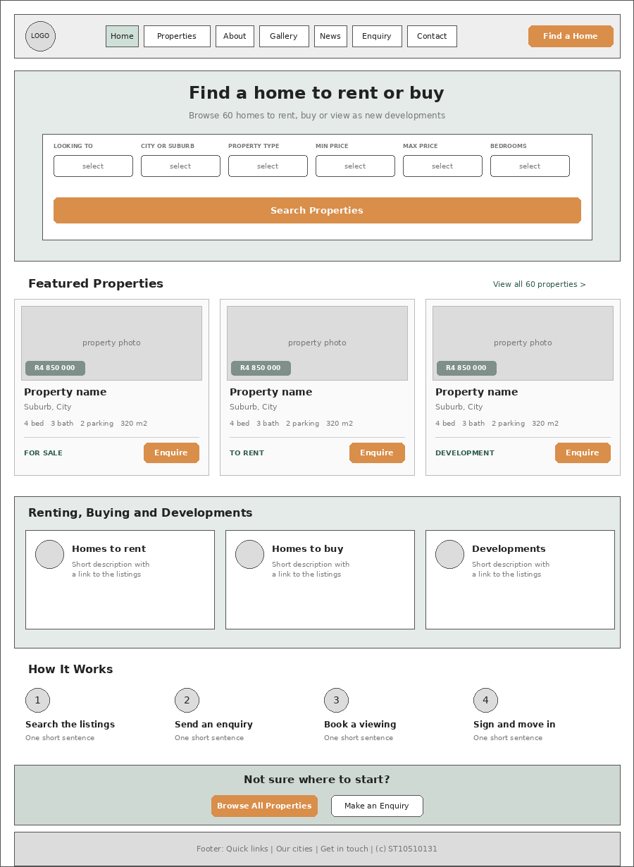
Figure 1: Home page desktop wireframe
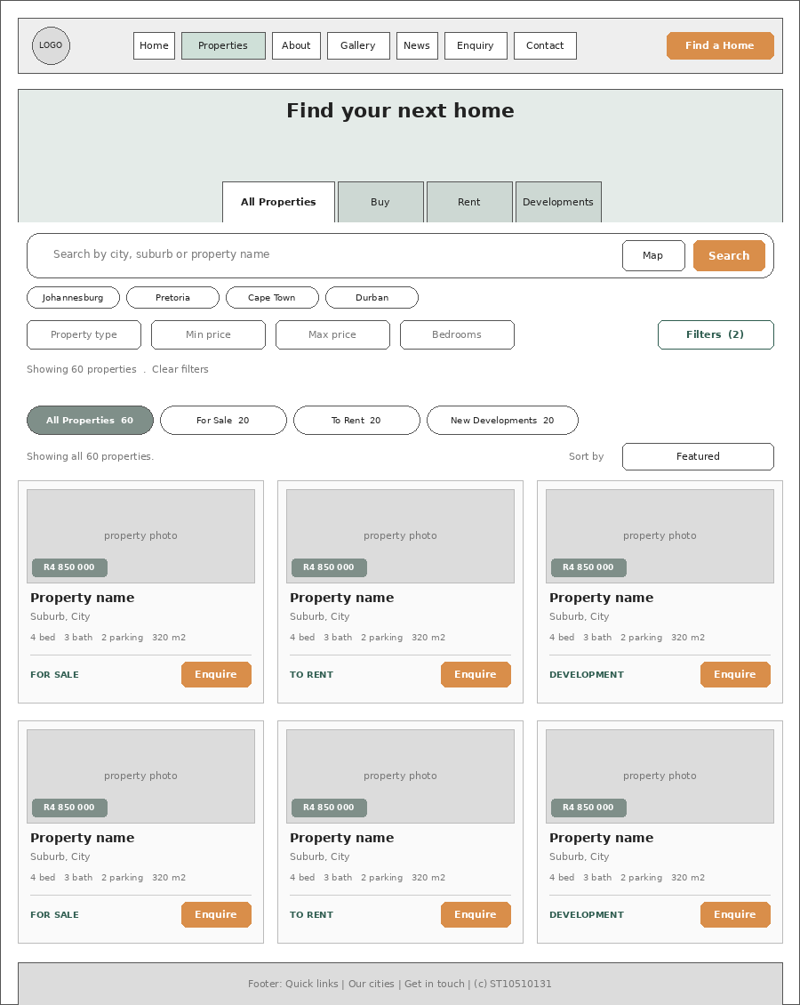
Figure 2: Properties page desktop wireframe
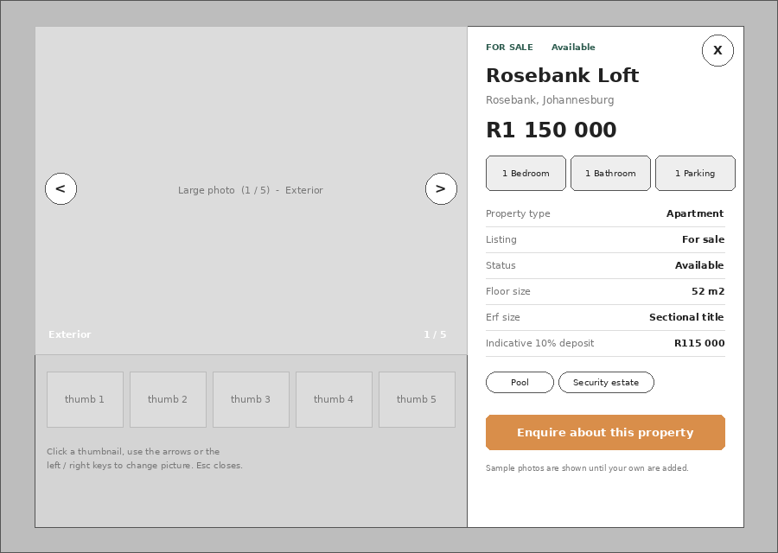
Figure 3: Property details window (photo gallery and details card)
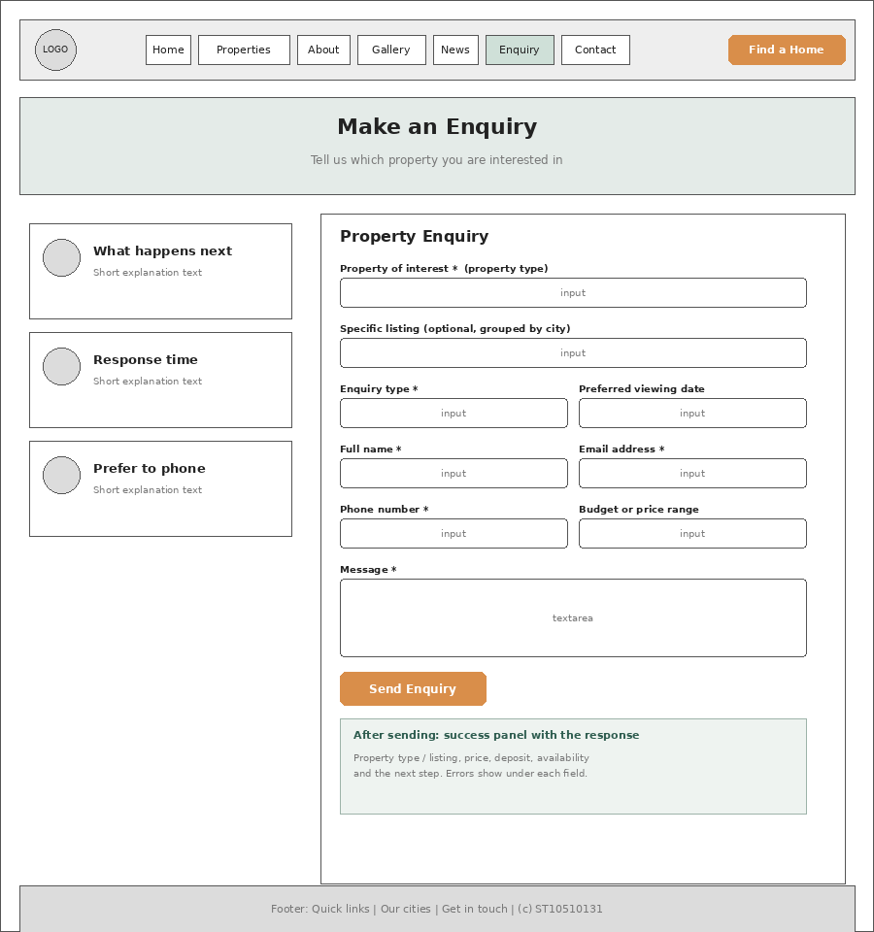
Figure 4: Enquiry page desktop wireframe
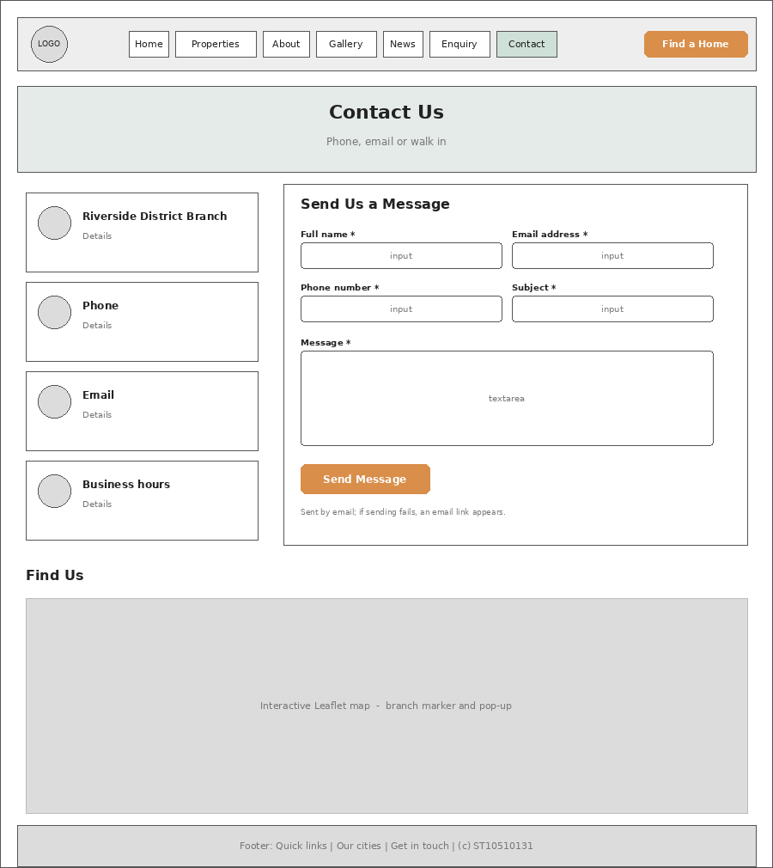
Figure 5: Contact Us page desktop wireframe

7. Expanded Sitemap
The site consists of seven pages, all accessible from a persistent navigation menu on every page:
- Home (home.html) — landing page, search form, featured listings, how it works
- Properties (products-and-services.html) — searchable catalogue of listings to buy, rent and developments, with map and details window
- About Us (about-us.html) — history, mission, vision, target audience, values, process, team
- Gallery (gallery.html) — categorised property photography with full-screen viewer
- News and Updates (news-and-updates.html) — guides and company announcements
- Enquiry (enquiry.html) — property enquiry form with instant cost and availability response
- Contact Us (contact-us.html) — branch details, hours, message form, map
Supporting files: css/style.css and css/properties.css (styling), js/script.js, js/properties.js, js/properties-data.js and js/forms.js (behaviour and data), robots.txt and sitemap.xml (search engines), and README.md (documentation).

8. Part 3 Implementation Summary

8.1 Interactive elements
- Tabs: All Properties, Buy, Rent and Developments switch the listings instantly without reloading the page.
- Filters panel: a slide-in dialog with grouped filters and a live count on its search button.
- Details window (modal): clicking a property opens a window with a photo gallery (arrows, thumbnails, counter) and a side card showing price, key details, features, availability and an Enquire button. Esc closes it and the left and right arrow keys change picture.
- Animations and transitions: CSS transitions on hover and focus states, a slide-in animation for the filters panel, and a fade-in for the details window.
- DOM manipulation: the listing cards, counts, suggestions, thumbnails and form messages are created and updated by JavaScript.

8.2 Dynamic content and search
The Properties page builds every listing card from the data file, so adding a property means adding one record rather than editing HTML. Visitors can search by city, suburb or property name; narrow results by type, price, bedrooms, bathrooms, parking, floor and erf size, features and listing status; and sort by price (low to high or high to low) or by number of bedrooms. The results message and every tab count update as the filters change, and an empty-state message with a “Clear all filters” button appears when nothing matches. Links from the Home page carry the visitor’s choices to this page through the address.

8.3 Interactive maps
Two maps use Leaflet (Agafonkin, 2023) with OpenStreetMap tiles (OpenStreetMap contributors, n.d.). The Contact page shows the Riverside District branch with a marker and pop-up. The Properties page opens a map from the Map button with one marker per city showing how many properties match the current filters; selecting a marker filters the list by that city. The library is loaded only when a map is needed, so it never delays the rest of the page.

8.4 Gallery lightbox
The Gallery page has five filter buttons (All Photos, Living Areas, Kitchens, Bedrooms, Exteriors). Clicking a photo opens it in a full-screen viewer with previous and next buttons, a caption, and keyboard control; the viewer cycles through only the photos in the selected category.

8.5 Forms: enquiry and contact
Both forms use native form controls (text, email, telephone, date, select and textarea), each with a visible label, and both are submitted with the Fetch API to the form service named in the form’s action attribute. They are validated in JavaScript before sending (Mozilla Contributors, n.d.):
Field | Rule | Message shown
Full name | Required; letters, spaces, apostrophes and hyphens; 2–60 characters | Enter your full name (letters only, at least 2 characters).
Email address | Required; must look like name@domain.tld | Enter a valid email address, e.g. name@example.com.
Phone number | Required; South African number: 0 plus nine digits, or +27 plus nine digits (spaces, hyphens and brackets ignored) | Enter a valid South African number, e.g. 082 123 4567 or +27 82 123 4567.
Message | Required; at least 10 characters | Please write at least 10 characters so we can help.
Drop-down lists | Required where marked: an option must be chosen | Please choose an option.
Preferred viewing date | Optional; must be today or later | Choose today or a future date.

Fields are checked when the visitor leaves them and again as they correct them, and on sending the first invalid field receives focus. Error messages appear beneath the field, are announced to screen readers, and the field is outlined in red.
Enquiry response. On the Enquiry page the visitor chooses a property type from four groups — residential, commercial and industrial, land and developments, and alternative options — and may also pick a specific listing. After a successful send, the page shows a response built from the listing data: the price, the deposit and move-in total for a rental (one month’s deposit), an indicative ten percent deposit for a purchase, the build stage for a development, and whether the property is available, under offer or sold. If only a property type was chosen, the response explains that matching listings and costs will follow by email.
Contact email. The Contact form collects name, email, phone number, subject (the type of message) and a full message. The details are compiled into an email table and delivered to the recipient address written in the form’s action (FormSubmit, n.d.). If sending fails, the page shows a link that opens the visitor’s own email application with the same message already written, addressed to the same recipient.

8.6 Search engine optimisation
On-page SEO follows Google’s SEO starter guide (Google, n.d.b). The table summarises what was applied.
Technique | Implementation
Keyword research | Each page targets keywords that match what a renter or buyer would search for (see the keyword table below) and uses them naturally in headings and text.
Title tags | A unique title on every page in the form “Page name | UrbanNest”.
Meta descriptions | A unique, readable description of about one to two sentences on every page.
Meta keywords | A page-specific keyword list on every page.
Header tags | One h1 per page, with h2 and h3 headings in a logical order.
Image optimisation | Descriptive alt text on every image; property photographs follow a descriptive naming convention (for example sandton-view-1.jpg); images below the first screen are lazy-loaded.
URL structure | Short, lower-case, hyphenated file names such as products-and-services.html.
Internal linking | The navigation and footer link every page; cards, calls to action and the Home search link into filtered results.
Mobile-friendliness | Viewport meta tag and responsive breakpoints at 1024px and 600px (Marcotte, 2010).
robots.txt and sitemap.xml | Both files sit in the site root; the sitemap lists all seven pages (Google, n.d.a; sitemaps.org, n.d.).
Page speed | No framework, small scripts, lazy-loaded images, and the map library loaded only on demand.
Security | Visitor input is validated before sending; text inserted into the page by JavaScript is escaped; external links use rel=“noopener”; no passwords or keys are stored in the code; HTTPS comes from the host.
Off-page SEO (after launch) | Plan: listing the branch on local business directories, a Google Business Profile for local search, and sharing news articles on social media to earn backlinks.

Page | Target keywords
Home | homes to rent Johannesburg, houses for sale Pretoria, apartments for rent Cape Town, property for sale Durban
Properties | houses for sale South Africa, homes to rent Johannesburg, new developments Cape Town, property for sale Pretoria, rental property Durban
About Us | about UrbanNest, property agency South Africa, estate agents Johannesburg, property team Cape Town
Gallery | property photos South Africa, apartment gallery, house interiors, UrbanNest gallery
News and Updates | South African property news, rental market updates, property market Johannesburg, UrbanNest news
Enquiry | property enquiry South Africa, book a property viewing, confirm rental availability, ask about house price, UrbanNest enquiry
Contact Us | contact UrbanNest, property agency phone number, Riverside District branch, property enquiry South Africa

8.7 Version control and deployment
The project is developed in a Git repository on GitHub (GitHub, n.d.a) with small, descriptive commits for each feature. The README documents the pages, the files, the Part 3 changelog and the references. The finished site is deployed to a free static hosting platform (GitHub, n.d.b), after which the live address replaces the placeholder in robots.txt and sitemap.xml.

9. Response to Part 2 Feedback
The Part 2 mark sheet awarded full marks for the stylesheet, typography, layout, colour, pseudo-classes, responsive design and GitHub criteria, and identified two areas for improvement. The table shows how each was addressed in Part 3.
Part 2 feedback | Action taken in Part 3 | Where to find it
Changelog incomplete or missing (1 out of 10) | The README now contains a dated, detailed changelog that lists every file changed, what changed and why, including a separate group of entries for the edits made in response to this feedback. | README.md in the GitHub repository
References missing (0 out of 5) | A Harvard reference list has been added with in-text citations in this addendum and in the README, and the list was checked so that every citation has an entry and every entry is cited. | Section 11 of this document; README.md
Strong areas to keep | External stylesheet, typography, layout, colour, pseudo-classes and the tablet and mobile breakpoints were kept and extended to the new pages and components. | css/style.css and css/properties.css

10. Known Limitations and Next Steps
- The listings, prices, availability and some photographs are sample content for the assessment. Real inventory replaces the data file when UrbanNest goes live.
- The gallery images currently use short temporary file names; renaming them to descriptive names (for example living-room-open-plan.jpg) and updating the pages is the next SEO task.
- Form delivery through FormSubmit must be activated once from the real recipient inbox; the email link fallback covers any failure in the meantime.
- Off-page SEO and the Google Business Profile start after the site is live at its permanent address.

11. References
Agafonkin, V. (2023) Leaflet: an open-source JavaScript library for interactive maps, version 1.9.4. Available at: https://leafletjs.com (Accessed: 31 October 2026).
FormSubmit (n.d.) FormSubmit: form backend service for HTML forms. Available at: https://formsubmit.co (Accessed: 31 October 2026).
GitHub (n.d.a) About READMEs. GitHub Docs. Available at: https://docs.github.com/en/repositories/managing-your-repositorys-settings-and-features/customizing-your-repository/about-readmes (Accessed: 31 October 2026).
GitHub (n.d.b) What is GitHub Pages? GitHub Docs. Available at: https://docs.github.com/en/pages/getting-started-with-github-pages/what-is-github-pages (Accessed: 31 October 2026).
Google (n.d.a) Introduction to robots.txt. Google Search Central. Available at: https://developers.google.com/search/docs/crawling-indexing/robots/intro (Accessed: 31 October 2026).
Google (n.d.b) Search Engine Optimization (SEO) starter guide. Google Search Central. Available at: https://developers.google.com/search/docs/fundamentals/seo-starter-guide (Accessed: 31 October 2026).
Marcotte, E. (2010) ‘Responsive web design’, A List Apart, 25 May. Available at: https://alistapart.com/article/responsive-web-design/ (Accessed: 31 October 2026).
Mozilla Contributors (n.d.) Client-side form validation. MDN Web Docs. Available at: https://developer.mozilla.org/en-US/docs/Learn_web_development/Extensions/Forms/Form_validation (Accessed: 31 October 2026).
OpenStreetMap contributors (n.d.) Copyright and license. Available at: https://www.openstreetmap.org/copyright (Accessed: 31 October 2026).
Private Property (n.d.) Private Property: property for sale and to rent in South Africa. Available at: https://www.privateproperty.co.za (Accessed: 31 October 2026).
Property24 (n.d.) Property24: property for sale and to rent in South Africa. Available at: https://www.property24.com (Accessed: 31 October 2026).
sitemaps.org (n.d.) Sitemaps XML format. Available at: https://www.sitemaps.org/protocol.html (Accessed: 31 October 2026).
World Wide Web Consortium (W3C) (2025) Web Content Accessibility Guidelines (WCAG) 2.1. Available at: https://www.w3.org/TR/WCAG21/ (Accessed: 31 October 2026).

