# **Wireframe**

# Created on December 09 2020

# **Table of Contents**

1.0. Home

2.0. Friends

3.0. Rating

# **1.0. Home**

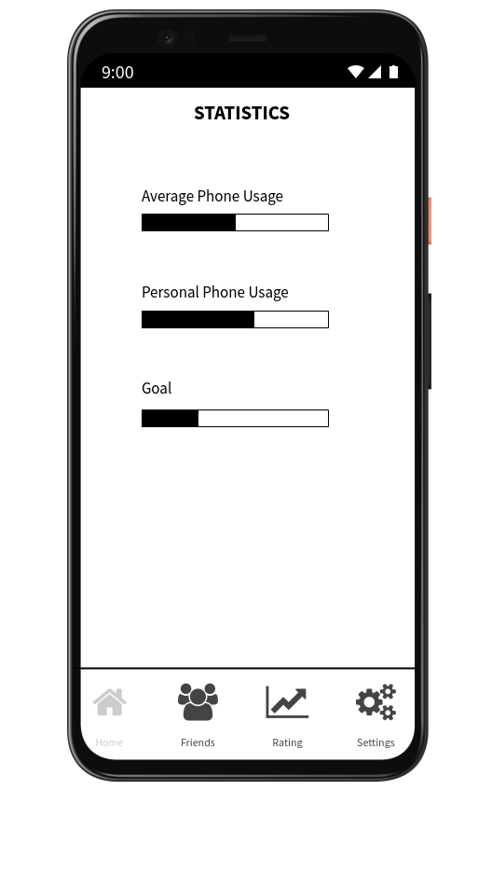

# **2.0. Friends**

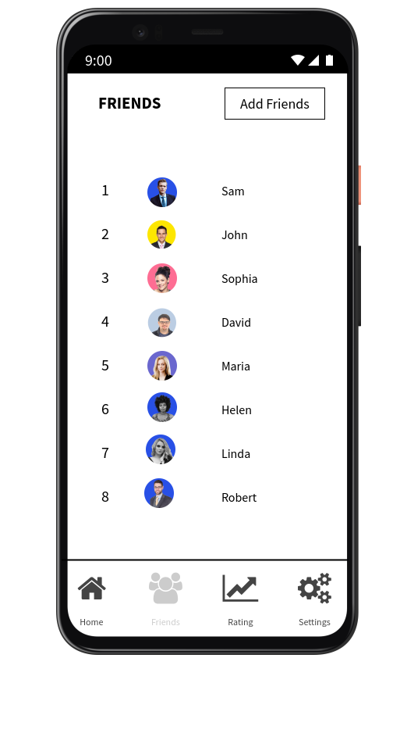

# **3.0. Rating**

