Introduction
The application that our group is developing is an agreement-based app which shows an overview of the status and progress of the user.
In order to consider the best way to approach our users we decided to collect and analyse user feedback on insights part.

We sent a prototype and a description of our application to 5 students who have at least 2 group projects per year during their study.

We asked them to fill out a questionnaire and give us their feedback on how they would like to view and track their progress. we collect and analyse their responses.

This document provides information on collected data and analysed results.

Survey

No: 1 Age: 23 occupation: physiotherapy student

Please complete the following questionnaire with specific regard to the
above enquiry, by placing a CROSS in the appropriate box.

how do you prefer to see the total hours that you spend in a lobby?

Daily weekly monthly

x

Do you like to be able to share your insights with your friends through the app?

No yes

x

Which one do you think is a most convenient and effective way for you to track your progress?

Bar chart that displays your daily records in a month
x

Bar chart that displays your agreements records

Frequently monitoring progress toward goals increases chance of success.

Strongly disagree.

Disagree

Neutral

Agree

x
Strongly agree.

Survey

No: 2 Age: 22 occupation: physiotherapy student

Please complete the following questionnaire with specific regard to the
above enquiry, by placing a CROSS in the appropriate box.

how do you prefer to see the total hours that you spend in a lobby?

Daily weekly monthly

x

Do you like to be able to share your insights with your friends through the app?

No yes

x

Which one do you think is a most convenient and effective way for you to track your progress?

Bar chart that displays your daily records in a month

Bar chart that displays your agreements records
x

Frequently monitoring progress toward goals increases chance of success.

Strongly disagree.

Disagree

Neutral

Agree
x

Strongly agree.

Survey

No: 3 Age: 25 occupation: ICT student

Please complete the following questionnaire with specific regard to the
above enquiry, by placing a CROSS in the appropriate box.

how do you prefer to see the total hours that you spend in a lobby?

Daily weekly monthly

X

Do you like to be able to share your insights with your friends through the app?

No yes

X

Which one do you think is a most convenient and effective way for you to track your progress?

Bar chart that displays your daily records in a month
X

Bar chart that displays your agreements records

Frequently monitoring progress toward goals increases chance of success.

Strongly disagree.

Disagree

Neutral

Agree
X

Strongly agree.

Survey

No: 4 Age: 24 occupation: Graphic design student

Please complete the following questionnaire with specific regard to the
above enquiry, by placing a CROSS in the appropriate box.

how do you prefer to see the total hours that you spend in a lobby?

Daily weekly monthly
x

Do you like to be able to share your insights with your friends through the app?

No yes

x

Which one do you think is a most convenient and effective way for you to track your progress?

Bar chart that displays your daily records in a month

Bar chart that displays your agreements records
x

Frequently monitoring progress toward goals increases chance of success.

Strongly disagree.

Disagree

Neutral

Agree

x
Strongly agree.

Survey

No: 5 Age: 24 occupation: ICT student

Please complete the following questionnaire with specific regard to the
above enquiry, by placing a CROSS in the appropriate box.

how do you prefer to see the total hours that you spend in a lobby?

Daily weekly monthly

x

Do you like to be able to share your insights with your friends through the app?

No yes

x

Which one do you think is a most convenient and effective way for you to track your progress?

Bar chart that displays your daily records in a month
x

Bar chart that displays your agreements records

Frequently monitoring progress toward goals increases chance of success.

Strongly disagree.

Disagree

Neutral

Agree

x
Strongly agree.

Conclusion

Almost all the students agree or strongly agree that tracking the progress is important in order to reach a goal.

80% of students prefer to see their daily records in a month.

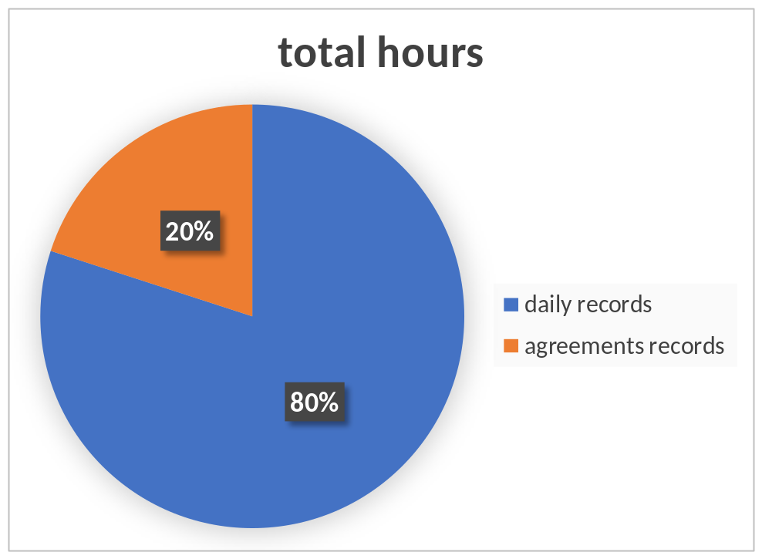

60% of students prefer to see their weekly report.
20% of them prefer to review it monthly and 20% prefer it to be monthly.

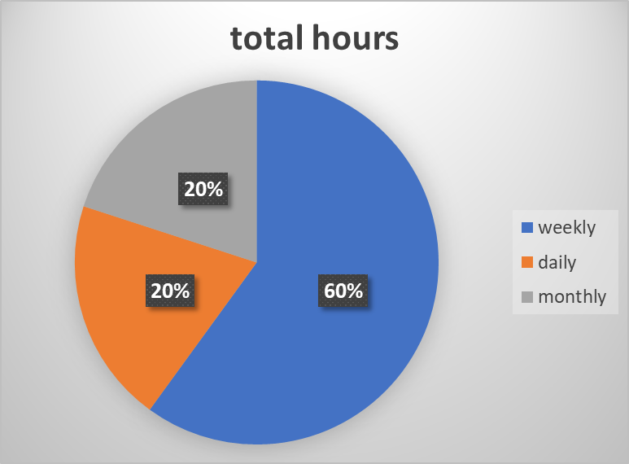

Final design based on the results.

