RIQMA ECOSYSTEM ENTERPRISE REPORT
Full Illustrated Technical Architecture, 2D Workflow with Decision Diamonds & Back-Cycles
riqma-webapp (Management Portal) & RIQMA-Pro (Field Auditor Tool)

1. Executive Overview of the RIQMA Ecosystem
RIQMA (Renom Integrated Quality Management Application) is the mission-critical digital quality operating system engineered for Renom Energy Services LLP. It governs multi-brand wind turbine quality assurance (Suzlon, Gamesa, Vestas, Inox, GE), 5S workplace audits, and Kaizen continuous improvement across 9 Indian states. The system links frontline field auditors climbing 100-meter towers with corporate management at headquarters:
• riqma-webapp (Management & Admin Portal): Flutter Web Single Page Application for master data setup, checklist template authoring, monthly audit scheduling, split-screen managerial reviews, Digital SQA certificate generation, and bulk Excel exports.
• RIQMA-Pro (Field Auditor Application): Flutter mobile/tablet app for on-site checklist execution, camera photo capture with ~400KB compression, offline persistence (IndexedDB), live preliminary scoring previews, and push notification alerts.

2. Basic Project Details & Technology Stack
Parameter / Dimension | riqma-webapp (Management) | RIQMA-Pro (Field Tool)
Project ID | riqma-pro (GCP / Firebase) | riqma-pro (GCP / Firebase)
Auth Domain | riqma-pro.firebaseapp.com | riqma-pro.firebaseapp.com
Storage Bucket | riqma-pro.firebasestorage.app | riqma-pro.firebasestorage.app
Operating Platform | Web (Chrome, Edge, Firefox, Safari) | Android, iOS, Web, Tablet PWA
Frontend Technology | Flutter Web (CanvasKit / WebAssembly) | Flutter (Material 3 Mobile UI)
Database Layer | Cloud Firestore (22 Collections) | Cloud Firestore + Local Persistence
File Storage | Google Cloud Storage (Reports) | Google Cloud Storage (Photos)
Spreadsheet Engine | Syncfusion Flutter XlsIO & excel 4.0.6 | excel 4.0.0 package
PDF Report Engine | pdf 3.11.1 & printing 5.13.2 | pdf 3.10.0 & printing 5.11.0
Source Code Directory | E:/riqma-webapp | E:/RIQMA-Pro

3. Illustrated 2D Workflow & Feedback Decision Cycles
Below is the complete 2D illustrated operational workflow diagram with geometric decision diamonds, Pass/Fail condition paths, and multi-tier feedback loops (including the Checklist Iteration Loop and Manager Correction Loop):
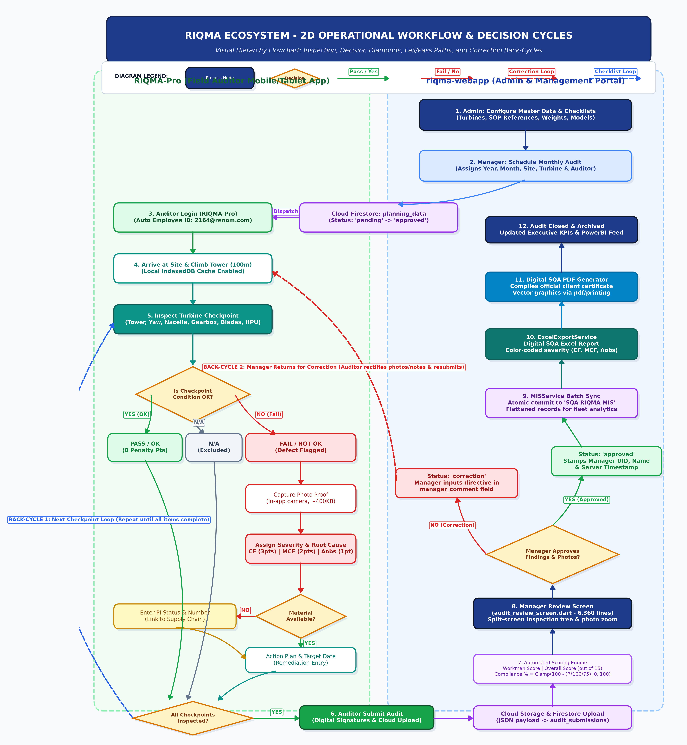
Figure 1: RIQMA 2D Operational Flowchart with Decision Diamonds and Return Back-Cycles

4. Operational Lifecycle & Decision Back-Cycles Breakdown
1. Decision Diamond 1 — Condition OK? (Pass vs Fail):
• If PASS / OK: 0 penalty points awarded. Proceeds to completeness check.
• If N/A: Checkpoint excluded from both earned points and maximum possible points.
• If FAIL / NOT OK: Triggers mandatory photo evidence capture, severity assignment (CF: 3 pts, MCF: 2 pts, Aobs: 1 pt), and root cause tagging.
2. Decision Diamond 2 — Material Available? (Supply Chain Linkage):
• If NO: System mandates Purchase Indent (PI) Status & PI Number to ensure procurement visibility.
• If YES: Auditor specifies corrective action plan and target resolution date.
3. BACK-CYCLE 1 — Checklist Iteration Loop:
• If 'All Checkpoints Inspected?' is NO: A return loop routes the auditor back to inspect the next checkpoint across Tower, Yaw, Nacelle, Gearbox, Blades, HPU, and Panels until 100% complete.
4. BACK-CYCLE 2 — Manager Correction & Rejection Loop:
• If Manager rejects or flags unclear photos/remarks during split-screen review (audit_review_screen.dart): Status changes to 'correction' and manager comments are appended.
• A prominent back-cycle return routes the audit back to the field auditor in RIQMA-Pro with a push notification to rectify and resubmit.
• If APPROVED: Stamped with manager UID and timestamp, triggering automated MIS synchronization and report generation.

5. Core Business Logic: Rating Calculation & Excel Export

A. Exact Mathematical Rating & Penalty Calculation (mis_service.dart)
Quality is evaluated on a 15-point scale and percentage compliance using a normalized weighted penalty model:
• Severity Penalties: Critical Finding (CF) = 3 pts | Major Critical Finding (MCF) = 2 pts | Observation (Aobs) = 1 pt.
• Workman Penalty: If mapped to workmanship error in audit_configs/nc_categories, penalty is charged to maintenance crew.
• Reference Grouping: Only the MAX penalty per standard reference group is added to the total (preventing penalty inflation).
• Score Formula (_getAssessmentScore out of 15.0):
- Penalties <= 0 ==> Score = 15.0 (Perfect)
- Penalties <= 20 ==> Score = 15.0 - (Penalties * 0.5)
- Penalties == 21 ==> Score = 4.8
- Penalties == 22 ==> Score = 4.5
- Penalties >= 23 ==> Score = 4.4 - ((Penalties - 23) * 0.1)
- Penalties >= 66 ==> Score = 0.1 (Floor)
• Overall Compliance (%) = Clamp( 100.0 - (Total Penalties * 100 / 75.0), 0.0, 100.0 )
Rating Grade | Score Range | Color Hex | Operational Interpretation
Excellent | 14.0 – 15.0 | #00B050 (Green) | Full compliance; minor/no defects
Good | 11.0 – 13.9 | #FFFF00 (Yellow) | Satisfactory; minor CAP within 30 days
Improvement | 8.0 – 10.9 | #00B0F0 (Cyan / Blue) | Substandard; urgent CAP within 14 days
Poor | 5.0 – 7.9 | #FABF8F (Orange/Peach) | Multiple major defects; crew retraining
Worst | < 4.5 | #FF0000 (Red) | Critical failure; immediate machine stoppage

B. Excel Export Architecture (excel_export_service.dart)
Excel exporting is executed via Syncfusion Flutter XlsIO in riqma-webapp:
1. Digital SQA Report Excel: Formatted multi-tab workbook with corporate logos, color-coded score badges (#00B050, #FFFF00, #FF0000), metadata, and itemized defect tables.
2. NC Tracking Excel: Exports active defects with photo thumbnails, root causes, and Purchase Indent numbers.
3. SQA Dump Excel: Large-scale BI data dump across all wind sites for PowerBI and pivot tables.
4. Master Data Export: Exports Sites, Turbines, and Checklists into formatted multi-sheet workbooks.

6. Cloud Infrastructure, Free Tier & Cost Simulations
The system runs on Google Cloud / Firebase Serverless BaaS (Project: riqma-pro). Key Free Tier (Spark Plan) quotas include 50k reads/day, 20k writes/day, 1GB Firestore storage, 5GB Cloud Storage, 50k MAU Auth, and 10GB Hosting bandwidth.
Cost Driver | Pilot Scale (10 Auditors) | Current Fleet (50 Auditors) | Enterprise (200 Auditors)
Monthly Audits | 200 audits / mo | 1,000 audits / mo | 5,000 audits / mo
Monthly Reads | 150,000 (Free) | 950,000 | 4,800,000
Monthly Writes | 25,000 (Free) | 140,000 | 750,000
Photos Stored | 2,000 (1.0 GB) | 25,000 (12.5 GB) | 150,000 (75.0 GB)
TOTAL MONTHLY BILL | $0.00 USD (FREE) | $3.95 USD (~ Rs 330 INR) | $24.40 USD (~ Rs 2,030 INR)

7. Ecosystem Advantages & Disadvantages (Fayde & Nuksan)
• Advantages (Fayde): Real-time field-to-office sync within 200ms; 100% elimination of paper checklists; photo and GPS verification prevents false sign-offs; offline resilience in remote wind farms; 98% cheaper cloud costs (<$25/month) compared to legacy software.
• Disadvantages / Challenges (Nuksan): Dual codebase updates for new checklist fields; NoSQL structure requires denormalized reporting collections ('SQA RIQMA MIS'); mobile device hardware diversity among field technicians.

8. Business Benefits for Users and Renom Energy Services
• For Field Auditors: Fast tap-to-answer interface, camera photo capture directly inside the app, auto-calculated scores, and zero loss of data when offline.
• For Quality Managers: 360-degree fleet visibility, 6,360-line split-screen review screen with instant photo zoom, and 1-second Excel/PDF report downloads.
• For Renom Energy Services: Audit review turnaround slashed from 14-21 days to under 24 hours; airtight ISO 9001:2015 audit trails; direct procurement linkage between defective parts and Purchase Indent (PI) numbers prevents turbine downtime.

