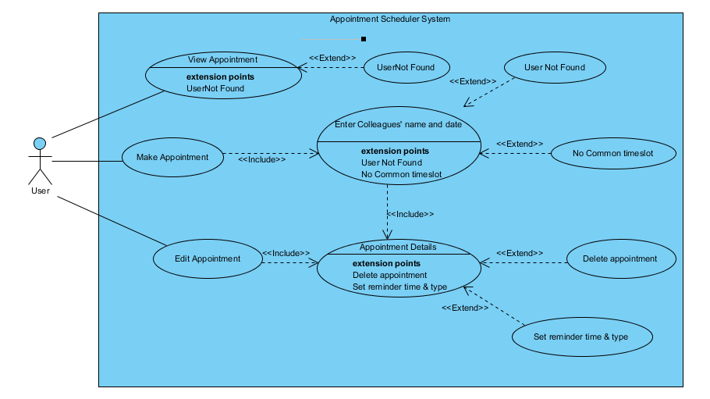

|  |  |
| --- | --- |
| **Name** | View Appointment |
| **Description** | This use case describes how the users view their own appointments. |
| **Actors** | User |
| **Pre-conditions** | 1. The user has logged in. |
| **Basic Flow** | 1. The use case begins when the user selects “View Appointment” from the main menu. 2. The system will display all the appointments belong to the user. 3. User enter a colleague’s name for query his/her appointment. 4. The system validates colleague’s name. 5. The user will need to enter a date for query the appointments. 6. The system will prompt to ask the user either want to view by the date, or view the whole week the date in. 7. The system displays the appointment s of the colleagues. 8. The use case ends successfully. 9. Go back to step 3 until user enter ‘qqqq’. |
| **Alternative Flows** | 1. User not found   If in step 4 of the basic flow fail, then the user need to enter colleagues name again.   1. User cancel process   If in any step of above user cancels the process by type enter a ‘qqqq’. |
| **Post-conditions** | 1. Successful Completion   The appointment displayed successfully.   1. Failure Condition   The user cancels the request, the system returns to the main menu. |

|  |  |
| --- | --- |
| **Name** | Make Appointment |
| **Description** | This use case describes how the users create appointments. |
| **Actors** | User |
| **Pre-conditions** | 1. The user has logged in. |
| **Basic Flow** | 1. The use case begins when the user selects “Create Appointment” from the main menu. 2. User enters a colleague’s name. 3. The system validates colleague’s name. 4. Go back to step 2 until user enters ‘0’ to finish enter colleague’s name 5. The user will need to enter a date for query the appointments. 6. The system will generate a list of common free timeslot 7. User have to select the timeslot for the appointment 8. The system will prompt to key in the appointment details. 9. User enter 0 to confirm creation of appointment. 10. The use case ends successfully. |
| **Alternative Flows** | 1. User not found   If in step 3 of the basic flow fail, then the user need to enter colleagues name again.   1. No Common free time slot   If in step 6 of the basic flow, if there’s no common free timeslot, system will need to ask the user to enter another date.   1. User cancel process   If in any step of above user cancels the process by type enter a ‘qqqq’. |
| **Post-conditions** | 1. Successful Completion   The appointment created successfully   1. Failure Condition   The user cancels the request, the system returns to the previous page. |

|  |  |
| --- | --- |
| **Name** | Edit Appointment |
| **Description** | This use case describes how the users edit their own appointments. |
| **Actors** | User |
| **Pre-conditions** | 1. The user has logged in. |
| **Basic Flow** | 1. The use case begins when the user selects “Edit Appointment” from the main menu. 2. The system will display all the appointments belong to the user. 3. User selects one appointment. 4. The system displays the details of the appointment. 5. The user selects which details of the appointment need to change. 6. The system will prompt to ask the user enters new data. 7. Go back to step 4 until user enter 0 to confirm. 8. The use case ends successfully. |
| **Alternative Flows** | 1. No Common free time slot   If in step 4 of the basic flow, user choose to edit the data, and the system will prompt to ask user enter a date, if there’s no common free timeslot, system will need to ask the user to enter another date.   1. User selects the option of delete appointment.   If in step 4 of the basic flow, user choose to delete the appointment, and the system will prompt to user choose confirm or cancel by enter Y/N.   1. User cancel process   If in any step of above user cancels the process by type enter a ‘qqqq’. |
| **Post-conditions** | 1. Successful Completion    1. The appointment edited successfully.    2. The appointment deleted successfully 2. Failure Condition   The user cancels the request, the system returns to the previous page. |